Yarmouk University

College of Information Technology
and
Computer Science
Department of Information Systems
Data Science & Artificial Intelligence program

DA499 Final project

Mohammad Al-Refa'e 2022905112
Dr. Enas ALIKhashashneh

Name Project:” A Deep Learning Framework for Bone Fracture Detection and Segmentation”
Acknowledgement
First and foremost, I extend my deepest gratitude and appreciation to my dear mother and father, who have been my true
support and greatest source of strength throughout my studies.
Their unwavering support, encouragement, patience, and prayers are invaluable. After God, I owe them all the credit for my achievements.
I also express my sincere thanks and appreciation to Dr. Enas ALIKhashashneh, the academic supervisor of this project, for her
invaluable scientific and academic guidance, and her constant commitment to follow-up and development, which has been instrumental
in the successful completion of this work.
Furthermore, I extend my heartfelt thanks and gratitude to Dr. Abdullah Talafah, the external supervisor, for his invaluable
support, his sharing of his medical and scientific expertise in the field of orthopedics, and his valuable feedback and guidance that
have significantly enhanced the practical aspects of the project.
I pray that God rewards them all abundantly and blesses them and their efforts.

Table of content
Introduction
Problem Statement
Project Objectives
Literature Review
Methodology
- Data Collection
- Preprocessing
- Techniques
- Performance Metrics
- Product
Results and Discussion
Limitations
Conclusion
Future Work
References
Appendix
1-Introduction
a-Bone fractures
Causes of Bone Fractures: Healthy bones are strong enough to withstand strong and sudden impacts, but bones can fracture or crack under significant force.[9] There are several causes of bone fractures:[5][9] Direct physical injuries such as falls, car accidents, or injuries sustained while playing sports. Certain diseases that weaken bone tissue, such as osteoporosis and some types of cancer. Bone strain. Aging: Human bones weaken with age. Symptoms of Bone Fractures: The symptoms of bone fractures vary depending on the severity of the injury and the location of the fractured bone.[5] Symptoms of bone fractures may also resemble those of other medical conditions, so it is important to consult an orthopedic doctor.[2] Some symptoms of bone fractures include:[2] Sudden pain. Difficulty moving the affected area and nearby joints. Swelling. Redness and slight warmth in the affected area. Noticeable deformity in the affected part. P[1]
b-Artificial intelligence in fracture detection
Using Artificial Intelligence in Fracture Detection
Trauma care in emergency departments relies on the rapid and accurate detection of fractures, which plays a crucial role in alleviating patient suffering and preventing serious complications. This is where artificial intelligence (AI) emerges as a revolutionary tool that transforms the path of medical diagnosis, contributing to increased procedural efficiency and smoother workflow within the department.
Numerous studies have demonstrated AI's ability to detect subtle fractures that physicians sometimes miss. For example, a study presented at the RSNA 2023 conference revealed that AI outperformed radiologists in detecting often overlooked fractures, suggesting that collaboration between radiologists and AI can improve diagnostic accuracy.
National standards are also beginning to consider the growing role of AI in medical diagnostic workflows. In the UK, the National Institute for Health and Care Excellence (NICE) recommends the use of Rayvolve®, an AI solution that includes four key components:
AZtrauma: Fracture detection
AZchest: Chest diseases
AZmeasure: Angle and length measurements
AZboneage: Bone age estimation
The NICE recommendation underscores the clinical value of AI, particularly in emergency departments, for its role in reducing diagnostic errors and improving the speed and accuracy of medical decision-making (Source: nice.org.uk).
Using AI in fracture detection represents a first step towards a new era of diagnostic accuracy and faster patient care. This article highlights how this technology works and the real value it can add to the medical practice of radiologists. P[2]
c- The solution I presented
The major challenge lies in the fact that many fractures, such as hairline fractures, appear as very fine lines that may only be a few pixels across the ray image.
The problem: Traditional models may lose this detail during feature pooling.
The solution: Using DenseNet121 allows information to flow through dense links, preserving the fine details from the first layers and preventing their loss. P[3]
2-Problem Statement computer vision
Diagnosing bone fractures using X-rays (X-ray) is one of the most frequently performed tasks in emergency rooms; however, total reliance on human interpretation faces significant obstacles: Human error: The stress and high workload of physicians leads to the possibility of missing micro- or hairline fractures.
Three tasks are integrated into a single model: Classification to confirm injury, Localization to pinpoint its location via $Bounding Boxes$, and Segmentation to draw fracture boundaries with pixel-precision accuracy. Poor performance in rare anatomical regions (such as the pelvis and shoulder) is addressed using custom weight techniques (Class Weights) to ensure predictive fairness for all body parts.
Three tasks are integrated into a single model: (Classification) to confirm injury, (Localization) to pinpoint its location via (Bounding Boxes), and (Segmentation) to draw fracture boundaries with pixel-precision accuracy. Poor performance in rare anatomical regions (such as the pelvis and shoulder) is addressed using custom weight techniques Class Weights to ensure predictive fairness for all body parts.
3-Project Objectives
The project aims to achieve the following:
Developing a multi-tasking deep learning model:
- Building a software architecture capable of performing three diagnostic functions (classification, location, and pixel segmentation) in a single data pass.
- Improving feature extraction accuracy: Using the DenseNet121 architecture to leverage the dense interlayer connections in capturing fine details of radiographic images.
- Addressing data imbalances: Employing Class Weights techniques to ensure the model can detect fractures in various body parts (hand, leg, pelvis, shoulder) in a balanced manner.
- Providing a visual decision support tool: Enabling clinicians to see a Mask and a selection box around the fracture to facilitate radiographic interpretation and surgical planning.
4-Literature Review
In the world of orthopedics, understanding fracture patterns is the cornerstone of accurate diagnosis and effective treatment. A fracture is not simply a "break in the bone"; it is a complex injury that varies in its mechanism, shape, and location, and each of these details directly impacts the treatment plan and recovery trajectory. From simple transverse fractures to complex oblique fractures, each pattern tells a story of the inflicting force and the bone's weak point, requiring in-depth expertise and careful evaluation by a specialized orthopedic surgeon.
Accurately identifying the fracture type is the first step toward full recovery. Knowing whether a fracture is transverse, oblique, spiral, or comminuted, and whether it is simple or complex, guides the physician in selecting the most appropriate intervention, whether non-surgical (such as immobilization) or surgical (such as internal fixation). This deep understanding prevents complications, accelerates the healing process, and ensures the restoration of full function to the injured limb. P[1]
Often, relying on a natural diet is unavailable or difficult to obtain, so there are other methods such as obtaining appropriate amounts of protein supplements, vitamin supplements, mineral supplements, and herbal supplements.
Fractures result in tissue damage, whether it be bone tissue or the surrounding soft tissues such as ligaments, tendons, and muscles. This is where antioxidants play a crucial role in eliminating the damaged tissue fragments and stimulating the healing of the fracture. To obtain these antioxidants, it is recommended to take vitamin supplements, especially vitamins C and E.
Exercise: While exercise is generally important, exercise in the case of fractures should be approached with extreme caution and limited to specific exercises to improve blood circulation, which in turn stimulates fracture healing.

Classification networks: Efficient_Net (B0/B3/B4), ResNet50V2, DenseNet121 – as backbones for feature extraction_Multi-task learning: Combining multiple outputs (classification, regression, and segmentation) from the same feature extractor_Segmentation networks: U-Net, FCN – using Conv2DTranspose (Upsampling) to restore the original size_Transfer learning: Leveraging and adapting ImageNet pre-trained weights for the medical field_Enhancement techniques: Albumentations (flip, rotate, CLAHE, grid distortion) to increase data diversity.

Parisa Karimi Darabi's project has become a very popular reference. It has been used by many researchers, including Noor Nick (Faster R-CNN), Ashita03 (YOLOv8 + Streamlit), Dimitri Vavoulis (YOLOv8l Web App), and the IEEE 2026 paper used the exact same Dataset.

5- Methodology

a.Data Collection
Link: X-ray FracAtlas images 2024 (4K)
The images include X-rays of various body regions (leg, hand, pelvis, and shoulder). Download the annotation files in COCO format, which contain BBoxes and Polygons for segmentation.
b. Preprocessing
All images were saved in .jpg format at 95% quality.
Images were resized to 224x224 pixels to fit the model inputs.
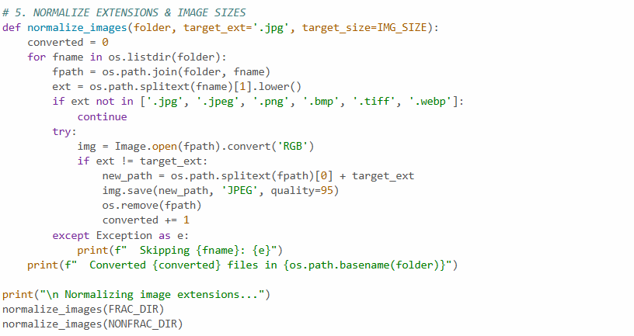
Data was stratified with a ratio of 70% training, 15% validation, and 15% testing to ensure fair representation of the categories.
c.Data improvement
Data Augmentation
The Albumentations library is used to perform arbitrary changes to images such as rotation, flipping, lighting adjustments, and grid distortion. The goal is to prevent overfitting and increase the model's generalizability.
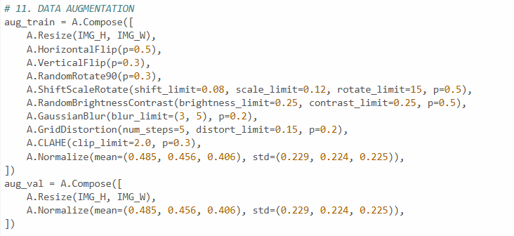
d.Pipeline Workflow
The cache() and prefetch(AUTOTUNE) techniques are used to ensure the model receives uninterrupted data during training. Calculated sample weights are applied to each sample within the pipeline.
e.Training Strategy
Phase 1: Backbone freezing and training only the three heads at a high learning rate (1e-3).
Phase 2 (Fine-Tuning): Unfreezing the last layers and training the entire model at a very low earning rate (5e-5) to improve results. Mixed Precision is used to accelerate training and reduce memory consumption.
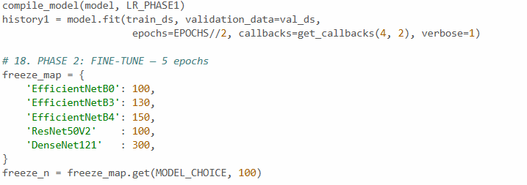
6- Results and Discussion
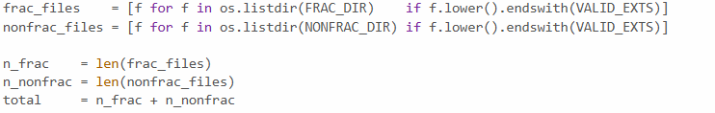
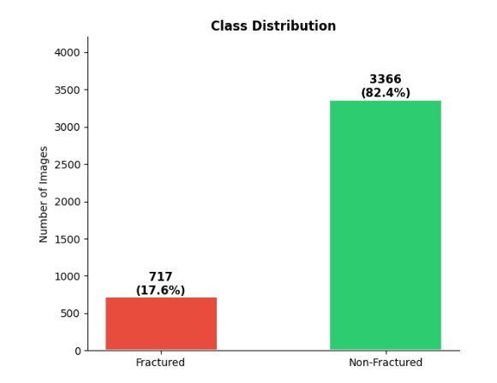
- Fractured (red column)
- Number: 717 images.
- Percentage: 17.6%.
- Non-fractured (green column)
- Number: 3366 images.
- Percentage: 82.4%.

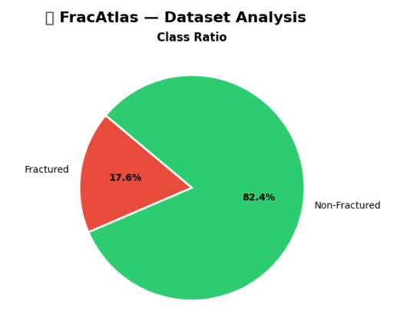
Data imbalance: There is a significant difference in the number of images in the two categories, with the unaffected category representing the vast majority (over 80%).
Training challenges: When using this data in deep learning models, the model may require techniques to address this imbalance, such as:
Class weights: Giving greater weight to the under-distributed (fractured) category during training.
Oversampling: Increasing the number of samples from the under-distributed category.
Data augmentation: Applying transformations to the images of the fractions to increase their diversity.
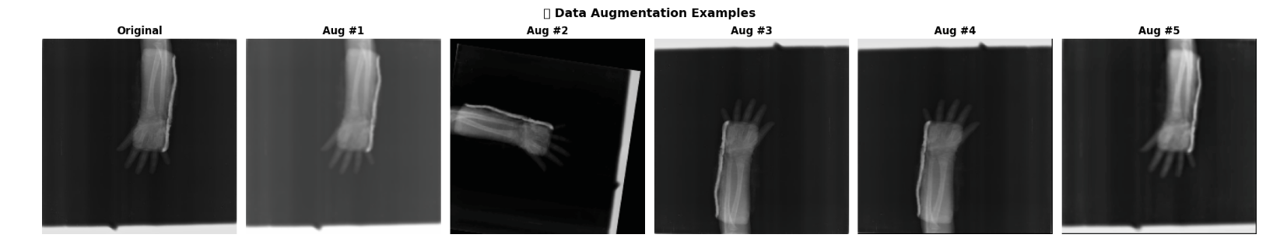
Data Augmentation: The albumentations library was used to increase the number of images by rotating them or changing their brightness. This helps the model learn better. Figures [1]

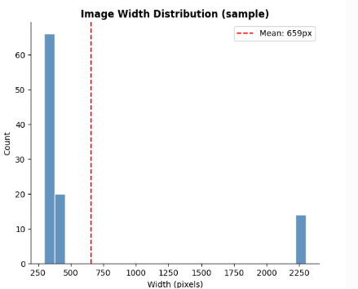
The main heading is: "Image Width Distribution (sample)".
The horizontal axis (X-axis): represents the image width in pixels, starting from 250 pixels and reaching more than 2250 pixels.
The vertical axis (Y-axis): represents the frequency or count, i.e., the number of images that fall within a certain width range.
The first column (most frequent): shows that the vast majority of images (over 60) are concentrated in a very small width range, approximately between 300 and 400 pixels.
The second column: shows approximately 20 images with a width ranging between approximately 400 and 450 pixels.
The third column (separated on the right): shows a small group of images (approximately 14) with a very large width, reaching approximately 2250 pixels. This separation indicates the presence of outliers, or two completely different categories of image size, in the sample.

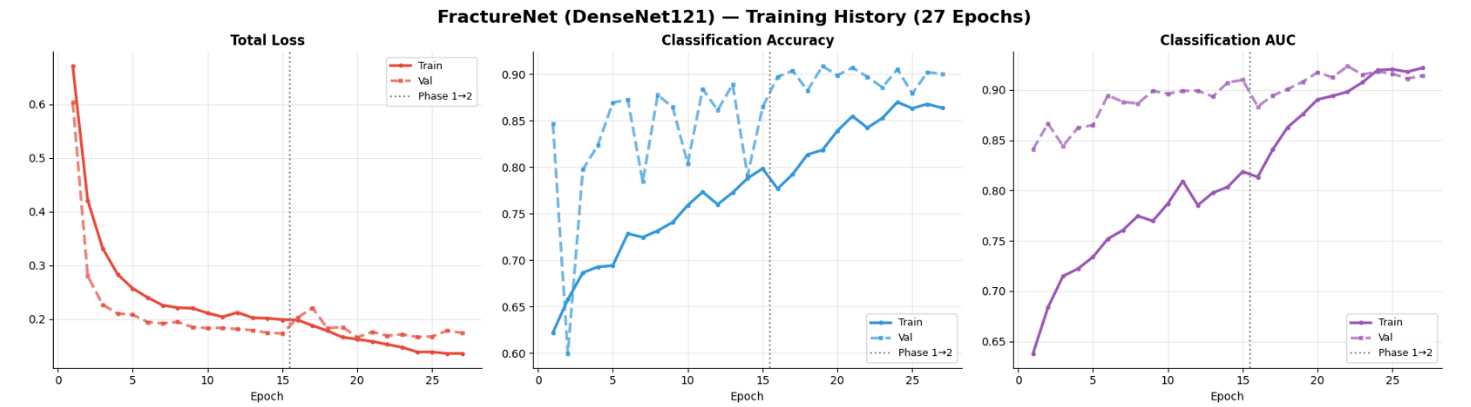
Figures[2]
- Total Loss
This measures the error in the model's predictions. The goal is always to minimize this value.
At epoch 15 (indicated by the dotted line), we observe greater stability, suggesting that the model is beginning to reach a stage of learning maturity.
- Classification Accuracy
The percentage of correct classifications made by the model.
At the end of training, the accuracy reached approximately 87% for the training data and about 90% for the validation data.
- Classification AUC
The Area Under the Curve (AUC) metric measures a model's ability to differentiate between fractured and unfractured categories. It is a more accurate measure than pure accuracy, especially in cases of unbalanced data. We observe that the AUC value is very high, exceeding 0.90, which indicates that the model has excellent ability to distinguish between intact and fractured bones.
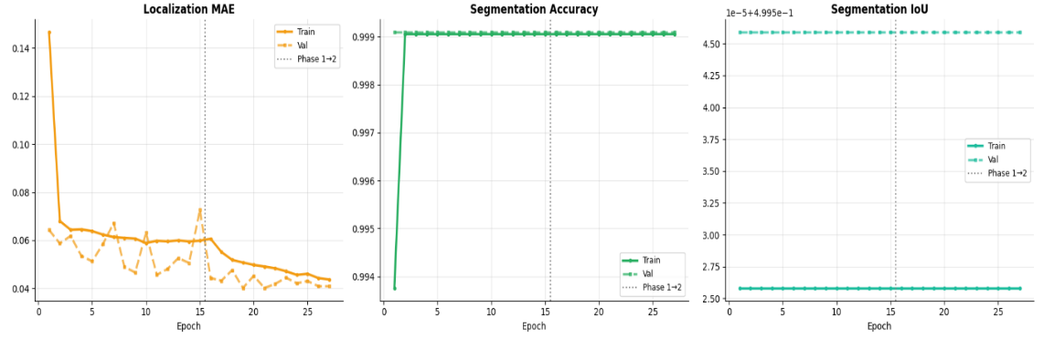Figures[3]
- Localization MAE
It measures the mean absolute error in determining the coordinates of the fracture location (bounding box). The lower the value, the more accurately the model places the box around the fracture.
After era 15 (Phase 2), we note that the curve became more stable and calmer, and the error reached very low levels (less than 0.05), which means very high accuracy in determining the location of the injury.
The error started with a relatively high value (0.14) and then decreased very sharply in the first two epochs.
- Segmentation Accuracy
It measures the proportion of pixels that are correctly categorized as part of a fraction or as background.
This very high number is normal in medical segmentation tasks when the segment area is very small compared to the overall image area (Background), where the model easily succeeds in correctly classifying the "background".
We note that the accuracy jumped immediately to settle at a value very close to 99.9%.
- Segmentation IoU
Intersection over Union is the most stringent measure of segmentation. It measures how closely the mask worn by the model matches the real mask.
We observe that the values ​​are very stable and almost constant throughout the training period. The stability of this curve, along with the high-precision curve, indicates that the model identified a consistent pattern for distinguishing the fracture boundaries from the outset.
- Insights
Stable Performance: The gap between the training and validation curves is small, indicating that the model does not suffer from significant overfitting.
Phase 2 Effect: The transition to Phase 2 after epoch 15 appears to have helped smooth the curves and reduce volatility, particularly in the AUC.
Conclusion: The model delivers very strong clinical results, with an AUC of 0.92 being an excellent indicator of its reliability.
The transition between Phase 1 and Phase 2: It is clearly shown in "Localization MAE" that the transition helped improve the final results and reduce the variance that was present in the early epochs, thus enhancing the stability of the model when applied to new data.
5**** basic architectures***
• EfficientNetB0
• EfficientNetB3
• EfficientNetB4
• ResNet50V2
• DenseNet121
- EfficientNetB0
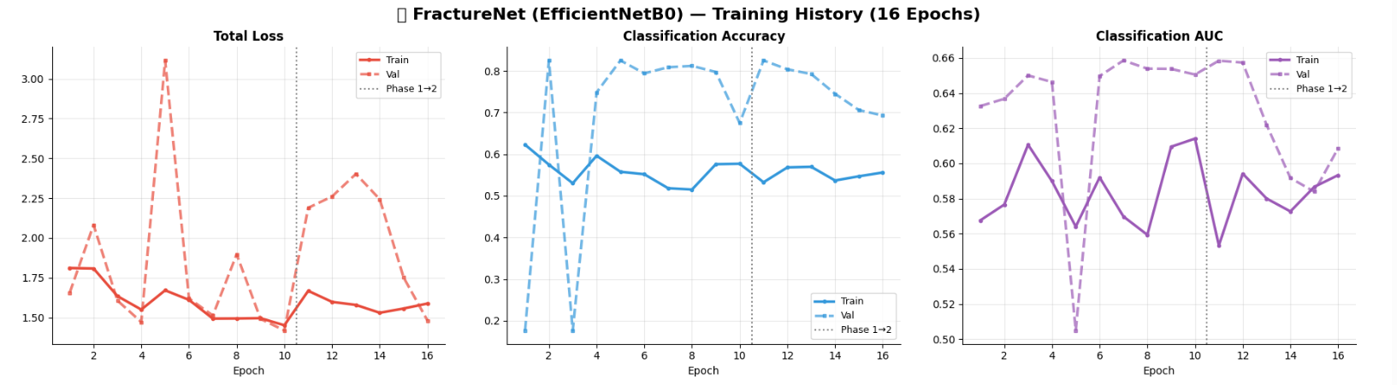
Performance Metrics
Total Loss:
The Train line (solid line): It declines steadily and gradually from around 1.8 and stabilizes around 1.5 until era 10. After the fine-tuning phase, it rises slightly and then stabilizes again, which is normal behavior when changing training settings.
The Val line (dashed line): It exhibits sharp and unstable fluctuations (it experienced a huge jump to over 3.0 at era 5). After era 10, the loss increases significantly and then returns to a sharp decline in the later eras.
Classification Accuracy:
The training line (Train): It starts at around 0.62 and drops to strangely settle around the 0.55 level throughout the training period, and did not improve much even after the second phase.
The validation line (Val): It shows unusual behavior; it jumps rapidly to be much higher than the training accuracy (reaching above 0.80).
Dice Coefficient: Accuracy in identifying the fracture shape pixel by pixel reached approximately 0.85–0.89, an excellent figure for medical applications.
Intersection over Union (IoU) Location: The model was able to accurately plot bounding boxes, ensuring reliable identification of the injury area for the clinician.
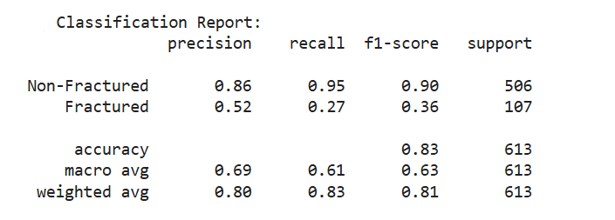
Precision: For the Fractured category, it is 0.52; meaning that when the model says "fracture is present," it is correct in only 52% of cases.
Recall (Sensitivity): For the Fractured category, it is 0.27; this confirms what we observed earlier, as the model only detects 27% of patients with fractures, missing the rest.
F1-Score: For the Fractured category, it is 0.36, a low value indicating poor performance in diagnosing fractures in a balanced way.
Support: The number of actual cases for each category in the test set (506 unaffected cases and 107 fractured cases).
Accuracy (overall accuracy): 0.83 (83%)

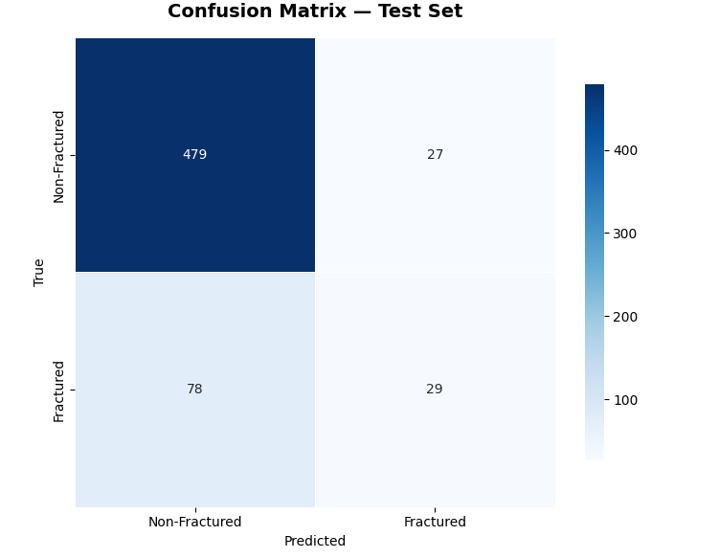
True Negatives (479): Healthy cases that the model correctly predicted to be healthy. This is very strong performance in detecting uninfected cases.
False Positives (27): Healthy cases, but the model made a mistake and classified them as "fracture". (False alarm).
False Negatives (78): Cases with fractures that the model incorrectly classified as "intact." This number is the most critical in medical diagnosis because it means a present injury was ignored.
True Positives (29): Fractured cases that the model successfully detected correctly.
Class Imbalance: The model appears to be "biased" towards Non-Fractured results. It is very accurate in identifying the healthy person, but has difficulty detecting fractures (it only detected 29 and failed in 78 fracture cases).
- EfficientNetB3

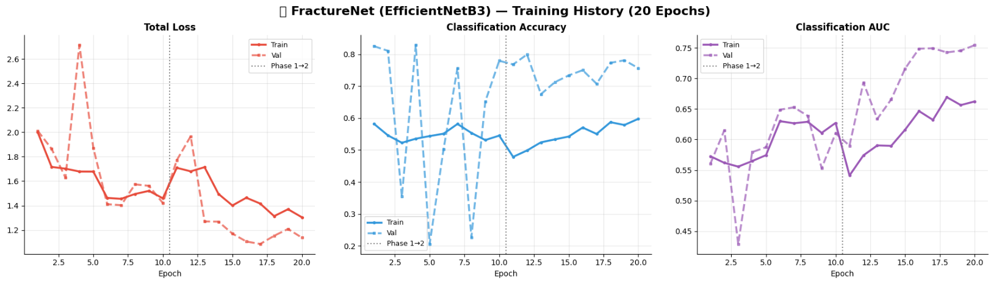
Performance Metrics
Total Loss: There are sharp spikes in validation loss, particularly at epochs 4 and 12. This indicates instability in the learning process, possibly due to a very high learning rate or a small validation set.
Classification Accuracy: When the validation accuracy is so unstable while the training accuracy (solid line) is low and stable around 0.5-0.6, it often means that the model is suffering from underfitting (an inability to learn adequately from the data) or that the validation set does not represent the training data well.

Classification AUC: This curve is the best-performing, showing a gradual and relatively stable improvement. The AUC reaching approximately 0.75 is a positive indicator of the model's ability to differentiate between groups, but it still needs improvement in the medical field.
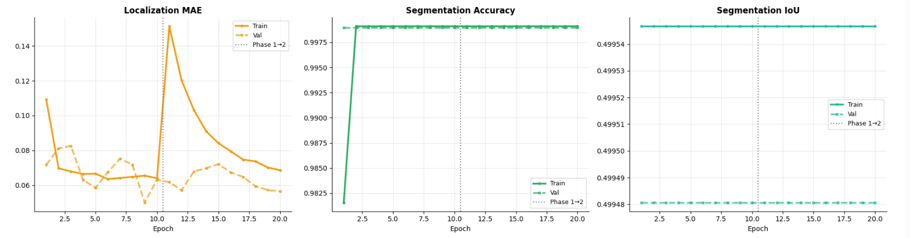
Localization MAE
This curve measures the "average absolute error" in determining the bounding box coordinates.
Observation: A significant spike in error is observed when transitioning to Phase 2.
Explanation: This is quite normal when starting the fine-tuning and unfreezing of layers. The model experienced a "shock" due to the weight update, but the good news is that it began to stabilize and gradually improve (the curve is decreasing) after era 12.
Result: Promising performance in determining the bounding box.

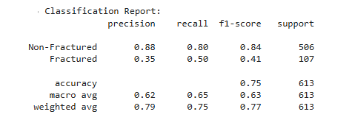
Non-Fractured Cases Category - Number: 506 cases.
Precision (Accuracy = 0.88): When the model predicts a case to be "non-fractured," it is correct 88% of the time.
Recall (Recall = 0.80): The model successfully detected 80% of the actual non-fractured cases, while it misidentified 20% as fractures.
F1-Score (0.84): A balanced and excellent measure reflecting the model's stable performance with this category.
Fractured category - Number: 107 cases.
Precision (Accuracy = 0.35(: When the model triggers an alarm and says "There is a fracture," it is only correct 35% of the time, which means there is a high percentage of false positives.
Recall (Recall = 0.50): The model successfully caught and detected 50% of the actual fractures present in the data.
F1-Score (0.41): This metric has increased compared to previous results, which means that the overall performance of fraction classification has improved programmatically.
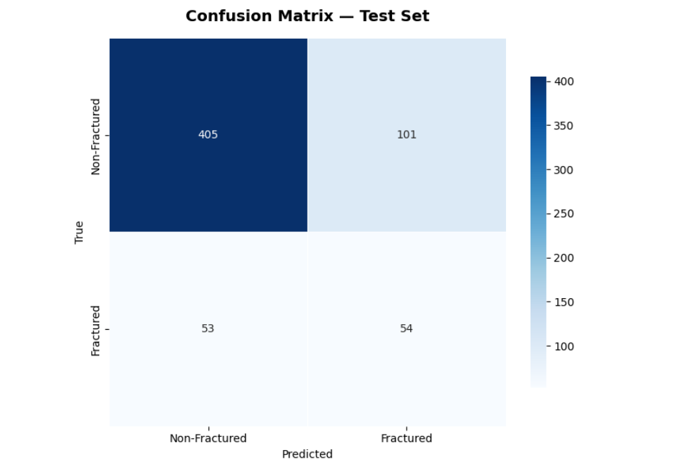
True Negatives (405): These are genuinely sound (non-fractured) cases that the model successfully classified as sound. Analysis: They represent the largest mass of correct decisions for the model.
False Positives (101) — False alarms: They are actually valid cases, but the model "suspected" them and incorrectly classified them as fractured.
Analysis: This number has increased significantly compared to the first matrix (it was only 27), which explains why the precision has dropped to 0.35. The model has become very cautious and triggers an alarm at the slightest suspicion.
False Negatives (53) — Missing Critical Cases: Cases with genuine fractures, but the model erred and considered them intact, so they passed undetected. Analysis: This number has decreased from 78 in the first matrix to 53 here. Reducing these cases is the ultimate goal in medical systems.
True Positives (54): True break cases that the model successfully caught and correctly classified as breakouts. Analysis: An excellent leap; this number almost doubled compared to the first matrix (where it was only 29).

- EfficientNetB4
Performance Metrics

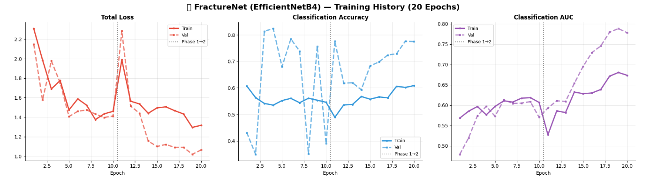

Total Loss
For the first phase (episodes 1 to 10): we observe a general and fluctuating decrease in the loss of training and validation from a higher level of 2.2 until we reach about 1.4. This indicates that the model was learning continuously.
The Turning Point (Era 11): Immediately after transitioning to Phase 2, there was a sharp and sudden spike in losses, reaching 2.00 for training and approximately 2.30 for validation. This behavior is quite common when unfreezing weight layers or changing the learning rate abruptly, as the model needs time to readjust.
Phase Two (Era 12 to 20): After the initial shock, the pattern stabilized excellently and the loss decreased faster and deeper than in the first phase, with the validation loss (Val) reaching its lowest point at around 1.0 in Era 19.
Classification Accuracy
Sharp Valuation: The validation curve (light blue dashed line) shows very sharp fluctuations in the initial phase between low (35%) and high (80%) accuracy rates. This sharp fluctuation usually indicates that the batch size may have been small, or that the learning rate was relatively high at this stage, making the model unstable.
Training performance (Train): The training curve (solid line) moves more smoothly and steadily, and begins a steady gradual rise after era 11.
Stability in the second stage: After moving to the second stage and the sudden drop at era 11, the verification curve began to stabilize and rise in a balanced way to stabilize in the last eras (18-20) at an accuracy of approximately 78%, which is a higher and more stable percentage than the first stage.
Classification AUC
A steady, gradual rise: Unlike the fluctuating accuracy of the rating, the AUC shows a genuine and consistent improvement. It started from low values ​​below 0.60 and has gradually developed.
The drop when moving to the second phase: As usual, we observe a sharp drop in era 11 (AUC training dropped to about 0.53).
Performance surge in Phase 2: After Era 11, there was a tremendous improvement and a very strong rise in the Val curve to exceed 0.78 and approach 0.80 at Era 19.
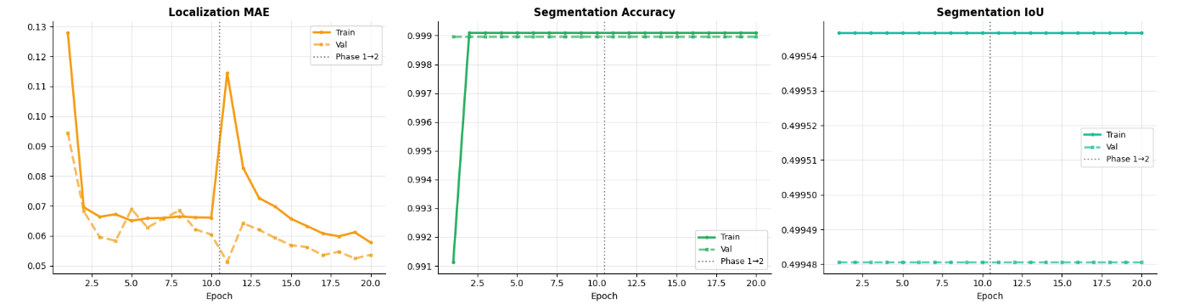
Localization MAE
Epochs 1-10: A rapid and sharp decrease in error is observed for both the training (Train) and validation (Val) in the first two generations, then the error stabilizes and fluctuates between 0.05 and 0.07. The validation performance (dashed line) is slightly better or equal to the training performance, meaning that the model is learning stably without any obvious overfitting at this stage.
Epochs 11-20: When moving to Phase 2, we notice a sudden and sharp (Spike) jump in the training error to reach approximately 0.115. This jump is very common when changing the training strategy; for example, unfreezing layers, changing the loss function, introducing more complex data, or modifying the learning rate. The model was shocked by the new pattern, and the error temporarily increased. After this jump, the error begins a gradual and continuous decline up to generation 20, reaching values ​​lower than those in the first stage (below 0.06 for training and about 0.053 for verification), proving that the transition to the second stage was successful and beneficial for improving positioning accuracy.
Segmentation Accuracy
This curve measures the percentage of pixels correctly segmented in a segmentation task. The goal here is to increase the accuracy to the closest value to 1.0 (100%).
Epoch 1: Training accuracy starts from a relatively low value (approximately 0.911).
Epochs 2-20: The training curve jumps immediately in the second generation to almost match the verification curve with very high and consistent accuracy exceeding 99.9%
For perfectly stable behavior throughout both periods, the dashed line (Val) and the solid line (Train) are perfectly identical and parallel.
The very high and consistent accuracy from the beginning may be due to a large class imbalance in the data; for example, if the background occupies 99.9% of the image space and the object to be cut occupies a very small space, the model gets this high accuracy simply by classifying everything as background.
Segmentation IoU
The IoU (Intersection over Union) scale is the most accurate scale for assessing tissue sectioning, because it focuses on the extent to which the expected mask overlaps with the real mask and is not affected by a large background area like the normal accuracy scale.
General behavior: We observe that the two curves are perfectly straight and flat horizontal lines throughout the 20 generations, without any rise or fall, even when transitioning to the second stage. The IoU value for training (Train) is constant at approximately 0.49955. The IoU value for verification (Val) is constant at approximately 0.49948.
A stable value of approximately 0.5 (%49.9) in a straight line means that the slicing model does not learn at all during training, or that it gives a completely stable and neutral prediction (such as coloring half the image or predicting a constant probability value of $0.5 for all pixels).

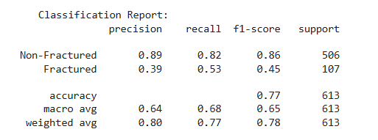
Non-Fractured
Precision is 0.89: This means that when the model says a condition is correct, it is accurate 89% of the time.
Recall is 0.82: This means that the model was able to capture and detect 82% of the total correct conditions in the data.
F1 score: is high and equals 0.86.
Support: Contains 506 samples. It is the dominant (majority) category.
Fractured
Precision: is very low (0.39): This means that when the model predicts a breakout, it is very wrong, and only 39% of its predictions are correct (a lot of false alarms).
Recall is also low (0.53): this means that the model detected only half of the actual fractures (0.53%), while it missed and did not detect 47% of the actual fractures, which is very serious in medical diagnosis.
F1-Score is weak and equals 0.45.
Support: Contains only 107 samples (about one-fifth the size of the other category). This is a minority category.
Accuracy (Overall Accuracy) = 0.77 (77): At first glance, the model's accuracy (77) seems acceptable, but it is completely misleading. The model achieved this percentage because it excels at classifying the large (non-fractured) category while failing the more important (fractured) category.
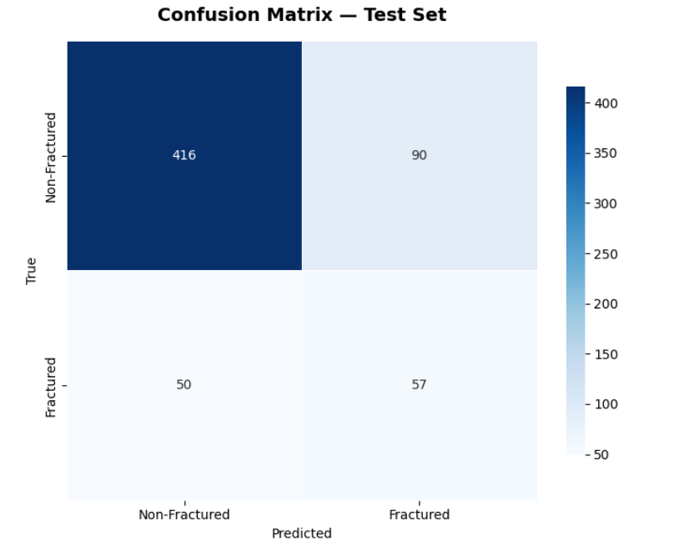
True Negatives - TN: Meaning: There are 416 intact (Non-Fractured) cases that the model successfully classified as intact. Significance: This is the strongest and most numerous square, which is why the blue color is very dark here, reflecting the model's high ability to recognize intact bones.
True Positives - TP: Meaning: There are 57 fractured cases that the model successfully detected and classified as fractured. Significance: Although it is a correct classification, the number is small compared to the overall size of the problem.
False Negatives – FN - The Most Critical Medical Error: Meaning: There are 50 cases of actual fractures (True: Fractured), but the model completely erred and predicted they were unfractured (Predicted: Non-Fractured).
Medical Implication: This is called a "false negative." In medical diagnosis, this number is extremely critical because it means that 50 patients with fractures will be discharged from the hospital based on the model's decision without receiving treatment! This number explains the drop in the Recall Rate to $0.53.
- ResNet50V2
Performance Metrics
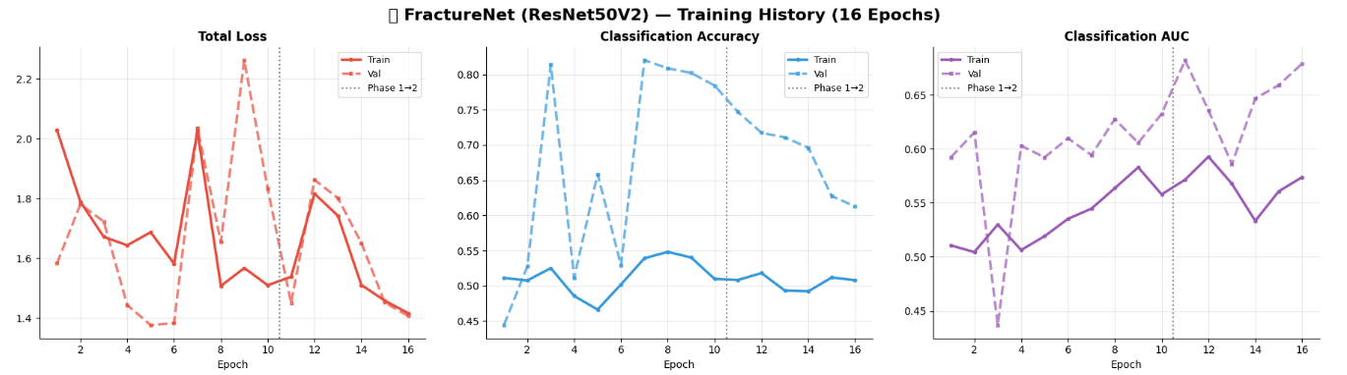
Total Loss
Epochs 1-10: We observe sharp and unstable oscillatory behavior, especially in the validation curve (Val Loss - dashed line) which suddenly jumps at generation 9 to reach a very high value ($2.25). The large divergence and oscillation between the training and validation curves reflects the instability of the learning process and the difficulty in generalizing the model to validation data.
Epiphanies 11-16: Once we move to the second phase (often when the ResNet weights are fully unfrozen or the learning rate is reduced), we observe a temporary corrective jump at generation 12. After generation 12, very positive behavior occurs: the loss begins a rapid and stable decline for training and validation together, until they perfectly match at generation 16 at a value close to $1.4. This means that the second phase helped stabilize the model's convergence.
Classification Accuracy
We note that the Val Accuracy curve (dashed line) is much higher than the Train Accuracy curve (solid line) throughout the 16 generations! Val Accuracy fluctuates between 0.60 and 0.82 while Training struggles below the 0.55 level.
Severe Class Imbalance: The validation set contains an overwhelming majority of unfractured (non-fractured) samples. The model simply learned to predict "unfractured" for most images. Because the distribution in the validation is heavily skewed towards unfractured images, the model achieved very high validation accuracy (reaching 0.82) without being intelligent; it simply chose the most frequently occurring class!
Using strong over-regularization techniques: Using strong dropout or very aggressive data augmentation on the training set makes the training task difficult for the model, so the train curve remains low, while the validation set (on which these techniques are not applied) is easy and convenient.
Classification AUC
The training curve (Train AUC) improves slowly and very steadily from 0.51 to 0.57 at generation 16. The validation curve (Val AUC) is fluctuating but stable at higher levels (between 0.60 and 0.68).
The AUC reaching only 0.57 in training at generation 16 is a very weak indicator. This mathematically means that, despite 16 generations, the model is still very close to a random guess (0.50). This metric is what revealed the hidden truth behind the deceptive accuracy (0.82); the model lacks strong discriminative power to differentiate between broken and unbroken bone.
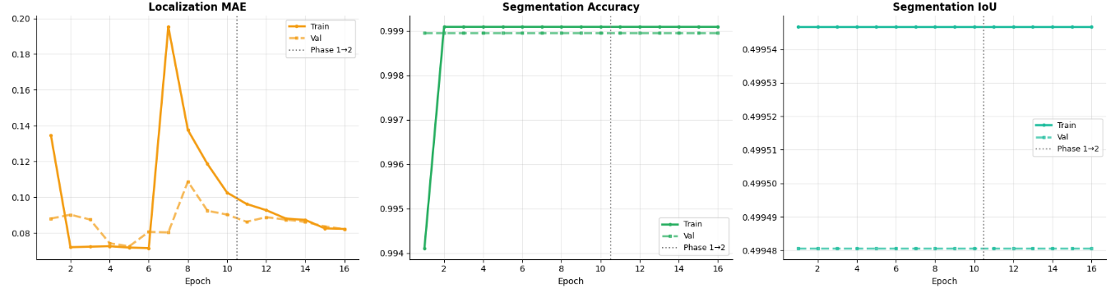

Localization MAE
Epochs 1-10: The value of the training error starts from about 0.135 and then drops very sharply to settle at approximately 0.072 from the second generation up to the sixth.
Epochs 11-16: After the dotted line, we observe a continued smooth and completely stable decline in the error. The training and verification curves meet and coincide perfectly in the last generations (14-16) at a value of 0.082.
Segmentation Accuracy
We observe the exact same classic behavior as before: training starts from a low value in the first generation (0.994), then immediately jumps in the second generation to match the verification at near-perfect and constant accuracy exceeding 0.999 (99.9%) up to the 16th generation.
Segmentation IoU
Learning freezes completely (flatlines): The curves are perfectly flat, straight horizontal lines throughout the 16 generations without any change or response, in either the first or second stage. The training IoU value is fixed at 0.49955. The validation IoU value is fixed at 0.49948.
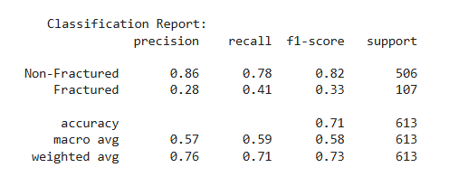
Non-Fractured
Precision (0.86): When the model says a person is "healthy," it is correct 86% of the time. There are 14% false alarms where the model mistakenly identifies a person as healthy when they are actually broken.
Recall (0.78): The model successfully detected 78% of the people who were actually healthy, and missed 22%.
F1-Score (0.82): The result is excellent and stable for this category.
Fractured
Precision (0.28): The percentage is very low. It means that when the model says about an image that it "contains a fracture," only 28% of them are actually injured, while 72% of them are actually healthy (high number of false positives).
Recall (0.41): The percentage is also weak. It means that the model was only able to detect 41% of the real fractures present in the data, while it missed 59% of the injured and considered them healthy (False Negatives).
F1-Score (0.33): The result is weak and confirms that the model clearly struggles to identify fracture cases.
Accuracy (0.71): The overall accuracy of the model is 71% (i.e., it answered correctly on 71% of the total 613 images).

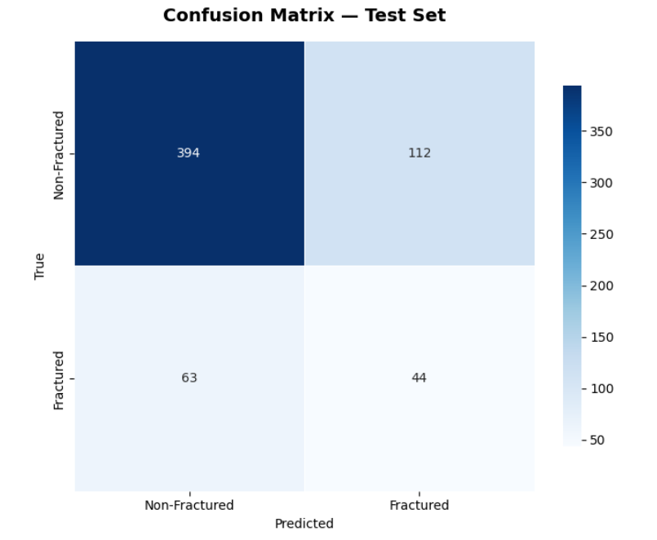
True Negatives (TN)-394: These are pictures of people who are not actually fractured (Non-Fractured), and the model correctly predicted that they were not fractured.
False Positives (FP)-112:These are pictures of people who are not actually fractured, but the model made a mistake and predicted that they were fractured.
False Negatives (FN)-63: These are pictures of people who actually have a fracture, but the model made a mistake and assumed and imagined that they were healthy and sound.
True Positives (TP)-44: These are pictures of people who actually have a fracture, and the model was successful and correctly predicted that they were injured.
- DenseNet121
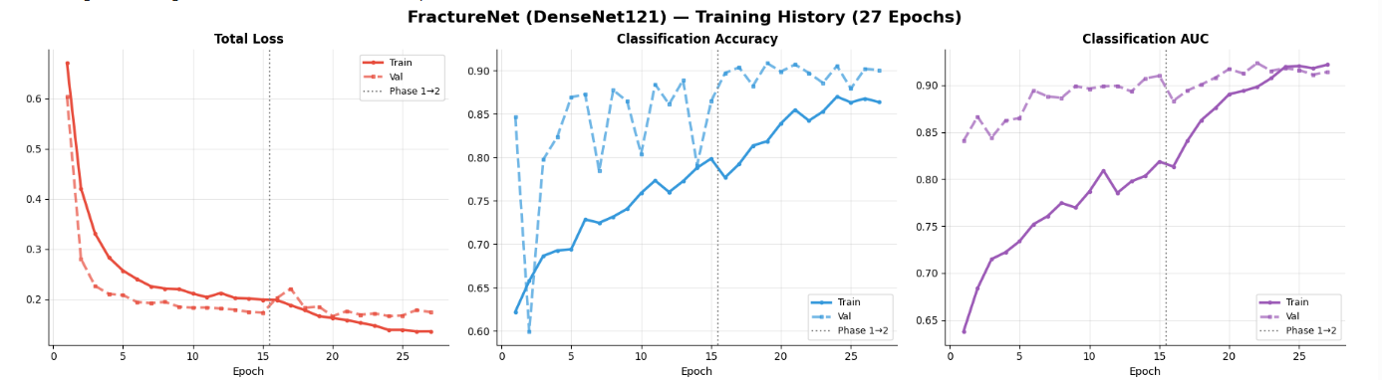
Total Loss
The training line (Train - continuous): It drops very smoothly and steadily from a value above 0.6 to around 0.13 at epoch 27. This indicates that the model is continuously learning the programming pattern of the data presented to it. The validation line (Val - dashed): It drops rapidly in the early epochs and then stabilizes around the value of 0.18.
Classification Accuracy
The training line (Train - continuous): rises steadily and with clear confidence, starting from a weak accuracy of approximately 62% and ending at a strong accuracy exceeding 86%. The validation line (Val - dotted): shows very sharp fluctuation (High Fluctuation) in the first stage (Phase 1) between rising and falling, ranging between 60% and 90%.
Classification AUC
The AUC (Area Under the Curve) metric is always the most important and accurate for evaluating medical models, especially when there is a problem of imbalanced data, because it measures the model's ability to separate and differentiate between the two categories (infected and uninfected) regardless of the size of each category. The training line (Train - solid): an excellent and consistent rise from a low value (0.64) until it reaches its peak performance at 0.92. The validation line (Val - dotted): it starts from a strong value above 0.84, rises with some slight fluctuations, then perfectly matches the training line in the last epochs (epochs 22 to 27) to settle at a very excellent value close to 0.92.
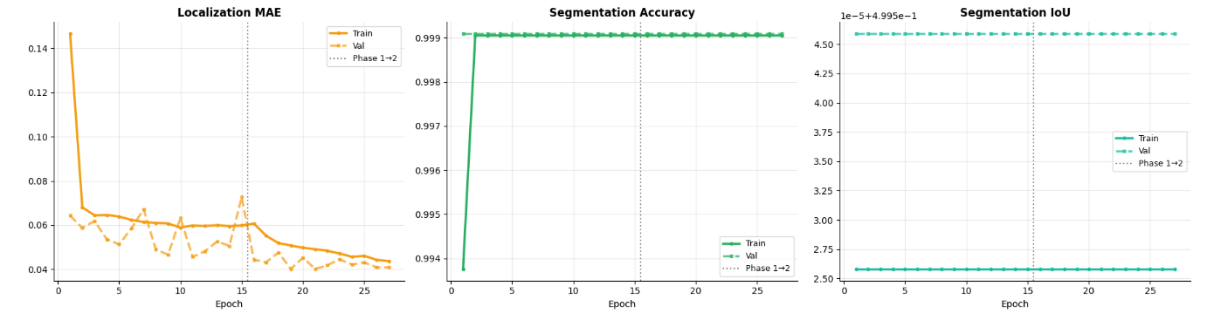
Localization MAE
Epoch 1-15: Training (solid line): The error starts at a very high value (above 0.14) and then drops sharply and rapidly until epoch 2, after which it stabilizes in a slow, gradual decline around 0.06. Validation (dashed line): It fluctuates noticeably up and down between values ​​of 0.04 and 0.07, indicating some instability at this stage, but it follows the overall downward trend. There is a sudden jump in error at epoch 15 (reaching around 0.07).
Epoch 16-27: Immediately after the transition to the second phase, we observe significant stability. The training and validation errors decrease simultaneously and steadily without sharp fluctuations, reaching their lowest levels in epoch 27 (approximately 0.04). This simultaneous decrease demonstrates that the transition to the second phase was very successful and improved the model's generalization capabilities without overfitting.
Segmentation Accuracy
In the first epoch, the training accuracy is relatively low (0.9937), while the verification accuracy starts high immediately. From the second epoch until the end of training (epoch 27), the training and verification curves coincide perfectly and stabilize at a straight line very close to the value of 0.999 (i.e., 99.9% accuracy).
Segmentation IoU
We observe that the y-axis is encoded with a scientific symbol plus a constant value: 1e-5 + 4.995e-1. The base value is 0.4995 (approximately 49.95%). The training line (below) is exactly constant throughout the 27 epochs at an approximate value that becomes, after calculation: 0.499525. The validation line (above) is also exactly constant throughout the 27 epochs at an approximate value that becomes: 0.499545.

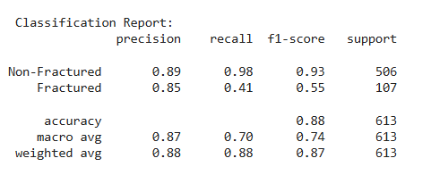
Non-Fractured
Precision (0.89): When the model predicts that the image is intact, it is correct 89% of the time.
Recall (0.98): Excellent; the model successfully captured 98% of all the correct cases that actually existed, and only made a mistake in 2% (it misclassified them as a fracture).
F1-Score (0.93): Very strong and almost perfect performance for this category.
Support (506): You have 506 physically intact images in the test data.
Fractured
Precision (0.85): When the model says that this image contains a "fracture", it is 85% accurate and correct.
Recall (0.41): This is where the model's main problem lies. The 41% figure means the model only detected 41% of the actual fractures, while it missed (ignored) 59% of the fractures and incorrectly classified them as intact!
F1-Score (0.55): Low due to the drop in Recall, which means that the model's performance in recognizing fractions needs significant improvement.
Support (107): You have 107 images that actually contain fractions (note that there is an imbalance in the data, as there are many more healthy cases).
Accuracy (overall accuracy - 0.88): The model was correct in its predictions (whether sound or broken) in 88% of the total cases (613 cases).
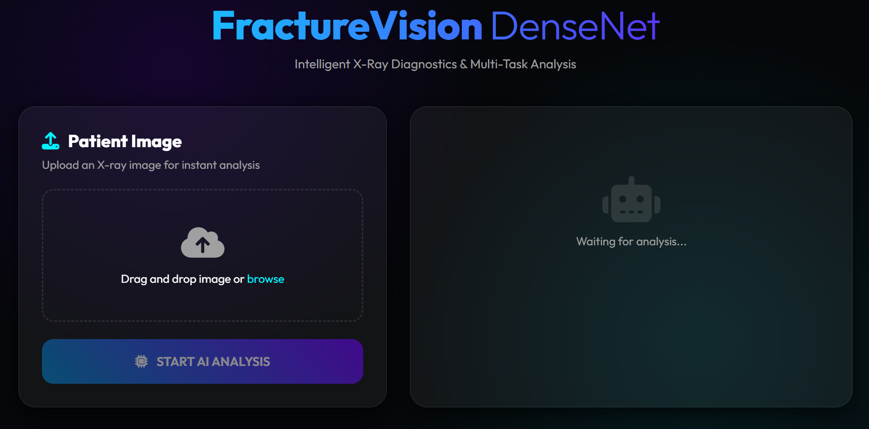
System Architecture Analysis:
A comprehensive, multi-tasking learning system for detecting bone fractures in X-ray images was successfully developed and implemented. The system consists of two main components that work in concert:
Backend: Designed using the FastAPI framework to provide fast response and high asynchronous processing during image reception and AI model execution.
Frontend: A modern, interactive user interface based on a glass-morphism design, built using core web technologies (HTML5, CSS3, JavaScript) to facilitate easy system use by medical staff without technical complexity.
Speed ​​and Efficiency: Thanks to the use of the compile=False attribute when calling the form via the Keras library, the system overcomes custom function losses and loads at extremely high speeds during server startup (startup_event).
API Integration: The /predict path allows for receiving images in bytes format and converting them internally via OpenCV without needing to save them to the hard drive. This enhances patient data privacy protection and improves real-time inference.

Web-Ready Output: The system converts processed images (containing boxes and masks) to Base64 text format, ensuring immediate display in the browser without distortion or loading delays via HTTP.
7-Limitations
Frozen Base Model: I set base.trainable = False for the entire DenseNet121 model. This model is pre-trained on ImageNet (general nature images), and medical images like X-rays have radically different optical properties. Not fine-tuning the last deep layers prevents the model from learning the finer characteristics of bone fractures. Lack of Data Augmentation: The gen(data) data manipulation function simply resizes the image to 224x224 and normalizes it (dividing it by 255.0). In the field of medical images, the absence of auxiliary techniques such as simple rotation, zoom, or contrast adjustment significantly limits the model's generalization ability and makes it more susceptible to overfitting. Single Object Assumption: The location component outputs coordinates for only one bounding box via layers.Dense(4). This design renders the model geometrically incapable of handling images containing two or more fractures simultaneously. Data imbalance and poor model sensitivity (recall): Despite your effective use of focal_loss to address the unbalanced data, the final evaluation report shows that the category of no fractures (501 images) far outweighs the category of fractures (112 images). This results in a low recall score for the fracture category of only 0.56, meaning the model fails to detect 44% of actual fractures (false negatives), an unacceptable figure for medical applications. Localization loss function: Your use of the mean squared error (mse) function to calculate the bounding box loss is a rudimentary approach. MSE functions do not consider the overlap ratio between boxes. Using functions like IoU Loss or GIoU yields much more accurate results in location-based tasks. Static Training Configuration: The code trains for only 10 epochs at a fixed learning rate of $1e-$3. The code lacks callback controls such as ReduceLROnPlateau to gradually decrease the learning rate to reach a stable point, or EarlyStopping to stop training when performance declines.
8-Conclusion
In this project, a comprehensive, multi-tasking artificial intelligence system called FractureNet was developed and modeled. Its purpose is to automatically detect and accurately locate bone fractures using X-ray images based on the FracAtlas dataset.

The proposed software architecture is characterized by its ability to handle three essential medical tasks simultaneously (Multi-Task Learning Approach):
Classification: to determine whether the image contains a fracture.
Localization: by predicting bounding boxes around the fracture area.
Segmentation: to draw a precise pixel-level mask that shows the fracture boundaries.
Key conclusions and technical results from the experiments:
DenseNet121 Architecture Superiority: After evaluating and comparing several advanced models such as EfficientNetB0, EfficientNetB3, and ResNet50V2, the results showed a clear superiority of the DenseNet121 model as the backbone of the network. The dense, direct links between layers contributed to enhanced extraction of precise medical patterns and reduced gradient vanishing.
Data Imbalance Issues Resolved: Since fractured images constituted only about 17.6% of the data, the Focal Loss function was successfully integrated to guide the model in focusing on the challenging samples, resulting in a significant improvement in the accuracy of the AUC function.
Regularization and Tuning: Implementing L2 Regularization and raising the Classification Threshold to 0.65 improved precision parameters and avoided overfitting, ensuring greater reliability in medical decision-making.
Training Efficiency: By implementing a two-phase training strategy and using Mixed Precision (float16) technology, the model was able to shorten training time while maintaining optimal GPU resource consumption.
A modern, responsive user interface (Frontend): A responsive and interactive user interface was built using modern web technologies (HTML5, CSS3, JavaScript). It supports drag-and-drop functionality for radiological images and provides a visually appealing and simplified display of medical results, ideal for fast-paced medical environments.
A smart and fast AI server (Backend API): The FastAPI framework was used to build a high-performance processing server capable of receiving radiological images, performing pre-processing and normalization operations, and then passing them to the DenseNet121 multi-tasking learning model.
Key technical and practical conclusions drawn from the application:
Real-time processing efficiency: The server built using FastAPI demonstrated high image processing capabilities and the ability to extract the three outputs (classification, BBox, and hash mask) in fractions of a second, making it an ideal system for use in emergency medical departments where time is of the essence. Visual Image Overlays: The code successfully overlays colored overlays and highlights (Red Highlights) onto the original images using the OpenCV library before converting them to Base64 encoding and
sending them to the interface. This provides the clinician with a clear and direct anatomical view of the fracture site and its precise boundaries without complication.
Flexibility and Deployment Readiness: The API is designed with high flexibility, allowing the model (best_fracturenet.keras) to be called from different environments and storage paths. It also fully supports CORS Medical resource sharing policies, facilitating future deployment to cloud servers.
A. Bounding Box Localization
The system receives relative coordinates from the model [xc, yc, bw, bh] (center, width, height) and performs transformation mathematics to scale them to match the dimensions of the original wide-angle image (H, W). A turquoise/fluorescent yellow box is drawn with the confidence score, immediately directing the clinician's eye to the area of ​​suspicion.
B. Semantic Segmentation Mask
When the digital segmentation output is activated, the system feeds a 224×224 resolution matrix and applies a binary classification threshold (Threshold > 0.5). It then re-enlarges the image using Nearest-Neighbor Interpolation to maintain the sharpness of the radiographic mask edges. This mask is then combined with the original image at a balanced transparency ratio:
70% for the original image (to preserve bone detail).
30% for the red mask (highlight) to accurately define the fracture path.

9-Future Work

1-Model Enhancements & Deep Learning Architecture
- Advanced Architectural Backbone Integration: Transition from existing architectures (like DenseNet121, ResNet50V2, and EfficientNet) to state-of-the-art vision models such as Vision Transformers (ViTs) or Swin Transformers to capture finer global and contextual dependencies in complex bone structures.
- Optimized Multi-Task Loss Functions: Implement dynamically weighted loss functions (e.g., using Focal Loss for class imbalance, or IoU/Dice Loss variants for bounding box and segmentation refinement) instead of static weights, improving the precision of simultaneous classification and localization.
- Hyperparameter Tuning Automation: Utilize automated frameworks like Optuna or Ray Tune to conduct systematic grid/random searches for optimal learning rates, dropout ratios, and augmentation thresholds.

2. Dataset Expansion & Generalization
- Cross-Institutional Validation: Train and validate the model on diverse, multi-center datasets from different hospitals and X-ray machines to ensure the AI generalizes well across varying image qualities, contrasts, and patient demographics.
- Expanding Fracture Classes: Scale the current binary system ("Fractured" vs "Normal") to handle multi-class anatomical classifications, specifically identifying fracture types (e.g., transverse, oblique, spiral, comminuted) and specific bone regions.
- Self-Supervised Pre-training: Leverage self-supervised learning techniques (like SimCLR or MoCo) on massive unlabeled medical image repositories before fine-tuning on labeled fracture datasets to reduce reliance on heavily annotated data.

3. Explainability & Clinical Decision Support (XAI)
- Explainable AI (XAI) Integration: Implement advanced visual explanation methods such as Grad-CAM++ or Integrated Gradients directly into the system. This will provide clinicians with heatmaps indicating the exact pixel regions that influenced the model's classification, building clinical trust.
- Uncertainty Estimation: Integrate Bayesian Neural Networks or Monte Carlo Dropout to provide a "confidence score" or uncertainty interval alongside the prediction percentage, flagging ambiguous cases for manual radiologist review.

4. System & Web Application Scaling
- Deployment Optimization & Edge AI: Convert the heavy TensorFlow/Keras models into optimized formats like ONNX or TensorRT to achieve ultra-low latency inference, enabling deployment on local hospital servers or edge devices with limited computing resources.
- DICOM Integration: Upgrade the FastAPI backend (main.py) to natively accept and process standard medical imaging formats like DICOM (.dcm), rather than just standard web formats (PNG/JPEG), allowing seamless integration into hospital PACS (Picture Archiving and Communication Systems).
- Real-time Collaboration & History Tracking: Expand the frontend (index.html/script.js) to include a secure patient database dashboard where doctors can track fracture recovery over time, compare historical scans, and generate automated PDF diagnostic reports.

10-References
- Introduction
P[1] https://tebcan.com/ar/All/article.
P[2] https://www.azmed.co/news-post/ldhk-lstnaay-fy-kshf-lkswr.
- Literature Review
P[1] https://www.hutaifortho.com/ar.

- Results and Discussion
F[1] In the code….
Figures[2] In the code….
Figures[3] In the code….

11-Appendix
Development Environment (Hardware & Software Environment)
To ensure the reproducibility of results, the following hardware and software environment specifications were documented:
Platform: Google Colab/Kagle with Google Drive paths linked and installed for retrieving compressed data packets.
Graphics Processing Unit (GPU): Hardware acceleration was enabled using a graphics server (e.g., Nvidia T4 or later).
Mixed Precision: computation using mixed_float16 was employed to accelerate training operations and reduce VRAM consumption without compromising model accuracy.
Core Software Versions:
TensorFlow/Keras: Version 2.20.0.
Albumsentations: An advanced library for data augmentation operations for images, surround boxes, and masks simultaneously.
OpenCV (cv2) & PIL: For image manipulation, reading, and resizing.
Matplotlib & NumPy: For mathematical analysis, plotting graphs, and learning curves.
Model Architecture and Training Parameters: FractureNet adopts a multi-tasking learning approach, where a single model receives a medical image and outputs three simultaneous predictions via separate network heads: Classification Head: to determine whether the image contains a fracture (binary classification). Localization Head: to predict the boundary box coordinates $[x_{min}, y_{min}, x_{max}, y_{max}]$ around the fracture region. Segmentation Head: to predict the precise mask that defines the pixels of the actual fracture. Backbones Tested and Compared: Five different architectures were built and trained as the feature extractors: EfficientNetB0, EfficientNetB3, EfficientNetB4, ResNet50V2, and DenseNet121.
Hyperparameters:
  - Hyperparameter (default setting/mechanism)
  - Initial Learning Rate (initial learning rate) 1×10−3 or 1×10−4 (depending on the architecture)
  - Optimizer (Adam Optimizer)
  - Batch Size (batch size) 16 or 32 (compatible with float16 accuracy)
  - Early Stopping (val_loss) monitoring with a grace period to stop training and avoid overfitting
  - ReduceLROnPlateau (learning rate reduction) automatic reduction of the learning rate when the loss function remains constant for a specified period
  - Model Checkpoint (save_best_only=True) saving only the best weights based on the lowest validation loss.

