Decision table including overfishing limits for the assessment of Rougheye/Blackspotted rockfishes in 2025
NULL
Table 1: Decision table summary of 10 year projections beginning in 2027 for alternative states of nature based on an axis of uncertainty about natural mortality for the base model. Columns range over low, base, and high states of nature and rows range over different catch level assumptions. The base model estimated natural mortality of 0.036 yr$^{-1}$ for males. The low state of nature assumed a natural mortality of 0.032 yr$^{-1}$ and the high state of nature assumed a natural mortality of 0.039 yr$^{-1}$ for males. Catch in 2025 and 2026 were based upon removal assumptions provided by the GMT.
Mgmt | Year | Catch | Low OFL | Low Fraction of Unfished | Base OFL | Base Fraction of Unfished | High OFL | High Fraction of Unfished
A | 2025 | 155 | 370 | 0.733 | 955 | 0.872 | 2,680 | 0.933
A | 2026 | 187 | 372 | 0.734 | 961 | 0.875 | 2,698 | 0.936
A | 2027 | 882 | 373 | 0.735 | 966 | 0.877 | 2,714 | 0.939
A | 2028 | 866 | 358 | 0.704 | 954 | 0.864 | 2,712 | 0.937
A | 2029 | 850 | 344 | 0.674 | 942 | 0.852 | 2,710 | 0.935
A | 2030 | 834 | 330 | 0.645 | 930 | 0.840 | 2,707 | 0.933
A | 2031 | 818 | 316 | 0.617 | 919 | 0.829 | 2,703 | 0.932
A | 2032 | 803 | 303 | 0.589 | 908 | 0.818 | 2,699 | 0.930
A | 2033 | 788 | 290 | 0.563 | 896 | 0.808 | 2,694 | 0.929
A | 2034 | 774 | 277 | 0.537 | 885 | 0.798 | 2,688 | 0.927
A | 2035 | 758 | 265 | 0.512 | 874 | 0.787 | 2,680 | 0.925
A | 2036 | 744 | 253 | 0.487 | 862 | 0.777 | 2,671 | 0.923
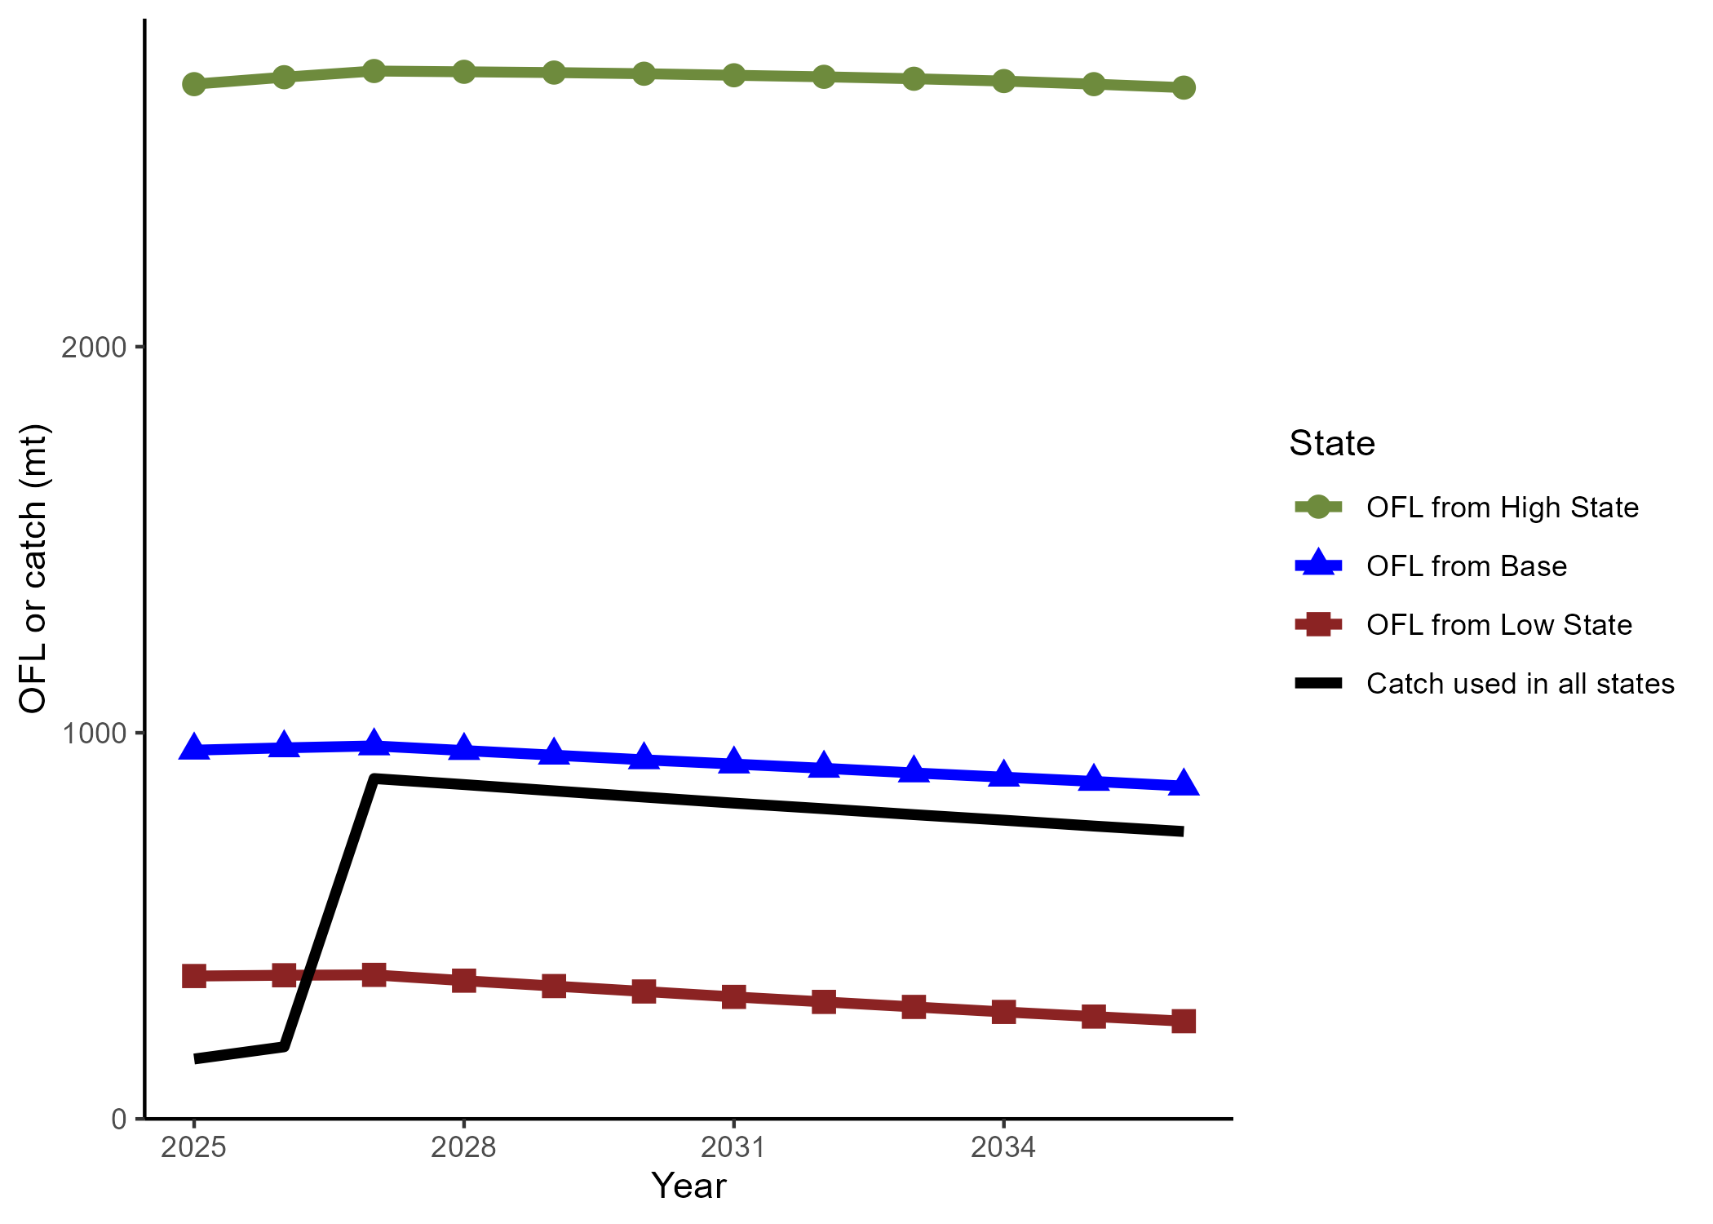
The GMT provided removals for 2025-206 and ACLs for 2027-2036 with a P* = 0.45 and sigma = 1 (black line) and the model estimated OFLs for 2025-2036 from the base model (blue line), low state of nature (red line), and high state of nature (green line).

