IS 607 Week02 Assignment

1. Which destination in the flights database is the furthest distance away?

select max(distance) from flights

1. What are the different numbers of engines in the planes table? For each number of engines, which aircraft have the most number of seats?

select distinct(tailnum), seats from planes

1. What weather conditions are associated with New York City departure delays?

select origin, precip, visib, temp from weather

select origin, dep_delay from flights

Even if I do a join on origin between the weather and flights table, I cannot distinguish which airplane was late because of weather because I can only do a join by origin (airport) instead of tailnum or flight number.

1. Are older planes more likely to be delayed?

select distinct(flights.tailnum), avg(dep_delay) as avg_delay, planes.year

from flights join planes

on flights.tailnum = planes.tailnum

where dep_delay>0

group by flights.tailnum, planes.year

order by avg_delay desc, planes.year

Results and conclusion: It appears that older planes are later but missing data exists in the plane year variable.

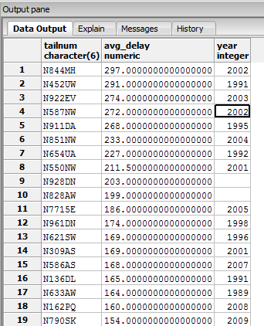

1. Ask(and if possible answer) a question that also requires joining information from two or more tables in the flights database, and/or assumes that additional information can be collected in advance of answering your question.

Identify the airport with the least flights:

select airports.name, count(*)

from flights

inner join airports

on flights.dest = airports.faa

group by airports.name

order by count(*) asc limit 1;