**Patient UI Requirements Analysis**

1. **Login Page**

* **Function** : Ensures only authorized patients can access the system.
* **element** :
  + **Login form** : Enter username and password fields.

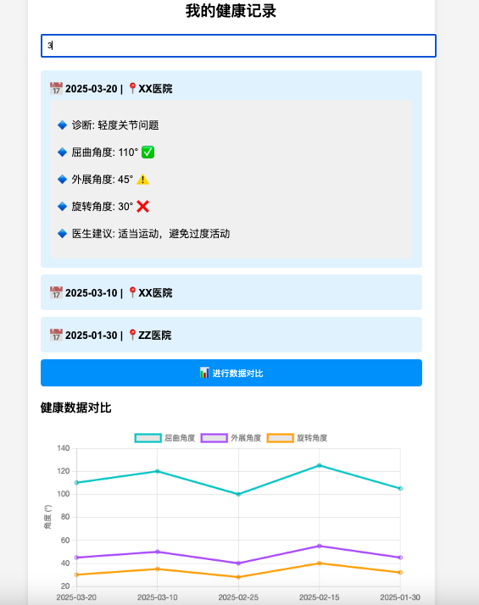

Patient UI diagram

**Doctor UI Requirements Analysis**

**1. Login page**

* **Function** : Ensure that only authorized doctors can access the system.
* **element** :
  + **Login form** : Enter username and password fields.

**2. Patient management page**

* **Function** : Manage and view the list of patients you are responsible for and their basic information.
* **element** :
  + **Create Patient** : Create a new patient
  + **Search bar** : Quickly find a specific patient. (As shown below)

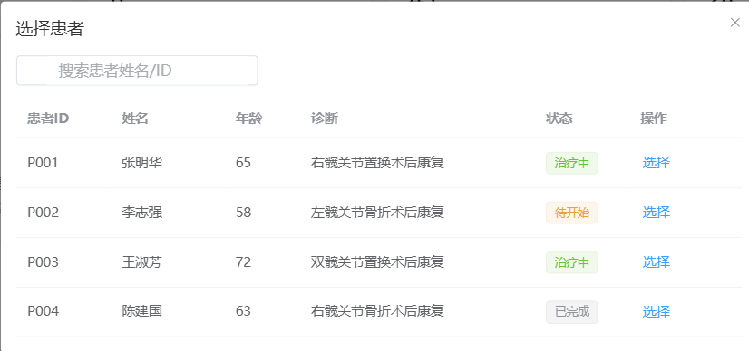

**3. Patient details page**

* **Function** : In-depth review of each patient's detailed health information and recovery progress , and storage of user's **historical records and data analysis results** , and the ability **to generate visual reports based on historical records**
* **element** :
  + **Patient card** : Each card contains the patient's photo, name, age, latest recovery progress , and lists underlying diseases, allergy history, etc. (as shown below)
  + **Storing history records:** used to obtain history records
  + **Create new records:** used for subsequent new data generation
  + **Obtain visual reports and historical analysis:** Generate visual information such as charts, comparative analysis, etc. based on the rehabilitation data in the historical records to provide decision-making assistance for doctors;
  + 



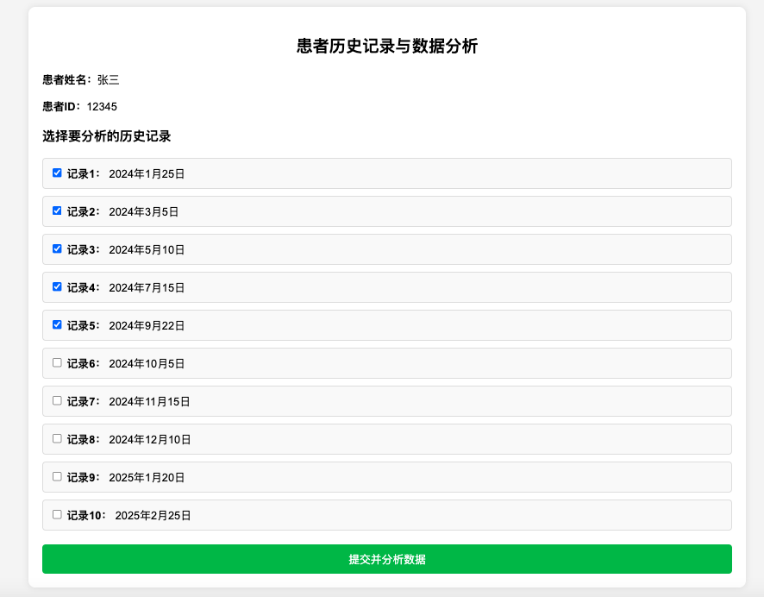

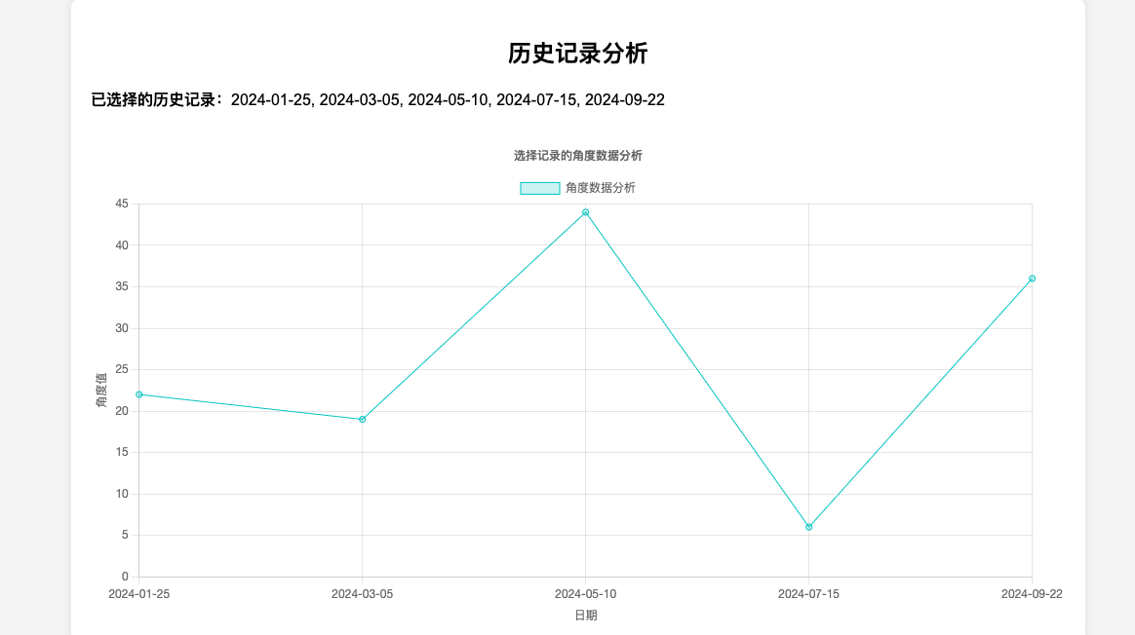

**4. Measurement preparation page**

* **Function** : The user wears the sensor correctly and enters the measurement mode.
* **element** :
  + **Animation Demonstration** : A simple animation diagram shows how to correctly fix the sensor on the lower limb joint.
  + **Tips** : Brief text description of wearing points and precautions.
  + **Start Button** : Large, obvious "Start Measuring" button.

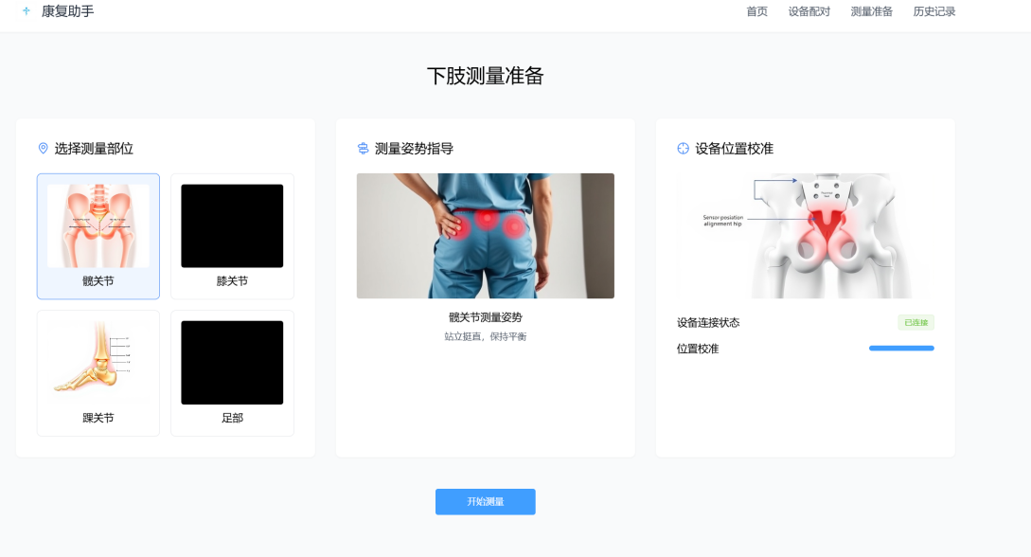

Preparation page diagram

**5. Real-time data display page**

* **Function** : Real-time display of lower limb movement status, including angle changes, etc.
* **element** :
  + **3D model** : simulates lower limb movement and intuitively reflects the angle of the current movement.
  + **Numerical display area** : displays the specific value of the current joint angle.

**6. Result feedback page**

* **Function** : Analyzes measurement result data using advanced algorithms and provides immediate rehabilitation recommendations.
* **element** :
  + **Suggestions** : If the expected goal is not achieved, provide suggestions or adjust the plan . The suggestions come from the doctor combined with the measurement results .
  + **Data analysis report** : summarizes recent rehabilitation achievements and existing problems.
  + **Recovery progress chart** : shows the patient's recovery progress .

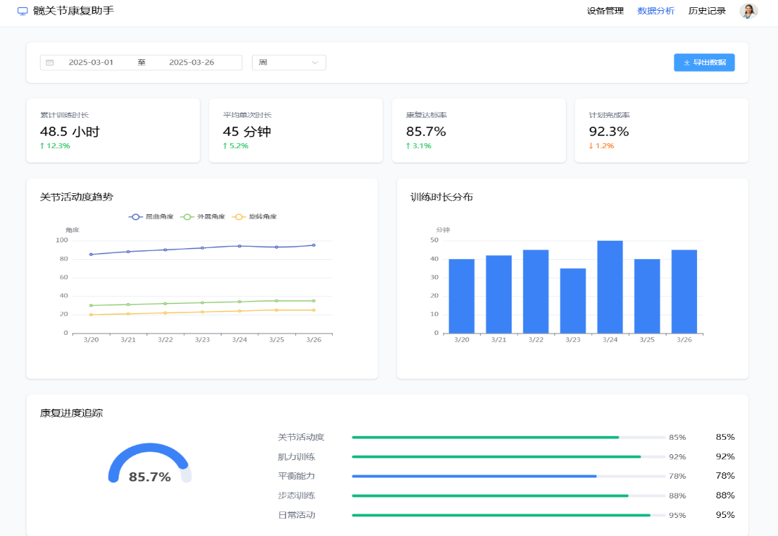

**7. Database comparison**

**Function:** Provide a standard database for medical staff to compare data

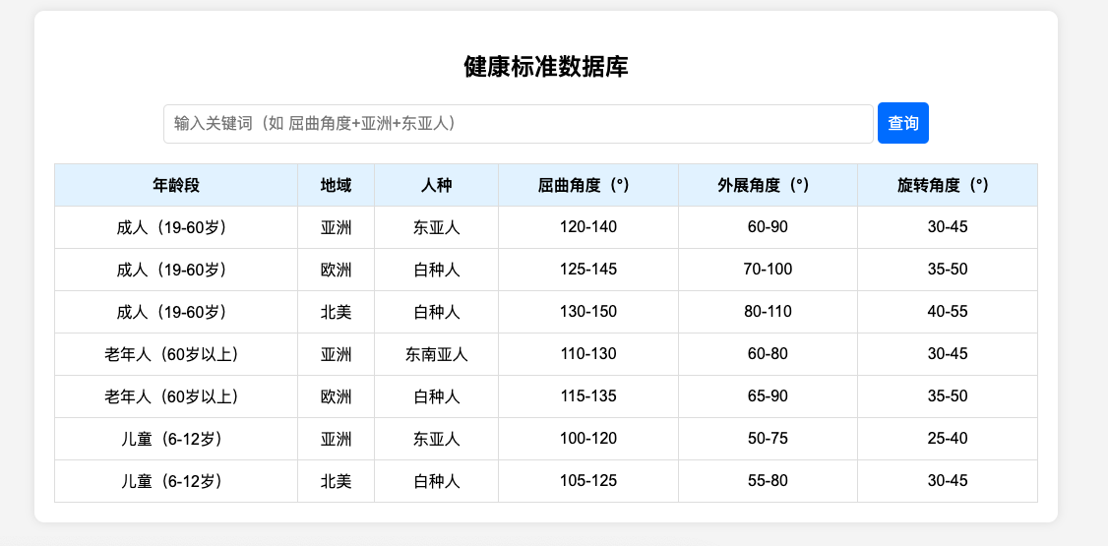

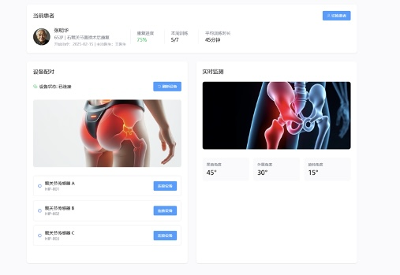

Doctor UI Diagram