# The claims API endpoint from docker

Curl request: curl --location 'http://localhost:8080/claims/1001'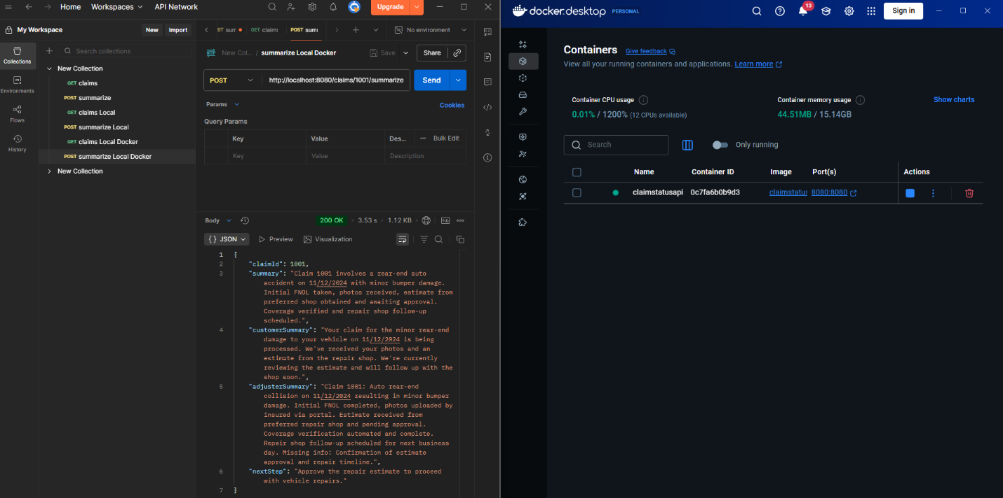

# The claims summarization API endpoint from docker

Curl request: curl --location --request POST 'http://localhost:8080/claims/1001/summarize'

# Azure AI setup

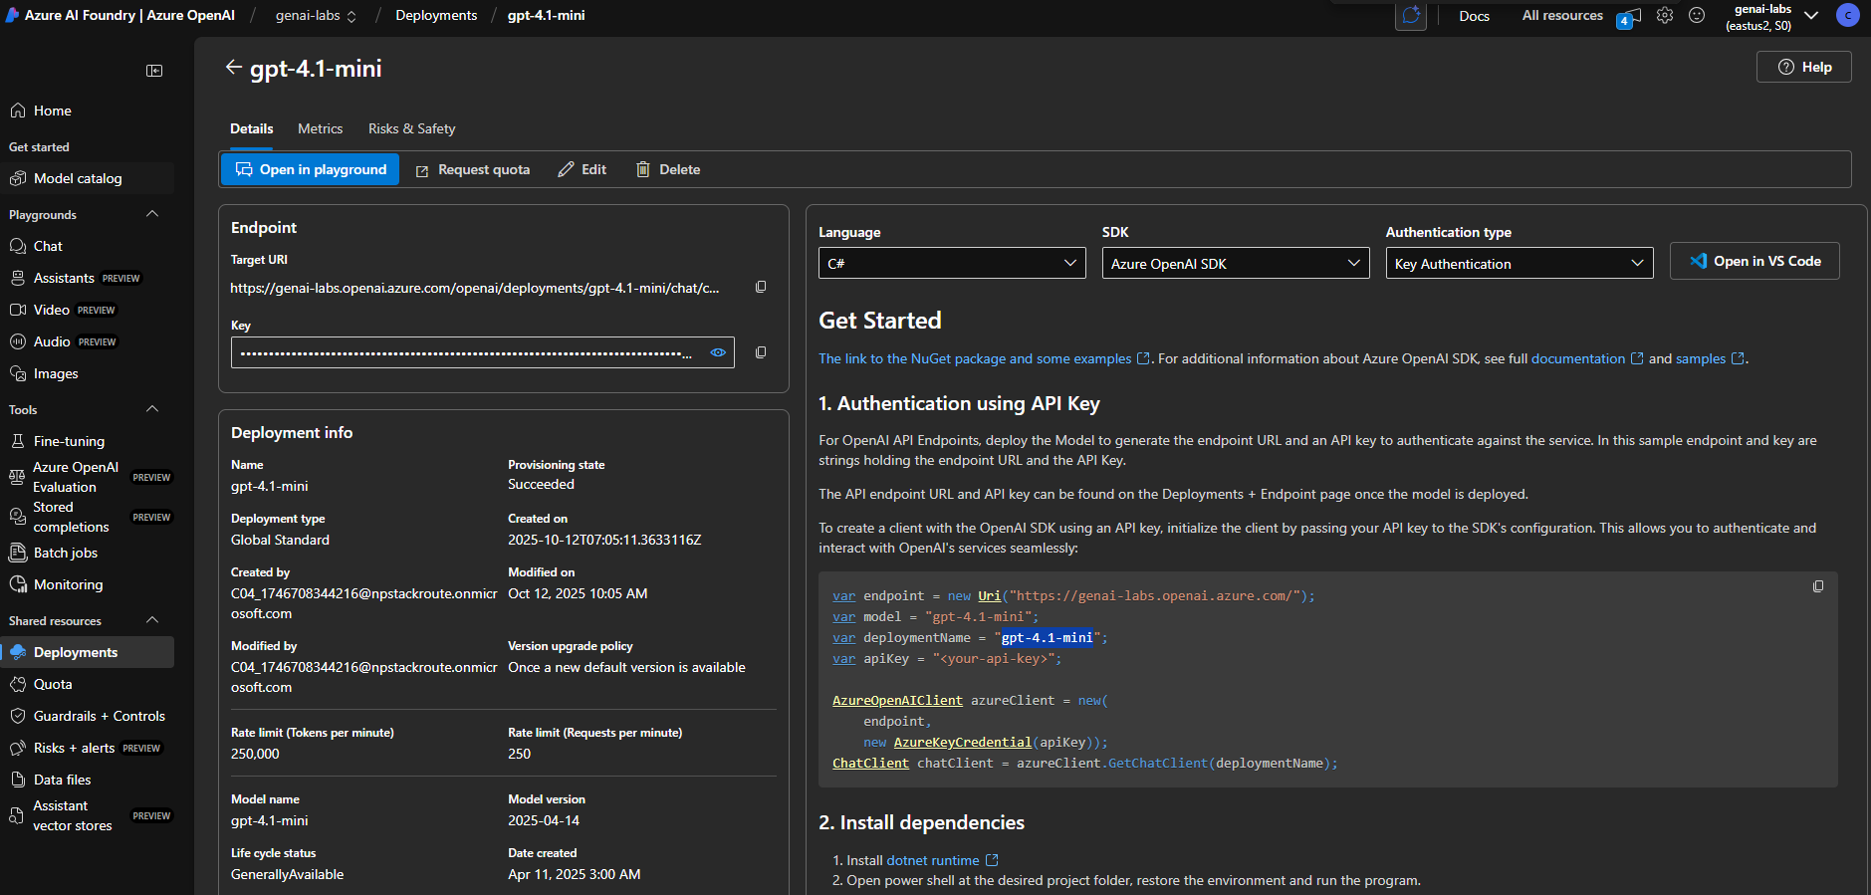

# Cloud API request

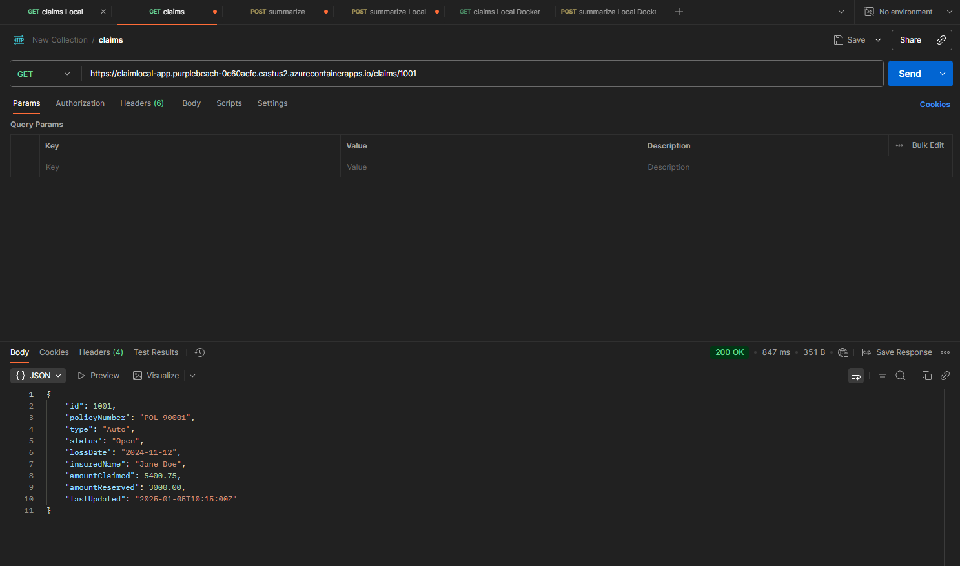

# Pipeline runs

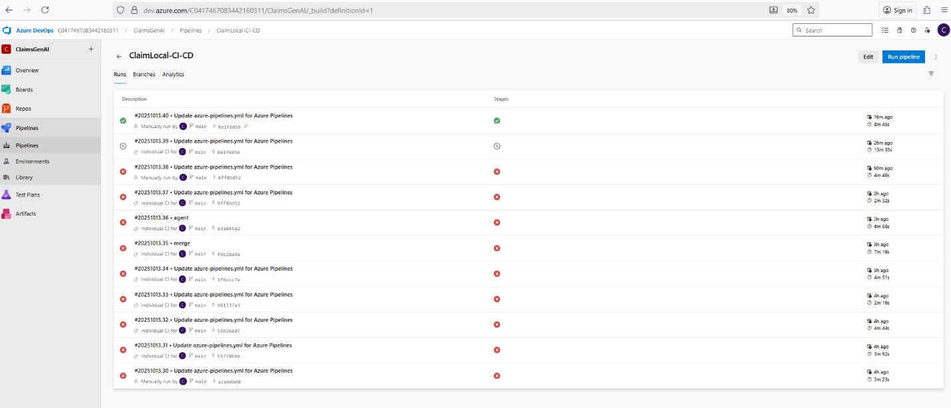

# Pipeline build

# Pipeline build and deploy

