**ASSIGNMENT – 1**

**Group Name:** DVI_GROUP014

**Problem Statement:** DVI_ASSIGNMENT1_PS4_PUBLIC GRIEVANCE ANALYSIS_M

**Group Members:**

1. Maripina Ravi Teja - 2018AC04558 (Group Leader)
2. Mohammad Shadab - 2018AC04567
3. Tess Zacharias - 2018AC04535
4. Agalya - 2018AC04560

**Summary:**

CPGRAMS is a monitoring system which maintains the study involved identification of top grievance causing issues and recommendation of systemic reforms.

**Objective:**

As a head of department of the CPGRAMS, they have to ensure how the data is been flown and how exactly are reaching the target by serving the people. To check the outline of that we have created a dashboard where the data is shown as a visualization to the current mechanism.

So, we have created a story by channeling into 4 charts from the data provided with the columns Organization Name, Month, Year, No. of Disposals and No. of Receipts. We have thought the below charts would tell us how actually it would be helpful in viewing the data and more summarized way.

**Chart 1: Monthly Analysis**

Here we have taken *Continuous Line Graph* in order to differentiate between Disposals and Receipts that were received and delivered throughout the years for each month. So that we can check when is peak time that most of the requests were received. Also we can check whether the delivery is up to the mark or not.

To achieve this, we assigned one dimension with Month column and two measures which are Receipts and Disposals columns.

Added the analytics function which *Forecast* option where we could see predict the upcoming requests or deliverables in next month.

Along with that we have also added the average lines for Receipts and Disposals. With the help of range filter to the month we can analyze the data changes accordingly.

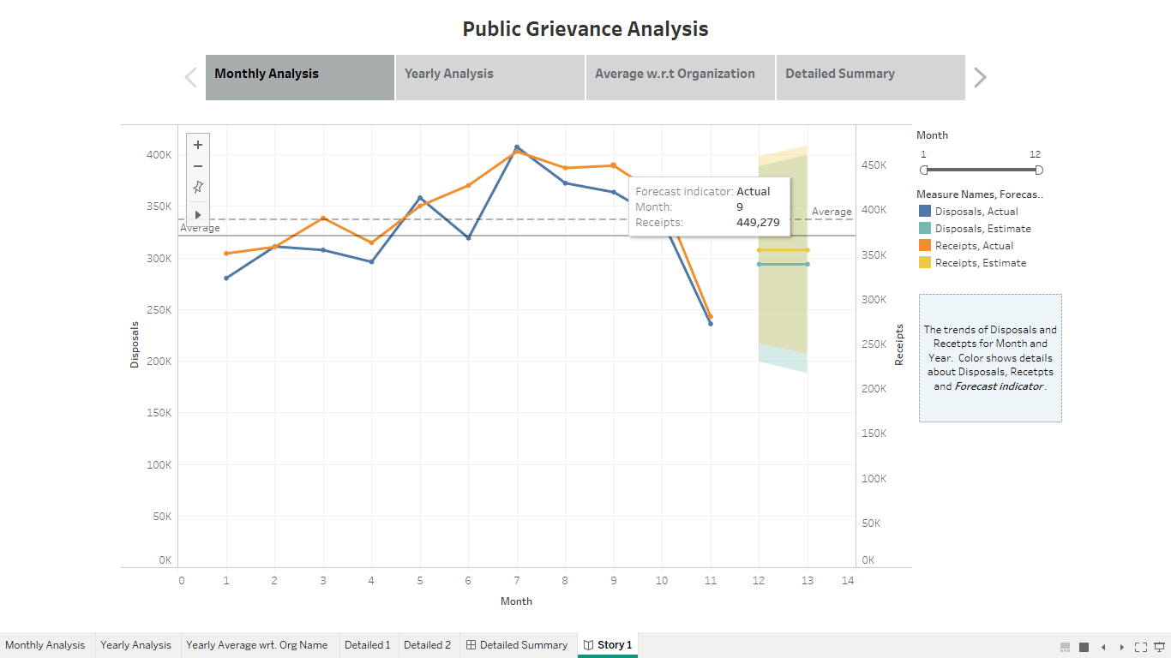

**Chart 2: Yearly Analysis**

Here as well we took *Continuous Line Graph* in order to differentiate between Disposals and Receipts that were received and delivered throughout for each year. So that we can check when is peak time that most of the requests were received. Also we can check whether the delivery is up to the mark or not.

To achieve this, we assigned one dimension with Year column and two measures which are Receipts and Disposals columns.

Along with that we have also added the average lines for Receipts and Disposals. Since the data is not vast the Forecast is not generated for this which we can see the at the right corner of visualization.

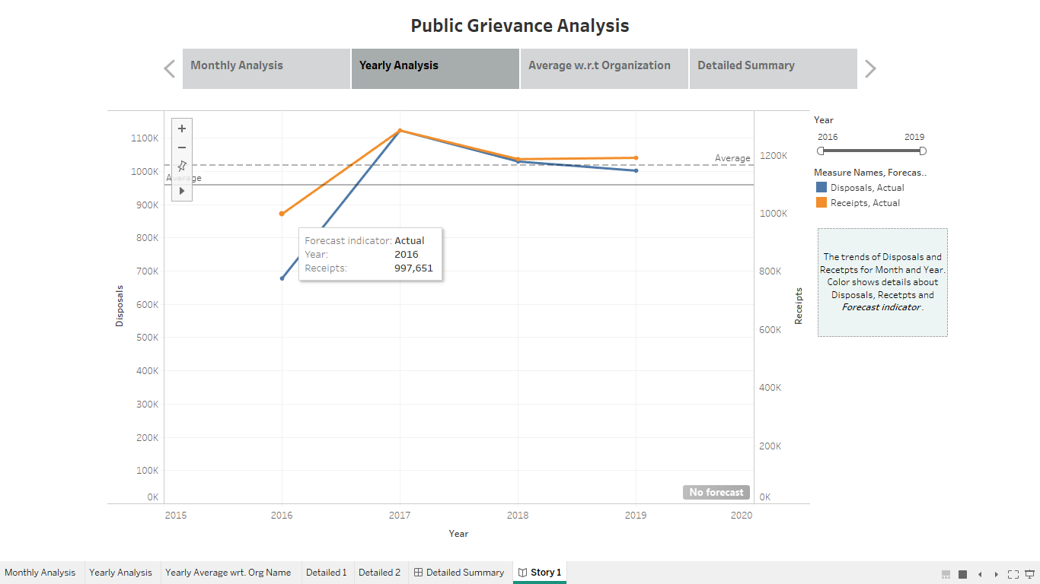

**Chart 3: Average with respect to Organization Name**

In this visualization we used *Bar Chart* as to check the Average of Disposals and Receipts are covered for each Organization Name in a particular year.

We could able to view which Org Name has most average of both in a year by giving the colors section with Year column. In Columns section it is Org Name and Rows has Average of Receipts and Disposals.

Added multiple filters, so that the particular department can have a clear understanding of their current progress and how much they reached the target.

The stacked bars help us to differentiate the years for each Org Name and with axis values we could see how much the range is.

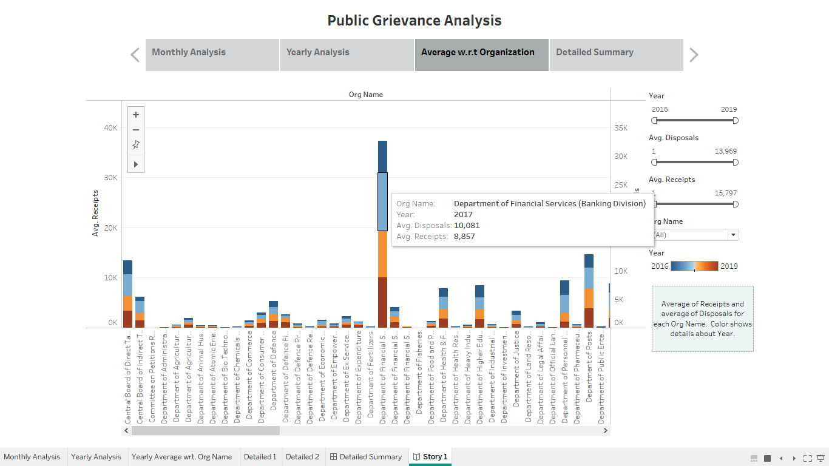

**Chart 4: Detailed Summary**

It’s a combination of *Horizontal Bar Graph* and *Data/Text Table* which we clubbed in a dashboard and linked with the common filters.

This will allow users to have summarized values for both of the categories and also can check what exactly the numbers are being shown for each Organization Name. Along with the grouping of year and month.

The filters are linked for these two sheets where we can have clear view on the numbers to specific Name or Month or Year, along with the sorted order mechanism.

Also, the we can see ad-hoc report how many have been requested and delivered, which the data will be appended on to the current dataset.

