Jesus, Strong and Kind (Sing! Hymnal #362)
Words & Music: Colin Keith, Robert Buchanan, Michael Farren, Jonny Robinson, Rich Thompson

[ CHORDS ] D G C9 Dsus Em [ CAPO 5 ]
xoo=== ==oo== o==o== xoo==o ======
|||||| |||||| |||||| |||||| ||||||
|||O|O |O|||| ||O||| |||O|| |OO|||
||||O| O|||OO |O||OO ||||OO ||||OO

[ INTRO ] | G | C9 G | Em D | G |

[ VERSE 1 ] G C9 G Em D G
Je-sus said that if I thirst, I should come to him
G C9 G Em D G
No one else can sa-tis-fy, I should come to him

[ CHORUS ] C9 G D G
For the Lord is good and faith-ful
C9 G Dsus D
He will keep us day and night
C9 G D Em
We can al-ways run to Je-sus,
C9 D G
Je-sus, strong and kind

[ VERSE 2 ] G C9 G Em D G
Je-sus said if I am weak, I should come to him
G C9 G Em D G
No one else can be my strength, I should come to him

[ CHORUS ]

[ VERSE 3 ] G C9 G Em D G
Je-sus said that if I fear, I should come to him
G C9 G Em D G
No one else can be my shield, I should come to him

[ CHORUS ]

[ VERSE 4 ] G C9 G Em D G
Je-sus said if I am lost, He will come to me
G C9 G Em D G
And he showed me on that cross, He will come to me

[ CHORUS ] x 2

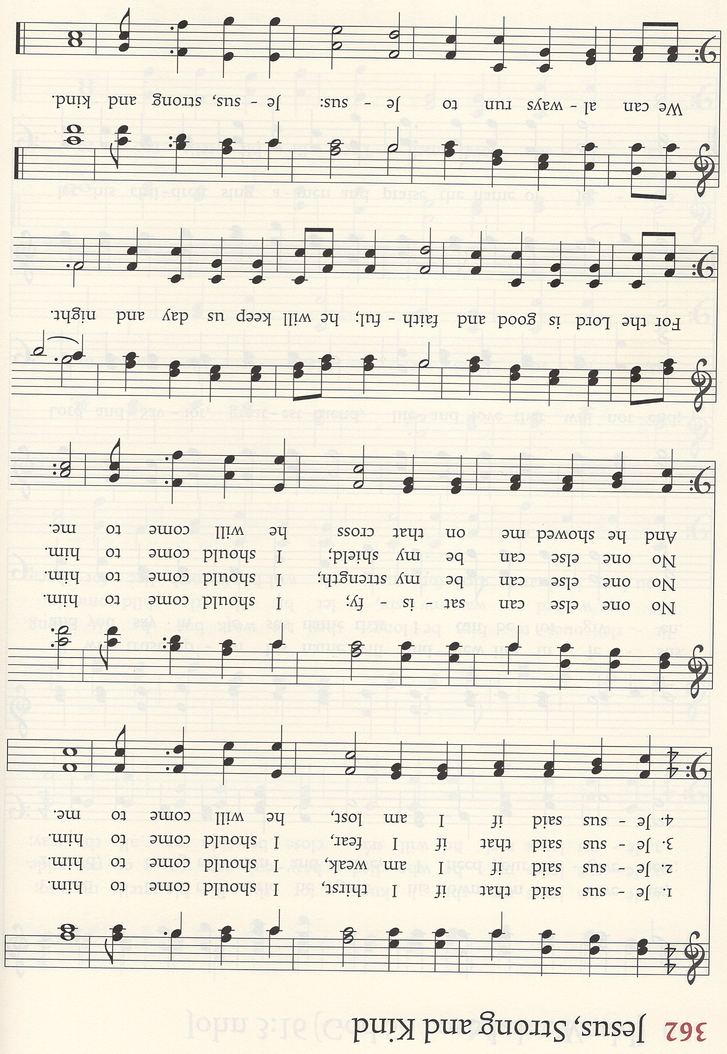

CCLI Song # 7139992 © 2019 CityAlight Music | Farren Love And War Publishing | Integrity's Alleluia! Music | Wanaaring Road Music. For use solely with the SongSelect® Terms of Use. All rights reserved. www.ccli.com CCLI License # 3266058

