Only A Holy God (Sing! Hymnal #11)

[ CHORDS ] Bm D G A [ NO CAPO ]
====== xoo=== ==oo== oo===o
|||||| |||||| |||||| ||||||
OO|||O |||O|O |O|||| ||OOO|
||||O| ||||O| O|||OO ||||||
||OO|| |||||| |||||| ||||||

[ INTRO ] | Bm D G | D | Bm D G | D |

[ VERSE 1 ] Bm D G D
Who else com-mands all the hosts of heav-en,
Bm D G D
Who else could make ev-’ry king bow down
Bm D G D G A D
Who else can whis-per and dark-ness trem-bles, On-ly a Ho-ly God
[ CHORUS ] Bm G D A
Come and be-hold Him, the One and the On-ly
Bm G D A Bm
Cry out, sing ho-ly for - ev-er a Ho-ly God,
G A D
Come and wor-ship the Ho-ly God

[ VERSE 2 ] Bm D G D
What oth-er beau-ty de-mands such praises,
Bm D G D
What oth-er splen-dour out-shines the sun
Bm D G D G A D
What oth-er ma-je-sty rules with just-ice, On-ly a Ho-ly God

[ CHORUS ]

[ VERSE 3 ] Bm D G D
What oth-er glo-ry con-sumes like fire,
Bm D G D
What oth-er pow-er can raise the dead
Bm D G D G A D
What oth-er name re-mains un-de-feated, On-ly a Ho-ly God

[ CHORUS ]

[ VERSE 4 ] Bm D G D
Who else could res-cue me from my fail-ing,
Bm D G D
Who else would of-fer His on-ly Son
Bm D G D G A D
Who else in-vites me to call Him Fath-er, On-ly a Ho-ly God

[ CHORUS x 2 ]
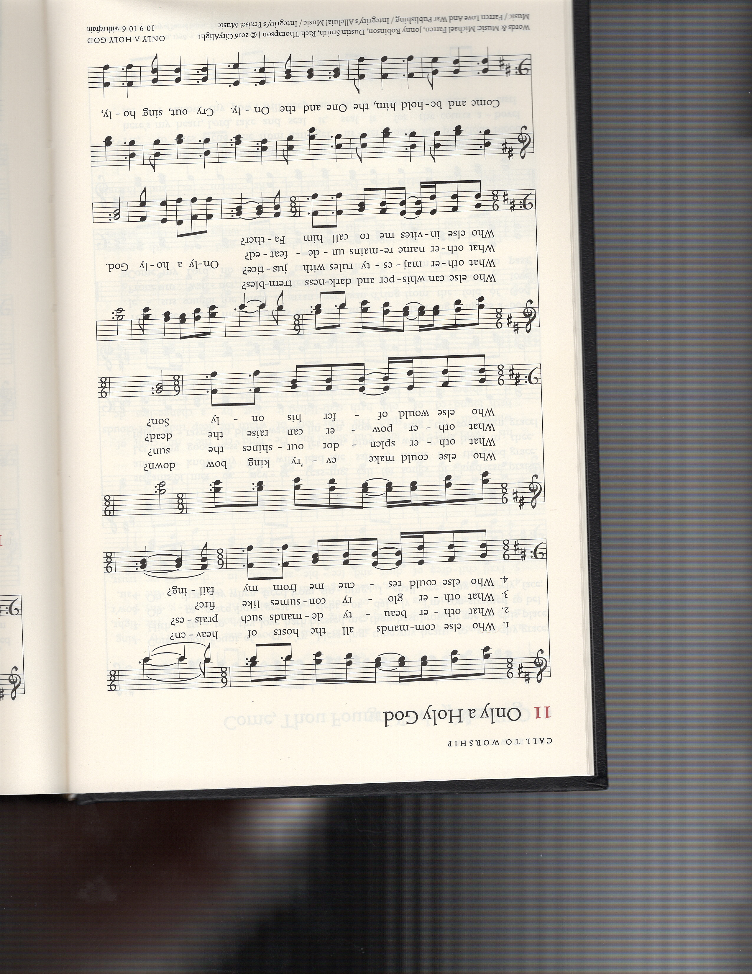
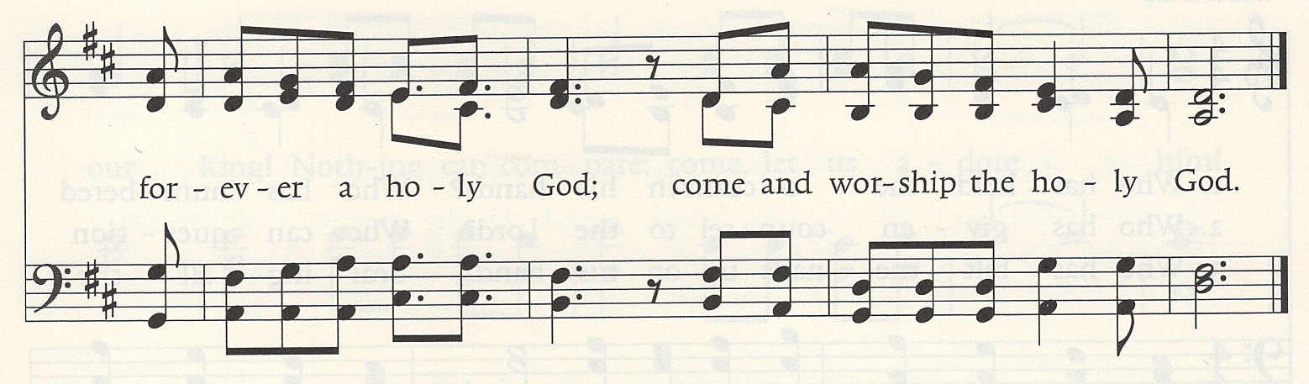

© 2016 CityAlight Music; Farren Love And War Publishing; Integrity's Alleluia! Music; Integrity's Praise! Music For use solely with the SongSelect® Terms of Use. All rights reserved.www.ccli.com. CCLI License # 3266058

