Glory Be to the Father (Blue Hymnal #670)
=========================================

Words: Gloria Patri Music: Henry W. Greatorex

[ CAPO 1 ]

[ CHORDS ] D A E7
xoo=== oo===o o===oo
|||||| |||||| |||O||
|||O|O ||OOO| |OO|||
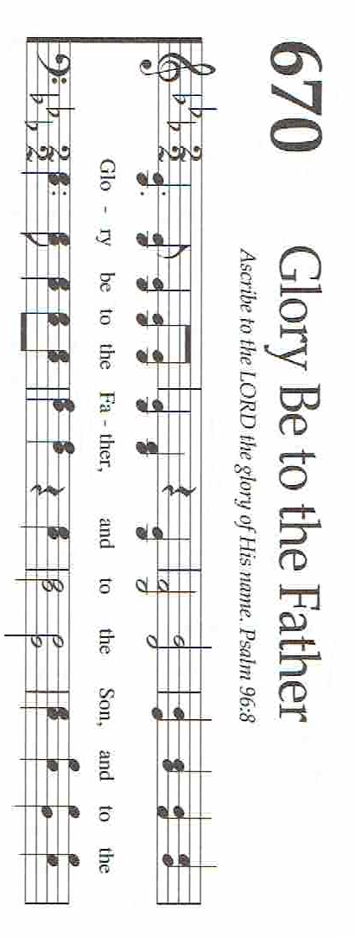
||||O| |||||| ||||||
|||||| |||||| ||||||

[ VERSE 1 ]
D A D A E A
Glo-ry be to the Fa-ther, and to the Son, and to the Ho-ly Ghost;
D A D
As it was in the be-gin-ning, is now and e-ver shall be,
D A D
World with-out end. A-men, A-men
