When I Survey the Wondrous Cross (Blue Hymnal #234)
Words: Isaac Watts Music: Lowell Mason

[ CHORDS ] D G A [ CAPO 3 ]
xoo=== ==oo== oo===o
|||||| |||||| ||||||
|||O|O |O|||| ||OOO|
||||O| O|||OO ||||||

[ INTRO ] | D | A | A | D |

[ VERSE 1 ] D G D
When I sur-vey the won-drous cross
D G D A
On which the Prince of Glo-ry died,
D G D
My rich-est gain I count but loss,
D A D
And pour con-tempt on all my pride.

[ VERSE 2 ] D G D
For-bid it, Lord, that I should boast,
D G D A
Save in the death of Christ, my God;
D G D
All the vain things that charm me most,
D A D
I sac-ri-fice then to His blood.

[ VERSE 3 ] D G D
See, from His head, His hands, His feet,
D G D A
Sor-row and love flow min-gled down;
D G D
did e're such love and sor-row meet,
D A D
Or thorns com-pose so rich a crown?

[ VERSE 4 ] D G D
Were the whole realm of na-ture mine,
D G D A
That were a pres-ent far too small;
D G D
Love so a-maz-ing, so di-vine,
D A D
De-mands my soul, my life, my all!

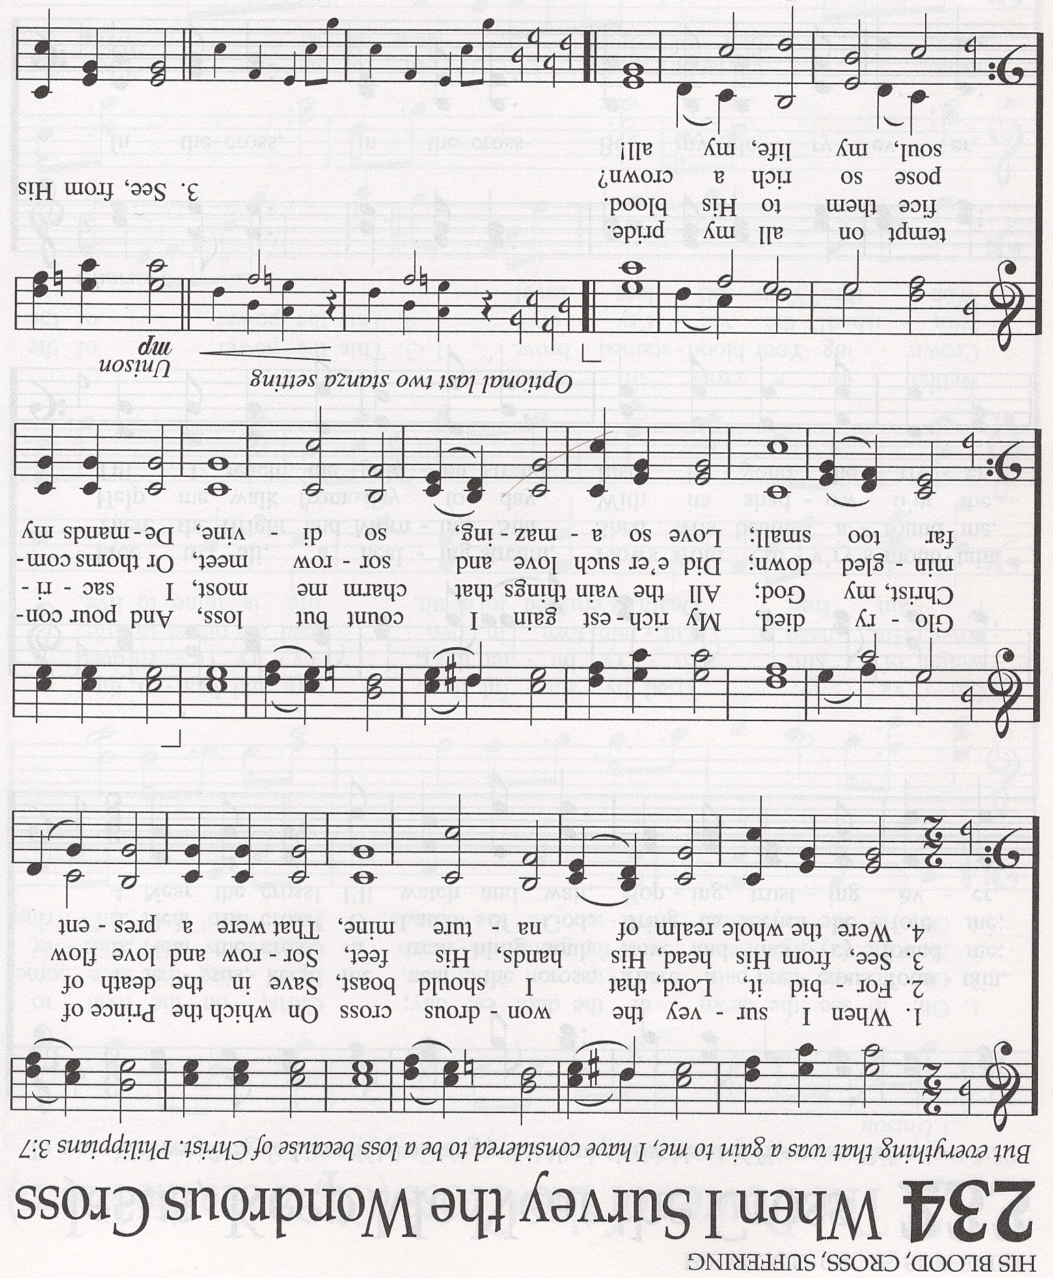
IGNORE

