1.

What is Algorithm?

Understanding and interpreting Flowchart’s Rules

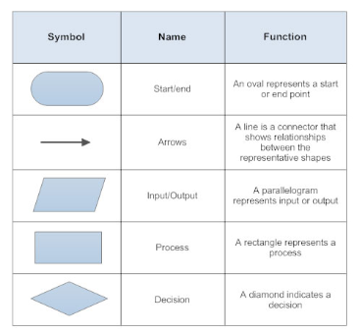

After understanding various examples, draw a flowchart of their own process of preparing for school.

Express flowchart that has already been drawn using the NCH tool.

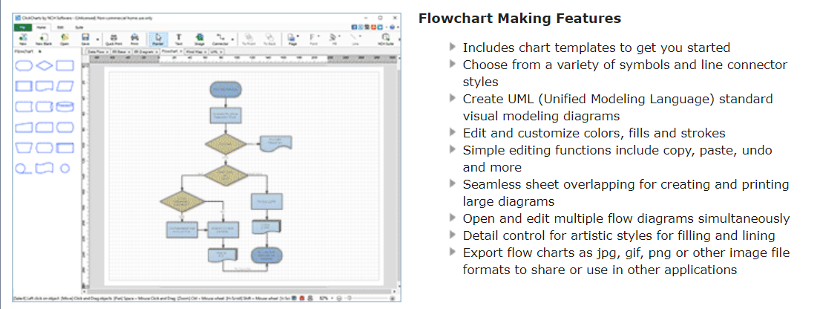

https://www.nchsoftware.com/chart/ko/index.html

2. Understanding of the binary system

<https://csunplugged.org/en/topics/binary-numbers/unit-plan/codes-for-letters-using-binary-representation-junior/>

Understanding of the binary system

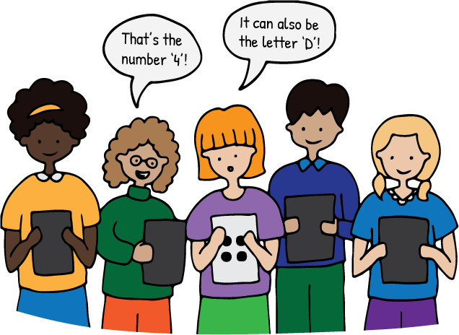

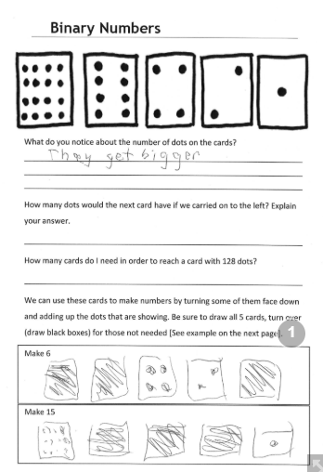 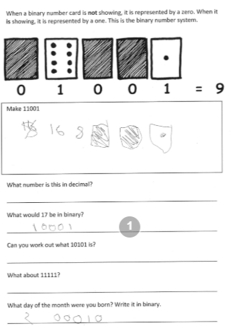

Creating and Decoding a Scytale or Caesar cipher

Scytale 원통 막대기를 다르게 하여 암호문을 만들고 친구와 바꿔 해독

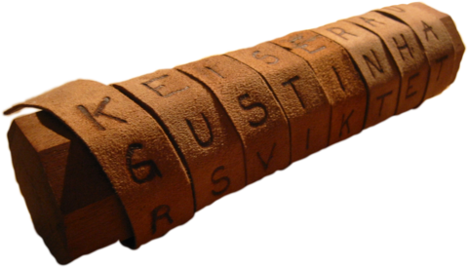



Caesar 암호문을 만들고 친구와 바꾸어 해독

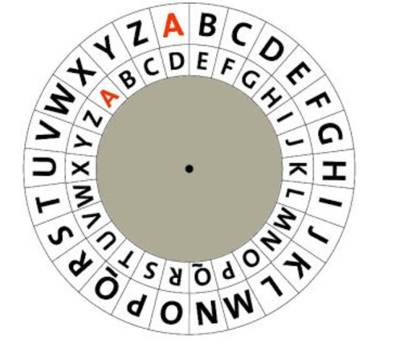

3. Computer’s Image Representation (Pixel)

Express and Interpret Images in Command

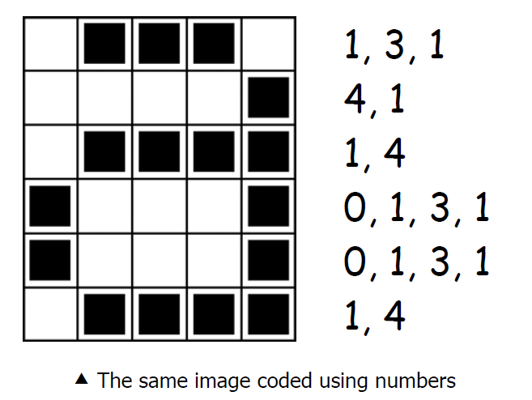

\* 활동지 별첨

4. Error Detection and Correction

Parity magic

<https://csunplugged.org/en/topics/error-detection-and-correction/unit-plan/parity-magic-junior/>

1. Teacher to class: "I’ve just learnt a magic trick I want to show you".
2. Teacher to class: "So who will be my assistant?"
3. Teacher to student: Hand the cards to the student and ask them to put up one row of 5 cards with some cards showing black and the other white. Ask them to add another row, but making sure there isn’t a pattern between the 2 rows. Continue to do that until you have a grid of 5 x 5. This is an opportunity to count all the cards, skip count in fives to 25, or to double check there really isn’t any patterns happening.

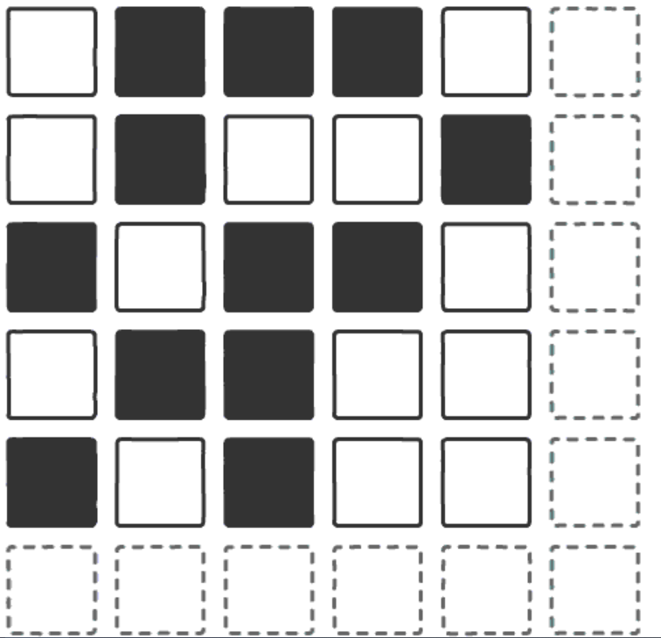

친구와 함께 parity bit을 작성하고 친구가 바꾼 bit 찾아내기

5. Sorting Networks.

실생활 안에서 차례대로 분류되거나, 오름차순 내림차순으로 정리된 예시

How computers are arranged in order?

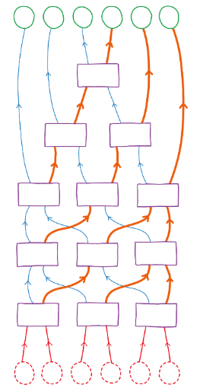

6. Quick Sort

Divide and Conquer

\*활동지 별첨

7. Array and Stack

8. Linked List and Queue

9. Breadth First Search (BFS)

10. Depth First Search (DFS)