- A customer gives you a fixed-width input file (reference: example_input.txt). You look at the file, and realize that while it has all the data you requested in the correct order, it does not meet your data specification and requires a data transformation. Please write a script or function that takes an input file in the sample format, and writes an output file matching the following specification:

  - File must be in valid CSV format

  - File must not contain duplicate rows

  - File must contain a header row with column names

  - Column 1: Account Number. If less than six digits, padded with leading zeroes

  - Column 2: Read Date. Format: YYYYMMDD

  - Column 3: Address (free text)

  - Column 4: Zip Code. Five-digit format
  - Column 5: Consumption (numeric value)

- A junior developer, Huckle Cat, comes to you with a bug report. It seems his predecessor, Fred “The Kludge” Flintstone, wrote a math object class with a StandardDeviation function call. The user passes the function a list of floating point values and the function is supposed to return the standard deviation of the list. The bug report in Huckle’s hand states a user passed the [1,2,3,4,5] list to the function and the function returned 1.2 as the answer. When the customer did the same thing with Excel, Excel returned 1.414. Huckle’s boss is really mad and wants the StandardDeviation method fixed immediately. What is the single problem causing the reported bug? Hint: the bug is not a syntax problem.

import math

def standard_deviation(number_list):

average = sum(number_list) / float(len(number_list))

stdev = 0

for value in number_list:

stdev += math.sqrt((average - value)**2) / float(len(number_list)) return stdev

- Another fellow developer gives you a sample of a data quality report they are working on. The report is expected to convey the month, the number of accounts that have reported so far, the average number of days each account was reporting for, and the average gallons of water per day used by each account. Additionally, it compares the values against the same period in the last month, and the last year. How would you interpret this report? What changes would you suggest to make it easier to read?
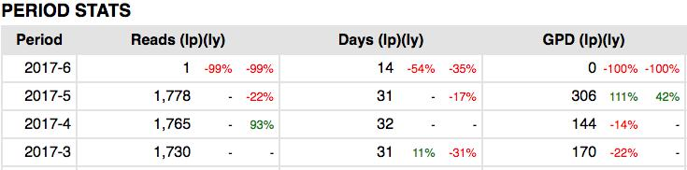

- Given the following simplified model of a pizza place, write a SQL query to find all customers that ordered a pepperoni pizza in the last 30 days. For extra points, find the customer who spent the most money in the last 30 days.

Customer |  | Order |  | Pizza
Customer_ID |  | Customer_ID |  | Pizza_ID
Name |  | Pizza_ID |  | Name
Address |  | Quantity |  | Price
Phone |  | Order_Date
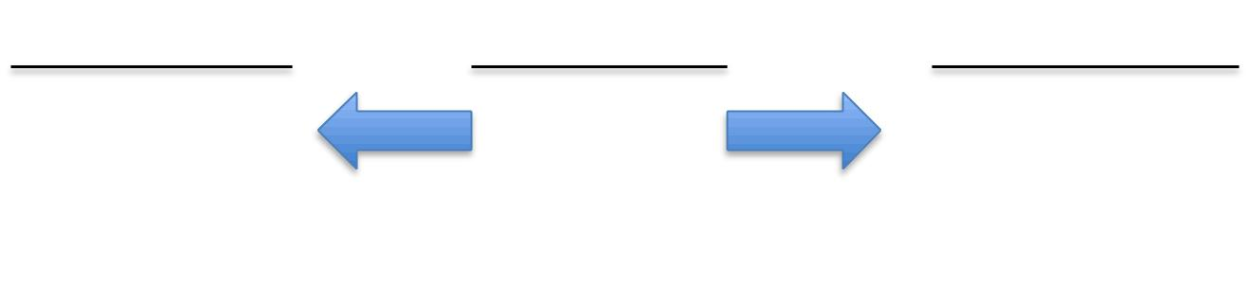

  - Imagine that a developer on your team has just finished a project to load daily weather data around the world. They’ve written a function with the interface below to retrieve data for any given day and location. You’ve been assigned to perform technical QA on the new interface and data. What documentation would you request, and what steps would you take to validate that the data has been loaded correctly and the function is working as expected?

- Returns a dictionary: {‘date’ => datetime, ‘min_temp’ => float,

- ‘max_temp’ => float, ‘avg_temp’ => float, ‘precipitation_type’ =>

- none/’rain’/’snow’/’mixed’, ‘precipitation_amount’ => float}
def get_weather(postal_code, date_requested): …

