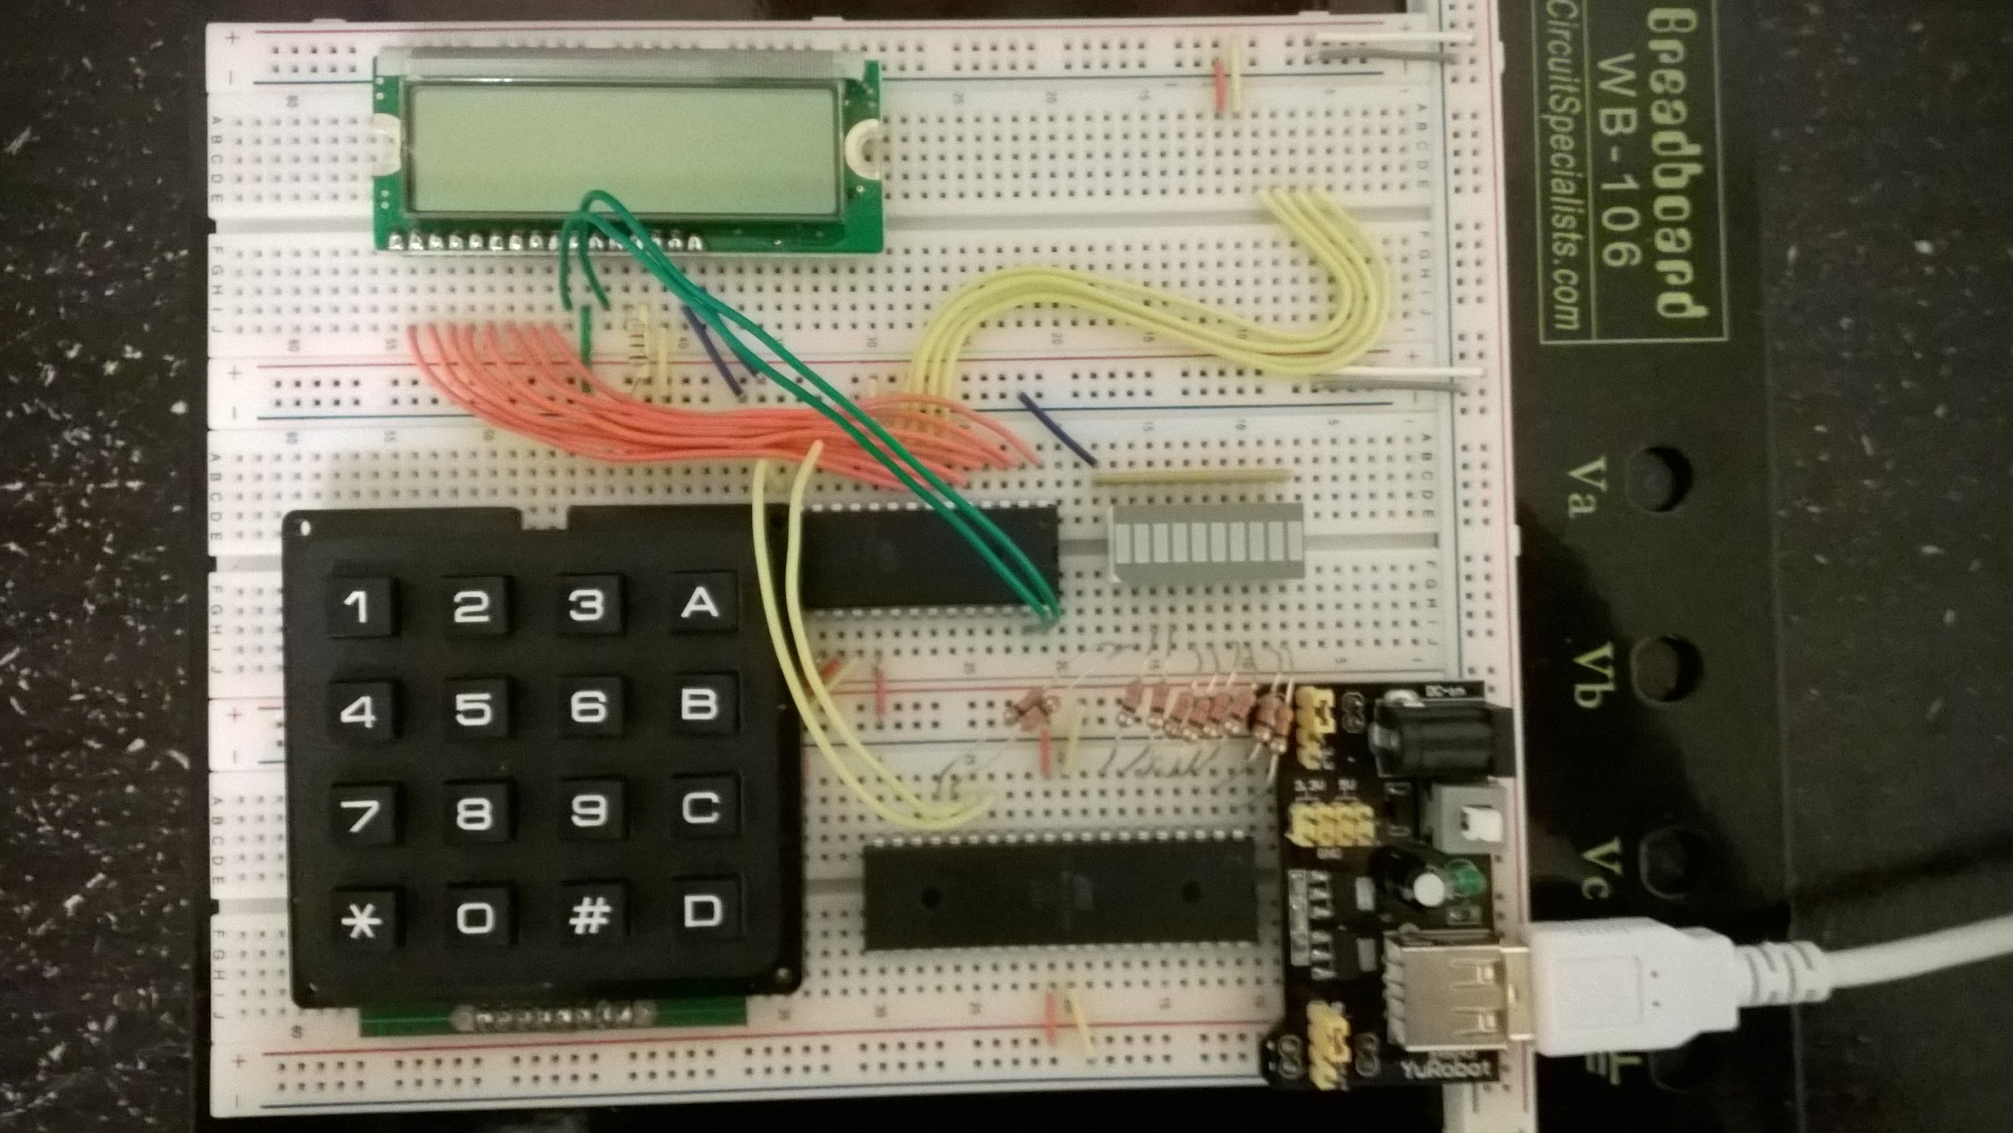

LCD Display Pin Connections

|  |  |  |  |  |  |  |  |  |
| --- | --- | --- | --- | --- | --- | --- | --- | --- |
| **LCD**  **PIN #** | **1** | **2** | **3** | **4`** | **5** | **6** | **7-14** | **15-16** |
| Connection | GND | 5 Volts | Potentiometer  (10KΩ)  thru. to  GND | AVR PORT  A0 | GND | AVR PORT  A1 | AVR PORT  B0-B7 | Vcc-GND |

Keypad Connections

|  |  |  |  |  |  |  |  |  |
| --- | --- | --- | --- | --- | --- | --- | --- | --- |
| Keypad  Pin # | 4 | 3 | 2 | 1 | 8 | 7 | 6 | 5 |
| Term | R1 | R2 | R3 | R4 | C1 | C2 | C3 | C4 |
| AVR Port | C0  Input | C1  Input | C2  Input | C3  Input | C4  Output | C5  Output | C6  Output | C7  Output |

LED Bar ( using microcontroller on the botton):

PORTB: B0-B7 to LED0-7

PORTD: B2, B3 to LED 8-9

USART:

PORTD(Pin#) PORTD(Pin#)

First Microcontroller 0 1

Second Microcontroller 1 0