<http://www.r20.nl/example_database_MySQL.htm>

<http://www.r20.nl/SQL_for_MySQL_v1.htm>

**Installing the Example Database**

Chapter 4 of *SQL for MYSQL Developers* describes how to install the example database. That description includes  explanations of how certain SQL statements work. This page contains a more concise description of the installation procedure.

We assume that you have successfully installed MySQL and WinSQL. If you havealready created a user, such as BOOKSQL, then start with step 4

Step 1: Start WinSQL and log on using the user name *root* with password *root*.

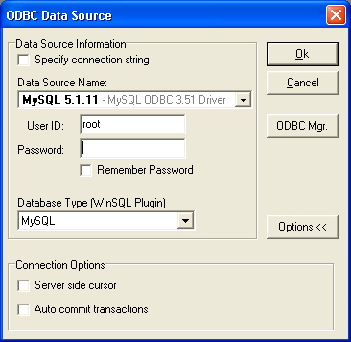  
  
Step 2: Create a new user called *BOOKSQL* with password *BOOKSQLPW*. Type in the following SQL statement:  
  
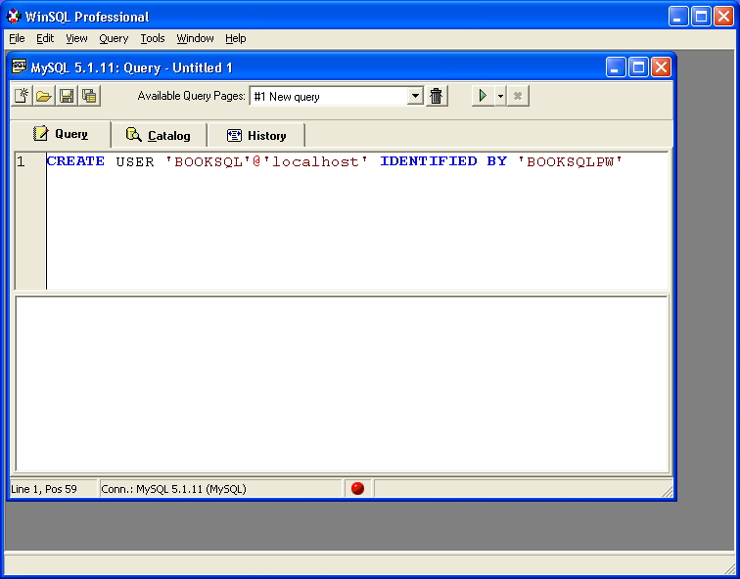  
  
Execute this statement by pushing the button with the green arrow. If the user is created, the following window appears:  
  
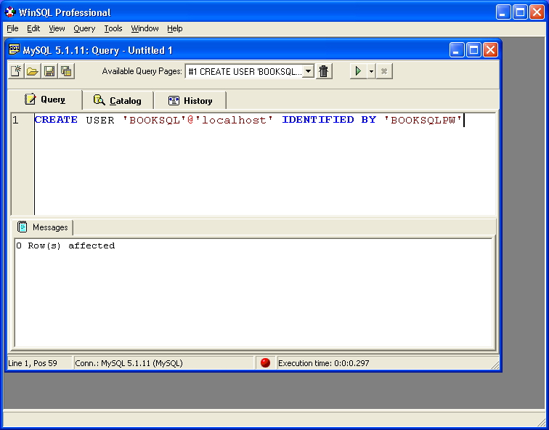  
  
Step 3: Assign *BOOKSQL* all the required privileges with the following statement, and execute the statement:  
  
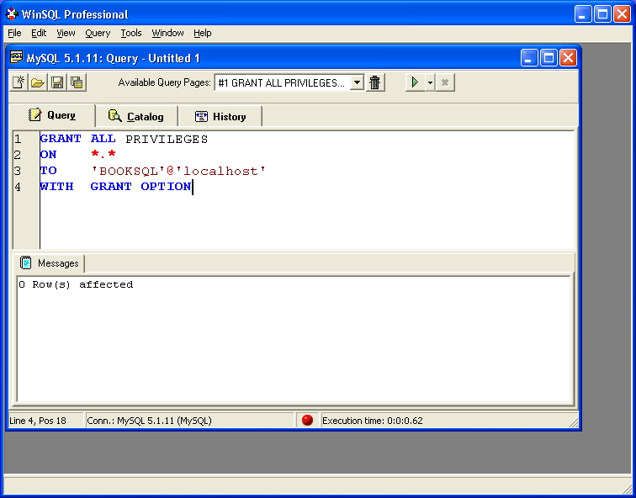

Stop WinSQL now.

Step 4: Start WinSQL and log on with user name *BOOKSQL* and password *BOOKSQLPW*:  
  
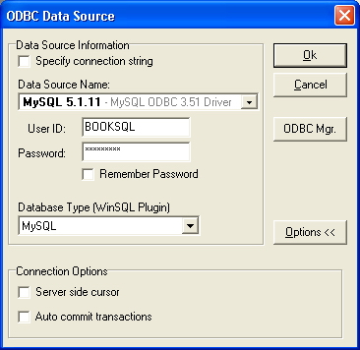  
  
Step 5: Create a new database called TENNIS using the CREATE DATABASE statement. Don't forget the execute the statement:  
  
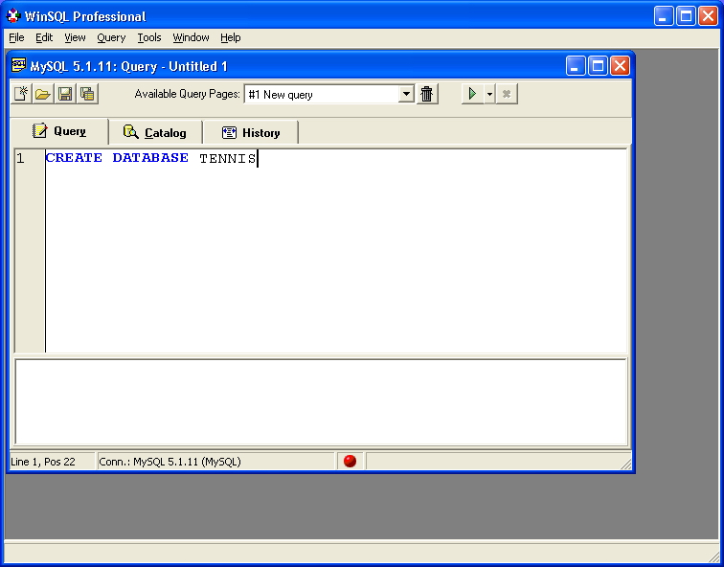  
  
Step 6: Make TENNIS the current database through the USE statement:  
  
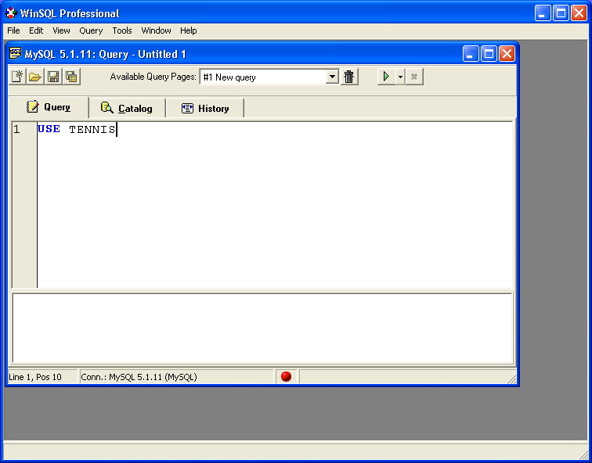  
  
Step 7: Download the file [SQLforMySQL_V1_create_new_database.txt](http://www.r20.nl/SQLforMySQL_V1_create_new_database.txt). Open the file with, for example, Notepad. Copy all the statements from the file into WinSQL:  
  
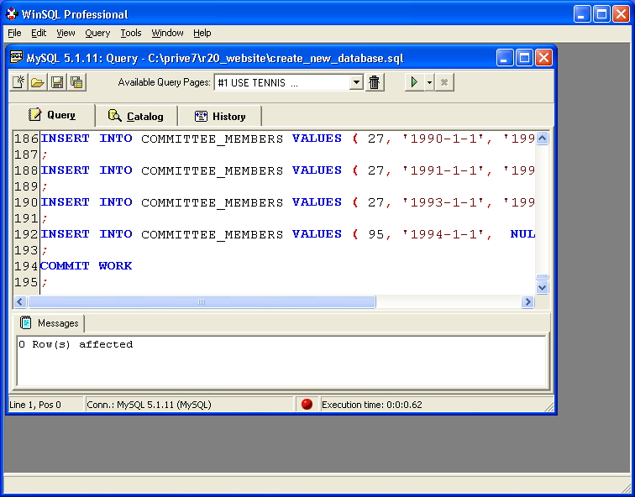  
  
Execute all the statements