# Description-J

## Content

**Java Server Pages (JSP)** - Demonstrate the ability to apply the JSP concepts covered in this section of this course.

**Assignments-J**

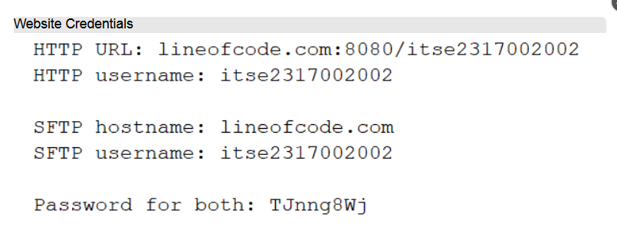

Top of Form

Bottom of Form

**Content**

* [**Install JDK, WildFly, and NetBeans**](http://www.titantraining.com/coursecontent/inew2338/01-jdk-wildfly-netbeans-setup-local.pdf)
* [**Website Setup & Assignment Publishing**](http://www.titantraining.com/coursecontent/inew2338/02-wildfly-setup-remote.pdf)
* **Student Website**

For assignments Asg09-12, include your **Website URL** in the assignment comments section when submitting.

**-10** points if your URL is missing in the comments section of your submission.

* **Assignment Requirements**

[Asg09.pdf](http://www.titantraining.com/coursecontent/itse2317/Asg09.pdf)

[Asg10.pdf](http://www.titantraining.com/coursecontent/itse2317/Asg10.pdf)

[Asg11.pdf](http://www.titantraining.com/coursecontent/itse2317/Asg11.pdf)

[Asg12.pdf](http://www.titantraining.com/coursecontent/itse2317/Asg12.pdf)

* **Student Website**

For assignments Asg09-12, include your **Website URL** in the assignment comments section when submitting.

**-10** points if your URL is missing in the comments section of your submission.

* **.**

Complete the Program Confirmation when you are ready to submit your program.

**Program Submission Links Appear after the Program Confirmation is Complete.**

The confirmations appear as 'Tests' but are not graded.

* [**Asg09 - Confirmation**](https://acconline.austincc.edu/webapps/blackboard/content/launchAssessment.jsp?course_id=_791020_1&content_id=_11219305_1&mode=view)

Complete the Confirmation and the Assignment submission link will appear.

* [**Asg10 - Confirmation**](https://acconline.austincc.edu/webapps/blackboard/content/launchAssessment.jsp?course_id=_791020_1&content_id=_11219307_1&mode=view)

Complete the Confirmation and the Assignment submission link will appear.

* [**Asg11 - Confirmation**](https://acconline.austincc.edu/webapps/blackboard/content/launchAssessment.jsp?course_id=_791020_1&content_id=_11219309_1&mode=view)

Complete the Confirmation and the Assignment submission link will appear.

* [**Asg12 - Confirmation**](https://acconline.austincc.edu/webapps/blackboard/content/launchAssessment.jsp?course_id=_791020_1&content_id=_11219311_1&mode=view)

Complete the Confirmation and the Assignment submission link will appear.

* [**Alternatives to Programming Assignments**](http://www.titantraining.com/coursecontent/itse2317/ProgrammingAlternatives.pdf)