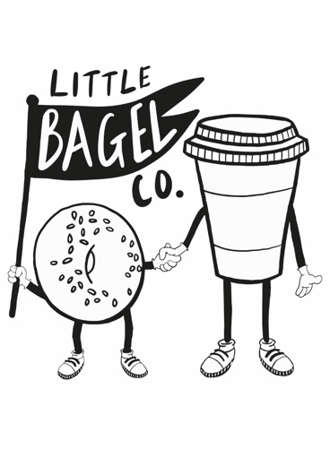

**MENU**

**Reuben** - Salt Beef, Sauerkraut, Pickles, Russian Dressing, Emmental Cheese

**Vegan Reuben**- Roasted Broccoli, Pickles, Vegan Russian Dressing, Sauerkraut **(VG)**

**Chicken Salad** - Chicken Mayo, Rocket, Tomato

**Kimcheesy** - Kimchi & Cheddar **(V)**

**Salmon & Cream Cheese**- Smoked Salmon, Cream Cheese, Red Onion, Capers, Dill

**Vegan Salmon & Cream Cheese**- Vegan Salmon, Vegan Cream Cheese, Red Onion, Capers, Dill, Tomato, Cucumber **(VG)**

**Schmear** - Cream Cheese, Capers, Dill, Tomato, Cucumber, Red Onion **(V)**

**Breakfast Bagel** - Bacon, Egg, Cheddar, Hot Sauce

**Vegan Breakfast Bagel**- Smashed Avo, Vegan Sausage, Hot Sauce, Tomato **(VG)**

Vegetarian **(V)**

Vegan **(VG)**