Technical Specification

Properties:

Style:

Men Boxy Fit Shirt.

Style number:

700696773017

Brand: MORLY

Sizes:

XS–XL

Commodity: Men's Shirts

E-mail:

customercare@morly.com

Care Address: Tower-B, 7th Floor, IBC Knowledge Park, Nagar, S.G. Palya, Bengaluru, Karnataka – 560029

Main image:
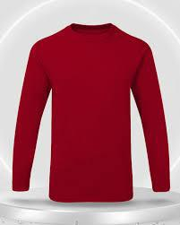

Dimensions:

Dim | Description | Comment | Tol | Tol |  | XS |  |  | S
Dim | Description |  | (-) | (+)
1B1 | Chest Width |  | -1.00 | 1.00 | Increm | Sam | Devia | Incremen | Sampl | Deviation
1B1 | Chest Width |  | -1.00 | 1.00 | ent | ple | tion | t | e
1X1 | Bottom Hem Width |  | -1.00 | 1.00 | 46.00 |  |  | 50.00
1F3 | Across Shoulder |  | -1.00 | 1.00 | 36.00 |  |  | 38.00
1F6 | Shoulder Angle |  | -0.50 | 0.50 | 2.50 |  |  | 2.50
1G5 | Sleeve Length (Short) |  | -1.00 | 1.00 | 37.00 |  |  | 39.00
1H2 | Armhole Depth |  | -0.50 | 0.50 | 21.20 |  |  | 22.00

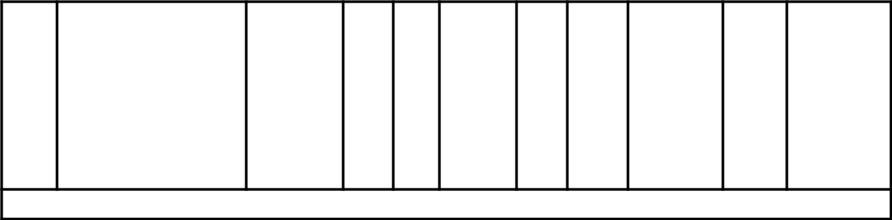

2A1 | Upper Arm Width | -0.50 0.50 | 17.00 | 18.00
2K1 | Sleeve Hem Width | -0.50 0.50 | 15.00 | 16.00
3B1 | Neckline Width | -0.50 0.50 | 16.20 | 17,00
Displaying 1-9 results

Dimensions:
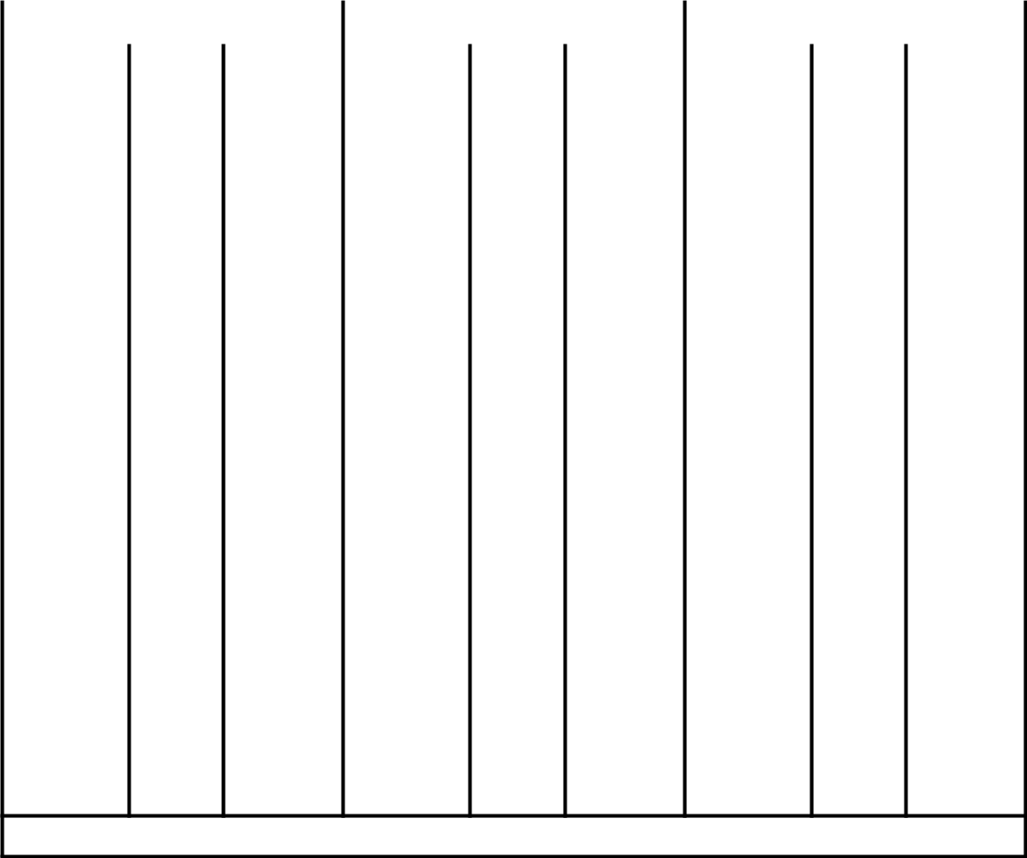

 | M |  |  | L |  |  | XL
Incremen Sampl Deviatio Incremen Sampl Deviatio Incremen Sampl Deviatio
t | e | n | t | e | n | t | e | n
54.00 |  |  | 58.00 |  |  | 64.00
40.00 |  |  | 42.00 |  |  | 44.00
2.50 |  |  | 2.50 |  |  | 2.50
41.00 |  |  | 43.00 |  |  | 45.00
22.80 |  |  | 23.60 |  |  | 24.40
19.25 |  |  | 20.50 |  |  | 21.75
17.25 |  |  | 18.50 |  |  | 20.50
17.80 |  |  | 18.60 |  |  | 19.40
Displaying 1-9 results

Dimensions:
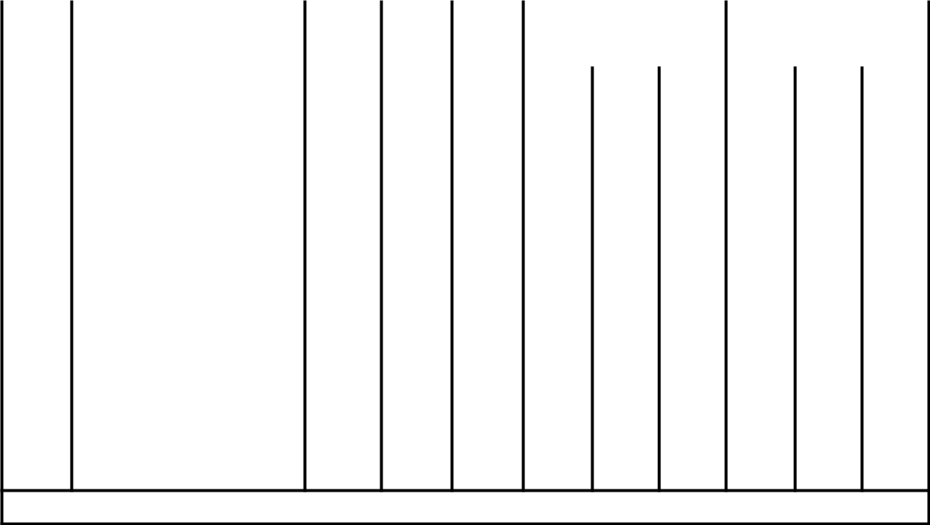

Dim | Description | Comm | Tol (-) Tol (+) |  | XS | S
Dim | Description | ent
3B2 | Front Neck Depth |  | -0.50 | 0.50 | 9.10 | 9.50
3B6 | Back Neck Depth |  | -0.50 | 0.50 | 2.00 | 2.00
 | Front Width (14 cm
1M1 | below HPS) |  | -1.00 | 1.00 | 33.00 | 35.00
 | Back Width (12 cm
1M4 | below HPS) |  | -1.00 | 1.00 | 34.00 | 36.00
1N2 | Full Back Length |  | -1.00 | 1.00 | 60.00 | 62.00
3C1 | Rib Width at Neck |  | 0.00 | 0.00 | 2.00 | 2.00
Displaying 10-15 results

Dimensions:
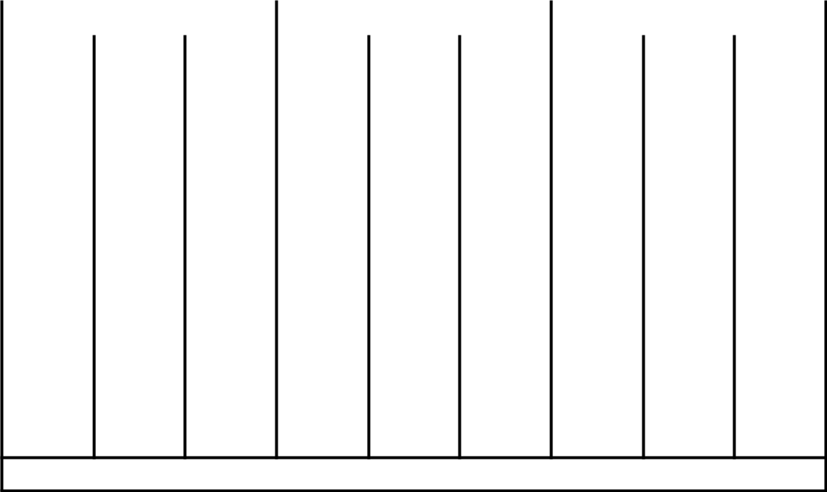

M | L | XL
9.90 | 10.30 | 10.70
2.00 | 2.00 | 2.00
37.00 | 39.00 | 41.50
38.00 | 40.00 | 42.50
64.00 | 66.00 | 69.00
2.00 | 2.00 | 2.00
Displaying 10-15 results

Spec Sheet:

Placement | Qty |  | Composition
Main Fabric | 3 | 100% | Organic in- conversion cotton Combed
Rib | 2
Finish/Treatment | 1
Thread | 2
Main Label | 1 | 100% | Recycled Polyester
Size Label | 2 | 100% | Recycled Polyester
Care Label | 1 | 100% | Recycled Polyester
Hang Tag | 1 | 100% Nylon

Sample Images:
