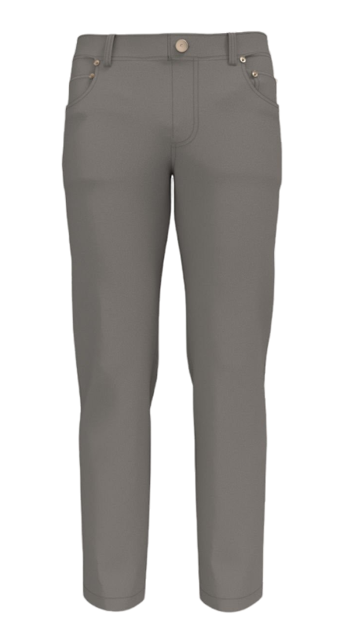96Style number : 70069773017  
Style: Men Linen Pants   
Brand: MORLY  
Size : XS – XL   
Commodity : men’s pants  
E-mail : [a0049632@gmail.com](mailto:a0049632@gmail.com)  
  
Care Address : 4-158/9 5th Cross Road, Sainikpuri, Secunderabad 500094, TS, IND   
  
 **Spec Sheet**

|  |  |  |  |  |
| --- | --- | --- | --- | --- |
| **Placement** | **Composition** | **Qty** | **Per rate** | **Total** |
| Main Fabric | Full organic cotton | 3 | 0.25 | 0.75 |
| Button | Plastic/Wood | 2 | 0.75 | 1.5 |
| Thread | mixed fabric | 2 | 0.25 | 0.5 |
| Main Label | Recycled Polyster | 1 | 0.25 | 0.25 |
| Size Label | Recycled Polyster | 2 | 0.25 | 0.5 |
| Care Label | Recycled Polyster | 1 | 0.75 | 0.75 |
| Hang Tag | Nylon | 1 | 0.5 | 0.5 |
| **Total** | | | | 4.75 |