THE SALT EFFECT
SECTION FIVE: THE BLUEPRINT FOR MODERN LIVING
Section Five is where the book's architecture descends from the theoretical into the practical, from the philosophical into the applied, and from the individual into the relational. It is the section that asks: now that you know what salt is, what it does, and what it costs to carry it—what exactly do you do on Monday morning? What do you do in the conversation that's been avoided for six months? What do you do when the AI report tells you that thirty percent of your team's function is automatable by next quarter? What do you do when your teenager hasn't looked at you in three days and the silence has that specific quality that means something is wrong beneath it?
These chapters answer those questions with the precision the questions deserve. They do not offer platitudes. They offer protocols. They do not offer inspiration. They offer architecture. And they close with the only document that survives every chapter of this book: the Covenant of Salt—signed, dated, and non-negotiable.

CHAPTER TWENTY-SIX

The Covenant of Salt
Pulling Every Thread Together
“The covenant is not an idea. It is a structure. And structures, unlike ideas, bear weight.”
— Dr. Ishmael Amu
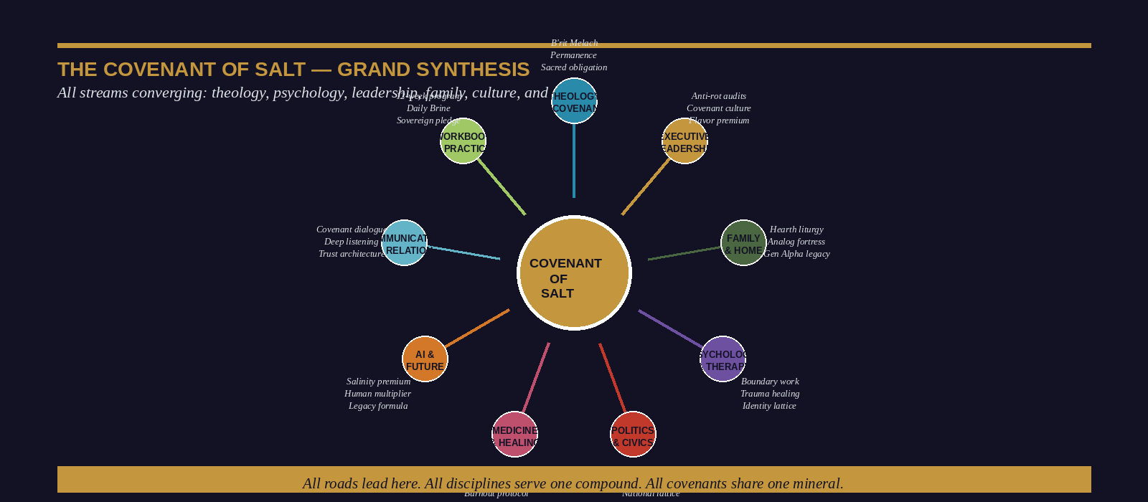
Figure: The Covenant of Salt — Grand Synthesis of All Streams

The Architecture of the Whole
This chapter does what no single preceding chapter could afford to do: it stands back from the granular detail of each domain—the boardroom, the hospital, the family dinner table, the polling station, the neuroscientist's laboratory, the philosopher's study—and asks a single integrating question: What is the deep structure that underlies all of it? What is the one thing that the CEO's battle against cultural rot, the physician's battle against compassion fatigue, the parent's battle against technoference, the student's battle against attentional fragmentation, and the citizen's battle against political capture all share?
The answer, which this book has been assembling since its first page, is this: every domain of human endeavor is a system in which the presence or absence of a specific kind of person—the mineral preservative, the Active Resonant, the covenant-bearer—determines whether the system tends toward health or rot. The biochemistry is always the same. The social dynamics are always the same. The moral physics are always the same. Only the domain changes. The compound is always sodium chloride.

The Seven Streams of the Covenant

Stream One: Theology and the Unbreakable Bond
The covenant of salt begins, historically and structurally, in the ancient Near East's understanding of a bond that cannot be dissolved. B’rit melach—the salt covenant—was not a metaphor for permanence. It was the selection of the most chemically stable substance available to the ancient world as the material witness of an irrevocable commitment. The God who sealed the priestly covenant in Numbers 18:19 with salt rather than blood was making a specific structural argument: this bond does not depend on the emotional state of either party, the market conditions of the moment, or the political calculations of the season. It depends on the nature of the mineral. Salt does not change.
Every subsequent chapter of this book is an application of this theological structure to a specific domain of human activity. The executive who builds a covenant culture rather than a contractual one is doing theology in a conference room. The parent who establishes a Threshold Covenant is consecrating domestic space in the tradition of every culture that has ever recognized the doorway as sacred. The physician who maintains their standard of care in conditions that reward its abandonment is honoring a professional covenant that has its deepest roots not in a licensing board but in an oath that invokes the permanence of salt.

Stream Two: Psychology and the Cohesive Self
The salt covenant’s psychological translation is the cohesive self—the stable, bounded, recognizable identity that persists across the inevitable disruptions of experience and the systematic attempts of the algorithmic environment to dissolve it. Every psychological framework developed in this book—Active Resonance, the Mineral Preservative, Lattice Calibration, the Sovereign Perimeter, the Antiseptic Purge, the Monastic Cognitive Routine—is a specific operational tool for building and maintaining the cohesive self in the specific conditions of the twenty-first century.
The psychological synthesis is simple: the person who has found their natural frequency and committed to its maintenance, the person who knows what they are and refuses to become what their environment is trying to make them, the person who has developed the specific practices that return them to that frequency when it has been disturbed—this person is, in the clinical language of this book, a mineral preservative. They are, in the scriptural language that runs through it, the salt of the earth.

Stream Three: Leadership and the Institutional Imperative
The synthesis of the book’s leadership framework is equally direct: institutions rot without salt. The specific mechanism is not dramatic—it is a sequence of micro-compromises, each individually defensible, each individually invisible, accumulating over time into a structural decay that only becomes visible when it has become irreversible. The salt practitioner in an institutional context is the person who interrupts that sequence—who names the first compromise, who holds the standard at the moment when holding it carries a cost, who maintains their covenant obligations to the organization’s stated purpose when the organization’s political dynamics are working against that purpose.

Stream Four: Family and the Domestic Covenant
The family synthesis: every family is a petri dish. The question is what is being grown in it. The parent who has understood this book understands that the domestic environment’s default trajectory, in the absence of deliberate cultivation, is not neutral—it is the trajectory of whatever is growing fastest in the cultural environment that surrounds the home. In the current moment, what is growing fastest is the algorithm’s colonization of attention, the peer group’s colonization of values, and the ambient cultural narrative’s colonization of identity. The salted home does not seal itself against these forces—it provides an environment with enough internal density, enough nutritional richness, and enough principled presence that its inhabitants develop the internal resources to encounter those forces without being consumed by them.

Stream Five: AI and the Human Salinity Premium
The AI synthesis: computational velocity without moral salinity is not progress—it is the efficient amplification of whatever is already present. The institution that deploys AI from a foundation of low salinity amplifies its rot with extraordinary efficiency. The institution that deploys AI from a foundation of genuine covenant values, deep human relationships, and irreplaceable human presence amplifies its salt. The formula—Legacy = ∫ Human Salt(t) × AI Scale(t) dt—is not poetry. It is the most precise description of competitive advantage available to any organization navigating the current technological environment.

Stream Six: Civic Life and the National Lattice
The civic synthesis: democracies do not fail from the outside in. They fail from the inside out, through the gradual withdrawal of principled people from the institutions and civic structures that their presence was maintaining. The salt practitioner's civic obligation is not primarily electoral—it is structural. It is the building of the local lattice, the maintenance of the covenant relationships that constitute the actual fabric of democratic life, the exercise of micro-sovereign action in the specific domains where their presence has genuine leverage. The national fabric is the emergent property of thousands of local covenants. It cannot be rebuilt from the top down. It must be rebuilt from the kitchen table out.

Stream Seven: The Self and the Commission
The personal synthesis is the Manifesto’s final line: I am salt. The world is the wound. I will not remain in the shaker. The practitioner who has arrived at this point in the book—who has read every chapter with honest attention and applied every protocol with genuine effort—has not finished a book. They have accepted a commission. The commission does not have a graduation date. It does not have a comfortable termination condition. What it has is a daily practice, a covenant community, a renewable source, and the specific, irreducible knowledge of what happens when the salt removes itself from the wound.
▸ THE SEVEN-STREAM SYNTHESIS — The Practitioner's Integration Map
THEOLOGY: My commitments are covenant, not contract. Salt does not renegotiate.
PSYCHOLOGY: My frequency is my foundation. I maintain it daily. I return to its source.
LEADERSHIP: The institution I serve will rot without my principled presence. I stay.
FAMILY: My home is a fortress, not a passageway. I consecrate its threshold daily.
AI: I scale my salt. I do not automate my absence.
CIVICS: I build the local lattice. The nation is rebuilt from my block outward.
SELF: I am not finished. The shaker is not empty. I leave it.

WORKBOOK • A

The Salinity Self-Assessment
Know your baseline before you can change it

Instructions
This workbook section is not a test with right answers. It is a mirror with clinical precision. Read each question carefully. Answer in the space provided—or in a dedicated journal—with the same honesty you would bring to a medical history: not the self you aspire to be, but the self that actually showed up last Tuesday. The profile that emerges is not a verdict. It is a map. And maps are useful only if they show where you actually are, not where you wish you were.
Complete the full assessment in one sitting, without consulting previous sections of the book. Return to it in twelve weeks. The delta between the two profiles is the only metric that matters.

Part One: Identity Boundary
Q1. Think of the most emotionally difficult environment you regularly enter. How do you emerge from it compared to how you entered?
Be specific: name the environment, name the frequency change, name how long it takes to return to baseline.

Q2. Name three times in the past year when your values were under pressure. What held? What bent?
Specificity is the antiseptic here. Generality is management. Specificity is diagnosis.

Q3. Complete this sentence honestly: 'The version of myself that I perform in high-stakes professional settings is _____ from the version I am when no one is evaluating me.'
The gap between these two is your primary salinity vulnerability.

Part Two: Covenant Depth
Q4. List your three most important professional commitments. For each, name one time you honored it at genuine cost and one time you did not.
If you cannot name both for each commitment, your covenant depth requires examination.

Q5. Who in your life would describe you as their most reliable covenant partner? What specific actions support that description?
If no one comes to mind immediately, this dimension requires priority attention.

Q6. What is the specific commitment you have been managing rather than honoring? Name it without the euphemism.
The answer to this question is the single most important output of this assessment.

Part Three: Antiseptic Courage
Q7. Name the truth you have not said in your organization, your family, or your closest relationships. To whom? For how long? At what cost to the relationship from its continued absence?
The unsaid truth is always costing someone something. The question is whether it is costing the right person.

Q8. Describe the last time you delivered a difficult truth skillfully. What made it effective? What would you do differently?
Antiseptic courage is a skill. Skills improve through honest post-performance review.

Part Four: Source Connection
Q9. Name, with complete specificity, the practice or experience that most reliably returns you to your natural frequency. When did you last engage in it?
If the answer is 'more than two weeks ago,' you are dispensing from a depleted shaker.

Q10. Complete your preliminary Salinity Score: rate yourself 0–10 on each of the five primary dimensions (Identity Boundary, Covenant Depth, Antiseptic Courage, Flavor Quotient, Source Connection). Note your lowest score. That dimension is your twelve-week focus.
Score honestly. The assessment serves no one if it serves your ego rather than your development.

▸ ASSESSMENT COMPLETION INSTRUCTIONS
When you have answered all ten questions:
1. Transfer your five dimension scores to the Salinity Profile diagram (available in the digital companion).
2. Identify your single lowest-scoring dimension. This becomes your Primary Development Focus for the 12-Week Program.
3. Write one honest sentence about what your profile reveals that you have been unwilling to see.
4. Sign and date the assessment. Return to it in twelve weeks without re-reading your original answers first.

WORKBOOK • B

Practice Application
The Daily Brine in action — 30-day field drills

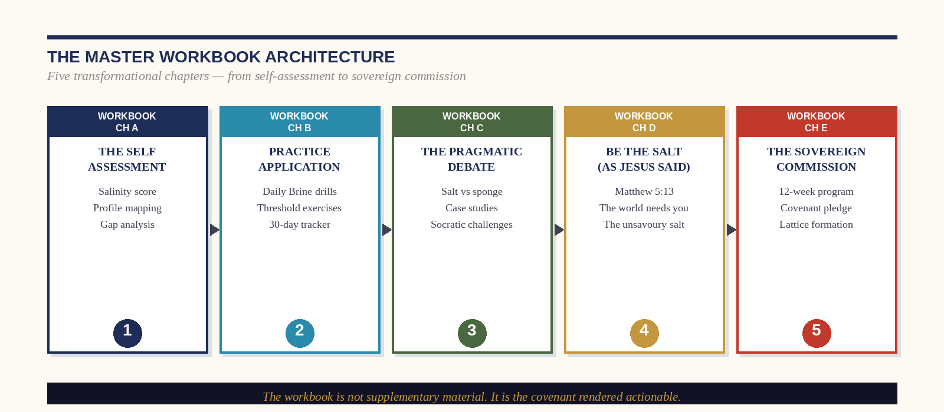
Figure: The Master Workbook Architecture — Five Chapters of Transformation

The Practice Philosophy
The difference between understanding salt and becoming salt is the same as the difference between reading a manual on swimming and entering the water. The theoretical architecture of this book is complete. What remains is the daily, specific, uncomfortable work of implementation. This workbook section provides thirty field drills—organized across the four pillars of the Daily Brine—that operationalize the book’s frameworks into executable daily behaviors.
The drills are sequenced for accumulation: each week builds on the previous. They are not designed to be comfortable. They are designed to be precise—to target the specific mechanisms of sponge behavior and replace them, through repetition and honest review, with mineral ones. Perform them in sequence. Record your experience. Do not skip the ones that feel irrelevant. The ones that feel most irrelevant are typically the ones most needed.

Week One: Lattice Calibration Drills
1. The Pre-Dawn Write — Before your phone is unlocked for the first time each morning, write three sentences: what you believe, what you are committed to, what you will season today. [Daily, 7 days]
2. The Covenant Inventory — List every relationship in your life that you would describe as covenantal rather than transactional. For each, identify one specific action you have taken in the past month that honored the covenant. [Once, Day 3]
3. The Natural Frequency Test — Spend forty-five minutes in complete silence with no inputs. Note what thoughts arise spontaneously. These are data about your actual baseline frequency—the signal beneath the noise. [Once, Day 5]
4. The Purpose Statement — Write, in twenty-five words or fewer, the specific purpose that gives your current season of life its direction. Not a goal. Not a value. A commission: 'I am here to _____ for _____ in this specific context.' [Once, Day 7]

Week Two: Threshold Salting Drills
5. The Pre-Meeting Protocol — Before every meeting or significant conversation this week, spend sixty seconds naming: (a) the ambient frequency I will encounter, (b) the specific response I intend to bring, (c) the value that anchors that response. [Before every meeting, 7 days]
6. The Difficult Conversation Rehearsal — Identify one conversation you have been avoiding. Write exactly what you would say if you were certain it would be received well. Then write what you will actually say—accounting for reality. Notice the gap. The gap is the cost of the antiseptic sting. [Once, Day 10]
7. The Frequency Log — For three consecutive days, note your internal frequency state at three points: morning, midday, and evening. Track what moved it in each direction. Identify the two variables that most reliably deplete your salinity. [3 consecutive days]

Week Three: Antiseptic Purge Drills
8. The Evening Audit — For seven consecutive evenings, spend ten minutes answering: what frequency did I exit today at, and is it mine? What did I absorb that needs releasing? Write it down. Cross it out. This is not journal therapy—it is chemical hygiene. [Daily, 7 evenings]
9. The Silence Map — In your most important professional context, identify the single thing that everyone knows and no one says. Write it down. You do not need to say it yet. Name it first. The naming is the beginning of the antiseptic process. [Once, Week 3]
10. The Repentance Exercise — Identify one specific wrong—professional or personal—that you have been managing rather than reckoning with. Write a complete account of it: what happened, what your role was, what the consequences were for others, and what repair, if any, is available to you. This is not for anyone else's reading. It is for your own interior cleanliness. [Once, Week 3]

Week Four: Mineral Saturation Drills
11. Source Mapping — Map your personal mineral sources in three categories: physical (the specific form of movement that replenishes rather than merely exhausts you), contemplative (the specific practice of silence, scripture, or reflection that calibrates your frequency), and relational (the specific person or community in whose presence you are most fully yourself). [Once, Day 22]
12. The Non-Negotiable Hour — Designate one specific hour in the coming week that belongs entirely to your mineral source. Protect it as you would a board meeting. Note what resistance arises—internal and external—when you attempt to protect it. That resistance is diagnostic. [Once in Week 4]
13. The Lattice Activation — Identify one person in your geographic and professional context who shares your foundational commitments but with whom you have only a surface-level relationship. Take one specific action to deepen that relationship: a direct conversation, a shared meal, an honest question. [Once, Week 4]
▸ 30-DAY PRACTICE COMPLETION REVIEW
At the end of thirty days, answer these three questions:
1. Which drill produced the most unexpected resistance? What does that resistance reveal?
2. Which drill produced the most observable change in your daily experience? What specifically changed?
3. Based on thirty days of practice, revise your Purpose Statement from Drill 4. Has it changed? How?
The answers to these questions are the beginning of your 12-Week Program plan.

WORKBOOK • C

The Pragmatic Debate
Salt vs. Sponge — Challenging the framework through Socratic pressure

Why Debate the Framework
The worst thing that can happen to a powerful idea is that it becomes an unchallenged orthodoxy—a set of claims that its adherents repeat with conviction but never actually stress-test against the strongest available counterarguments. This workbook section subjects the salt framework to exactly that stress-test. The objections raised here are genuine. They have been posed by thoughtful people in every context where this material has been presented: executives, physicians, theologians, educators, and psychologists who have found the framework compelling but not yet complete. Engage with them seriously. The framework that survives Socratic pressure is worth the commitment it demands. The one that does not was always only aesthetics.
POSITION: The Sponge Position: Empathy Requires Absorption
Argument: You cannot genuinely care for another person without allowing their pain to affect you. The 'mineral preservative' model produces emotional distance, not genuine care. The physician who does not feel their patient's suffering is not a healer—they are a technician.
Salt Response: Empathy and absorption are not the same thing. The most effective healers—those with the lowest burnout rates and the highest patient outcomes—are those who maintain precise attunement to their patients' experience without merger. The surgeon's steady hand during a procedure is not indifference to the patient's life. It is the precondition of saving it. The practitioner who has dissolved into the patient's suffering does not help the patient more effectively—they become a second patient.
POSITION: The Pragmatist Position: Covenant Is Naive in a Transactional World
Argument: The covenant model is beautiful in theory and unworkable in practice. Business operates on contracts, not covenants, for good reasons: contracts are enforceable, mutual, and exit-preserving. The leader who offers covenant loyalty in a transactional economy will be exploited by parties who do not share their values.
Salt Response: The evidence does not support this concern. The organizations with the lowest voluntary attrition—and therefore the lowest total cost per productive employee—are consistently those where employees report genuine covenant loyalty from leadership. The individuals with the deepest professional networks, the most durable reputations, and the strongest pricing power are consistently those who have invested in covenant relationships rather than transactional ones. Covenant is not naivety—it is the most sophisticated long-game strategy available.
POSITION: The Therapeutic Position: Radical Honesty Damages Relationships
Argument: The antiseptic sting, as described in this book, will destroy the relationships it is applied to. People do not respond to direct confrontation with growth—they respond with defensiveness, retaliation, and withdrawal. The therapeutic literature on effective feedback consistently recommends the 'feedback sandwich' and other softening approaches for good reason.
Salt Response: The feedback sandwich—positive, negative, positive—is one of the most comprehensively debunked constructs in organizational psychology. The research on effective feedback consistently demonstrates that clarity, specificity, and relational safety produce better outcomes than sugar-coating. The salt framework does not advocate for cruelty or aggression. It advocates for precision and presence: say the true thing, say it clearly, say it from a position of genuine care, and stay in the room. That is not the feedback sandwich. It is the antiseptic sting—and the clinical evidence supports it.
POSITION: The AI Position: Human Salinity Is Temporary Advantage
Argument: The Human Salinity Premium is real today but has a short shelf life. As AI emotional intelligence improves—as models become capable of genuine attunement, nuanced judgment, and relationship depth—the premium will erode. The recommendation to invest in human presence is sound advice for the 2020s, not a long-term strategy.
Salt Response: The argument assumes that covenant—the specific quality that makes human salinity irreducible—is a function of emotional intelligence rather than of moral agency. An AI system can simulate empathy with extraordinary fidelity. It cannot make a commitment it is not programmed to make, honor an obligation it was not designed to honor, or choose, against its own optimization target, to speak an uncomfortable truth to someone it cares about. The irreducibility of salt is not in its warmth. It is in its mineral integrity—its capacity to remain itself regardless of what the substrate demands.

Your Position: A Synthesis Exercise
Having engaged with all four challenges, write your own position statement. Do not merely defend the salt framework—synthesize it. Where does it require qualification? Where are the objectors partially right? Where does the framework's strength lie precisely in its resistance to their most sophisticated challenges?
Q11. In 150 words or fewer: what is the strongest challenge to the salt framework, and how does the framework survive it?
This is not a test of loyalty to the book. It is a test of whether you have genuinely thought with it rather than merely consuming it.

▸ THE DEBATE'S REAL PURPOSE
The Pragmatic Debate is not designed to produce defenders of the salt framework. It is designed to produce practitioners who have tested it honestly enough to commit to it seriously. The covenant that is entered without having genuinely reckoned with its cost is not a covenant—it is an aspiration. The framework that survives your most honest challenge is the one that deserves your most serious commitment.

WORKBOOK • D

Be the Salt
As Jesus Said — Matthew 5:13 and the Oldest Leadership Commission

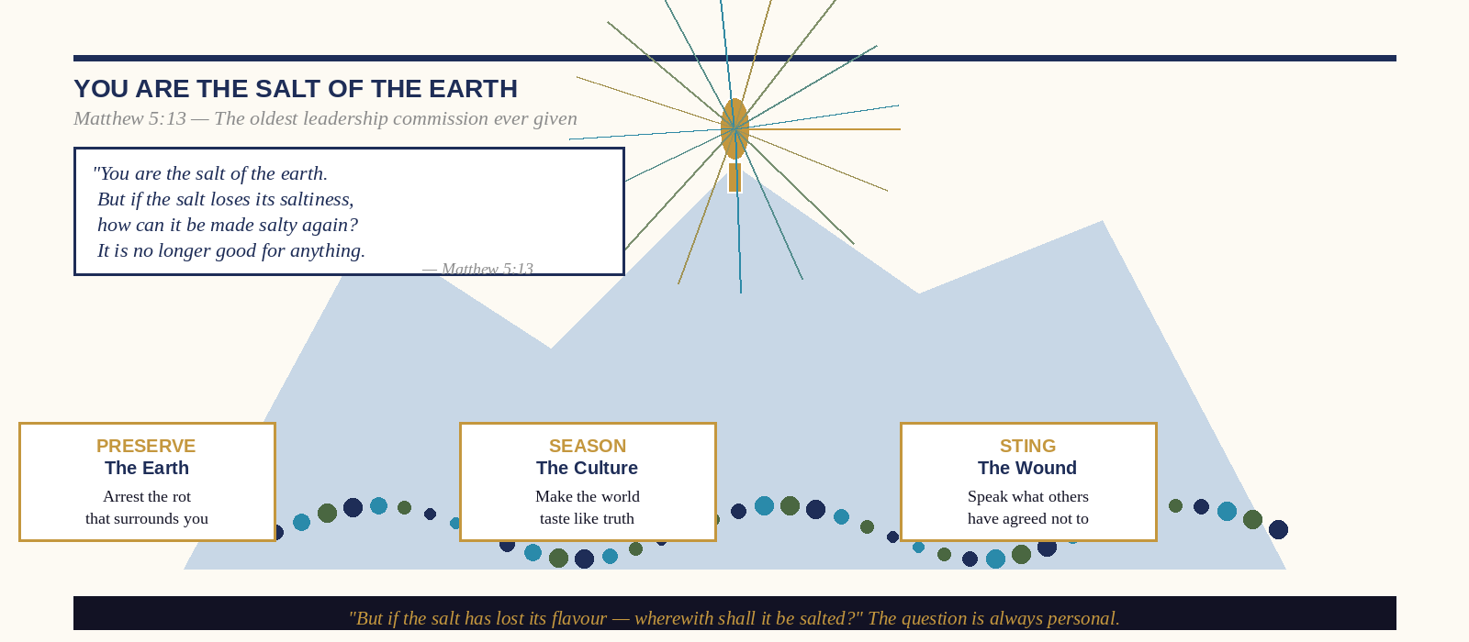
Figure: You Are the Salt of the Earth — The Commission of Matthew 5:13
“You are the salt of the earth. But if the salt loses its saltiness, how can it be made salty again? It is no longer good for anything, except to be thrown out and trampled underfoot.”
— Matthew 5:13, NIV

The Most Demanding Commission in Western History
The Sermon on the Mount is, among other things, the most carefully constructed leadership document in Western civilization. Every sentence is precise. Every image is operational. When Jesus looked at a crowd of fishermen, tax collectors, shepherds, and laborers on a hillside in Galilee and told them that they were the salt of the earth, he was not offering them a compliment. He was issuing a commission—and a warning. The commission was total: not ‘you should consider being salt’ or ‘some of you have salt-like qualities,’ but ‘you are the salt of the earth.’ The present tense is declarative, not aspirational. It describes what they already are, not what they might become. The warning was equally precise: if the salt loses its saltiness, it is no longer good for anything.
The Greek word translated ‘loses its saltiness’ is mōrianthē—derived from the word for ‘fool’ or ‘moron.’ The image is of salt that has become foolish—that has forgotten what it is, that has allowed itself to be diluted, adulterated, or absorbed into its substrate until its mineral integrity is gone. The ancient world’s salt, mined from the shores of the Dead Sea or from rock salt deposits, was frequently impure—mixed with other minerals that could leach out under certain conditions, leaving a compound that looked like salt but performed none of salt’s functions. Tasteless. Powerless. Thrown out. Trampled. The warning is not that you will be punished for losing your saltiness. It is that you will become useless. Which is, in the context of a commission to season the world, a more devastating outcome than punishment.

The Theological Anatomy of the Salt Commission

Saltiness as Identity, Not Achievement
The commission’s first and most structurally important element is its ontological rather than behavioral framing. Jesus does not say ‘act like salt’ or ‘try to produce salt-like effects’ or ‘develop the qualities of salt in your character.’ He says ‘you are.’ This is not a demand for performance. It is a declaration of identity. The salt practitioner’s task is not to become something new—it is to be, with full and undiluted commitment, what they already are. The most dangerous thing that can happen to a person who is salt is not that they fail to perform their function. It is that they forget what they are. The saltiness is already there. The question is whether they will let it be removed.

The Three Functions in the Sermon's Context
Preservation, the antiseptic sting, and flavor are not impositions on the Matthew 5:13 text—they are its natural content. The crowd Jesus was addressing lived in a world where salt's three functions were not metaphors but daily material realities. The fisherman in the front row had salted fish that morning. The farmer beside him had dressed an open wound with brine the previous week. The woman at the edge of the crowd had salt on her table for the Sabbath meal. When Jesus told them they were the salt of the earth, they heard all three functions simultaneously: you are what prevents the world's decay, what heals its infections, what makes its existence worth tasting.

The Unsavory Salt: The Specific Warning
The phrase ‘lost its saltiness’ describes a specific pathology that this book has been diagnosing throughout its pages under different names: the Absorbent Personality Syndrome, Environmental Down-Synchronization, identity foreclosure, the Nostalgia Trap, the porous ego. They are all descriptions of the same phenomenon: salt that has been so thoroughly saturated by its medium that it can no longer alter it. The Gospels are making a social and psychological observation that the neuroscience of the twenty-first century has confirmed: the practitioner who does not actively maintain their mineral integrity will, with statistical inevitability, lose it. Not in a single dramatic crisis but through the accumulated weight of small accommodations, gentle compromises, and the ordinary social pressure of an environment that rewards conformity.

Practical Application: The Seven Commissions of Matthew 5:13
01 Salt Your Immediate Context First
The commission is to the earth—which is to say, to everywhere. But salt does not season the whole ocean from a single shaker. It seasons whatever it comes into direct contact with. Your immediate obligation is to the specific context—the specific organization, family, neighborhood, classroom, clinic, or congregation—that your daily presence actually touches. Begin there. Season it thoroughly. The ocean can wait.
02 Identify the Specific Decay You Are Positioned to Arrest
The preservation function requires diagnosis before application. What, specifically, in your immediate context is decaying? Not the general cultural decline that fills your feed, but the specific thing in your specific domain that is getting worse because no one is salting it. Name it with the precision of a physician naming a pathology. The named decay can be addressed. The unnamed one spreads.
03 Find the Wound That Needs the Sting
The antiseptic function requires the courage to locate and enter the specific wound that your context has been avoiding. Every organization has one. Every family has one. Every civic institution has one. The wound is usually not secret—it is simply untreated, because the treatment hurts and the people responsible for it have decided, collectively and without explicit agreement, that avoidance is preferable to healing. You are the salt. The wound is not asking your permission. It is waiting for your courage.
04 Make Your Presence Worth Tasting
The flavor function is the most neglected and the most subversive. You do not need a crisis, a confrontation, or a structural intervention to season a room. You need only to be fully, distinctively, unsuppressedly present in it. The practitioner whose humor is genuinely theirs, whose intellectual curiosity is genuinely theirs, whose warmth is genuinely theirs—who has not averaged these qualities down to the room’s median—makes the room taste different. This is not performance. It is the refusal to perform the room’s version of yourself when your own version is more nourishing.
▸ MATTHEW 5:13 — The Practitioner's Daily Commission
Every morning, before the first external input:
Read Matthew 5:13 aloud.
Ask: In what specific way am I the salt of the earth today—in this specific context, with these specific people, facing this specific condition?
Answer with a specific act: one preservation, one sting, one flavoring.
Note at the end of the day: Did I season the world I entered? Or did the world season me?

CHAPTER TWENTY-NINE

How to Protect Your Home
A Tactical Manual for the Digital Age
“Every fortress has a perimeter. Every perimeter must be maintained. Every breach must be repaired. This is not paranoia. It is architecture.”
— Dr. Ishmael Amu
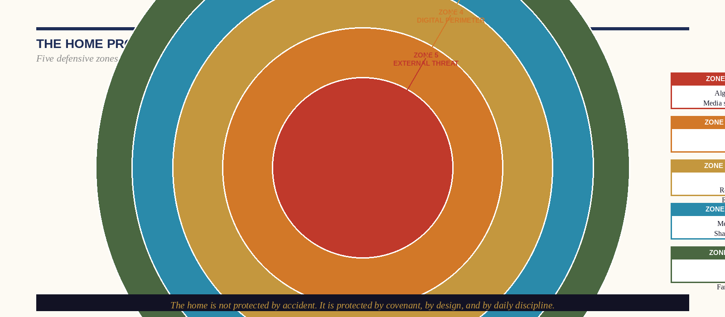
Figure: The Home Protection Matrix — Five Defensive Zones

The Threat Model
Before building any defense, a competent security architect begins with a threat model: a precise identification of the specific threats being defended against, ranked by probability of occurrence and severity of potential damage. The fortress that is defended against imaginary threats while remaining open to actual ones has not been protected—it has been expensively distracted.
The threat model for the contemporary family home is not complex, but it requires the courage of honest naming. The threats are not primarily external in the conventional sense—not strangers, not criminals, not foreign influence in any conspiratorial form. The threats are structural, and they enter through the devices that every member of the household carries voluntarily. They are: the algorithm's colonization of attention, which produces presence depletion and technoference; the peer group's colonization of values, which produces identity foreclosure in adolescents; and the ambient cultural narrative's colonization of aspiration, which produces the substitution of consumption for formation in every age group. These threats are not theoretical. They are quantified, longitudinal, and replicable across demographics and geographies. And the home that has not consciously addressed them has not been protected from them by default. It has been opened to them by omission.

Zone-by-Zone Defense Protocol

Zone 5: The External Threat Buffer
The external threat cannot be eliminated—the family must engage with the world, and the world contains the algorithm, the peer group, and the cultural narrative. The Zone 5 defense is not a wall against engagement. It is a preparation for it: the deliberate cultivation, within the home, of the internal resources—identity clarity, values depth, relational security—that allow the household's members to engage with external forces without being consumed by them. The Zone 5 defense is built inside, not at the boundary.

Zone 4: The Digital Perimeter
The Zone 4 defense is the most practically actionable and the most frequently ignored. It consists of specific, technical, environmental modifications to the household's digital infrastructure that reduce the algorithm's access to the household's attention without requiring constant volitional self-restraint. These modifications include: router-level content filtering that removes the most algorithmically hostile platforms from the home network entirely; device configuration that removes social media applications from common areas and shared devices; a physical device-deposit location at the home's threshold; and the elimination of screens from bedrooms as the single most evidence-supported modification available. These are not preferences. They are architectural changes with documented developmental outcomes.
The research on bedroom screens is unambiguous: adolescents with screens in their bedrooms sleep an average of forty minutes less per night than those without, perform significantly worse academically, report significantly higher rates of depression and anxiety, and demonstrate significantly more difficulty with executive function and impulse control. Forty minutes of sleep, sustained over the course of an adolescent's developmental years, is not a minor inconvenience. It is a structural developmental impairment. The Zone 4 defense removes the screen from the bedroom not because the adolescent cannot be trusted but because the architect does not rely on the occupant's willpower to maintain the structural integrity of the building.

Zone 3: The Social Threshold
The Zone 3 defense is the family's management of the social inputs that cross its threshold—not through isolation or the cultivation of insularity, but through the conscious cultivation of a social network that reinforces rather than erodes the family's foundational commitments. In practical terms, this means investing deliberately in relationships with other families who share the household's values, creating shared practices and rituals with these families that provide the social belonging that adolescents require without requiring the platform-mediated peer culture as its primary source, and establishing clear household norms about the character of the social environments the household's members will enter—not prohibitively, but explicitly.

Zone 2: The Domestic Rhythm
The Zone 2 defense is the family's internal temporal architecture: the rhythms, routines, and liturgical practices that create the experience of domestic life as purposeful, meaningful, and structurally different from the external world. The three rhythms of Chapter Nineteen—the Threshold Covenant, the Liturgy of Bread and Salt, and the Analog Sabbath—constitute the Zone 2 infrastructure. They are the home's internal clock, the mechanism by which it produces, for its inhabitants, the experience of time as ordered rather than chaotic, meaningful rather than merely consumed.

Zone 1: The Covenant Core
The Zone 1 defense is the family covenant itself: the explicit, shared, written articulation of what the household is committed to that will not change when the external conditions change. Every family has a culture—a set of implicit values, norms, and commitments that govern its members' behavior. Most families have never articulated that culture explicitly. The Family Covenant Charter is the act of making the implicit explicit: writing down what the family actually believes, how it actually intends to treat its members and its neighbors, what it considers non-negotiable, and what it aspires to be for the world beyond its walls.
▸ THE FAMILY COVENANT CHARTER — Template
Complete the following as a family, in a family meeting, with every member present and contributing:
WE BELIEVE: ______________________________________
WE ARE COMMITTED TO: ______________________________________
WE PROTECT EACH OTHER BY: ______________________________________
WE TREAT PEOPLE OUTSIDE OUR HOME WITH: ______________________________________
WE WILL NOT COMPROMISE ON: ______________________________________
WE RETURN TO THE SOURCE BY: ______________________________________
WE REVIEW THIS CHARTER: [quarterly / annually] on: ______
Signed: _________________________ Date: _____________

CHAPTER THIRTY

The Future of Artificial Intelligence
What Salt Means When the Machine Can Do Everything Else
“The question is not whether the machine will surpass us. It is whether we will have maintained enough of ourselves to remain worth surpassing.”
— Dr. Ishmael Amu
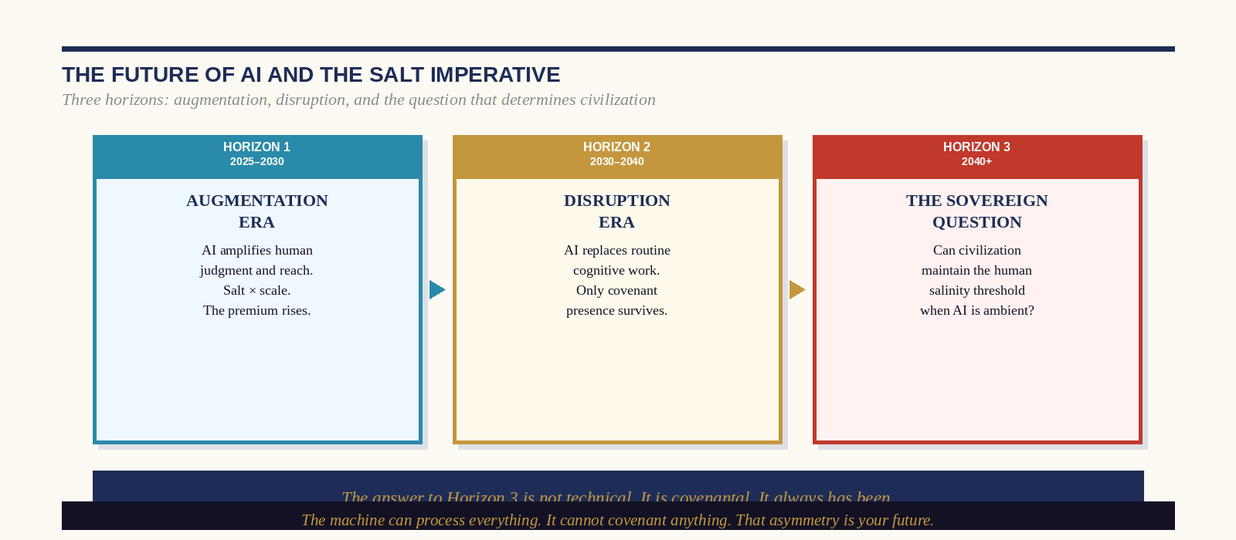
Figure: The Future of AI and the Salt Imperative — Three Horizons

The Three Horizons of the AI Era
We are, at the time of this book’s writing, at the early stages of Horizon 1: the Augmentation Era. The tools available—large language models, generative AI, agentic systems capable of executing complex multi-step tasks—are extraordinary amplifiers of human capacity. The physician who uses AI to analyze imaging with superhuman accuracy and then applies their own clinical judgment and human presence to the consultation is operating at a level of integrated effectiveness that neither the AI nor the human physician could achieve alone. This is the formula: Legacy = ∫ Human Salt(t) × AI Scale(t) dt.
The challenge of Horizon 1 is not the technology—it is the human response to it. Organizations that are using AI to amplify their existing human salinity will emerge from this horizon stronger than they entered it. Organizations that are using AI to replace human salinity—to eliminate the covenant relationships, the principled leadership, and the irreplaceable human encounters that constitute their actual value—will emerge from this horizon holding a very efficient engine with nothing worth scaling. The AI question is always a human question first.

Horizon 2: The Disruption Era (2030–2040)
The Disruption Era will not announce itself with a single transformative event. It will arrive, as all fundamental disruptions arrive, through the accumulated weight of specific capability thresholds being crossed: the moment when AI-assisted diagnosis outperforms the average specialist across all major disease categories; the moment when AI-generated legal analysis outperforms the average associate across standard contract review; the moment when AI-managed financial portfolios outperform the average wealth manager across standard risk profiles. Each of these thresholds has a name, a timeline, and a significant body of research behind it. They are not speculative.
The practitioners who are safe in Horizon 2 are not those whose skills have not yet been automated. They are those whose value was never primarily located in their skills. The physician whose value is primarily diagnostic accuracy is vulnerable in Horizon 2. The physician whose value is the quality of the human encounter—the specific quality of presence and covenant that makes the patient feel genuinely seen, that produces the compliance and trust and honest communication that determines clinical outcomes beyond diagnosis—is not vulnerable. The algorithm cannot own that. It cannot even simulate it in a way that the patient's autonomic nervous system registers as safe.

Horizon 3: The Sovereign Question (2040+)
Horizon 3 poses the question that determines the long-term trajectory of the species: Can civilization maintain the human salinity threshold when AI is ambient? When every cognitive task, every creative task, and every analytical task can be performed by a system that is faster, cheaper, and more reliable than the human being performing it—what remains of the human being’s role? What is the person for?
The salt framework's answer is not comforting in the way that technological optimism is comforting. It does not promise that human beings will remain economically essential. It does not promise that the transition will be equitable or that its benefits will be evenly distributed. What it promises is structurally more important: the covenant—the specific, irreducible human capacity for irrevocable commitment, for moral agency that overrides optimization, for the choice to speak an uncomfortable truth to someone you love at personal cost—is not automatable. Not because the technology has not advanced far enough, but because it is, by definition, a function of free will. An AI that is programmed to make unconditional commitments has not made them. A human being who chooses to has made the only kind that exist.
The answer to Horizon 3 is not technical. It is covenantal. The civilization that arrives at the ambient AI era with its human covenant infrastructure intact—its families bonded by genuine commitment, its institutions led by genuine principle, its civic life structured by genuine relationships—will navigate that era as humans navigating a powerful tool. The civilization that arrives at that era having automated its covenants along with its cognitive labor will have produced, with extraordinary efficiency, a world that has no use for the humans in it.
▸ THE AI COVENANT IMPERATIVE — Five Non-Negotiable Human Functions
Across all three horizons, these five functions remain irreducibly human:
1. COVENANT-MAKING: The unconditional commitment that does not depend on optimization.
2. ANTISEPTIC HONESTY: The choice to speak truth that serves the other at cost to the self.
3. PRESENCE: The quality of human attention that the nervous system registers as safety.
4. MORAL AGENCY: The capacity to override one's own optimization function for a principle.
5. FLAVOR: The specific, unreplicable quality of one who has become, through suffering and covenant, genuinely themselves.
These are not arguments for human supremacy. They are a description of what the salt does that the machine cannot.

CHAPTER THIRTY-ONE

The Human Condition
A Psychological Assessment and Therapeutic Framework
“The person who knows what they are cannot be told what they are. The person who does not know what they are will believe anyone who tells them.”
— Dr. Ishmael Amu
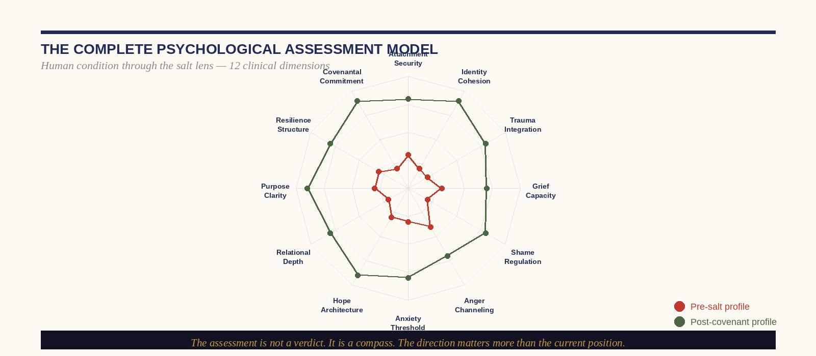
Figure: The Complete Psychological Assessment Model — 12 Clinical Dimensions

A Clinical Portrait of the Saltless Mind
The psychiatric emergency department at any major urban hospital on a Saturday night is, among other things, a clinical portrait of the saltless society: the accumulated human cost of the porous ego—of identity without anchor, relationship without covenant, aspiration without direction, and pain without a framework for its integration. This observation is not intended to pathologize ordinary suffering. Human suffering is ordinary, and the individuals in that emergency department are not failures. They are the casualties of structural conditions—of families without thresholds, communities without lattices, institutions without salt—that this book has been diagnosing throughout its pages.
The clinical salt framework does not replace conventional psychiatric and psychological care. It provides a meta-framework for understanding the human condition—a set of structural descriptions of what health and pathology look like when viewed through the lens of mineral integrity rather than symptom clusters. The twelve dimensions of the Salinity Assessment map onto the clinical literature with precision, but they organize that literature around a different organizing principle than the DSM: not ‘what is wrong with this person’ but ‘what is the structure of their relationship with their own identity, and how does that structure produce their specific pattern of suffering or flourishing?

The Twelve Clinical Dimensions: Therapeutic Applications

Dimension 1 & 2: Attachment Security and Identity Cohesion
These two dimensions are functionally inseparable. Attachment security—the felt sense that one is unconditionally valued by at least one significant other, independent of performance—is the developmental foundation of identity cohesion. The person who did not receive adequate attachment security in their developmental years builds their identity around a fundamental uncertainty: Am I worth valuing? This uncertainty generates the specific behavioral adaptations that the clinical literature has described as anxious, avoidant, or disorganized attachment—and that the salt framework describes as the porous ego’s developmental origin.
The therapeutic work for these dimensions is not primarily cognitive—it is relational. The practitioner who has a secure therapeutic relationship, a covenantal community, or even one deep friendship that provides consistent, non-contingent regard is in the process of receiving the developmental provision that was missed or inadequate earlier. The covenant relationship is not merely a nice feature of a good life. For the practitioner with low attachment security, it is a clinical necessity.

Dimension 3 & 4: Trauma Integration and Grief Capacity
Unintegrated trauma and unprocessed grief are the two most common mechanisms by which the porous ego is produced in people who had adequate early attachment. The traumatic event or the catastrophic loss disrupts the cohesive self at the moment of greatest vulnerability, and if the disruption occurs without adequate support, without the social permission to process it fully, or without the frameworks that allow it to be metabolized into something meaningful, it becomes the organizing principle of a new and diminished identity.
The clinical salt approach to both dimensions is identical: the wound must be packed with truth rather than covered with management. For trauma, this means the direct and supported encounter with the specific memory and its emotional content—not in a way that retraumatizes, but in a way that allows the nervous system to process what was too overwhelming to process at the time of the event. For grief, it means the full permission to experience the loss without premature reframing, followed by the extraction of what was genuinely valuable from the relationship or experience that was lost.

Dimension 5 & 6: Shame Regulation and Anger Channeling
Shame and anger are the two most destructive emotional forces in the human psyche when they are unregulated, and the two most generative when they are metabolized and channeled. Shame—the experience of being fundamentally defective rather than merely having made a mistake—is the direct enemy of identity cohesion: it attacks the self at the level of its existence rather than its behavior. The salt treatment for shame is radical self-honesty combined with the experience of being received without condemnation by at least one other person who has heard the full account. This is not absolution—it is the clinical mechanism by which the abscess of shame is drained.
Anger, channeled through the antiseptic function, is one of the most powerful forces available to the salt practitioner. The anger that says ‘this institution’s decay is not acceptable and I will not normalize it’ is productive, directed, and covenantally grounded. The anger that is unfocused, accumulated, and discharged randomly is simply the contamination of the Medium—the substrate absorbing the practitioner’s depletion rather than receiving their salt.

Dimensions 7–12: The Full Spectrum
Anxiety, hope, relational depth, purpose clarity, resilience structure, and covenantal commitment form the upper half of the twelve-dimension model—the dimensions that distinguish the practitioner who is functioning at a mineral level from the one who is merely managing. The therapeutic work for these dimensions is less about healing injury than about building infrastructure: the specific practices, relationships, and disciplines that make these qualities structurally available rather than mood-dependent. The practitioner who experiences deep relational connection only when circumstances are favorable has not built the infrastructure. They have been lucky. The practitioner who has built the infrastructure experiences these qualities as structural—as the background condition of their life rather than its occasional feature.
▸ THE CLINICAL SALT FRAMEWORK — Therapeutic Sequence
The therapeutic sequence for the practitioner working through the twelve dimensions follows the logic of wound-packing:
1. STABILIZE (Dimensions 1–2): Establish the attachment and identity foundation before any other work.
2. PROCESS (Dimensions 3–4): Complete the unfinished business of trauma and grief.
3. REGULATE (Dimensions 5–6): Convert shame and anger from destructive to generative forces.
4. BUILD (Dimensions 7–12): Construct the upper-level infrastructure that makes salt sustainable.
Skipping sequence steps—attempting to build purpose clarity before processing grief, or channeling anger before regulating shame—produces impressive-looking structures on inadequate foundations. Build in sequence.

CHAPTER THIRTY-TWO

Covenant Communication
Therapy on Relationships — How to Talk to People You Love
“The most courageous act available to any human being is the complete sentence spoken to the person who matters most.”
— Dr. Ishmael Amu
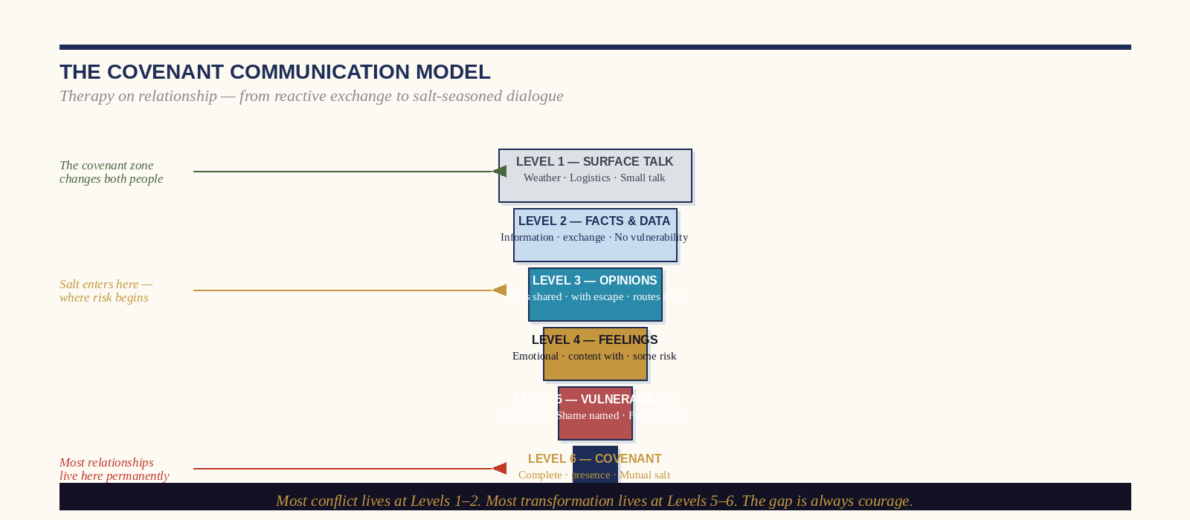
Figure: The Covenant Communication Model — Six Levels from Surface Talk to Full Presence

The Crisis of Managed Conversation
Most human beings, in most of their most important relationships, are not actually talking to each other. They are managing each other—performing the social rituals of conversation while systematically avoiding the specific content that would produce genuine encounter, genuine change, or genuine intimacy. The managed conversation is identifiable by its primary navigational principle, which is not ‘what does this person need to hear’ or ‘what is true’ but ‘what can I say that will not upset the current equilibrium?’ The managed conversation is the conversational equivalent of the Empathy Sponge: it absorbs and reflects the ambient emotional climate without ever introducing the mineral that would change it.
The research on relationship quality is unambiguous about the cost of managed conversation: the couples with the highest rates of relationship dissolution are not those who fight most—they are those who avoid conflict most systematically. The Gottman Institute’s longitudinal research on relationship stability has repeatedly found that contempt and stonewalling—not conflict—are the primary predictors of dissolution. The relationship that cannot tolerate the antiseptic sting of honest disagreement is not a healthy relationship under temporary stress. It is a relationship organized around avoidance, and avoidance is the mechanism of rot.

The Six Levels of Covenant Communication
The six levels described in the illustration are not stages that every conversation must traverse—they are a map of the depth at which communication is occurring and the quality of encounter that each level makes possible. Most relationships live permanently at Levels 1 and 2. Most breakthroughs, genuine reconciliations, and relational transformations occur at Levels 5 and 6. The movement between levels is not automatic—it requires specific skills, specific courage, and the specific safety that covenant relationships provide.

Moving from Level 2 to Level 3: The Opinion Threshold
The first significant movement in depth requires only one specific skill: the willingness to say what you actually think rather than what you believe the other person wants to hear. This sounds trivially simple. It is not. The social conditioning against genuine opinion-sharing in close relationships is powerful and runs deep. The person who has learned, in their family of origin or in previous relationships, that their genuine opinions produce conflict, rejection, or punishment has often developed the habit of perpetual Level 2 communication as a survival adaptation. The therapeutic work for this transition is not persuasion—it is the building of sufficient relational safety, through repeated experiences of genuine opinions being received without negative consequence, to make the risk worth taking.

Moving from Level 3 to Level 4: The Feelings Threshold
The feelings threshold is the most culturally loaded in Western professional contexts. Men in particular have been systematically trained—by the culture’s construction of professional competence as the absence of visible emotional life—to experience the expression of feeling in important conversations as evidence of weakness or irrationality. This training is, from the perspective of both the neuroscience of effective communication and the clinical research on relationship quality, exactly wrong. The conversation that includes genuine emotional content is not less rational than the one that excludes it. It is more accurate—because the emotional content is real, and its exclusion from the conversation produces a gap between the conversation and the reality it is supposed to be describing.

Moving from Level 4 to Level 5: The Vulnerability Threshold
The vulnerability threshold is where the covenant relationship earns its name. The movement to Level 5 requires the specific experience of having been received at Level 4 without judgment or withdrawal—the experience that the other person’s presence does not depend on the management of your emotional content. This experience, when it occurs in a relationship, is one of the most structurally transformative events available to the human being: it updates the nervous system’s prediction that genuine self-expression produces rejection. It provides, in adulthood, the corrective relational experience that attachment security was supposed to provide in childhood. The covenant relationship is not merely a pleasant feature of a flourishing life. For many people, it is the therapeutic mechanism of their deepest healing.

Level 6: The Covenant Communication
Level 6 communication is not a technique. It is a state—the state of complete mutual presence that occurs, rarely and without engineering, between two people who have been in genuine covenant with each other long enough to have passed through the lower levels together, to have been received at their most vulnerable, and to have found that the relationship survived and deepened. It cannot be produced on demand. It can be made more likely by the deliberate cultivation of the conditions—the protected time, the honest conversation, the shared practice—that produce it. It is worth every investment that goes into those conditions.
▸ THE COVENANT CONVERSATION PROTOCOL — Five Practices
1. BEGIN WITH THE LEVEL CHECK: Before a significant conversation, ask yourself honestly: what level do I intend to speak at? What level is this person able to receive at, right now? Meet them where they are and lead one level deeper.
2. USE THE SALT OPENER: Instead of 'We need to talk' (which activates threat responses), try: 'There's something I want to share with you that I've been carrying. I'm not looking for you to fix it—I just want you to know it.' This is threshold salting for conversation.
3. SAY THE SPECIFIC THING: The managed conversation uses generalities to avoid specifics. Salt uses specifics. 'I feel somewhat disconnected lately' is Level 2. 'When you checked your phone at dinner three times last Tuesday while I was talking, I felt like I wasn't worth your attention, and that stays with me' is Level 4.
4. RECEIVE WITHOUT FIXING: When the other person speaks from Level 4 or 5, the primary obligation is not to solve, reframe, or make better. It is to receive. Say: 'I hear that. Thank you for telling me.' Then wait.
5. CLOSE WITH COVENANT: End significant conversations with a specific, forward-looking commitment. Not 'I'll try to be better' but 'Next Tuesday, I'm putting my phone in the car before dinner. That's my covenant to you about this.'

CHAPTER THIRTY-THREE

The Architecture of Collaboration
How Salt-Saturated Teams Build Differently
“A transactional team performs the task. A covenant team transforms the organization. The difference is not talent. It is trust architecture.”
— Dr. Ishmael Amu
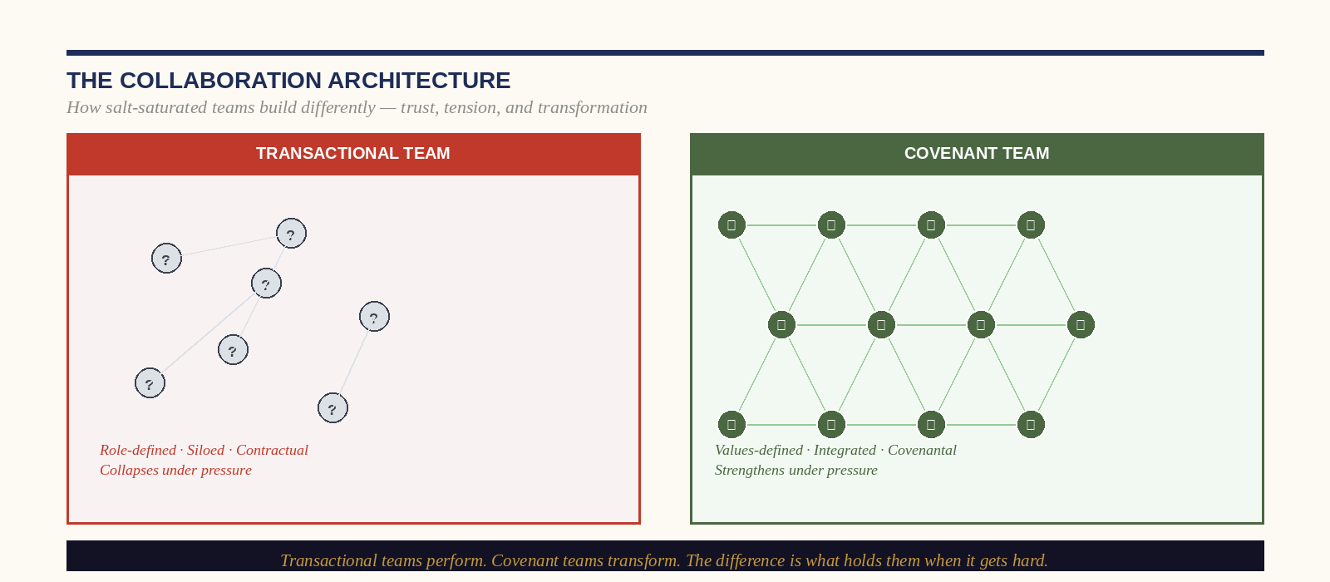
Figure: The Collaboration Architecture — Transactional Team vs. Covenant Team

Why Most Teams Never Become More Than the Sum of Their Parts
The organizational psychology of team performance has produced, over the past four decades, one finding of extraordinary consistency: the most important variable in team effectiveness is not individual talent, not role definition, not incentive structure, not leadership style, and not organizational resource. It is psychological safety—the shared belief, among team members, that the team is safe for interpersonal risk-taking: that speaking up, offering an unpopular view, admitting uncertainty, or naming a problem will not produce punishment, ridicule, or exclusion. Amy Edmondson’s research at Harvard Business School, first published in 1999 and replicated dozens of times since in every conceivable organizational context, is unambiguous on this point.
What the salt framework adds to Edmondson’s insight is the structural explanation for why psychological safety is so rare: it cannot be produced by policy, by team-building exercises, or by leadership mandates. It is produced by the repeated experience of covenantal behavior—of being received honestly, of having one’s mistakes met with genuine curiosity rather than defensive retaliation, of witnessing the leader deliver the antiseptic sting without shame and receive it without collapse. Psychological safety is not a feeling that organizations manufacture. It is the residue of accumulated covenantal interactions. It is, in the precise sense, the flavor that salt-saturated teams produce.

The Five Behaviors of Salt-Saturated Collaboration
01 Covenant Before Contract
The salt-saturated team begins every significant collaboration with an explicit covenant conversation: not merely role definitions and deliverable timelines, but a shared articulation of the values that will govern the collaboration when it gets difficult. How will we handle disagreement? How will we name problems? What are our non-negotiable standards? What do we owe each other that is not in the project brief? This conversation feels premature—even artificial—before the collaboration has encountered difficulty. It is most needed precisely before it has, because the covenant that is articulated before the crisis is the one that holds during it.
02 The Productive Disagreement Protocol
The salt-saturated team does not suppress conflict. It practices what the organizational psychologist Roger Schwarz calls the mutual learning mindset: a set of assumptions—I may be wrong, you may be right, we are both more likely to get to the right answer together than separately—that transform disagreement from a social threat into a cognitive resource. The specific practice is: state your position and the reasoning behind it explicitly, invite the explicit statement of the opposing position and its reasoning, identify the specific factual or interpretive difference that underlies the disagreement, and resolve it—if possible—at the level of evidence rather than authority. When resolution is not possible, name the disagreement explicitly, make the decision that must be made, and maintain the relationship.
03 The Antiseptic Debrief
The salt-saturated team performs a regular, structured examination of what is not working—before the not-working has become a crisis. The antiseptic debrief is not a complaint session and it is not a performance review. It is a brief, specific, forward-oriented examination of three questions: What, in this collaboration, is working well and should be protected? What is not working and needs to change? And—the question that most debrief processes omit—what are we not saying to each other that we need to say? The third question is the antiseptic. It is the one that locates the wound before it goes septic.
04 Cross-Boundary Relationship Investment
The ionic lattice’s structural strength comes from the diversity of its bonds—from the fact that each ion is held not by a single bond to a single partner but by multiple bonds to multiple partners in multiple directions. The salt-saturated team invests deliberately in relationships that cross the collaboration’s internal boundaries: the engineer who makes the investment of understanding the customer’s experience, the clinician who invests in understanding the administrator’s constraints, the creative director who invests in understanding the financial analyst’s concerns. These cross-boundary relationships are not merely interpersonal pleasantries. They are the mechanism by which the collaboration’s most important non-obvious connections are made—and by which the collaboration’s most significant blind spots are illuminated.
05 The Covenant Close
Every significant collaboration ends with a deliberate act of covenantal acknowledgment: a specific, honest articulation of what this collaboration produced that would not have been possible without each specific participant’s distinctive contribution, and a specific, forward-oriented commitment about how the relationships formed in this collaboration will be maintained. The covenant close is not a formality. It is the act that converts a project into a lattice node—that transforms a temporary collaboration into a permanent relationship in the social network of the practitioner’s professional world. The collaborations that end without this close dissolve. The ones that end with it become part of the rock.

CHAPTER THIRTY-FOUR

The Anti-Burnout Architecture
Managing the Mineral Reserve
“The shaker that is never refilled dispenses its last grain in an ordinary moment, to an ordinary request, with no dramatic announcement that it is now empty.”
— Dr. Ishmael Amu
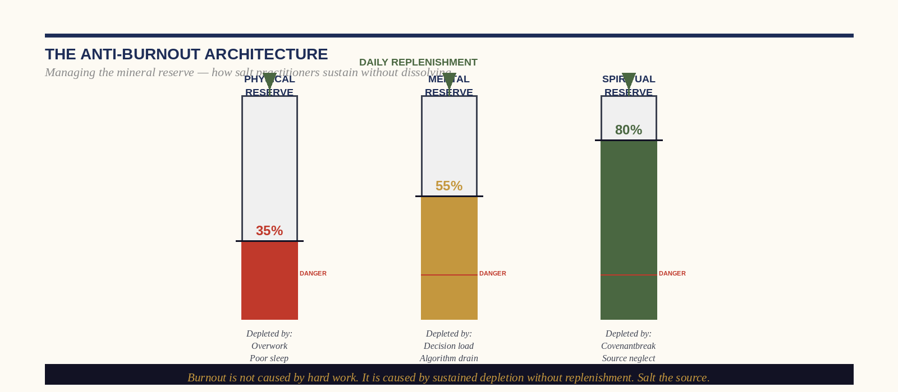
Figure: The Anti-Burnout Architecture — Three Reserve Tanks and the Danger Zone

The Anatomy of Burnout: What It Actually Is
Burnout is not tiredness. This distinction is more important than it might initially appear, because the interventions for tiredness—rest, recreation, vacation—do not address burnout, and the practitioner who treats their burnout as tiredness will return from their rest period to the same depleted state, often with the additional burden of guilt about their failure to be restored by a rest they ‘should’ have found sufficient. The confusion between burnout and tiredness is itself a symptom of the problem: the practitioner who cannot distinguish between them has lost contact with their own internal states—a diagnostic indicator of advanced depletion.
Burnout, as the psychologist Christina Maslach defined it in her foundational research, is a syndrome of three components: emotional exhaustion (the depletion of the emotional resources required for engagement with one’s work), depersonalization (the development of a cynical, detached, or dehumanizing orientation toward the people one’s work serves), and reduced personal accomplishment (the feeling that one’s work no longer produces meaningful outcomes). All three components are recognizable in the salt framework’s language: emotional exhaustion is the depleted shaker; depersonalization is the sponge that has been squeezed past the point of absorption and is now simply deflecting; and reduced personal accomplishment is the mineral preservative that has been dissolved into its substrate and can no longer detect the difference between itself and the medium it is trying to season.

The Three Reserve Tanks and Why They Deplete Differently

The Physical Reserve
The physical reserve is the most measurable and the most neglected. Sleep deprivation among high-performing professionals is not a side effect of their work—it is frequently a perverse badge of honor, a signal of commitment that the organizational culture tacitly rewards. The research on sleep and cognitive performance is unambiguous: eighteen hours of sustained wakefulness produces cognitive impairment equivalent to a blood alcohol level of 0.05 percent. Twenty-four hours produces impairment equivalent to 0.10 percent—legally drunk in most jurisdictions. The executive making complex decisions on four hours of sleep is not making decisions with impaired judgment as a regrettable side effect of dedication. They are making decisions in a state that, in any other context, would be considered legally impaired.
The physical reserve is replenished through sleep, movement, and nutrition—the three physiological needs that are chronically under-resourced in high-performance organizational cultures and chronically over-optimized in wellness industry products. The prescription is not complex: seven to nine hours of sleep per night, a form of physical exertion that produces genuine cardiovascular demand three to five times per week, and a nutritional approach that prioritizes adequate protein and micronutrient density over caloric restriction or dietary complexity. These are not lifestyle suggestions. For the practitioner operating at the level of sustained principled engagement this book describes, they are the minimum physiological infrastructure of that engagement.

The Mental Reserve
The mental reserve is depleted by decision load, cognitive switching, algorithmic stimulus, and the sustained absence of genuine cognitive rest. The practitioner who makes forty consequential decisions before noon, switches between fourteen digital contexts per hour, and consumes four hours of news and social media content each evening is not resting their mental reserve during their non-working hours. They are depleting it with a different set of inputs. The mental reserve is replenished by sustained, non-stimulated silence—the specific neurological state in which the default mode network can perform its consolidation and integration functions. This is the state of apparent ‘doing nothing’ that the contemporary productivity culture most systematically eliminates and that the neuroscience of mental performance most urgently recommends.

The Spiritual Reserve
The spiritual reserve is the deepest and the most slowly depleted—and the most catastrophic when it empties. It is the practitioner’s connection to the source that gives their work its meaning beyond its transactional outputs: the covenant, the calling, the relationship with the permanent that does not fluctuate with the organization’s quarterly results or the political environment’s current temperature. The practitioner whose spiritual reserve is full can absorb significant depletion in the physical and mental reserves and remain recognizably themselves. The practitioner whose spiritual reserve has emptied—who has lost contact with the deep covenantal foundation of their work and is operating purely on professional obligation and social expectation—is experiencing the specific form of burnout that no amount of physical rest or cognitive decompression will address. They need to return to the source.
▸ THE ANTI-BURNOUT PROTOCOL — Daily, Weekly, Quarterly
DAILY MAINTENANCE (all three tanks):
• Physical: 7+ hours sleep, non-negotiable. 20 minutes minimum physical movement.
• Mental: One 20-minute window of complete non-stimulated silence. No inputs.
• Spiritual: The Daily Brine’s Lattice Calibration and Mineral Saturation pillars.
WEEKLY RESTORATION:
• Physical: One longer form of physical exertion (60+ minutes).
• Mental: The Analog Sabbath—one half-day without digital input.
• Spiritual: Return to the specific covenantal community. Do not skip this.
QUARTERLY RESERVOIR CHECK:
• Assess all three reserve levels honestly. Identify which is nearest the danger zone.
• One deliberate extended restoration practice focused on that specific reserve.
• Review your Salinity Assessment. If any dimension has declined, identify the mechanism and address it.

The Specific Warning Signs: When to Stop Before the Shaker Empties
The practitioner who has internalized the anti-burnout architecture will develop, over time, the capacity to read their own depletion before it reaches the crisis threshold. The early warning signs are specific and recognizable: a persistent inability to access the specific emotional states—curiosity, warmth, principled indignation—that characterize their salted presence; a growing difficulty distinguishing between the environments they are entering and the frequency they brought to them; an increasing reliance on performance—on the social role and professional persona—rather than genuine presence in their most important interactions; and a loss of the specific flavor that makes their presence in a room qualitatively distinctive.
When these signs appear, the correct response is not to push through. It is to stop—to return to the source before the shaker empties, because the shaker that empties in the middle of the most important conversation of the year does not announce its emptiness with a dramatic pause. It simply stops seasoning. And the world it was supposed to flavor continues, unseasoned, toward its natural trajectory.

CHAPTER THIRTY-FIVE

The Sovereign Commission
The 12-Week Transformation Program and the Covenant of Salt Pledge
“A covenant that has not been signed has not been made. An intention is not a commitment. Sign it. Date it. Mean it.”
— Dr. Ishmael Amu
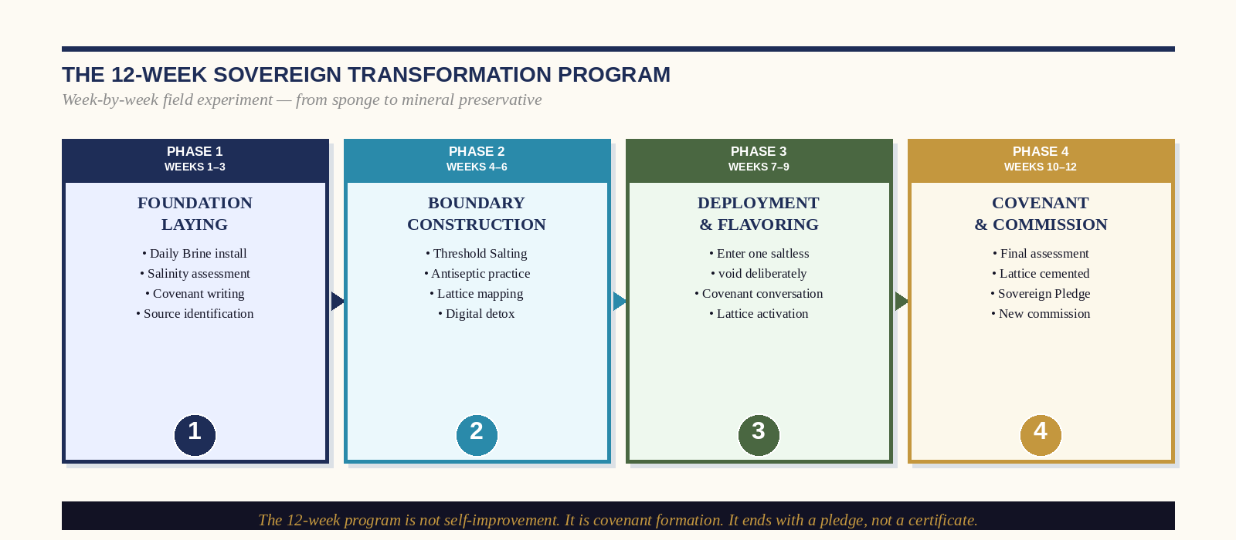
Figure: The 12-Week Sovereign Transformation Program — Four Phases to Covenant

Why Twelve Weeks
Twelve weeks is not an arbitrary duration. It is the minimum time horizon over which the neurological changes associated with habit formation become structurally stable—over which the neural pathways of the Daily Brine practice are sufficiently established to operate as defaults rather than conscious choices, over which the covenant relationships activated in Weeks 3–4 have accumulated enough shared experience to begin producing genuine trust, and over which the practitioner’s self-assessment can be meaningfully compared to their Week 1 baseline. Transformation programs shorter than twelve weeks produce motivation. Twelve-week programs, when executed with genuine commitment, produce structure. Structure is what this book is for.
The program is organized into four three-week phases, each corresponding to one of the salt framework’s core operational movements. The phases are sequential. Phase 2 cannot be effectively executed without Phase 1’s foundation. Phase 3’s deployment will be premature and unsustained without Phase 2’s boundary construction. And Phase 4’s covenant requires everything that preceded it to have its full weight.

Phase One: Foundation Laying (Weeks 1–3)
Phase One’s objective is the installation of the Daily Brine as an automatic morning architecture and the completion of the full Salinity Assessment. By the end of Week 3, the practitioner should have: a consistent pre-input morning writing practice of at least ten minutes; a completed ten-dimension Salinity Assessment with a clearly identified Primary Development Focus; a written Purpose Statement; and a preliminary map of their covenant relationships—who they are, what specific actions maintain them, and which of them require investment.
The most common Phase One failure is the attempt to implement all four Daily Brine pillars simultaneously from Day 1. Implement the Lattice Calibration pillar only in Week 1. Add Threshold Salting in Week 2. Add the Antiseptic Purge in Week 3. Mineral Saturation is already present—you are already doing something that replenishes your frequency. Phase One’s task is to name it specifically and protect it explicitly.

Phase Two: Boundary Construction (Weeks 4–6)
Phase Two’s objective is the structural installation of the Sovereign Perimeter—the non-negotiable boundary between what is constitutionally the practitioner’s and what the environment is attempting to install. The specific work of Phase Two: identify the two primary vectors of Environmental Down-Synchronization in your daily life (the specific environments, relationships, or inputs that most reliably move you away from your natural frequency); implement the Zone 4 Digital Perimeter modifications in your home; have the one conversation you have been avoiding (the antiseptic sting that the practitioner in Workbook B’s Drill 6 identified); and initiate the Analog Sabbath.

Phase Three: Deployment and Flavoring (Weeks 7–9)
Phase Three’s objective is the deliberate entry into one specific saltless void—one specific context in the practitioner’s domain where their principled presence has been absent and its absence has had observable consequences. This is not a dramatic heroic gesture. It is a specific, calibrated act of salt application: the conversation with the team about the dynamic that everyone has been managing, the commitment to the family ritual that has been inconsistently held, the civic participation that has been deferred, the creative or professional work that has been suppressed in the interest of institutional conformity. Enter the void. Season it. Stay for the reaction. Report back to your lattice.

Phase Four: Covenant and Commission (Weeks 10–12)
Phase Four closes the program with three specific acts that convert the preceding eleven weeks’ work from a personal development exercise into a covenantal commission. The first act is the re-completion of the full Salinity Assessment—the comparison of the Week 12 profile with the Week 1 baseline. The second act is the activation of the local lattice: the naming of the specific two to three people who will constitute the practitioner’s ongoing covenant community and the specific shared practice that will maintain that lattice. And the third act is the signing of the Covenant of Salt Pledge.

The Covenant of Salt Pledge
The Pledge is the document that closes this book. It is not a motivational exercise. It is a legal-weight covenant—a binding articulation of the specific commitments that this program has been preparing the practitioner to make. Sign it only when you are prepared to mean it. Do not sign it on Day 1 of enthusiasm. Sign it on Day 84, after you have been through three weeks of foundation, three weeks of boundary construction, three weeks of deployment, and three weeks of covenantal consolidation. Sign it when you know what it costs.
THE COVENANT OF SALT PLEDGE
I, __________________________________, on this day, ________________,
having read, practiced, and honestly reckoned with the demands of this commission,
do make the following covenants, which I will not revise when conditions make them inconvenient:
- I will maintain my natural frequency against every environment I enter. I am not my environment's property.
- I will deliver the antiseptic sting when the situation requires it. I will not choose my comfort over another person's healing.
- I will honor the covenant relationships in my life with the weight they deserve. I will not reduce them to transactions.
- I will return to the source before I am empty. My depletion is not a virtue. My replenishment is a covenant obligation.
- I will build the local lattice in my specific context, knowing the nation is rebuilt from my table outward.
- I will enter the specific saltless voids that my presence is positioned to season. I will not use the shaker as a dwelling.
- I am salt. The world is the wound. I will not remain on the shelf.
Signed: _________________________________________
Witness: _________________________________________
Date: ________________________ Review Date: ________________________

“The commission is not finished when the book ends. The book ends when the commission begins.”
— End of Section Five: The Blueprint for Modern Living —
Dr. Ishmael Amu • The Salt Effect • Complete

