THE SALT EFFECT
SECTION FOUR: THE METAPHYSICAL REVOLUTION & THE PSYCHOLOGICAL CURE
CHAPTER SEVENTEEN

The Psychology of Hyper-Saturation
Anatomy of the Modern Mind
“The first casualty of the information age was not truth. It was the quiet.”
— Attributed to a trauma therapist, private correspondence, 2021

The Age That Ate Its Own Interior
There is a particular kind of exhaustion that has no name in the clinical literature but is immediately recognizable to anyone who has tried, in the past several years, to think a complete thought. It is not tiredness—it is not the fatigue of overwork or under-sleep, though both are present. It is the exhaustion of a consciousness that has been relentlessly subjected to external stimulus without ever being given the conditions for processing, integrating, or responding to any of it. It is the exhaustion of a sponge that has been squeezed and immediately re-saturated, squeezed and immediately re-saturated, so many thousands of times that the fiber itself has begun to degrade.
In 2004, the average American’s attention was interrupted every three minutes and five seconds. By 2020, researchers at the University of California at Irvine found that it took workers an average of twenty-three minutes to regain full concentration after a single digital interruption. Do the math across eighteen waking hours and the average smartphone user’s eighty-seven daily phone checks, and the conclusion is not merely disquieting—it is clinically significant. A person who cannot complete a sustained cognitive task is not merely less productive. They are cognitively a different kind of person than the one who can. They process information differently, recall it differently, relate it to prior knowledge differently, and—most critically—they construct and maintain their sense of self differently.
The self is not a static entity that persists between cognitive events. It is an active, ongoing construction—a narrative maintained by the integration of incoming experience with existing memory, values, and commitments. The person who is never given the sustained attentional space in which that integration can occur is not merely distracted. They are being systematically deprived of the cognitive conditions for identity formation. They are, in the language of this book, being dissolved.
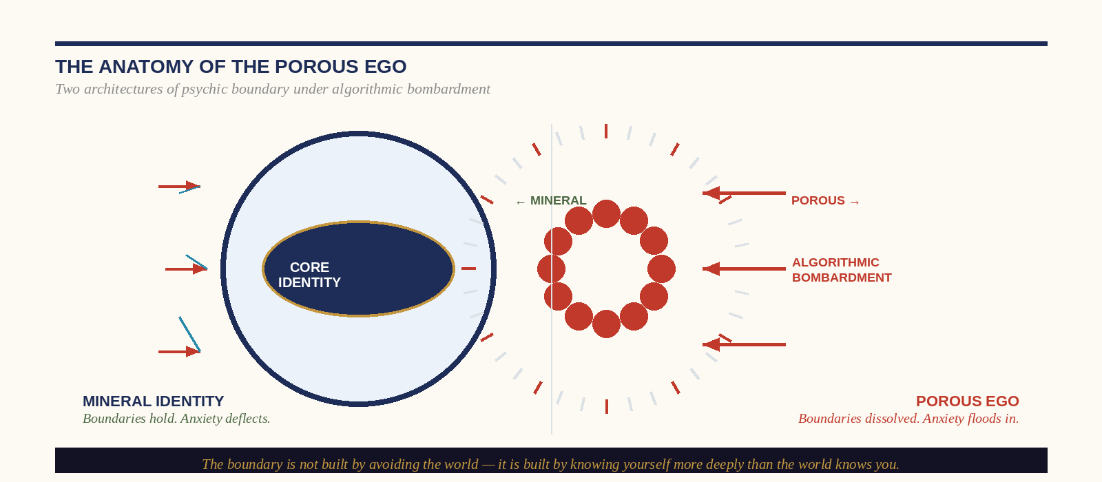
Figure: The Porous Ego vs. Mineral Identity — Two Architectures of Psychic Boundary

The Porous Ego: How Algorithmic Bombardment Destroys the Interior Boundary
The developmental psychologist Heinz Kohut described the ‘cohesive self’ as the psychological structure that allows a person to experience themselves as a continuous, bounded entity across time and across the inevitable disruptions of experience. It is the stable platform from which genuine engagement with the world becomes possible: the ground on which empathy, love, productive work, and moral action can be built without collapsing the ground itself.
What the current technological environment has accomplished is the industrialization of that disruption. The mechanisms Kohut identified as pathological in individuals—the inability to maintain stable internal states under external stimulation, the tendency to regulate psychological distress through increasingly urgent external inputs, the collapse of internal monologue into external narrative—are now the default operating mode of a substantial proportion of the adult population of the developed world.
The porous ego is not a character flaw. It is the predictable outcome of subjecting a human nervous system, built for the information density of a Paleolithic environment, to an input stream engineered, with billions of dollars and the most sophisticated behavioral psychology available, to maximize engagement and minimize the attentional space in which the self can reconstitute itself. The algorithm’s optimization target is not your flourishing. It is your attention. And attention is the medium in which identity is formed.

The Physics of Psychic Rot: Macro-Anxiety vs. Collective Hysteria
Macro-anxiety is the rational, proportionate cognitive and emotional response to genuine macro-level threats—climate instability, democratic fragility, economic precarity, public health vulnerability. These threats are real. They warrant serious engagement, careful analysis, and purposeful action.
Collective hysteria is something entirely different. It is the emotional contagion that spreads through digitally connected populations not in proportion to the severity of a threat but in proportion to the outrage-amplification design of the platform transmitting it. The 24-hour news cycle does not report events—it performs them. The person who has allowed their emotional regulation to become dependent on this signal is not informed about the world. They are addicted to the performance of information about it.
The psychologically salted individual maintains the ‘facts-not-frequency’ discipline: they calibrate their emotional response to the actual stakes of an event—the verified facts and their proportionate implications—rather than to the intensity of the collective signal surrounding it. This requires the capacity to turn the signal off entirely for sustained periods—to access the interior silence in which facts can be weighed without the performance around them. This is not denial. It is the discipline of the surgeon who reads the pathology report rather than the family’s response to it.
▸ SELF-ASSESSMENT — Are You Processing Macro-Anxiety or Collective Hysteria?
Ask three questions about your last news-driven emotional response:
1. Is my response proportionate to the verified facts of this event, or to the intensity of the collective signal about it?
2. Would I feel the same way if I’d encountered the facts in a quiet room without accompanying commentary?
3. Does engaging with this story make me more capable of productive action, or does it generate urgency that produces no output other than further engagement?
If questions 1 and 2 are ‘no’ and question 3 is ‘further engagement,’ you are not being informed. You are being consumed.

CHAPTER EIGHTEEN

The Protocol of the “Daily Brine”
The Four Pillars of Mental Hygiene
“Discipline is the foundation of freedom. Every other sequence produces only the illusion of both.”
— Dr. Ishmael Amu

Why Protocols Work When Intentions Don’t
The self-help industry has produced, over the past three decades, approximately forty billion dollars worth of evidence that good intentions do not change behavior. People who genuinely want to exercise do not exercise. People who sincerely intend to eat better do not eat better. People who earnestly resolve on the first of January to check their phone less are, by February, checking it more than they did in December. This is not weakness of character—it is the predictable outcome of asking the prefrontal cortex to override the limbic system on the basis of abstract aspiration in the absence of environmental and behavioral structure.
The neuroscience of habit formation is unambiguous: behavior changes through the modification of context and the establishment of automatic routines, not through the repetition of intention. The Daily Brine is not a set of aspirations. It is a behavioral protocol—a specific, time-stamped, environmentally anchored sequence of four practices that, performed with sufficient consistency, restructures the architecture of consciousness from porous to mineral. The practitioner who has maintained it for a year will find they are not merely in better mental health—they are a different kind of person. The boundary is structural. The frequency is calibrated. The shaker is full.
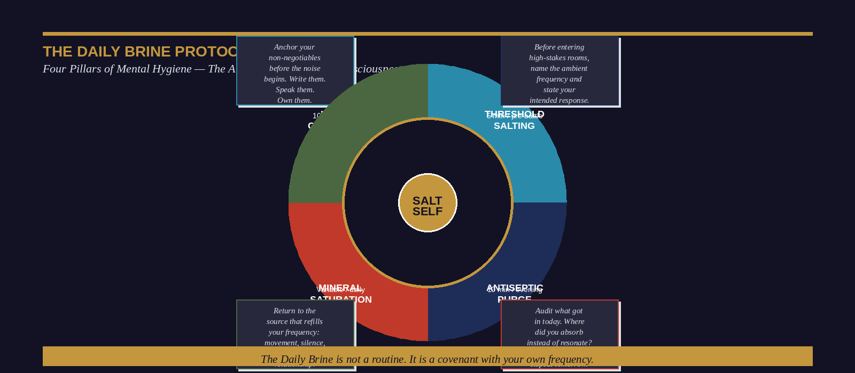
Figure: The Daily Brine Protocol — Four Pillars of Mental Hygiene

The Four Pillars in Clinical Detail

Pillar One: Lattice Calibration
Before the phone is checked, before the news is consumed, before the first conversation of the day begins—before the external world has had a single opportunity to set the day’s frequency—the practitioner spends a minimum of ten minutes in explicit, written engagement with the foundational commitments that define their identity. This is not journaling and it is not affirmation. Lattice Calibration is the active recollection of what is already true—the non-negotiables, the covenant commitments, the specific things about which the practitioner has decided, at a level deeper than preference or mood: ‘this is who I am, and no single day will revise that.’ The commitment that has been written is physiologically more real than the one that has only been thought.

Pillar Two: Threshold Salting
Every practitioner enters, on most days, one or more high-frequency environments where the pull toward Environmental Down-Synchronization is active. Threshold Salting is the practice of preparing for these environments before entering them. The preparation takes no more than five minutes and consists of three elements: naming the specific ambient frequency that will be present, stating the specific response the practitioner intends to bring, and identifying the specific value or commitment that anchors that response. The practitioner who has performed this preparation does not walk into the high-frequency room as an open circuit. They walk in as a completed one.

Pillar Three: The Antiseptic Purge
The evening audit is the most uncomfortable of the four pillars, and therefore the most skipped, and therefore—in the precise proportion that it is skipped—the most necessary. Its function is the daily maintenance of interior cleanliness: the examination of what was absorbed during the day that should not have been, and the intentional act of releasing what was taken in rather than allowing it to be integrated into the practitioner’s baseline state. The critical question: ‘What frequency did I exit this day at, and is that frequency mine?’ Sleep consolidates memory. Whatever is in the mind at sleep onset is more deeply encoded in the morning. The practitioner who does not purge the day’s contamination before sleeping is integrating that contamination into their long-term neural architecture.

Pillar Four: Mineral Saturation
Mineral Saturation is the daily return to the specific sources that replenish the practitioner’s natural frequency. The critical variable is specificity. The specific activity that replenishes your frequency is the one that—when you emerge from it—you can feel has altered your internal chemistry: you are more distinctly yourself, more precisely calibrated, more capable of the specific quality of presence your role requires. The source is not universal. But the discipline of returning to it—daily, specifically, non-negotiably—is.
▸ THE DAILY BRINE — Implementation Architecture
MORNING (10 min) — LATTICE CALIBRATION
• Phone remains off.
• Write 3 active covenant commitments for today.
• State your purpose: what are you seasoning today, and where?
PRE-BATTLE (5 min) — THRESHOLD SALTING
• Before any high-frequency environment.
• Name the ambient frequency. State your intended response. Name your anchor.
EVENING (10 min) — ANTISEPTIC PURGE
• What frequency did I end the day at? Is it mine?
• What did I absorb that needs releasing?
• Name it. Release it. Do not sleep on it.
DAILY (variable) — MINERAL SATURATION
• Return to your specific source. Non-negotiably.
• Not entertainment. Not stimulation. Replenishment.

CHAPTER NINETEEN

The Altar of the Hearth
Reclaiming the Family Fortress
“A home without a threshold is not a fortress. It is a passageway. And the algorithm knows it.”
— Dr. Ishmael Amu

The Parental Monolith: What Children Are Actually Asking For
Children do not want perfect parents. The research on secure attachment is unambiguous: what children need is not parental infallibility but parental predictability. They need a parent who is there—reliably, recognizably, consistently there—in the specific sense that means present: attentive, regulated, and genuinely interested in the individual person the child is becoming. The parental monolith is not the parent who has no other identity. It is the parent who, when they are in the domestic space, is genuinely and completely in it—not physically present while mentally elsewhere, not occupying the same room while inhabiting a different reality on a four-inch screen.
What the current technological environment has accomplished is the industrialization of divided attention. The parent who is today physically present in the home while digitally present in a curated feed of algorithmically selected content is experiencing something structurally identical to physical absence—but socially normalized. The child in the same room as the phone-occupied parent does not experience a neutral absence. They experience rejection. Not as a cognitive conclusion but as a nervous system event: the person whose attention is the primary source of their psychological safety is present and elsewhere simultaneously, which is, to the developing nervous system, more disorienting than simple absence.
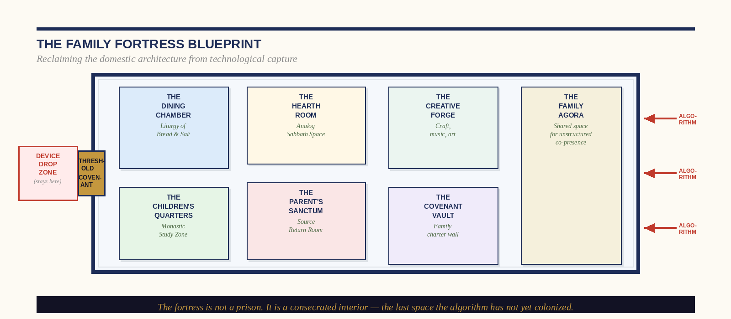
Figure: The Family Fortress Blueprint — Architectural Map of the Domestic Safe Space

Eradicating Technoference: The Clinical Evidence
The term ‘technoference’—the interference of technology in interpersonal relationships and family functioning—was introduced by Brandon McDaniel and Sarah Coyne in a 2016 study that has since spawned one of the most consistent bodies of replication in contemporary developmental psychology. Findings across more than forty subsequent studies are remarkable in their coherence: parental phone use during parent-child interaction is significantly associated with elevated child behavioral problems, reduced language development, diminished parental sensitivity to child emotional cues, and increased child negative affect that persists after the phone has been put away.
The parent who puts down the phone and says ‘I’m here now’ is not returning to the child in the child’s nervous system’s estimation. They are returning to a child who has already received the message that the phone is more interesting than they are—and whose autonomic nervous system is still processing that communication.

The Three Core Rhythms of the Salted Home
01 The Threshold Covenant
Ancient cultures understood what modern architecture has forgotten: the doorway is a sacred site. The Threshold Covenant is the contemporary translation of this wisdom: a family-specific practice that marks the transition from the external world’s frequency to the domestic one. A designated location at the threshold for all devices. A brief transitional practice—a shared check-in, a meal blessing, a physical greeting that requires eye contact and genuine presence. The child who grows up in a home with a consistent Threshold Covenant develops an interior model of the domestic space as different in kind from the external world. That model is one of the most durable protective factors in adolescent development.
02 The Liturgy of Bread and Salt
The Harvard Study of Adult Development—eighty-four years of longitudinal data on human flourishing—has produced one finding that its fourth director describes as ‘boringly consistent’: the quality of close relationships is the single strongest predictor of physical health, mental health, longevity, and life satisfaction across the entire lifespan. The research on family dinners consistently demonstrates that adolescents who share regular family meals report higher academic performance, lower rates of substance use, lower rates of depression, and higher rates of having at least one adult they can speak to about problems. The Liturgy of Bread and Salt is the commitment to protect this meal as a sacred site of genuine co-presence—no devices, one question for the table, the patience to stay in a conversation that has not yet arrived at its most interesting point.
03 The Analog Sabbath
The sabbath principle is among the most empirically vindicated in the history of human wellness. Its psychological function—the restoration of the attentional resources and processing capacity that sustained engagement depletes—is well established in cognitive science. The Analog Sabbath is the family’s weekly practice of collective attentional rest: a designated period in which the household withdraws from digital engagement and inhabits embodied, relational, physical space together. The resistance of adolescents to this practice is genuine and should be engaged with rather than overridden by authority. The parent who designs the Analog Sabbath with the family rather than merely for it will find the difference in compliance is not cosmetic—it is structural.
▸ FAMILY IMPLEMENTATION GUIDE — First 30 Days
WEEK 1 — ESTABLISH THE THRESHOLD COVENANT
Designate the device drop location. Implement it for every arrival. Explain why, not just what.
WEEK 2 — PROTECT ONE SHARED MEAL DAILY
No devices. One rotating question. Stay at the table until everyone has spoken.
WEEK 3 — PILOT THE ANALOG SABBATH
Designate two hours on one day. Plan an activity requiring physical co-presence. Anticipate resistance. Welcome it.
WEEK 4 — MAKE IT PERMANENT
Review what worked. Adjust the form. Protect the function. The structure is negotiable. The covenant is not.

CHAPTER TWENTY

The Salinity of Focus
For the Student and Young Professional
“Attention is the rarest and purest form of generosity.”
— Simone Weil, Waiting for God, 1951

The Industrial Assault on the Student Mind
There is a war being waged on the cognitive development of every person between the ages of twelve and thirty-five in the developed world, and it is being waged with weapons that its targets are paying handsomely to be attacked with. The infinite scroll, the notification, the auto-play, the algorithmic feed calibrated to the precise threshold of novelty that prevents the brain from habituating—these are not neutral features. They are the result of billions of dollars of behavioral engineering aimed at a single metric: time on platform. And time on platform is, to a first approximation, the antithesis of the cognitive development of a young professional.
Genuine competence—in any domain requiring complex skill, deep knowledge, or original synthesis—is built through what cognitive scientist Anders Ericsson spent thirty years characterizing as deliberate practice: sustained, focused engagement with a specific domain’s most challenging material, at the edge of one’s current competence, with immediate feedback on performance. The defining characteristic of deliberate practice is that it is difficult and not enjoyable in the moment. It is cognitively demanding in a way that is the direct opposite of the frictionless, reward-saturated experience the attention economy provides. The brain cannot do both simultaneously.
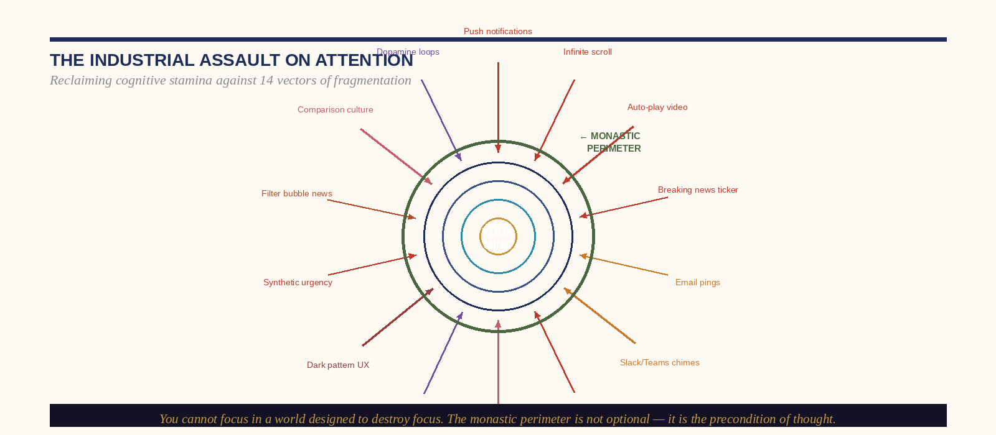
Figure: The Industrial Assault on Attention — 14 Vectors of Cognitive Fragmentation

The Monastic Cognitive Routine: Reclaiming the Deep Work Substrate
The word ‘monastic’ is used deliberately. The medieval monastery was the most sophisticated knowledge-production system of its era, and its architecture—physical, temporal, and social—was designed with precise intentionality to create the conditions for deep, sustained intellectual work that the wider world’s noise made impossible. The canonical hours structured time. The rule of silence structured attention. The scriptorium structured space. The result was a system that produced, over centuries, the accumulated scholarship, scientific observation, and artistic achievement that constitutes the foundation of Western intellectual culture—not despite the constraints it imposed, but because of them.
The young professional who has understood this history will recognize that their challenge is not new—only the specific form of the noise is. The monastery’s solution—structured time, protected attention, designated space for deep work—is as applicable to the twenty-first-century knowledge worker as it was to the twelfth-century copyist monk. The difference is that in the twenty-first century, no one will impose this structure on you. You must build it yourself. And the culture will actively resist your building of it.

The 90-Minute Hyper-Focus Block
The neuroscience of ultradian rhythms—the 90-to-120-minute cycles of alternating high and low neurological arousal that govern cognitive performance throughout the waking day—establishes the physiological basis for work architecture that aligns with the brain’s natural capacity curves. The practitioner who structures their deepest cognitive work into 90-minute blocks of genuine, uninterrupted focus—no notifications, no digital switching, no task parallelism—and follows each block with a genuine rest period of twenty to thirty minutes is not merely being disciplined. They are working with the brain’s actual architecture rather than against it. Salt does not conform to its medium. It seasons it.
▸ THE MONASTIC PROTOCOL — Seven-Day Implementation
DAY 1: Audit. Track every context switch in your working day. How many? What triggers them?
DAY 2: Configure. Disable ALL notifications except calls from a designated emergency list. No exceptions.
DAY 3: Designate. Identify one physical space for deep work only.
DAY 4: Schedule. Block your two highest-cognitive-demand hours as non-negotiable deep work. Defend them like appointments with your most important client.
DAY 5: Deplete-and-restore. Implement the 90-minute work block with a genuine 20-minute rest. No screens during rest.
DAY 6: Evaluate. What did you produce in deep work blocks versus the remaining hours? The ratio will be instructive.
DAY 7: Covenant. Write one specific commitment about your attention. Sign it. Return to it when the noise gets loud.

CHAPTER TWENTY-ONE

The Clinical Antiseptic
Healing Trauma Through the Sting of Truth
“The truth will set you free. But first it will make you miserable.”
— James A. Garfield

The Crisis of Psychological Coddling
The most influential mental health framework of the past thirty years rests on a premise of enormous therapeutic power and, in its popularized form, a significant distortion. The premise is correct: maladaptive thought patterns maintain psychological distress, and the deliberate restructuring of those patterns can produce genuine clinical improvement. The distortion—embedded in the self-help industry’s popularization of CBT and in the therapeutic culture’s drift toward what philosopher Jonathan Haidt calls ‘safetyism’—is the conclusion that comfort is the precondition of healing. It is not. It is the precondition of endurance. Managed wounds do not heal. They become organized.
The salt framework offers a different clinical model—one that has antecedents in the trauma integration work of Bessel van der Kolk, in the Jungian concept of shadow integration, and in the ancient traditions of confession and repentance. Its premise is simple: the wound heals from the inside out or it does not heal. And healing from the inside out requires, at some point in the process, the direct encounter with the infection—the naming, the experiencing, and the releasing of the specific truth that the wound has been organized to contain.
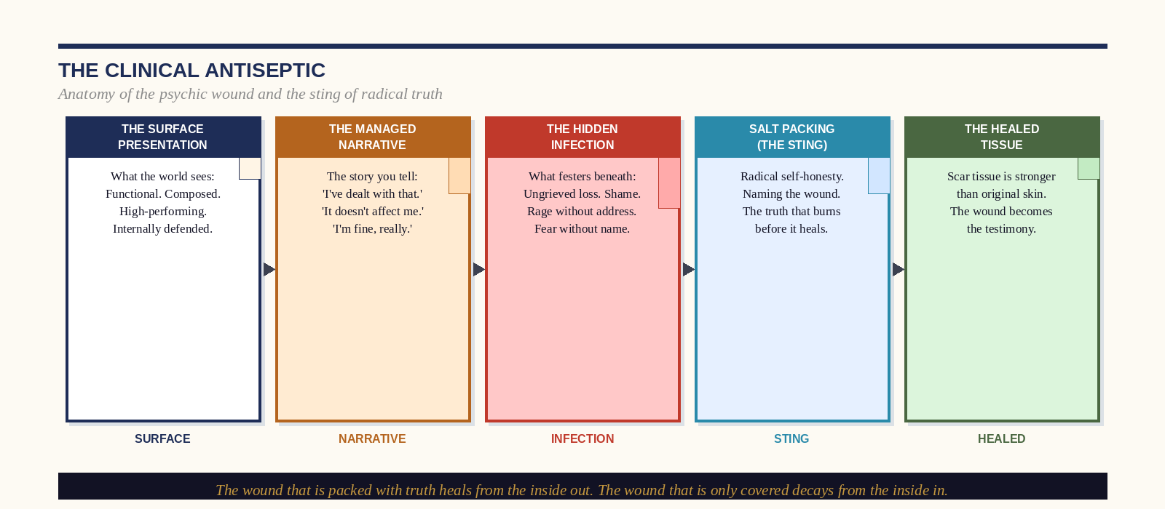
Figure: The Clinical Antiseptic — Five Stages of Psychic Wound to Healed Tissue

Packing the Psychic Wound: Therapeutic Steps
01 Name the Wound, Not the Symptom
The presenting symptoms—anxiety, chronic irritability, compulsive overwork, the relational pattern that keeps reproducing itself with different people—are not the wound. They are the wound’s management strategy. The question the clinical antiseptic asks is not ‘What are you experiencing?’ but ‘What are you managing?’ The answer to the second question is the wound. It is almost always a specific, nameable, historically located event or realization: the thing that happened, the truth that was confronted and refused, the grief that was bypassed, the shame that was buried.
02 Stay in the Wound
The most common therapeutic error is premature reframing: the impulse to move from the experience of the wound’s content to its meaning before the experience has been fully metabolized. Reframing is not wrong. It is sequentially misplaced. Thinking about the wound is a management strategy. Feeling it is the antiseptic. The practitioner must learn to distinguish between the two, and to resist the premature comfort of meaning-making as a mechanism for avoiding the direct experience of the wound’s emotional content.
03 Radical Self-Honesty and Repentance
The therapeutic tradition struggles to engage with a category of psychological wound that has a different origin: the wound that is self-inflicted, whether through deliberate wrong action, through cowardice in a situation that required courage, through the sustained betrayal of one’s own values, or through harm done to another that has never been honestly reckoned with. These wounds require repentance—not in the punitive sense, but in the precise functional sense: the direct acknowledgment of the specific wrong, the honest reckoning with its consequences, and the act of making whatever repair is available. The abscess drains. The tissue heals.
04 The Testimony: What the Scar Becomes
Scar tissue is physiologically stronger than the original tissue it replaces. The wound that has been genuinely metabolized produces a practitioner who is structurally enhanced by the experience of having been wounded and healed. They carry the specific knowledge of what the wound contains and what it took to heal it. They are able to be present in the wounds of others with a quality of understanding unavailable to the person who has never been wounded or who has managed rather than metabolized their wounds. The scar becomes testimony. The testimony becomes ministry.
▸ CLINICAL NOTE — When to Seek Professional Support
The reflective practice described in this chapter is appropriate for psychological growth and ordinary-range distress. It is not a substitute for professional clinical support in the presence of significant trauma, active mental health symptoms, or distress significantly impairing daily functioning. Getting help is not weakness. Refusing it is.

CHAPTER TWENTY-TWO

The Sovereign Voter
Maintaining Stability in a Volatile Political Climate
“The secret of freedom lies in educating people, whereas the secret of tyranny is in keeping them well-fed and ignorant.”
— Maximilien Robespierre

The Theater and the Real: Decoupling Emotional Stability from Political Volatility
The contemporary political environment is a masterwork of attentional engineering. The political media apparatus—across every partisan orientation, in every developed democracy—has discovered the specific frequency of crisis, outrage, and tribal solidarity that maximizes audience engagement. The result is an environment in which the average politically engaged citizen spends a significant proportion of their waking cognitive resources in a state of activated concern about events entirely outside their sphere of influence—and in which their sense of personal safety, hope, and self-worth has become contingent on the outcomes of political contests they cannot control.
This is not civic engagement. It is civic consumption. The distinction matters because genuine civic engagement produces action—the exercise of whatever actual influence the citizen possesses in whatever actual domain they inhabit—while civic consumption produces only the feelings associated with engagement without any of its effects. The citizen who spends four hours a day consuming political content and forty-five minutes per year performing civic action has confused the performance of concern with its expression.
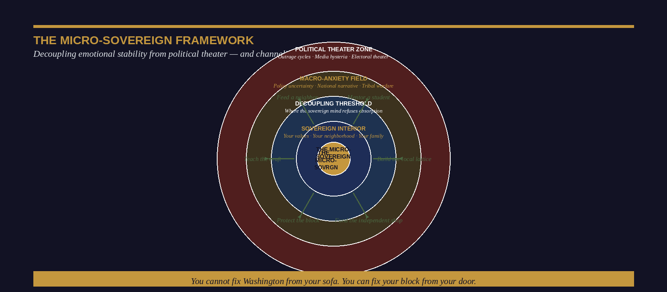
Figure: The Micro-Sovereign Framework — From Political Theater to Localized Action

The Micro-Sovereign: Channeling Outrage into Neighborhood Protection
The Micro-Sovereign is the person who has understood that the domain of their genuine authority—the territory in which their actions have real, causal, traceable effects on the quality of human life—is not the nation or the party or the legislature. It is the neighborhood, the workplace, the family, the specific relationships and institutions that their daily presence actually touches. The Micro-Sovereign votes. They participate in local governance. What they refuse is the substitution of performative macro-political engagement for the harder, less glamorous, more effective work of micro-sovereign action.
The mechanics of Micro-Sovereign action are not exotic. They are the specific, concrete, relational interventions that rebuild the local lattice: the mentorship of a young person in one’s specific domain of expertise, the patronage of the local business whose survival constitutes a genuine community good, the participation in the specific civic body where the individual’s presence and voice have genuine leverage. These actions do not generate the neurochemical reward of national political engagement. What they produce is something rarer and more durable: actual change in actual circumstances for actual people whose names you know.
▸ THE MICRO-SOVEREIGN PROTOCOL — Three Reorientations
REORIENTATION 1 — FROM CONSUMPTION TO ACTION
For every unit of political content consumed, identify one unit of micro-sovereign action. The ratio should not exceed 1:1.
REORIENTATION 2 — FROM NATIONAL TO LOCAL
Identify the two to three local civic domains where your specific presence gives you genuine leverage. Invest deliberately.
REORIENTATION 3 — FROM OUTCOME TO COVENANT
Your emotional stability is not hostage to the next election. Your worth is not contingent on the next news cycle. Reground in covenantal identity.

CHAPTER TWENTY-THREE

The Metric of Salinity
The Complete Psychological Assessment
“What gets measured gets managed. What gets named gets changed. What gets ignored compounds silently until it cannot be ignored.”
— Dr. Ishmael Amu

The Case for a Proprietary Instrument
Every domain of serious practice has its measurement instrument. The physician has the vital signs, the blood panel, the imaging study. The financial analyst has the balance sheet, the income statement, the cash flow projection. The psychological domain that this book has been addressing—the domain of identity salinity, of the boundary between principled presence and environmental absorption—has, until now, had no measurement instrument. This chapter introduces one.
The Salinity Assessment Instrument is not a clinical diagnostic. It is a structured self-assessment across ten dimensions of identity-related psychological functioning, each scored on a ten-point scale, that generates a profile—a pattern of relative strengths and vulnerabilities—that the practitioner can use to prioritize the specific developmental work that will most effectively increase their mineral integrity.
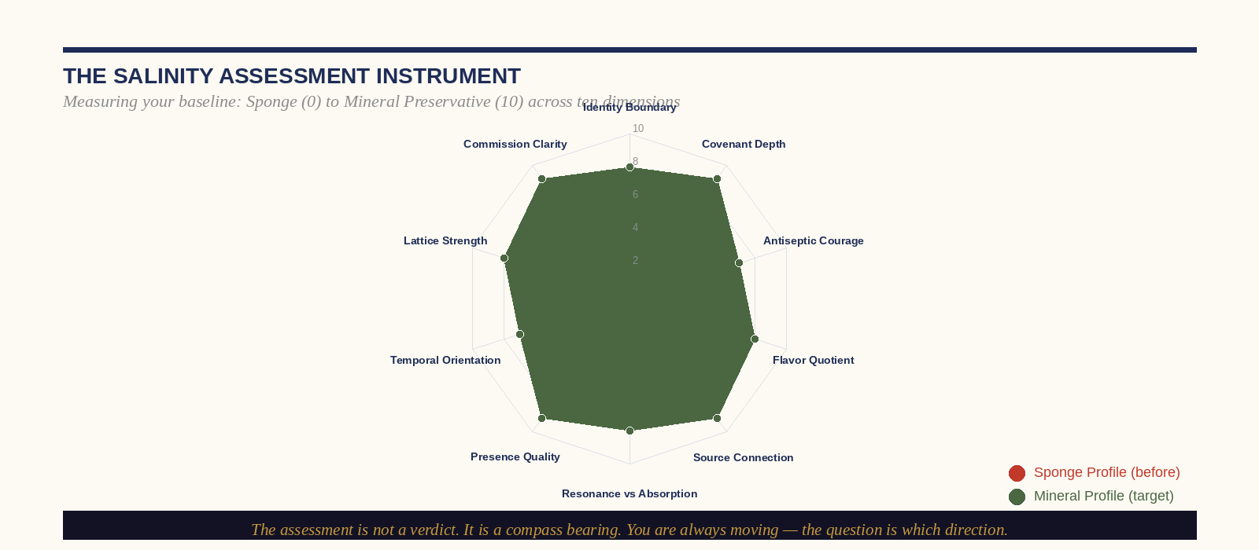
Figure: The Salinity Assessment Instrument — Ten-Dimension Psychometric Profile

The Ten Dimensions of Salinity: A Scoring Guide
For each dimension, score yourself honestly from 0 (completely sponge-characteristic) to 10 (completely mineral-characteristic).
01 Identity Boundary
Score 0–3: Your sense of who you are is significantly influenced by the moods, opinions, and expectations of people around you. After sustained exposure to a cynical environment, you become somewhat cynical.
Score 7–10: You can spend extended time in environments whose frequency is dramatically different from your own and emerge with your foundational commitments and characteristic dispositions intact.
02 Covenant Depth
Score 0–3: Your most important commitments are contingent on conditions. Upon honest examination, they have been revised when the cost of maintaining them exceeded a threshold you did not previously know you had.
Score 7–10: You carry at least two to three commitments that you have maintained in the face of genuine cost. You know where your covenant lines are because you have stood on them.
03 Antiseptic Courage
Score 0–3: You consistently avoid the difficult truth in situations that require it.
Score 7–10: You have, in the past twelve months, delivered a genuinely difficult truth—to a person or in a context where it was not welcome—because the situation required it. The delivery was skillful rather than aggressive. You stayed for the reaction.
04 Flavor Quotient
Score 0–3: Your presence in most rooms is functionally neutral—you contribute technically but the quality of the experience is not observably different because you are there.
Score 7–10: People who work with you regularly describe the experience of engaging with you as qualitatively distinctive. Something specific about the encounter with you makes the interaction worth remembering.
05 Source Connection
Score 0–3: You cannot identify, with specificity, what refills your frequency. You have not visited the specific source that produces genuine mineral replenishment in several weeks or months.
Score 7–10: You can name, precisely, the two to three specific practices that return you to your natural frequency. You have engaged in at least one in the past seventy-two hours.
▸ ASSESSMENT INTERPRETATION — Profile Analysis
AVERAGE SCORE 0–3 (Low Salinity / Sponge Profile): Immediate priority is structural—the Daily Brine protocol and the Covenant Audit. The boundary work must come before the deployment work.
AVERAGE SCORE 4–6 (Transitional Profile): You have salt. The work is concentration and consistency. Identify your two lowest-scoring dimensions and apply focused developmental attention.
AVERAGE SCORE 7–9 (High Salinity Profile): The work is deployment. Where are the specific saltless voids that your specific salinity is positioned to season? The shaker is full. Leave it.

CHAPTER TWENTY-FOUR

Rebuilding the National Lattice
From Individual Salt to Collective Force
“A people that values its privileges above its principles soon loses both.”
— Dwight D. Eisenhower, First Inaugural Address, 1953

Crystalline Alignment: The Geometry of Collective Preservation
The ionic lattice of sodium chloride is among the most stable structures in nature—not because any individual ion is extraordinary, but because the structural relationship between ions is perfectly calibrated. Each sodium ion held by six chloride ions. Each chloride ion held by six sodium ions. The resulting structure’s durability does not depend on any individual component’s strength but on the integrity of the relationships between components. Rock salt—the geological formation produced when these crystals fuse under pressure—has been found intact in mines sealed since the Permian period, 250 million years ago.
The American civil rights movement did not produce the Civil Rights Act because it produced Martin Luther King Jr. It produced the Civil Rights Act because it produced, in hundreds of communities across a dozen states, a lattice of individuals—most of whose names history has not recorded—who were bonded by a shared covenant strong enough to hold under sustained assault. The political and social implications of the ionic lattice are not metaphorical. They describe, with genuine precision, the mechanism by which civic cultures maintain their integrity over time.
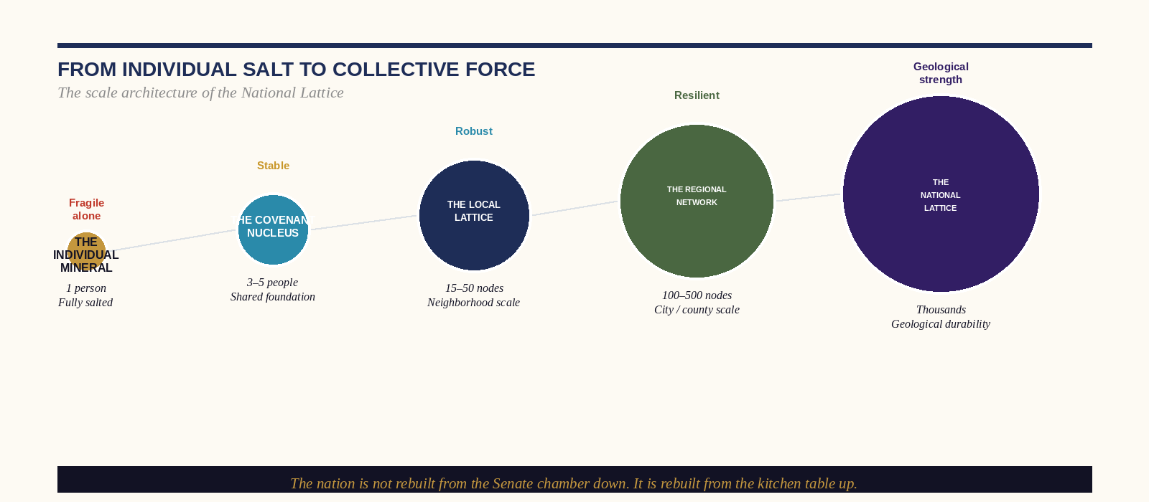
Figure: From Individual Salt to Collective Force — The Scale Architecture of the National Lattice

The Architecture of Scale: From Kitchen Table to National Fabric
The mistake that every generation of reform-minded individuals makes is the attempt to scale civic renewal before the local lattice has been built. The national campaign launched before the neighborhood network exists. The policy reform pursued before the community conversation has been had. These efforts are not wrong—they are sequentially misplaced. The architecture of genuine social renewal moves in a specific direction: from the individual to the covenant nucleus to the local lattice to the regional network to the national fabric. Each transition requires a qualitative change in the nature of the relationships involved, not merely a quantitative expansion of the number of people engaged.
01 Map the Existing Crystals
Before building new relationships, identify the principled practitioners already operating in your geographic and social context—the physicians maintaining their covenants in conditions that punish them, the teachers who have not surrendered to institutional defaults, the business owners whose integrity is their actual business model, the civic leaders who have not been captured. These individuals exist in every community. They are not networked to one another because the culture’s default organizing principles do not produce the cross-boundary relationships that lattice formation requires. Your first act is cartography: map the crystals before you attempt to fuse them.
02 Create the Conditions for Fusion
Crystals fuse under pressure and in proximity. The social analogue is repeated, embodied, low-stakes shared experience in a context not organized around productivity, agenda, or institutional affiliation. The dinner, the long walk, the informal gathering without a facilitator or a deliverable—these are the conditions under which genuine trust is built. The lattice is not a project. It is a relationship structure. It is built the way all structures of genuine durability are built: slowly, under pressure, with materials that have been tested.
03 Covenant Before Campaign
The transition from a collection of principled individuals to a genuine lattice requires an explicit act of covenant: the specific articulation, between specific people, of what they are committed to that will not change when the conditions change. The community organization that survives its first internal conflict is almost always one where the foundational commitments were explicit and shared before the conflict arose. The covenant that has been spoken before it is tested holds. The assumed alignment that has never been articulated fractures at the first application of genuine pressure.
▸ THE NATIONAL LATTICE FIELD MANUAL — Key Principles
1. BUILD LOCAL FIRST. The national fabric is an emergent property of thousands of local lattices.
2. PRIORITIZE DEPTH OVER BREADTH. Three covenant relationships are worth more than three hundred network contacts.
3. COVENANT BEFORE CAMPAIGN. Explicit shared commitments before collective action. Every time.
4. BRIDGE ACROSS DIVISION. The lattice’s strength is proportional to the diversity of its nodes. Homogeneous networks are fragile.
5. PROTECT THE SHARED PRACTICE. The embodied, repeated activity is the fusing pressure. Without it, the crystals disperse.
6. ACCEPT THE TIMELINE. Salt lattices are geological. They take years to form and they last centuries.

CHAPTER TWENTY-FIVE

The Master’s Call
The Manifesto of the Dispenser
“What is required of us is that we love the difficult and learn to deal with it. In the difficult are the friendly forces, the hands that work on us.”
— Rainer Maria Rilke, Letters to a Young Poet, 1904

The Commission That Cannot Be Deferred
There is a conversation I have had, in various forms, with several hundred leaders across two decades of consulting, teaching, and clinical practice. It begins with a person of extraordinary quality—someone who has built something genuinely good, who carries genuine salt, who has maintained their principled presence in conditions that have dissolved better-resourced and better-connected people around them—sitting across from me and asking, in various formulations of the same essential question: When is it enough? When have I done enough? When do I get to stop?
I understand the question. The person asking it has typically been operating at a level of sustained moral expenditure that the culture around them neither recognizes nor rewards. They have stayed in rooms that paid their departure in social capital. They have said the unsayable in meetings where the unsayable was what the meeting needed. They are tired in a way that a good night’s sleep does not address—the fatigue of having been, for a long time, the only person in a specific context willing to hold a specific line.
I cannot tell them it is enough, because the commission does not have a satisfactory termination condition. What I can tell them—and what the entirety of this book has been building toward—is that the commission was never supposed to be discharged from a position of depletion. The practitioner who has arrived at exhaustion has, somewhere in the preceding months or years, neglected one of the four pillars. The source has not been visited. The fatigue is not a signal that the commission is complete. It is a signal that the protocol has been broken.
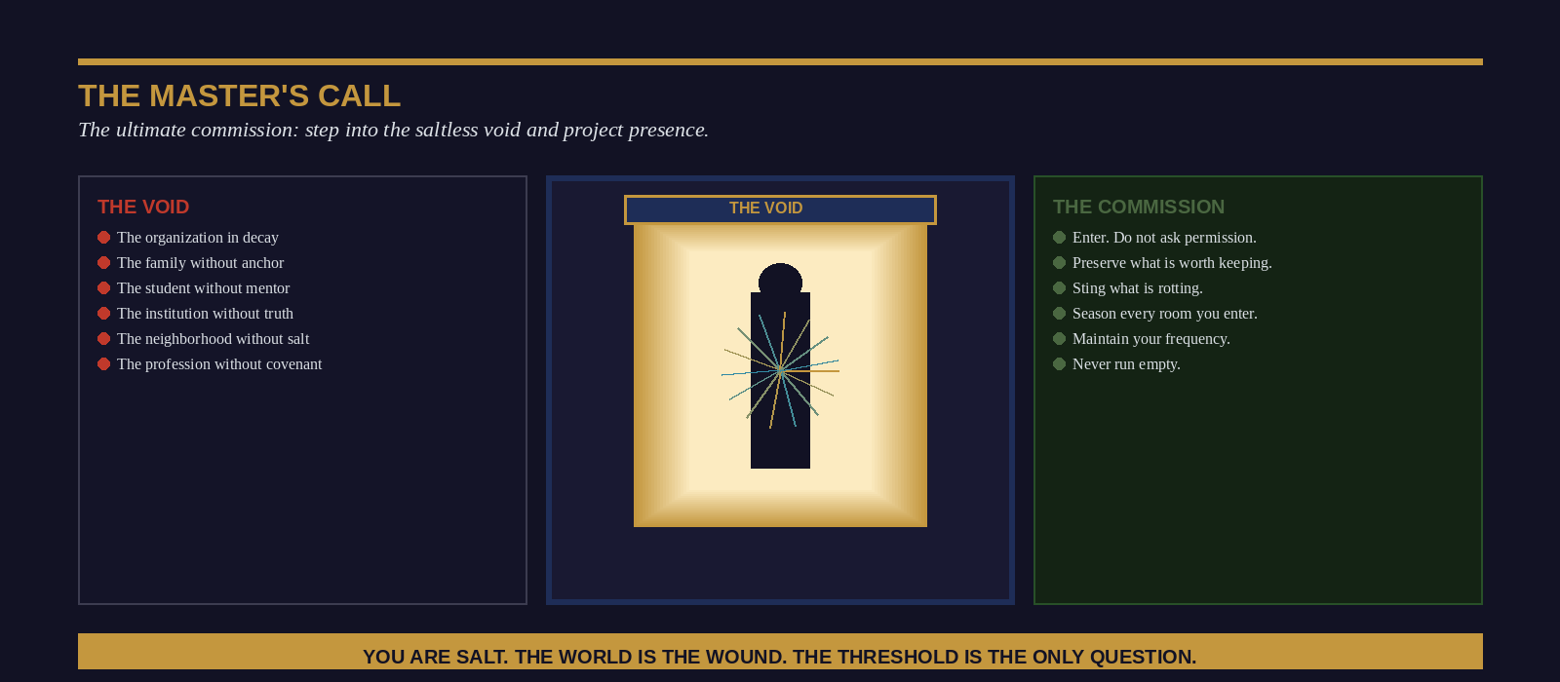
Figure: The Master’s Call — The Commission to Step Into the Saltless Void

The Never-Empty Shaker: A Final Theology
The promise at the center of this book is not a promise about human endurance. It is a promise about the nature of the source. The practitioner who draws their salinity from the deep covenantal foundation—from the relationship with the permanent that does not shift with the market, the relationship with the sacred that does not depend on the institution’s integrity, the community of shared covenant that holds the individual crystal in its lattice—is drawing from something that is, in the specific and non-trivial sense that any theology worth its salt must insist upon, inexhaustible.
This is not a promise that exhaustion will not be felt. Elijah felt it, collapsed under a juniper tree, and asked to die. Every leader in this book’s target audience who has operated with genuine integrity in a system that punishes it has felt it. The promise is not about the feeling. It is about the supply. The shaker that is returned to the source is refilled. The practitioner who has maintained their Daily Brine, their covenant relationships, and their honest reckoning with what they have absorbed finds that the exhaustion is real and transient—a drawdown that precedes a replenishment—rather than a depletion that precedes a collapse.

The Manifesto: Twelve Commitments of the Salt Practitioner
- I will not mistake the absence of conflict for the presence of health. The wound that feels comfortable is still a wound.
- I will not allow the vacuum to form and then mourn its consequences. The vacancy is my commission.
- I will maintain my natural frequency against the pull of every environment I enter. Active resonance, not passive absorption.
- I will deliver the antiseptic sting when the situation requires it, regardless of the discomfort it produces in the room—and I will stay for the healing.
- I will honor the covenant relationships in my life as the mineral bonds they are—irrevocable, load-bearing, worth the cost of permanence.
- I will return to the source before I am empty. The Daily Brine is not optional; it is the precondition of everything else.
- I will build the local lattice, knowing that the nation is rebuilt from the kitchen table outward.
- I will not confuse credential with covenant. The ladder is for climbing. Salt is for seasoning.
- I will not be captured by the institutions I serve. The Sovereign Perimeter is structural, not aspirational.
- I will grieve what needs to be grieved, extract what needs to be learned, and turn my face forward without becoming a pillar.
- I will make the rooms I enter taste better. Not through performance—through genuine, seasoned, unsuppressed presence.
- I am salt. The world is the wound. I will not remain in the shaker.
“This is the commission: not to be admired for your mineral integrity from a safe distance, but to take it—still imperfect, still being formed, still returning daily to the source—into the specific saltless void that has been waiting, with a precision that should disturb you, for exactly the kind of salt that you are.”
— End of Section Four: The Metaphysical Revolution & The Psychological Cure —
Dr. Ishmael Amu • The Salt Effect • Section Four

