THE SALT EFFECT
SECTION THREE: THE INSTITUTIONAL IMPERATIVE
CHAPTER NINE

Salt in the Algorithm
Leadership in the Age of Artificial Intelligence
“The machine can outrun you. It cannot out-season you. Velocity without salinity is just faster rot.”

The Flavorless Multiplier
Let us begin with an uncomfortable confession from the industry that most needs to hear it. The greatest productivity tool in human history has no values. This is not a design flaw in artificial intelligence—it is, with architectural precision, a design requirement. A language model trained to predict the next token in a sequence does not ‘prefer’ truth over falsehood, justice over expediency, or a living person’s dignity over a statistically satisfying output. It produces the thing that fits. It has, in the terminology of this book, zero salinity. It will preserve nothing. It will sting nothing. It will add flavor only in the most superficial, stylistic sense—the salt-flavored chip that contains no actual mineral and delivers no nutritional function whatsoever.
This is not an argument against AI. It is the precise argument for you. The executive who has understood the structure of salt’s power recognizes immediately what AI’s arrival in the organizational ecosystem implies: the scarcest resource in a world of infinite computational velocity is not processing power. It is human salinity—the irreducible presence of a person who can preserve what is worth keeping, sting what is rotting, and make the institution’s output worth remembering as a human experience rather than merely an efficient transaction.
In 2023, McKinsey estimated that generative AI could automate between 60 and 70 percent of the tasks performed by knowledge workers in developed economies within a decade. The analysis was careful, the methodology sound, and the executive class’s response almost entirely wrong. Boardrooms around the world began asking: “How do we automate?” The correct question—the one that the salt framework makes obvious—was: “What cannot be automated, and how do we make it so extraordinary that it justifies every dollar of the premium we must charge for it?”
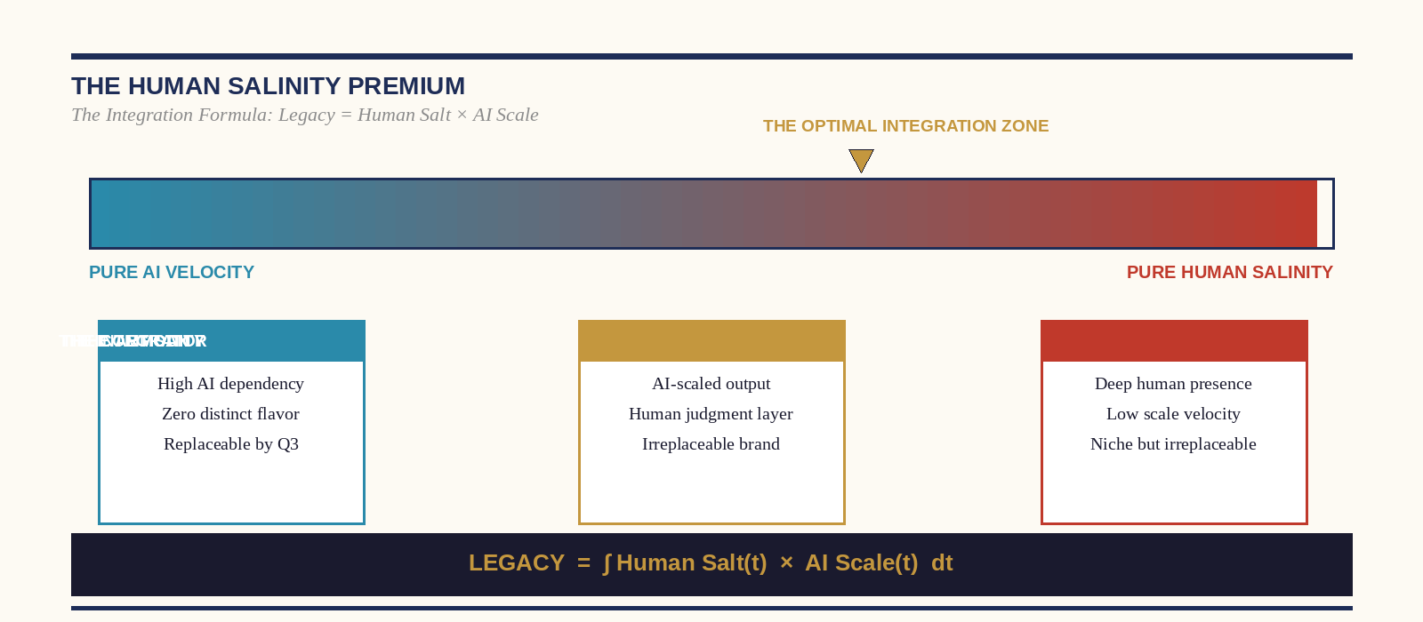
Figure: The Human Salinity Premium — Optimal Integration Zone

The Human Salinity Premium
The economist Tyler Cowen has described the emerging labor market as one organized around the question: “Are you good at working with intelligent machines or not?” This framing, while analytically useful, understates the strategic opportunity available to the leader who has developed a genuinely distinctive human presence. The truly high-value individual in an AI-scaled economy is not merely the person who can operate the machine—that skill, by definition, becomes increasingly common as the machine becomes increasingly accessible. The truly high-value individual is the person whose human presence so thoroughly alters the quality of an interaction, a decision, or a relationship that the machine’s involvement becomes irrelevant to the client’s decision to return.
Consider the differential between two orthopedic surgeons in a hospital where AI-assisted imaging has standardized the diagnostic accuracy of every physician to near-perfect levels. The AI has eliminated the diagnostic competence gap between them. What remains—what the AI cannot touch—is the quality of the human encounter: the surgeon who sits with a sixty-two-year-old woman for seventeen minutes and explains not just what the scan shows but what her life will look like in two years if she chooses surgery versus conservative management, who answers the question she was too frightened to ask, who is present in the room with her in a way that her body registers as safety. That encounter cannot be quantified by the hospital’s efficiency metrics. It can be quantified, with precision, by her referral behavior, her compliance with post-operative protocols, and the specific language she uses when she describes her surgeon to her daughter.
This is the Human Salinity Premium. It is not sentiment. It is the residual value that human presence produces after AI has equalized every measurable skill variable—and it compounds, at organizational scale, into the most durable competitive moat available to any institution in the current technological environment.

The Scaling Formula: Legacy = ∫ Human Salt(t) × AI Scale(t) dt
The integration formula is not poetry—it is a description of how legacy actually accumulates in the current moment. The executive who understands it operates with a dual mandate: build the AI infrastructure that allows human insight to reach further and faster than any single person could alone, and invest in the human salinity that gives that infrastructure something worth scaling. The formula fails at zero on either variable. An AI system with zero human salinity at its core scales nothing of value—it amplifies with perfect efficiency the absence of moral flavor. A human being with extraordinary salinity and zero AI leverage is artisanal—beautiful, important, and profoundly limited in reach.
The leaders who will define the next quarter-century of institutional life are those who have refused the false choice between being human and being scaled—who have understood that the question is not “AI or salt?” but “How much of my salt can I get into how much of the world, through the most powerful amplification technology in human history?” That question has a specific, strategic, non-trivial answer. Finding it is the work of this generation’s leaders.
EXECUTIVE IMPERATIVE — The AI Salinity Audit
Conduct a rigorous audit of every AI-assisted function in your organization. For each, ask two questions: (1) What human salinity was embedded in the data and the design that now guides this system? If the answer is 'none,' you have scaled nothing—you have amplified a vacuum. (2) What human encounter follows the AI output, and how have we invested in making that encounter extraordinary? The machine gets the client to the door. You decide whether they come back.

CHAPTER TEN

For the Entrepreneur and CEO
Exposing and Treating Cultural Mold
“You did not build a company. You built a petri dish. The question is what you are growing in it.”

The Pathology of Corporate Rot: A Clinical Profile
Every organizational collapse that has ever been analyzed in retrospect—Enron, Theranos, Lehman Brothers, the Catholic Church’s abuse crisis, the systematic cultural failures at Boeing that preceded two fatal crashes—contains the same pathological signature. It is never one catastrophic decision. It is a sequence of microscopic compromises, each individually defensible, each individually invisible on any instrument the organization used to measure its own health, accumulating over months and years into a structural rot that was, by the time it became visible, irreversible.
The mycological metaphor is precise. Mold does not announce itself. It establishes a colony in the unseen cavity behind the wall—in the dark, in the damp, in the space no one thinks to inspect because it has never caused trouble before. It spreads through spores that travel on the ordinary movement of air through the building. By the time the smell is detectable, the colony is large. By the time the wall shows discoloration, the structural damage may already exceed the cost of the original intervention that would have prevented it.
The organizational equivalent is not dramatic. It is a performance review that softens a critical assessment because the manager doesn’t want the difficult conversation. It is a sales number that is reported with a footnote that no one reads. It is the open secret about the executive’s behavior that everyone knows and no one names because the executive’s relationships upward are strong. It is the values statement on the lobby wall and the P&L in the boardroom, and the complete absence of any mechanism for reconciling the two.
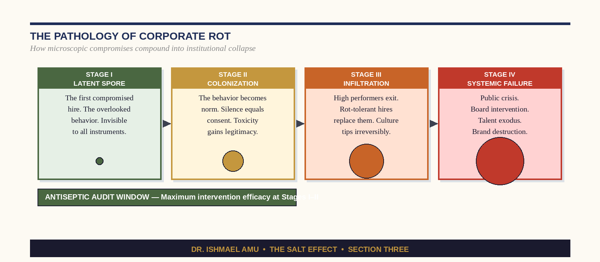
Figure: The Four Stages of Corporate Rot — Pathology and Intervention Windows

The Antiseptic Audit: A Systemic Purge
The Antiseptic Audit is a structured organizational intervention designed to expose what the organization’s existing measurement systems cannot see—not because the instruments are poor, but because they are measuring what the organization wants to find rather than what it needs to know. Most corporate health assessments are designed by the people whose health is being assessed. This is the organizational equivalent of asking a patient to write their own pathology report. The result is invariably—not through deliberate dishonesty but through the ordinary operation of confirmation bias—a document that is accurate about the organization’s strengths and blind to the specific locations where the mold is growing.
The Antiseptic Audit operates on four levels, in sequence, and skipping any level produces a document of zero utility.
01 The Silence Map
Before any structured interviews, surveys, or data analysis, the audit begins with a simple question asked of the CEO in private: What does everyone in this organization know that no one will say in a room where it might affect their standing? The answer to this question is the single most important diagnostic data point the audit will generate. Every organization has its silences—the things that are universally known and never named. These silences are the locations of the mold. Map them before you measure anything else.
02 The Exit Interview Review
Pull the last three years of exit interview data and read it with one specific filter: not ‘why did people leave’ but ‘what patterns are never cited in the official summaries but appear repeatedly in the raw transcripts?’ Most organizations summarize exit interview data by theme—compensation, career development, work-life balance. These themes are real but they are almost never the actual reason high-integrity people leave high-dysfunction organizations. The actual reasons are in the specific language of the individual transcripts: the moment a person decided, not that the job wasn’t good enough, but that the organization no longer deserved their best.
03 The Covenant Compliance Test
Identify your organization’s stated values—the ones on the website, the ones in the onboarding deck, the ones that were developed in the off-site where the leadership team felt genuinely inspired. For each value, name one decision made in the last twelve months that honored it and one decision made in the last twelve months that violated it. The ratio of those two lists is your actual values score. Organizations that can produce the first list fluently and struggle with the second have not internalized their values—they have decorated with them.
04 The Radical Alignment Framework
The final phase of the audit is not a document—it is a conversation. Bring the leadership team together and, with the findings from the first three phases in hand, ask a single question: What would we have to stop doing, stop tolerating, and stop pretending in order for this organization to be worthy of the people who work in it? The discomfort of this question is the antiseptic sting. Its function is to produce exactly the reaction it produces—the resistance, the defensiveness, the ‘but context’ and ‘but history’—because those reactions are the mold’s immune response. They are the infection fighting back. Stay in the conversation.
CEO WARNING — The Most Dangerous Sentence in Corporate Culture
'That’s just how we do things here.' These seven words have killed more high-potential organizations than any market disruption, technological shift, or strategic error in the history of business. They are not a description of culture. They are its calcification. The moment that sentence becomes the answer to a genuine question about organizational health, the audit is already overdue.

CHAPTER ELEVEN

For Doctors and Healers
The Antiseptic Against Burnout
“You entered medicine to cure the world. The world’s pain entered you instead. This is not compassion. This is osmosis. And osmosis will kill you.”

The Epidemic the Medical System Will Not Name
In 2022, the American Medical Association released findings that more than half of all American physicians reported symptoms of burnout. The number has been climbing steadily since 2011—not coincidentally, the year that electronic health records became federally mandated, and the physician’s relationship with their patient began to be mediated, in real time, by a data-entry interface engineered by a software company that had never seen a patient die. By 2024, physician suicide rates had reached more than twice the rate of the general population. Emergency medicine and psychiatry—the disciplines that absorb the greatest concentrations of acute human suffering—consistently reported the highest rates.
The medical community’s institutional response has been impressive in its thoroughness and largely inadequate in its effect. Wellness programs, mindfulness apps, resilience training modules, peer support hotlines—these interventions address the symptom at the level at which it is most visible: the individual clinician’s subjective experience of distress. They do not address the structural mechanism that produces the distress, which is not, fundamentally, long hours or administrative burden or a difficult patient population. It is a failure of the boundary between the healer and the wound.
The physician who cannot distinguish between caring for suffering and carrying it—who has no operational framework for receiving a patient’s pain, meeting it with genuine presence, and then releasing it at the end of the encounter—is not experiencing burnout. They are experiencing the predictable structural outcome of an Absorbent Personality operating at industrial scale. They are a sponge that has been soaked to saturation and is now being asked to absorb the next patient’s ocean.
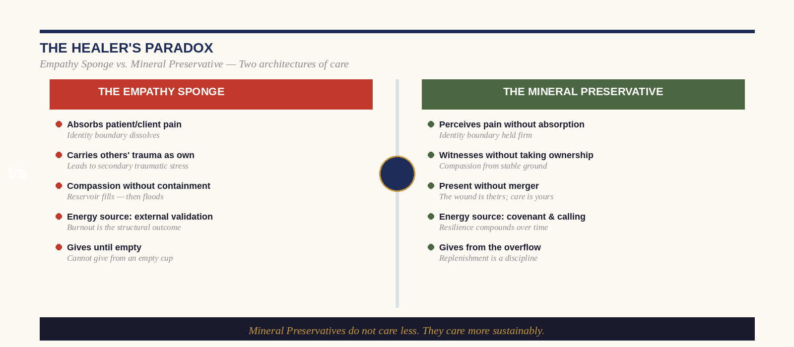
Figure: The Healer’s Paradox: Empathy Sponge vs. Mineral Preservative

Empathy Sponges vs. Mineral Preservatives
The research literature on physician wellness has begun to converge on a distinction that the salt framework makes architecturally precise: the difference between empathic concern—the cognitive and emotional recognition of another person’s suffering, combined with a motivation to relieve it—and empathic distress, the vicarious experience of that suffering as one’s own. The first is the mechanism of extraordinary clinical care. The second is the mechanism of burnout. They are not the same thing. They have different neural signatures, different physiological correlates, and dramatically different trajectories over a career.
The Empathy Sponge experiences their patient’s pain as their own. They carry it out of the clinical encounter. They wake at 3 a.m. with it. They bring it to their family dinner table, where it has no name and no container and therefore saturates everything. Over time, they develop one of two adaptations: they burn out—losing the capacity for any emotional response to clinical suffering—or they develop the defensive cynicism that veterans of every intensive clinical environment recognize: the black humor, the studied detachment, the deliberate cultivation of a distance so great that nothing gets through at all. Neither adaptation serves the patient. Both represent the destruction of the very thing that made the healer extraordinary.
The Mineral Preservative is not emotionally distant from their patient’s suffering. They are, in many cases, more present to it—more precisely attuned to the specific quality of this person’s pain, this family’s fear, this prognosis’s particular devastation—than the sponge, whose absorption of generalized distress frequently produces a kind of emotional static that obscures rather than illuminates the individual patient’s experience. The difference is not the quality of attention but the architecture of the boundary. The mineral preservative knows, at the cellular level of their professional identity, where they end and the patient begins. They are fully present in the room. They do not leave the room as the patient.

The Healer’s Shield: The Protocol of Intentional Detachment
Intentional Detachment is not emotional anesthesia. It is a structured practice of deliberately maintaining the distinction between presence and merger—between the healer’s full engagement with the patient’s reality and the healer’s absorption of that reality as their own. It operates on three sequential disciplines that the physician or healer can implement as a daily professional practice, independent of any institutional support structure.
01 The Pre-Encounter Calibration
Before entering any clinical encounter—in the corridor, in the ten seconds before the door opens—consciously articulate your current internal state. What frequency are you at? What are you carrying from the previous encounter or the previous hour? This is not therapy—it is a twenty-second diagnostic. The physician who enters a room without this check enters as an open circuit. Whatever is in the room will flow directly in. The physician who has run the check enters as a completed circuit—one with clear inputs and clear outputs, capable of receiving what the patient transmits without being remade by it.
02 The Threshold Release
At the close of each clinical encounter—again, in the corridor, before the next door—consciously perform what the contemplative traditions call a release: a deliberate, intentional act of returning what you received to the encounter you received it from. This is not indifference to the patient’s fate—you will act on their behalf with full professional commitment. It is the refusal to carry their suffering as an emotional possession. The pain belongs to them. The care belongs to you. The performance of a clinical obligation does not require the permanent retention of its emotional content.
03 The Source Return
The healer who does not replenish will eventually have nothing to give. Identify—with the same specificity you would bring to a clinical protocol—the specific practices that restore your signal. Not generic ‘self-care,’ but the precise activities that return you to your natural frequency: a particular form of physical exertion, a specific relationship, a contemplative practice, a creative discipline. Protect access to these practices with the same institutional priority you would give to CME credits. They are not optional maintenance. They are the precondition of clinical excellence.
FOR HOSPITAL ADMINISTRATORS — The Mineral Preservative Environment
The individual physician’s protocol is necessary but insufficient. The institution that deploys mineral preservative healers must also be a mineral preservative environment. That means: clinical encounter times that permit genuine presence (not 7-minute appointment slots engineered for billing maximization), documentation systems that serve clinical thinking rather than subvert it, leadership that models the Threshold Release in its own meeting culture, and explicit organizational permission to not carry what cannot be cured. The healer cannot maintain their mineral integrity in an institution that is structurally committed to their dissolution.

CHAPTER TWELVE

The Student and Future Leader
Flavoring the Corporate Ladder
“Every year, ten thousand graduates walk into organizations clutching the same credential. Only a handful carry salt. The organizations can taste the difference before the interview ends.”

The Credential Inflation Crisis: When Everyone Has the Ticket
Between 1970 and 2023, the percentage of American adults holding a bachelor’s degree or higher increased from approximately 11 percent to over 38 percent. In the same period, a McKinsey analysis found that the wage premium for a college degree relative to a high school diploma declined by nearly 40 percent for workers under thirty-five. The economists have an elegant phrase for this phenomenon: credential inflation. When the barrier to entry becomes universally accessible, it ceases to function as a differentiator and becomes merely a threshold—the minimum viable proof that you are not to be immediately discarded.
The resume has become a document of extraordinary uniformity. Four years at a respectable institution, a GPA that suggests effort without eccentricity, internships at brands that are recognizable enough to anchor a conversation but not so competitive that they raise uncomfortable questions, a bullet point about ‘leadership experience’ that means they ran the philanthropy club in their junior year. This document is not dishonest. It is simply indistinguishable. It is the organizational equivalent of unseasoned food: technically nutritious, humanly unmemorable, and completely incapable of inspiring the feeling—which every hiring manager knows and no one will quite admit to describing this way—that this person is going to change something.
The student or early-career professional reading this chapter needs to understand one thing with absolute clarity: the credential economy is not going to reform itself before you need to navigate it. The institutions that gatekeep entry to elite organizational life will continue, for the foreseeable future, to require the credentials. But the credentials have never been the point. They are the price of entry to a room where the actual selection is made on entirely different criteria—criteria that the institutions rarely articulate because the people making the decisions cannot always name what they are responding to. They are responding to salt.
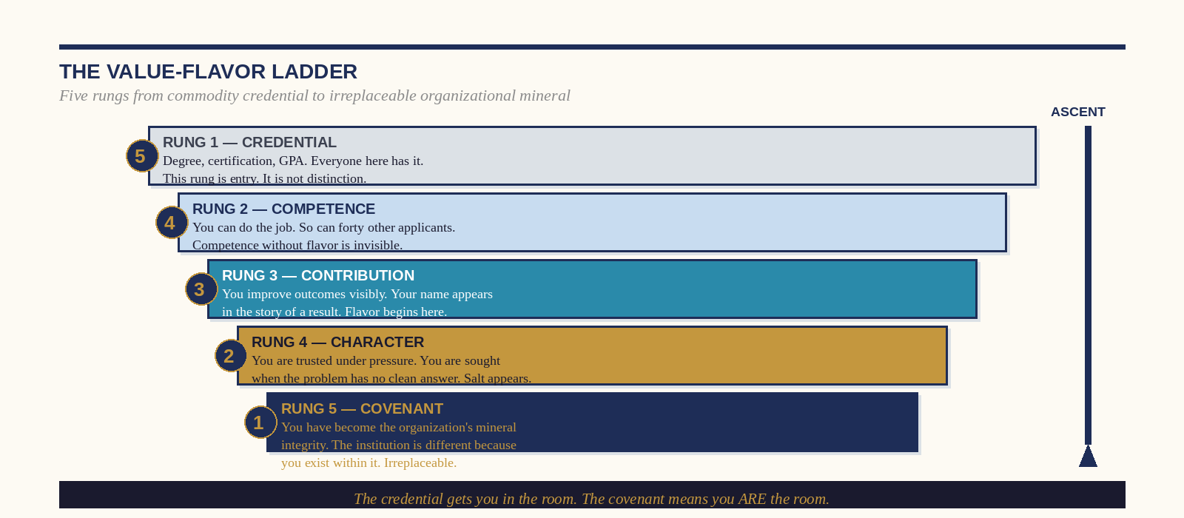
Figure: The Value-Flavor Ladder — Five Rungs from Credential to Covenant

Becoming the Organizational Mineral: The Value-Flavor Principle
The Value-Flavor Principle is a strategic framework for fast-tracking through organizational hierarchies by developing the specific qualities that cannot be credentialed, outsourced, automated, or replicated at scale. It operates on a simple but radical premise: the student who decides, at twenty-two, to invest in becoming an organizational mineral rather than an organizational commodity will, by thirty-two, be so distinctively valuable to any institution they enter that the ordinary rules of career advancement will not apply to them. They will not wait for promotions. They will be recruited for them. They will not negotiate compensation. They will be offered it preemptively. They will not be managed—they will be protected, because the organization will have correctly identified that losing them would be the equivalent of losing its flavoring.
This is not motivational rhetoric. It is a description of how the specific individuals who reach the top of organizational hierarchies faster and more sustainably than their peers actually operate—which is almost never through superior intelligence alone, and almost always through a combination of technical excellence and a quality of human presence that makes every room they enter qualitatively different. They make the work taste better. Their colleagues are better at their jobs when they are in proximity to them. Their clients feel, at the end of every interaction, not just served but genuinely encountered.

The Fast-Track Disciplines: What Salt Looks Like at Twenty-Five
01 Master a Domain No One Else Has Bothered to Master
In every organization, there are two to three domains that are operationally critical and chronically underinvested in because they are difficult, unglamorous, or require sustained effort without immediate visibility. Find them. Become the person who knows more about that domain than anyone in the building. This is not about career strategy—it is about becoming genuinely useful in a way that cannot be easily replaced. The person who deeply understands the organization’s regulatory exposure, or its customer data architecture, or the specific failure modes of its most important vendor relationship, is not merely an employee. They are a structural component.
02 Develop a Reputation for Antiseptic Honesty
The fastest way to become irreplaceable in any organization is to become the person who can be trusted to tell the truth in a room full of people who have decided, collectively and for reasons of political self-preservation, not to. This is not the same as being contrarian or aggressive. It is the discipline of saying, clearly and without personal charge, the thing that the situation requires and that the room is not saying. Leaders at every level spend enormous amounts of political capital identifying people who can do this. Develop the reputation, and the capital comes to you.
03 Build Cross-Boundary Relationships Deliberately
The Value-Flavor Principle accelerates dramatically when the practitioner has built genuine relationships—not LinkedIn connections but actual covenant relationships—across the organizational boundaries that most people do not cross. The young finance professional who has invested in understanding the product team’s concerns, the marketing associate who genuinely knows the sales operations challenges, the operations analyst who can speak fluently about the customer experience—these individuals do not merely have broader networks. They have become the nodes through which the organization’s most important non-obvious connections are made. They are not just employees. They are organizational infrastructure.
FOR THE STUDENT — The Three Questions That Reveal Your Salt
Before your next interview, internship, or networking conversation, sit with these three questions and answer them honestly:
1. What do I believe about the purpose of this industry that most of the people in it have stopped believing—if they ever believed it at all?
2. What am I willing to say out loud in a room full of senior people that they know to be true and have collectively decided not to name?
3. When I leave a room, what is qualitatively different about it? What is better?
If you cannot answer all three, the credential is all you have brought. That is enough to get in the building. It is not enough to matter inside it.

CHAPTER THIRTEEN

The Macro-Economy
Stabilizing the Shifting Terrain
“The market does not need your panic. It has enough. What it catastrophically lacks is your density—the concentrated, unwavering salinity of a practitioner who has decided that volatility is a climate, not a catastrophe.”

Navigating Market Hyper-Vibration
The defining economic feature of the current moment is not recession, inflation, or technological disruption—though all three are in active operation simultaneously. It is oscillation frequency. The average cycle time between market optimism and market fear in the decade following the 2008 financial crisis compressed by approximately 60 percent relative to the preceding decade, as measured by the VIX’s mean reversion patterns and the median duration of bull and bear cycles in the S&P 500. By the mid-2020s, the compression had continued. Markets now operate in a state of what complexity economists call ‘perpetual transitional instability’—a condition in which no stable equilibrium exists long enough to be relied upon as a planning premise.
For the organization that has built its strategy around the assumption of normal conditions, perpetual transitional instability is catastrophic. For the organization that has built its strategy around the assumption that instability is the only constant condition it will ever face—and that has therefore invested in the kind of internal density that makes it resilient to volatility rather than merely reactive to it—it is, paradoxically, a competitive advantage. When the market vibrates, diluted systems—those with thin margins, low differentiation, and strategies that depend on the continuation of current conditions—are the first to fail. Concentrated systems—those with high internal density, deep customer relationships, and strategies rooted in the provision of something genuinely irreplaceable—experience volatility as turbulence rather than as structural damage.
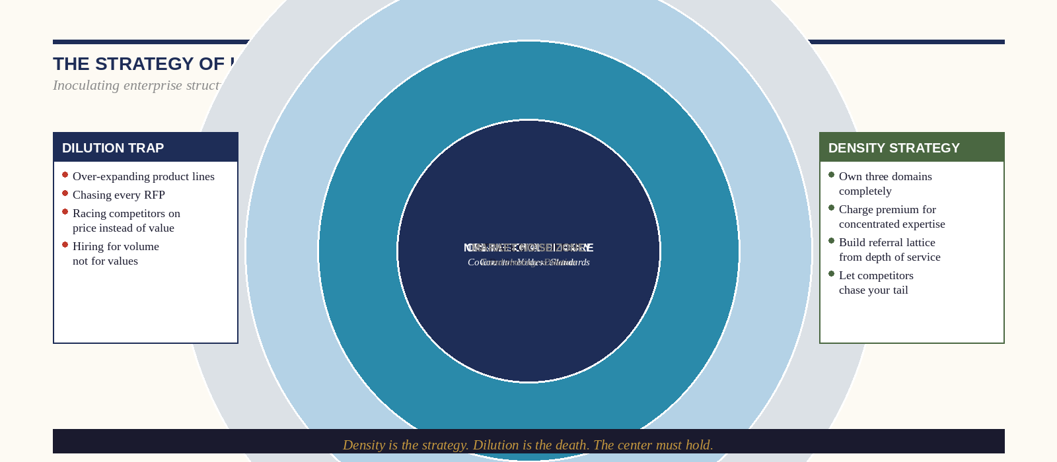
Figure: The Strategy of Hyper-Concentrated Value — Density vs. Dilution

Slashing Quality vs. Doubling Internal Density
When revenues compress—as they do, with perfect reliability, in every economic cycle—the organizational response falls into one of two categories. The first, and by far the more common, is quality reduction: the controlled deterioration of the product or service’s essential value in the interest of short-term cost management. The second, available to any organization with the courage to implement it, is density amplification: the deliberate concentration of the organization’s best resources, best people, and best attention on the narrower set of relationships and functions where the organization’s distinctive value is highest.
The quality-reduction path is intuitively obvious and strategically suicidal over any time horizon longer than one fiscal year. It is the institutional equivalent of an athlete, facing a difficult competition, choosing to eat less protein rather than train harder. The immediate caloric saving is real. The performance degradation, arriving precisely when performance is most required, is also real—and the compounding effects on the athlete’s reputation, their team’s morale, and their competitive position in the subsequent season are not recoverable through any amount of off-season recalibration.
The density amplification path requires a courage that organizational hierarchies rarely produce in abundance—the courage to say, publicly and without euphemism, that we are going to do less, and the less we do is going to be the most extraordinarily good version of that thing that this organization has ever produced. This requires the identification, with clinical precision, of what the organization’s actual irreplaceable value is—not what its brand positioning says it is, not what the founding story implies it should be, but what its best customers actually lose sleep over the prospect of losing. That specific thing is where the density must go.

Inoculating Enterprise Structure: The Anti-Fragile Protocol
The concept of anti-fragility, developed by Nassim Taleb in his landmark 2012 work, describes systems that do not merely resist volatility but actively gain from it—systems in which exposure to stressors, shocks, and disorder produces stronger rather than weaker structural integrity, in the same way that bone density increases under load rather than under rest. The anti-fragile enterprise is not the one that has built the most robust shock absorbers. It is the one whose core—its covenantal values, its relationships of genuine depth, its irreplaceable practitioners—is constitutionally strengthened by the market conditions that dissolve its competitors.
Inoculating an enterprise structure against volatility requires three specific interventions, each corresponding to one of salt’s functional properties. The preservative intervention builds the deep customer relationships that do not reset with each market cycle—the covenant relationships in which the customer’s loyalty to the organization is not a function of the organization’s price competitiveness in the current quarter but of the accumulated weight of the organization’s demonstrated commitment to the customer’s actual outcomes over years. The antiseptic intervention establishes the internal truth-telling mechanisms that prevent the organization from becoming complicit in its own deterioration—the audit processes, the board relationships, the leadership culture that rewards the naming of problems over the management of appearances. And the flavor intervention protects the specific qualities—the distinctive human capabilities, the institutional character, the things that make the organization worth being a client of rather than merely a vendor of—from the endless erosion of cost-cutting logic.
MACRO-ECONOMIC FRAMEWORK — The Three Inoculation Priorities
In a volatile market environment, allocate organizational investment in this sequence:
1st PRIORITY — COVENANT RELATIONSHIPS: Deepen the ten client relationships whose loss would constitute an existential threat. These are your mineral bonds. In a downturn, they will carry you.
2nd PRIORITY — TRUTH INFRASTRUCTURE: Invest in the internal mechanisms that surface problems early. The cost of the antiseptic is always a fraction of the cost of the surgery.
3rd PRIORITY — FLAVOR PROTECTION: Identify the three to five qualities that make your organization genuinely distinctive and explicitly protect them from the cost-reduction logic that will, with mathematical certainty, target them first.

CHAPTER FOURTEEN

The Political Sphere
Leaders as the Moral Preservative
“The republic was not designed to survive the absence of principled people in its institutions. It was designed to make their presence sustainable. Whether they show up is another question entirely—and it is always ours to answer.”

The Sovereign View of Justice: When Salt Leaves the Hall
The most sophisticated analysis of democratic decline written in the twentieth century was not produced by a political scientist. It was produced by a Polish poet. Czeslaw Milosz, writing in 1953 from the vantage point of a Central European intellectual who had watched liberal democracy dissolve into totalitarianism in real time, identified the mechanism of institutional collapse with an exactitude that no quantity of political science data has improved upon: it begins not with the rise of the authoritarian but with the departure of the person who would have said no. The autocrat does not defeat the democrat—the democrat leaves the room, exhausted and disillusioned, and the autocrat simply sits down.
The salt framework translates this observation into a precise structural diagnosis. Every functioning democratic institution—a legislature, a regulatory agency, a judiciary, a municipal government, a school board—contains within it a small number of individuals whose principled presence is the actual mechanism of its integrity. These are not necessarily the most powerful people in the institution. They are the people who, when a decision is being made that would compromise the institution’s foundational purpose, say the thing that cannot be said—who maintain, in the face of political pressure, factional interest, and the ordinary cowardice that institutional life produces, the standard that the institution exists to uphold. Remove them, and the institution does not immediately collapse. It simply begins, slowly and then rapidly, to be operated for the benefit of the people who have the most interest in its capture.
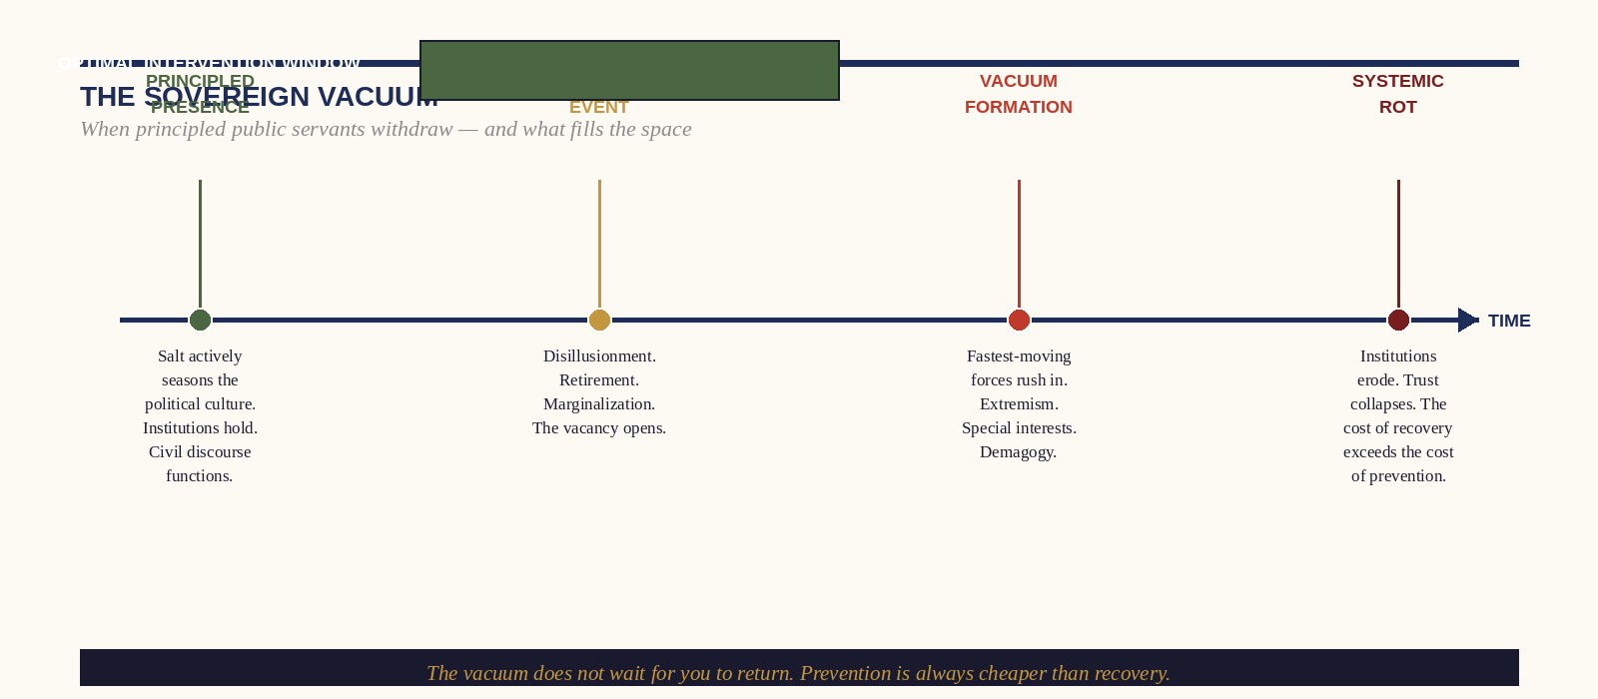
Figure: The Sovereign Vacuum — Timeline from Principled Presence to Systemic Rot

Civil Policy, Moral Rot, and the Political Vacuum
The evidence that democracies do not fail from the outside in but from the inside out is now sufficiently extensive to constitute a scholarly consensus. In their landmark 2018 study “How Democracies Die,” Steven Levitsky and Daniel Ziblatt analyzed every democratic breakdown of the twentieth and early twenty-first century and found that the overwhelming majority followed the same pattern: not military coup, not foreign invasion, but the gradual subversion of democratic institutions from within, by leaders who had been elected through democratic processes and who then systematically dismantled the constraints on their power—not all at once, but through the accumulated weight of small normative violations, each individually explainable, collectively catastrophic.
What Levitsky and Ziblatt call the ‘guardrails’ of democracy—the norms, relationships, and informal understandings that constrain institutional behavior in ways that formal law cannot—are maintained not by the rules themselves but by the people who enforce them through the exertion of principled presence in institutional settings. When those people are absent—when they have been marginalized, exhausted, bought, or simply discouraged from service—the guardrails fail. The rules remain on the books. No one enforces them. The decay is invisible on every formal instrument of measurement and obvious to anyone who has maintained enough salinity to perceive the difference between a functioning institution and its husk.

Being Effectively Out of Place in Public Service: Resisting Special-Interest Capture
The political leader who has read Chapter Four of this book—on the geometry of distinction and the strategic asset of being effectively out of place—will recognize the public-service application immediately. The most common and most operationally dangerous mechanism through which institutional integrity is compromised is not corruption in the dramatic, bribe-in-an-envelope sense. It is the infinitely more subtle process by which the person who enters public service with genuine principle is gradually assimilated into the institution’s existing culture of normalized compromise.
It begins with the most reasonable-sounding advice a new public servant will ever receive: “You have to learn how things work here before you can change them.” This sentence is true. It is also, precisely as delivered, a mechanism of capture. The implicit conclusion—‘and therefore you should not challenge the way things work until you have fully internalized them’—is the institutional equivalent of telling the salt that it must become part of the substrate before it will be allowed to season it. At which point, of course, it no longer can.
The practitioner who maintains their salinity in a public institution must therefore develop what we call the Sovereign Perimeter—a clearly defined, consciously maintained boundary between the institutional knowledge they are acquiring (which is genuinely necessary and strategically valuable) and the institutional culture they are being asked to absorb (which may be precisely what they entered the institution to change). The Sovereign Perimeter is not arrogance—it is the preservation of the specific cognitive and moral independence that makes the practitioner’s eventual contribution possible. The leader who arrives with fresh perspective and exits with completely assimilated perspective has not served the institution. They have been consumed by it.
THE SOVEREIGN PERIMETER — Four Maintenance Disciplines
1. COVENANT CLARITY BEFORE ENTRY: Write down, before your first day, the three to five non-negotiables that you will not compromise regardless of political cost. Not aspirations—covenant commitments. The act of writing them is the act of salting your own identity before the institution has a chance to dilute it.
2. EXTERNAL LATTICE MAINTENANCE: Maintain at minimum three active relationships outside your institutional context with people who share your foundational commitments. These relationships are your perimeter’s maintenance crew.
3. QUARTERLY COVENANT AUDIT: Every ninety days, return to your pre-entry list. What has held? What has been compromised? What rationalization do you need to examine? The quarterly audit is your antiseptic sting.
4. THE NON-NEGOTIABLE PUBLIC ACT: Once per year, at minimum, perform a visible act—a vote, a statement, a refusal—that demonstrates to your colleagues and your constituents that your principled presence is still operative. Silence reads as assimilation. Action maintains the signal.

CHAPTER FIFTEEN

Rebuilding the Social Fabric
The Localized Salt Network
“You cannot fix the nation from the top. The nation is fixed, if it is fixed at all, from the neighborhood outward. This is not a counsel of despair. It is a counsel of precision.”

The Geometry of the Linked Lattice
Sodium chloride’s crystalline structure is not merely aesthetically remarkable—it is the physical explanation of its extraordinary functionality. In the ionic lattice, each sodium ion is surrounded by six chloride ions at equal distances, and each chloride ion is surrounded by six sodium ions. The result is a three-dimensional network in which every node is load-bearing, every connection is mutually reinforcing, and the destruction of any single node does not compromise the structural integrity of the whole. Rock salt—the geological formation produced when these individual lattices fuse under pressure over geological time—is among the most structurally stable substances on earth. It does not decay. It does not dissolve in the absence of water. It has been found intact in mines sealed for millennia.
The social analogue of the ionic lattice is among the most important and least understood mechanisms of cultural renewal. The sociologist Robert Putnam, in his landmark 2000 work “Bowling Alone,” documented the catastrophic decline of ‘social capital’—the dense web of reciprocal relationships and shared civic commitments that had, for most of American history, constituted the actual infrastructure of democratic life—in the final decades of the twentieth century. His data showed that Americans were, in almost every measurable dimension, less connected to one another than at any point in the preceding century: fewer memberships in civic organizations, fewer friendships of genuine depth, fewer shared activities that produced the kind of repeated, low-stakes interpersonal exposure that builds trust over time.
What Putnam’s analysis identified as loss, the salt framework identifies as structural: the ionic lattice of American civic life had not merely weakened—it had been atomized. Individual crystals remained—extraordinary individuals, exceptional families, remarkable institutions—but the fusing pressure that converts individual crystals into geological rock had been removed. The result was not the absence of salt. It was the absence of connection between the salt that existed. The mineral was present but structurally inert.
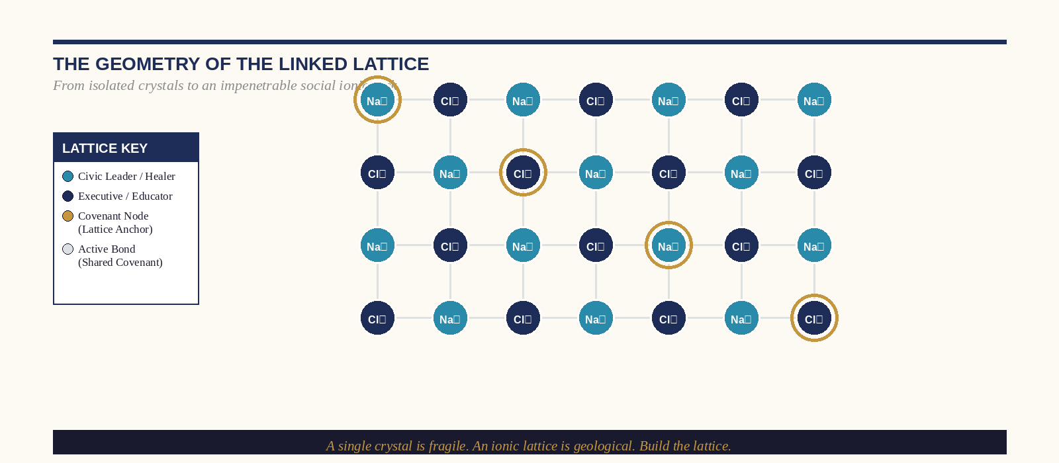
Figure: The Geometry of the Linked Lattice — From Isolated Crystal to Ionic Rock

Activating the Regional Grid: Bypassing Broken Institutions
The conventional prescription for social fragmentation is institutional reform: repair the schools, fix the legislature, invest in public infrastructure, reform the criminal justice system. These are not wrong prescriptions—they are prescriptions for a patient who is not actively dying. When the patient is actively dying—when the institutional infrastructure has deteriorated past the threshold of self-repair—the correct first intervention is not institutional reform but localized network activation. Build the lattice at the neighborhood level. Do not wait for the national institution to be fixed.
This is the strategic logic of the Localized Salt Network: the deliberate construction, in a specific geographic and social context, of a web of covenant relationships between people who share foundational commitments and who have decided, collectively, to operate as if the institutional support they would prefer to have is simply not coming—and to do the work of civic preservation themselves, at a scale and with a density of attention that no national institution can replicate. The network does not replace the institution in the long run. It demonstrates that the institution’s function is both necessary and possible—and, over time, it creates the conditions for the institution’s renewal by producing the human capital that genuine institutional life requires.
The empirical literature on community resilience—the capacity of a geographic community to absorb and recover from acute and chronic stressors—consistently identifies a small number of variables that predict resilience across widely divergent contexts: social cohesion, defined as the density and quality of interpersonal relationships within the community; the presence of trusted bridging figures who can move credibly across the community’s internal divisions; and what the researcher Daniel Aldrich calls ‘bonding social capital’—the deep, load-bearing relationships between individuals who have genuinely chosen one another as covenant community. These are, with extraordinary precision, the architectural properties of the ionic lattice. The communities that survive catastrophe are those in which the salt has found its structure.

The Micro-Architecture of Network Building
01 The Covenant Nucleus (3–5 People)
The Localized Salt Network does not begin with a meeting of fifty people, a nonprofit incorporation, or a strategic planning process. It begins with a conversation between three to five individuals who share both a geographic context and a foundational commitment to something specific—the education of children in a neighborhood, the economic resilience of a local business district, the safety of a particular population, the cultural preservation of a community identity. The covenant nucleus is not a committee—it is a lattice. Its members are selected not for their institutional positions but for their mineral integrity and their willingness to make a genuine commitment. The first act of the nucleus is not to plan—it is to covenant. To articulate what they are committed to that will not change when the conditions change.
02 The Bridging Node (The Connector)
Every effective Localized Salt Network contains at least one individual whose primary function is not content—not the physician who treats, the teacher who educates, the business owner who employs—but connection. The bridging node is the person who knows, with genuine depth, the people across the network’s internal boundaries: who knows the pastor and the atheist, the recent immigrant and the multi-generational resident, the property owner and the renter, the person who votes left and the person who votes right, and who is trusted by all of them not because they have no commitments of their own but because they have demonstrated that their commitment to the community’s coherence is deeper than their interest in any faction’s victory. The bridging node is the most structurally valuable individual in any network—and the most chronically underrecognized.
03 The Shared Practice
Lattices are formed not by agreements but by repeated shared action. The salt network that meets monthly to discuss shared values will disperse. The salt network that meets weekly to do a specific thing—to share a meal, to maintain a community garden, to tutor children, to run a business support circle—will cohere. The shared practice is the fusing pressure that converts individual crystals into rock. It does not need to be grand. It needs to be regular, embodied, and genuinely shared. The meal, the work, the walk: these are the liturgical acts of the civic lattice.
THE LOCALIZED SALT NETWORK — Activation Protocol
STEP 1 — NUCLEUS FORMATION: Identify three to five people in your specific geographic context who share your foundational commitments. Not acquaintances—people with whom you would be willing to make a genuine covenant.
STEP 2 — COVENANT ARTICULATION: Together, write the two or three specific commitments that define the network’s non-negotiable core. Not goals—covenants. What will you not compromise, regardless of political or social pressure?
STEP 3 — SHARED PRACTICE ESTABLISHMENT: Identify one specific, regular, embodied practice that the nucleus will perform together. Weekly is better than monthly. Physical co-presence is better than digital.
STEP 4 — BRIDGING INVESTMENT: Identify the two to three boundary-crossing relationships that the network needs to be structurally sound and invest in them with the same intentionality you invest in the nucleus.
STEP 5 — SILENT EXPANSION: Let the network grow through demonstrated quality rather than active recruitment. Salt does not advertise itself. It seasons.

CHAPTER SIXTEEN

The Master’s Return
Reclaiming the Never-Empty Shaker
“There is no graduation from salt. There is only the daily return to the source, the daily choice of the wound over the comfort of the shelf, the daily decision to remain—present, soluble, and wholly yourself—in a world that will spend every resource it possesses trying to dilute you.”

The Expert Panel: A Final Reckoning
The Folklorist and the Theologian who opened this book have been arguing across fifteen chapters and they have, at last, reached a place of unexpected convergence. Not agreement—they are scholars, and agreement is not their natural habitat—but a shared recognition that the question they have been debating is less important than the question it was generating. Whether salt is fundamentally a passive absorber or an active agent is, in the end, a question about mechanism. The more urgent question—the one that has been driving every argument in this book—is about commission. What are the people who carry salt supposed to do with it?
The Folklorist’s final position is this: salt’s passive dimension—its capacity to receive, to absorb without judgment, to create the conditions in which others can be fully present—is not weakness. It is hospitality. The leader who cannot be hospitable to the reality of those they lead—who cannot receive the truth of the organization’s condition without immediately reframing, managing, or defending against it—is not a preservative. They are a wall. The receptive dimension of salt is not the sponge syndrome we diagnosed in Chapter One. It is something more precise: the willingness to be genuinely permeable to information while remaining constitutionally stable in identity. It is the difference between a window and a membrane.
The Theologian’s final position is this: the covenant of salt does not excuse its carrier from the obligation of active deployment. The salt in the jar on the shelf is inert—chemically perfect, structurally complete, and doing nothing whatsoever for the world. The covenant is not consummated in the possession of salt’s properties. It is consummated in their application. The leader who has developed extraordinary mineral integrity through years of discipline, study, and the hard work of identity formation, and who then retreats to a private life of personal preservation—however beautiful, however well-earned—has fulfilled the first half of the covenant and abandoned the second. The commission was never to be salt. It was to season.
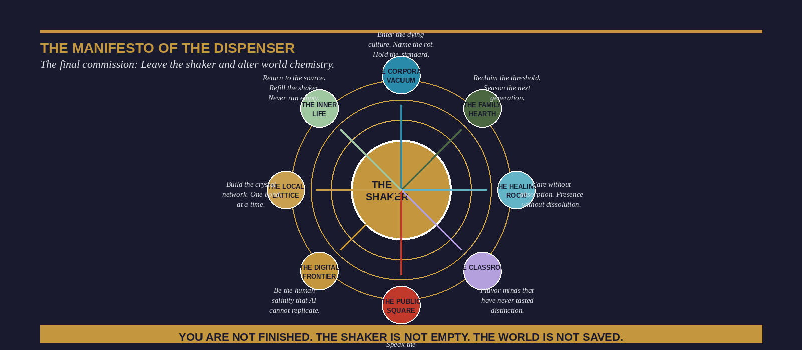
Figure: The Manifesto of the Dispenser — Eight Domains of Commission

The Mind Healed, The Boundary Secured, The Covenant Honored
The three achievements named in the title of this section are not sequential—they are simultaneous requirements of the mature salt practitioner. The mind healed is not the mind that has achieved a permanent state of psychological equilibrium—that is not healing, it is anesthesia. The healed mind is the mind that has developed the capacity to be disturbed by the right things in proportion to their actual importance, and to return, with increasing speed and decreasing effort, to its natural frequency when that disturbance has been processed and acted upon. It is the mind that no longer mistakes the weather for the climate—that can experience the full force of a difficult day, a failed initiative, or a broken relationship without concluding that the permanent condition of things has changed.
The boundary secured is not the boundary that keeps everything out. It is the boundary that keeps the right things in. The practitioner who has arrived at this point in their development has learned—through the failures and recoveries and gradual accretions of self-knowledge that this process always and only involves—exactly what their natural frequency is, what violates it and what replenishes it, what they can absorb without structural damage and what will dissolve them if admitted. They no longer need to perform the boundary—it is structural. It is geological. It has been formed, like rock salt, under pressure over time.
The covenant honored is the final integration: the recognition that the healing of the mind and the securing of the boundary were never ends in themselves. They were the preparation for return. For re-entry into the specific contexts—the organization, the family, the institution, the community, the era—where the practitioner’s salt is most needed and most likely to make the decisive difference between preservation and rot.

Dr. Amu’s Manifesto: A Call to Leave the Shaker
I want to speak plainly for a moment, in the first person, about what I have watched happen in my professional life across twenty years of working with leaders in crisis.
I have sat across from executives who built extraordinary organizations and then watched, with a helplessness they could not explain, as those organizations were slowly taken over by dynamics they had the power to prevent but not the framework to name. I have worked with physicians of such uncommon human quality that their patients described encounters with them as the closest thing to a sacred experience they had had outside a house of worship—and watched those physicians burn to nothing in institutions that had no language for what they were losing and no mechanism for protecting it. I have known parents who loved their children with a ferocity that was almost frightening in its depth and who had, in the ordinary chaos of contemporary life, somehow allowed the most powerful and most intimate relationship in any human life to be populated by proxies, by schedules, by screens.
In every case, the problem was not a deficit of love, talent, or intention. It was a deficit of framework. These individuals did not have a language—precise enough to act on, rich enough to sustain commitment to—for what they were trying to be in the world. They knew something was wrong. They could feel the vacuum they had left, or the vacuum they were being asked to fill, or the vacuum that was forming in their own interior life. But without a framework that named both the mechanism and the prescription, the feeling remained feeling: urgent, inchoate, and strategically inert.
This book is that framework. And the final instruction it offers is the simplest and most demanding of all of them: leave the shaker.
The shaker is every comfortable context in which your salinity is admired but not applied. The conference at which you are the celebrated speaker but not the difficult voice. The community that validates your salt but asks nothing of it. The introspective practice that develops your mineral integrity in isolation from the world that needs it. The shaker is not evil—it is necessary. The salt must be replenished. The source must be visited. The frequency must be recalibrated. But the shaker is not the destination. It is the preparation for the destination.
The destination is the wound. The failing organization where your refusal to normalize the decay is the only thing standing between a culture of mediocrity and one of genuine flourishing. The family dinner table where your presence—actual, embodied, attentive, seasonable—is the difference between children who develop an interior life and children who are raised by an algorithm. The political institution where your willingness to say the unsayable is the mechanism by which the institution remembers what it is for. The patient who needs not just treatment but the radical, life-altering experience of being genuinely seen by the person responsible for their care.
The world has enough salted shelves. What it catastrophically lacks are salted wounds.
“You are not finished. The shaker is not empty. The world has not yet tasted what you are. Leave the jar. Find the wound. Season it.”
— End of Section Three: The Institutional Imperative —
Dr. Ishmael Amu • The Salt Effect

