Human Graphics Pipeline documentation

Collecting the resources

There are a number of resources available for use in the Human Graphics Pipeline. Ideally, to get the best experience using these tools you would need the following raw materials.

- Thick markers, whiteboard or permanent
- A4 or A3 plain paper
- A4 or A3 acetate
- Sticky putty
- A group of people

All of the printable materials are available from this website

For the simple pipeline model and the mathematical rasterization addition you would need

- This document
- Transparent Pixel Grid printed on acetate
- Worldspace Grid
- Coordinate holder

For the simple pipeline with clipping you would need

- This document
- Transparent clipping pixel grid printed on acetate
- Clipping worldspace grid
- Coordinate holder

Depending on the scale of your implementation the quantity of each of these you print can vary.

Building the pipeline

Simple Pipeline
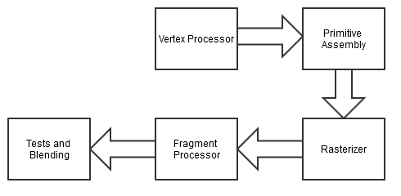

Stage 1 - Decide what primitive is to be drawn

Have someone begin the drawing process by setting what type of primitive to draw.

The easiest example to use is GL_TRIANGLE

Stage 2 - Provide vertices for the primitive

Have a group of people input a number of vertices, have them organised in a first in, first out way so that they can be picked up later in the pipeline in that order.

The vertices should be three dimensional, that means they should have an X,Y,Z layout. For simplicity the range of coordinates in all three directions should be limited to 1 to -1.

Stage 3 - Assemble the primitive

At this stage someone should build the primitive you want to draw from the vertices put in to the list in the previous stage. The number of vertices that are taken will depend on the primitive that is being drawn.

Stage 4 - Plotting to world space

The assembled primitive should then the taken by another person who plots the points into world space.

Once the points are plotted they should be joined up to create the primitive.

Stage 5 - Rasterizing

Overlay a pixel grid on the shape drawn in world space and mark the pixels that you think would be used to create the shape in pixel space.

Stage 6 - Fragment shading

Here the chosen colour should be used to shade in all the pixels that were marked as part of the shape in Stage 5.

Entire pixels should be shaded not just up to the line created by the primitive.

Stage 7 - Buffering

The final stage is to move all the data for the completed shape out of the work space and into a storage area, this is to simulate the data produced being put in to the display buffer ready to be drawn.

Advanced element 1 - Mathematical rasterizing

This element should be used to replace Stage 5 in the basic pipeline

Stage 5 - Mathematical Rasterizing

At this stage there are two mathematical methods that can be used to calculate what pixels are to be rendered, Half Space and Barycentric.

First overlay the pixel grid on the world space grid containing the plotted points and drawn primitive.

Create a bounding box around the primitive, this should be padded out to be to the nearest pixel that does not intersect the primitive. An example is below.
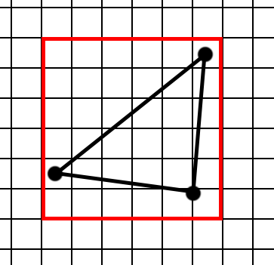

Place a point roughly in the center of each of the pixels within the bounding box and estimate their coordinates in world space.

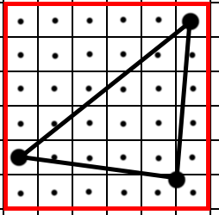

You should now be ready to apply an algorithm to the shape to find out what pixels it will occupy on screen.

You need to know the three world space coordinates for the triangle and the world space coordinate for the point you wish to check, you also need to know the order the vertices were placed into the scene, these should be labeled a, b and c respectively.

Below are two algorithms, Half-space and Barycentric, they will produce a true or false value for estimating if the point is within the triangle.

Half-space

To check if the point is within the triangle you run it through an algorithm that checks its position to the left or right of the lines connecting the primitives points together.

Point check algorithm - (2.x - 1.x) * (p.y - 1.y) - (2.y - 1.y) * (p.x - 1.x)

Algorithm steps :-

1 - Take triangle points a and b, a is point 1, b is point 2.

2 - Get the point you wish to check for, this is known as p.

3 - Put these points through the point check algorithm, .x is the first number and .y is the second in the vertex.

4 - Record the result.

5 - Repeat for b, c and c, a. Pay attention to the order of the vertices, this has an effect on the outcome.

6 - Collect all results, if they are all positive the pixel is within the triangle, if any or all of the numbers are negative then the pixel is not within the triangle.

Barycentric

Here you are using the vector of the lines to check if the point is within the triangle.

1 - Calculate the vectors, to do this the method is…

Vector 1 = (b.X - a.X, b.Y-a.Y)
Vector 2 = (c.X - a.X, c.Y-a.Y)
Point vector = (p.X - a.X, p.Y - a.Y)

These should produce three vectors with two values, one for X and one for Y.

2- Calculate two variables using these vectors.

s = (Point vector * Vector 2) / (Vector 1 * Vector 2)
t = (Vector 1 * Point vector) / (Vector 1 * Vector 2)

Once you have these two variables you can work out if the point is within the triangle.

3- Only if all these conditions are true will the point be considered as in the triangle.

s is greater than or equal to 0

t is greater than or equal to 0

s+t less than or equal to 1

An online calculator for both types of algorithm can be found at http://shearer12345.github.io/humanGraphicsPipeline/Calculator.html

Advanced element 2 - Edge Clipping

This stage should be done between stages 4 and 5 of the basic pipeline. Changes are made to stage 2 also.

The worldspace and pixel grid should be replaced with the clipping worldspace and clipping pixel grid, both available from http://shearer12345.github.io/humanGraphicsPipeline/Resources.html .

Advanced element - Edge Clipping

Stage 2 alteration

The 1 to -1 limit is removed from the incoming vertices, they can now be from 1.3 to -1.3 in all directions.

Edge Clipping

Once the shape has been plotted and the connecting lines drawn somone can plot the clipping points.

This is done visually by looking at where the line intersects with the bounding box around the world space area, the points should be plotted and treated as vertices.

After the clipping points have been plotted the resulting points should be joined up to make new triangles, this should be done in a clockwise direction starting at one of the points clipping with the edge and should be done until all vertices are grouped into triangles see below for an example.

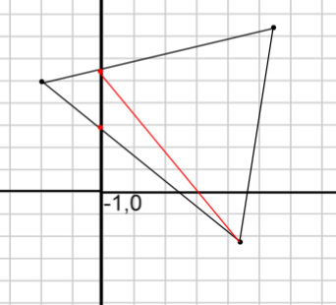

Each triangle should the be rasterized as a separate primitive.

