Ajith karate(jsaindia.in)

Home page

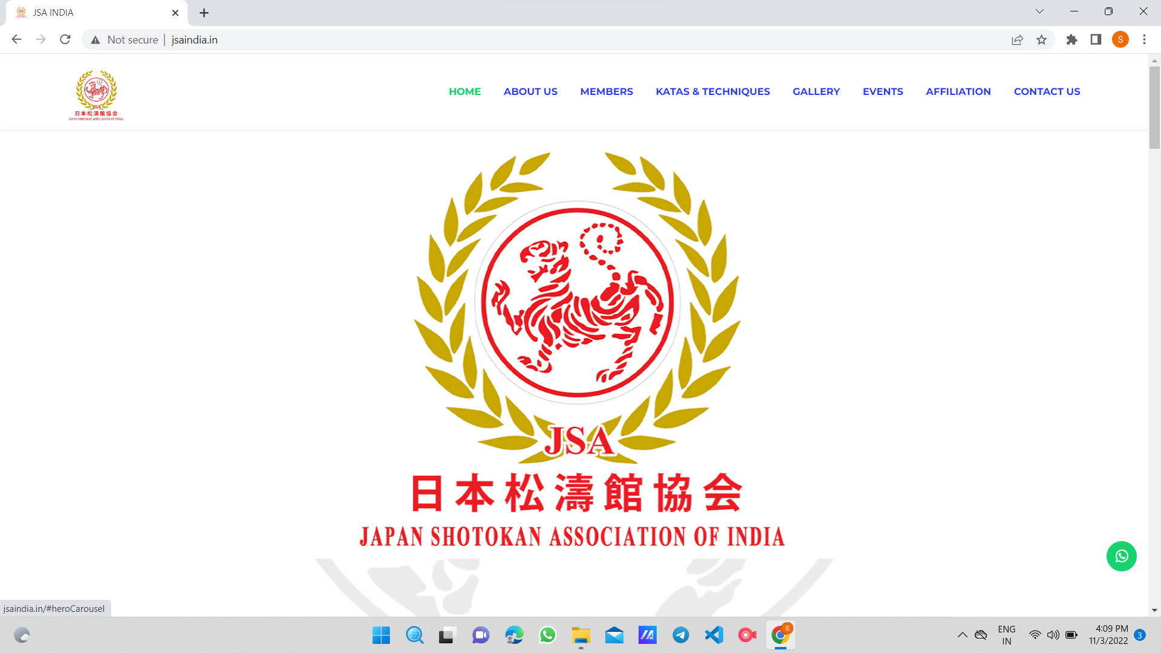
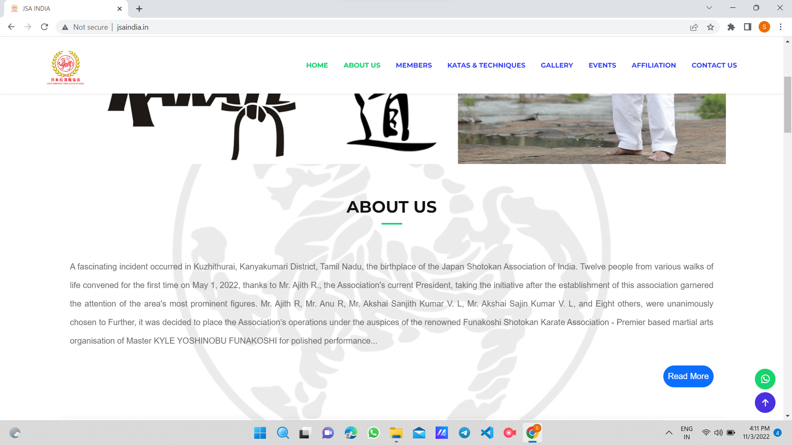

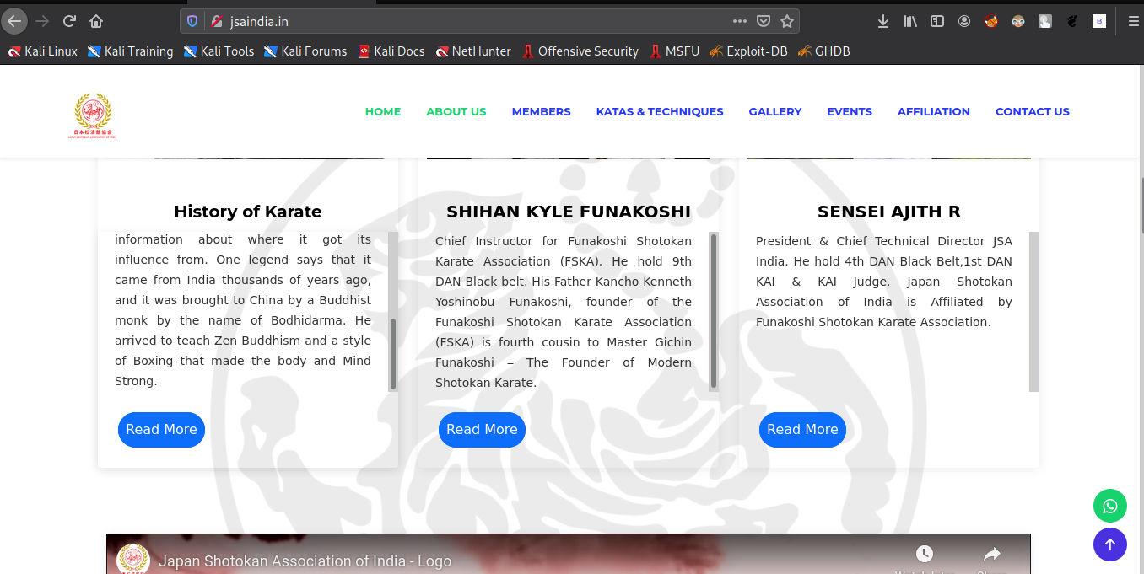

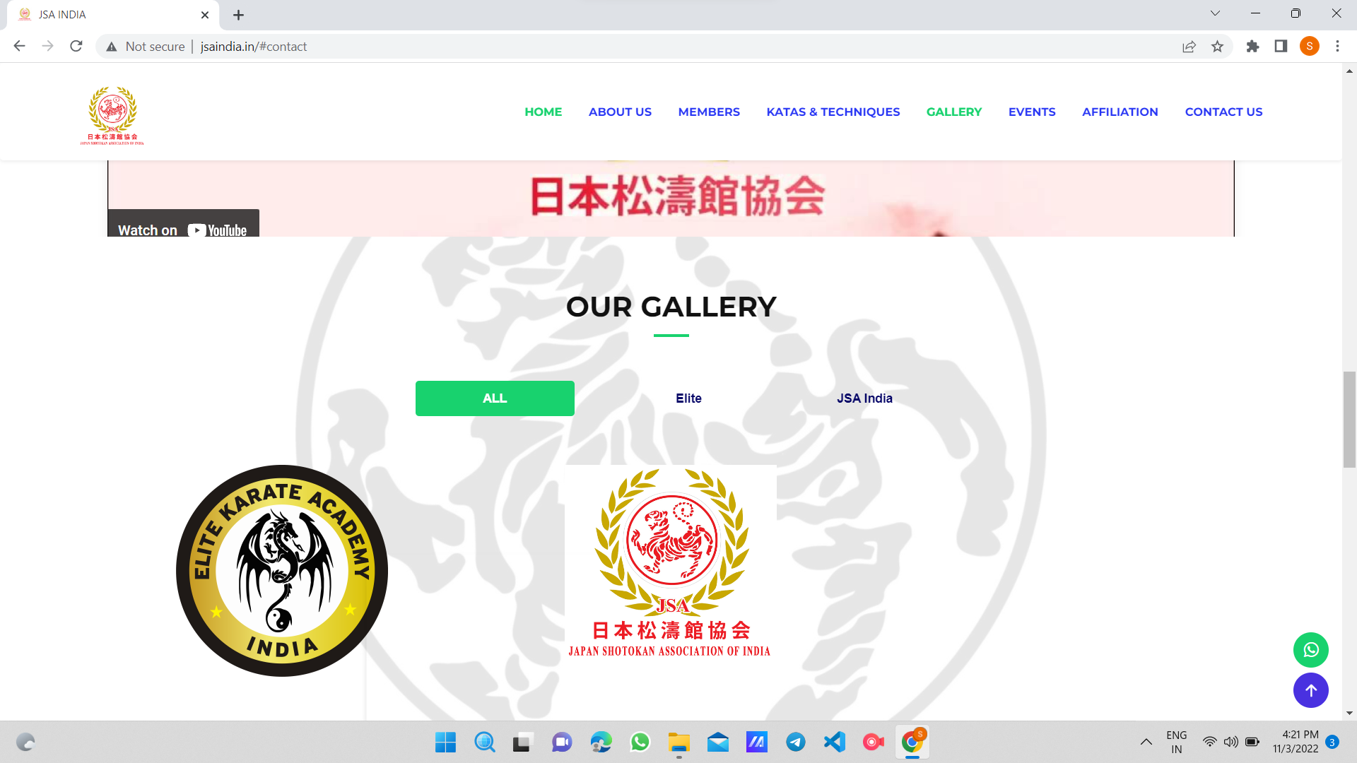


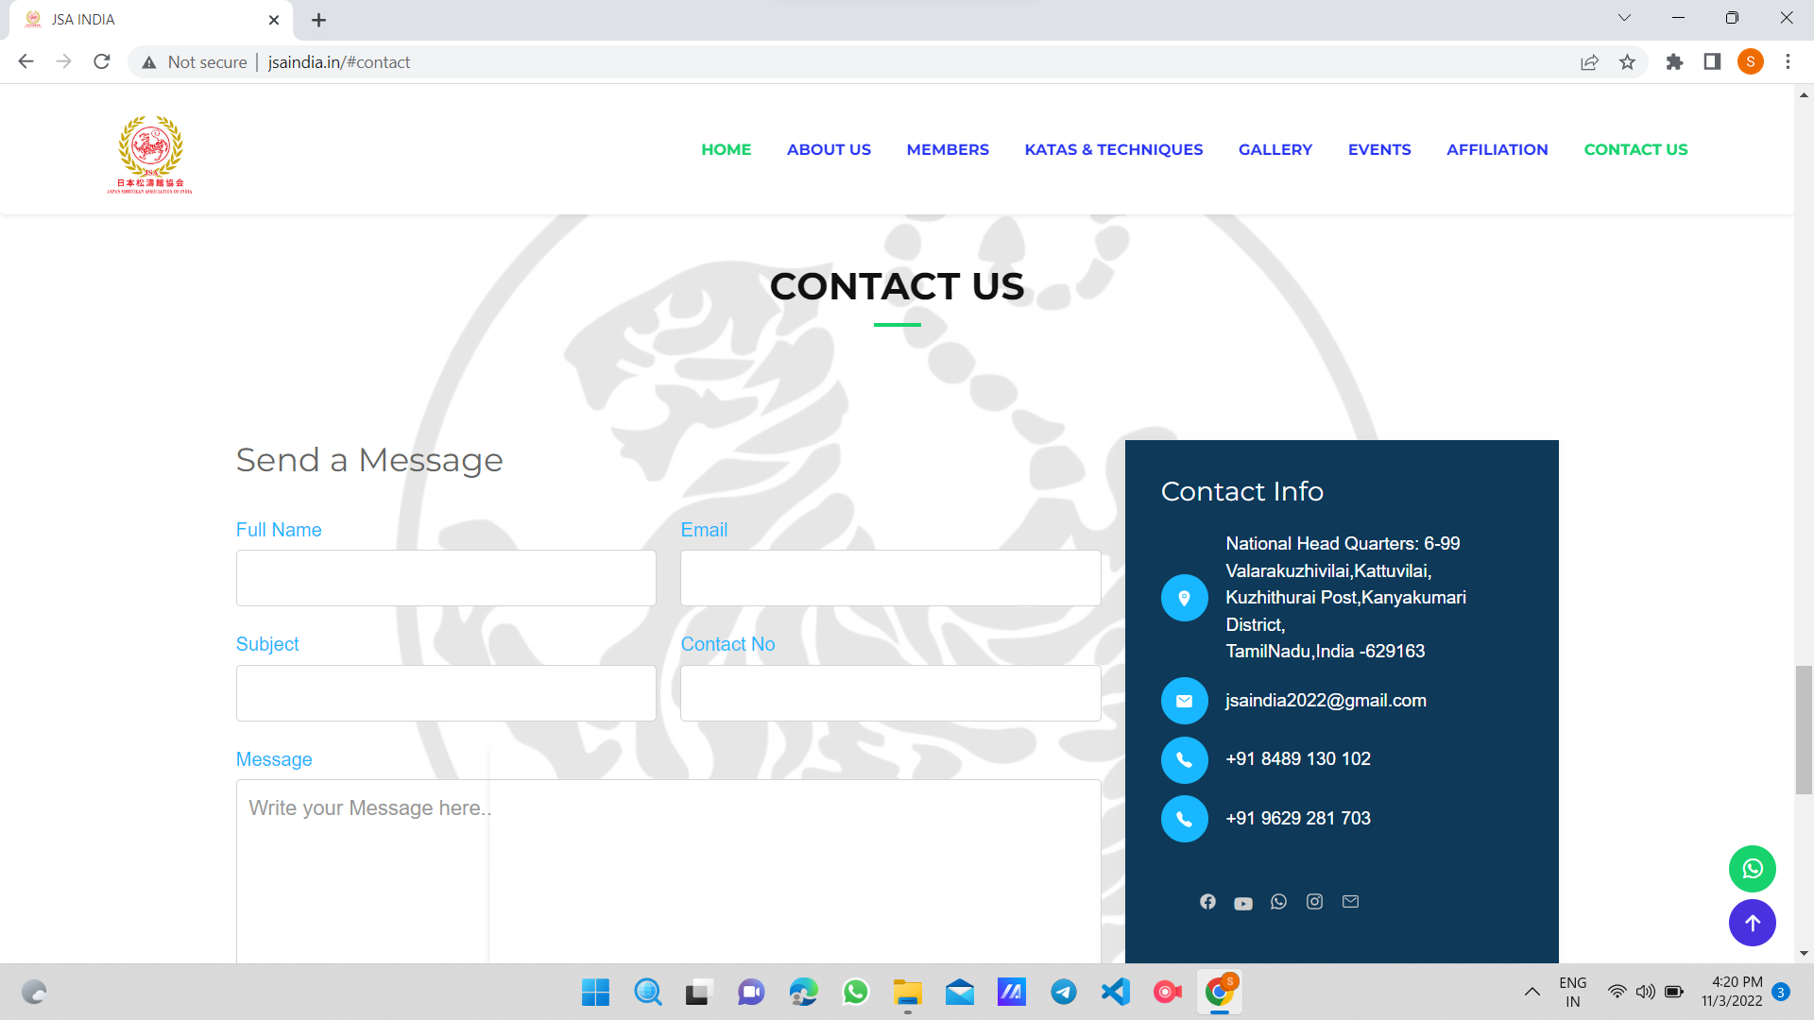

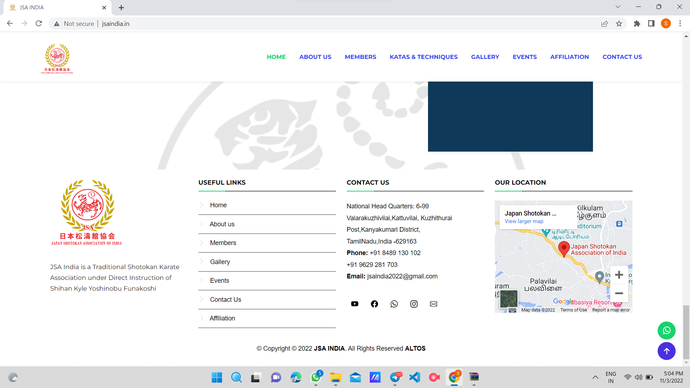
The home page consists of all the main details and features of the website.
We can see a carousel of 2 images consists of logos once we enter the site. Under that an ‘about us’ section is given which describes the history,details and timing of the organisation- There is a ‘read more’ button which expands the description .
Under that there is three section which is ‘History of karate’ – which describes the history of karate, ‘shihan kyle funakoshi’ – which desribes about the chief instructor of Funakoshi shotokan karate association(FSKA), ‘sensei ajith r’ – which describes about president and chief technical director of jsa india. There is a ‘read more’ button for these three sections which expands the description.
Under that there is a youtube video which is about japan shotokan association of india.
Under that there is a gallery section which is used to upload images as folder wise from backend.
Under that there is a call to action section there we have given a button which is used for calling the organisation and setup with the owner number.
Under that we have given a contact us form which can be used to contact the organisation.5 fields have been included in this form and when the user submits the form it directly goes into the admin panel and he can view the details of the contacted person easily. Also there we have given contact address.Also a news and events section which can be added from backend .And in the footer useful links,contact us details,location map have been provided.

Code flow

Contact us

The next navbar section is contact us.It directly points towards the same contact us form in home page

Code flow

Members section

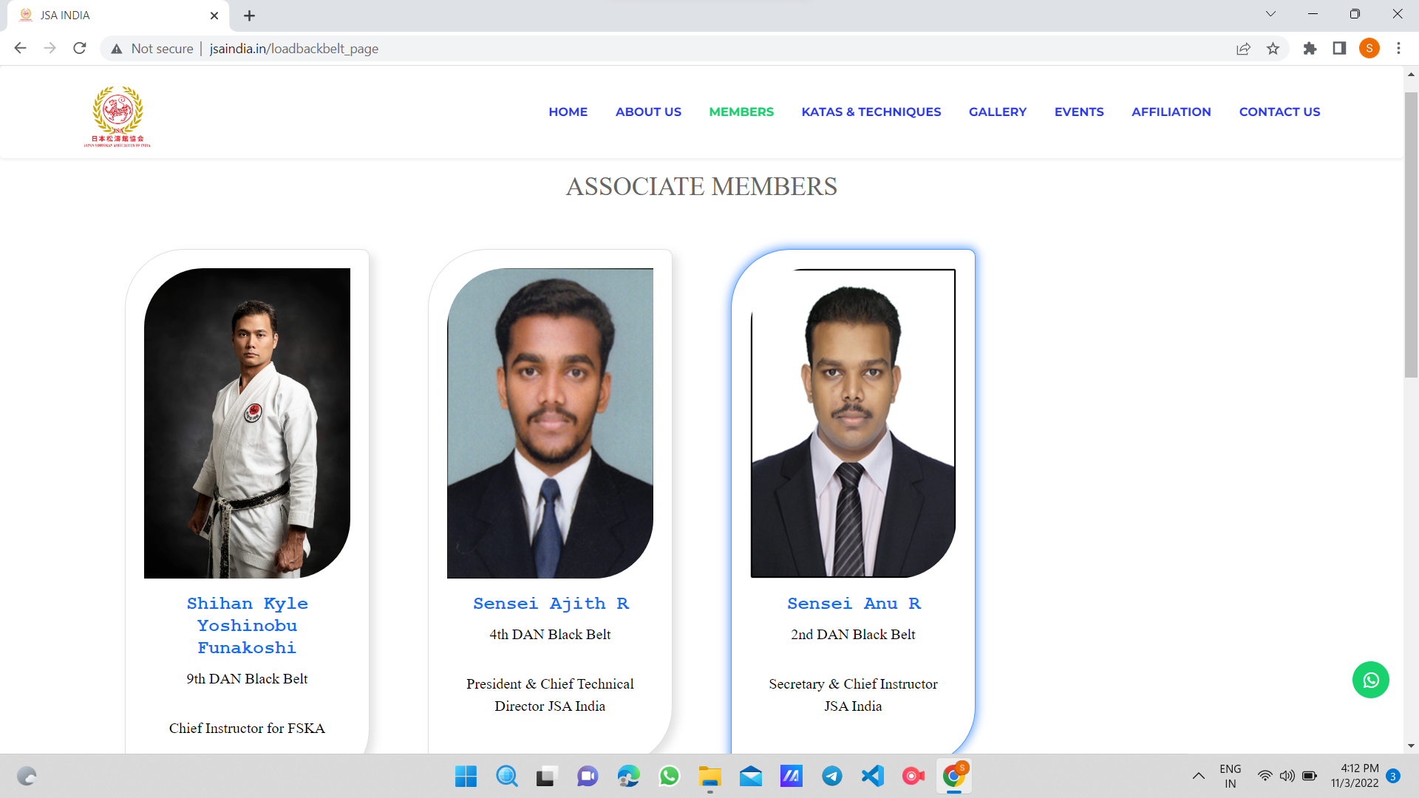
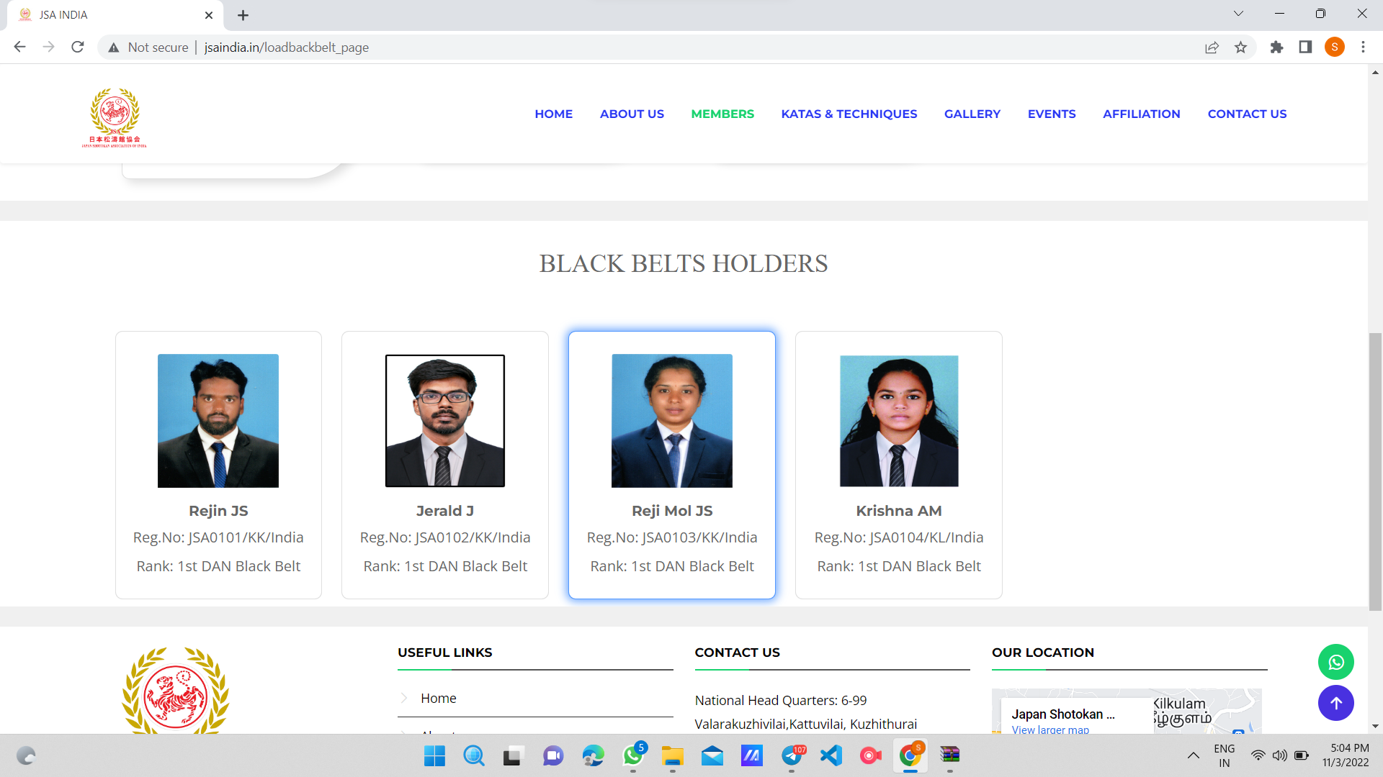
The next section shows about the members of jsaindia and there details and the same footer at the end of the page.

Code flow

Katas and techniques

The next section is katas and techniques.It includes multiple karate katas images which is adding from backend and the same footer at the end

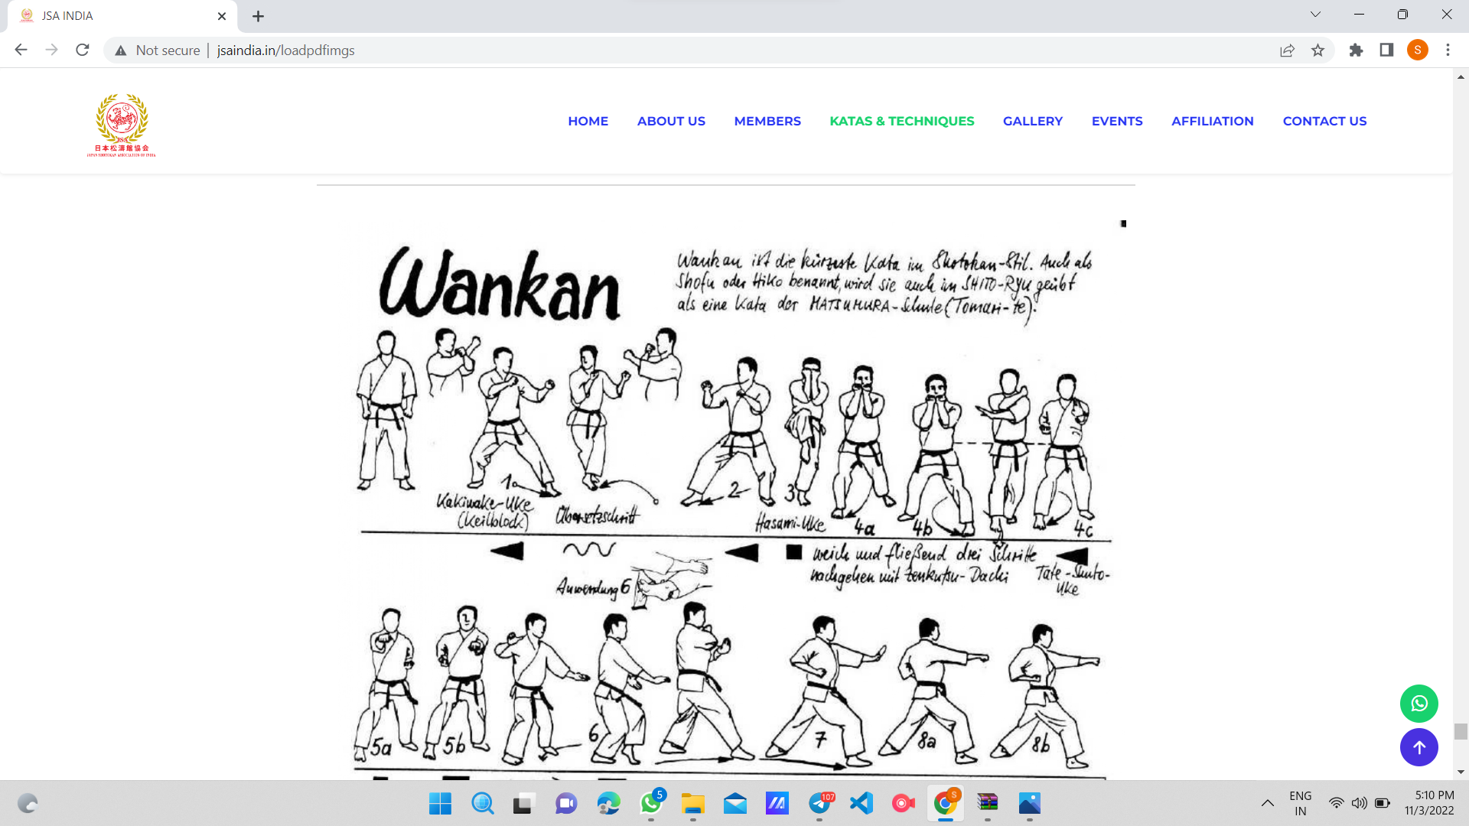
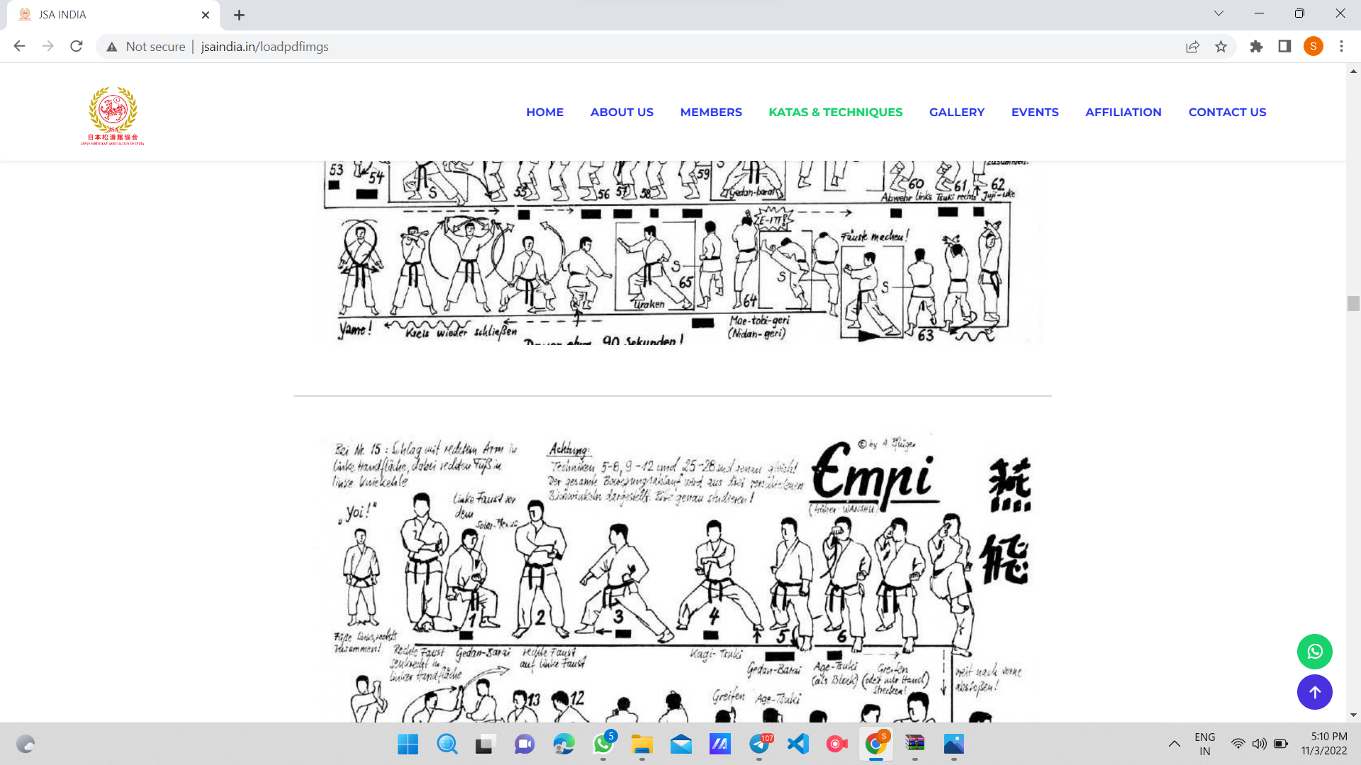

code flow

Gallery

Next section is gallery which directly points towards the gallery section in home page.

code flow

Event section

The next section is event. In event section we have provided options to add events, it’s details, images,attachments from backend.Also the same footer at the end.

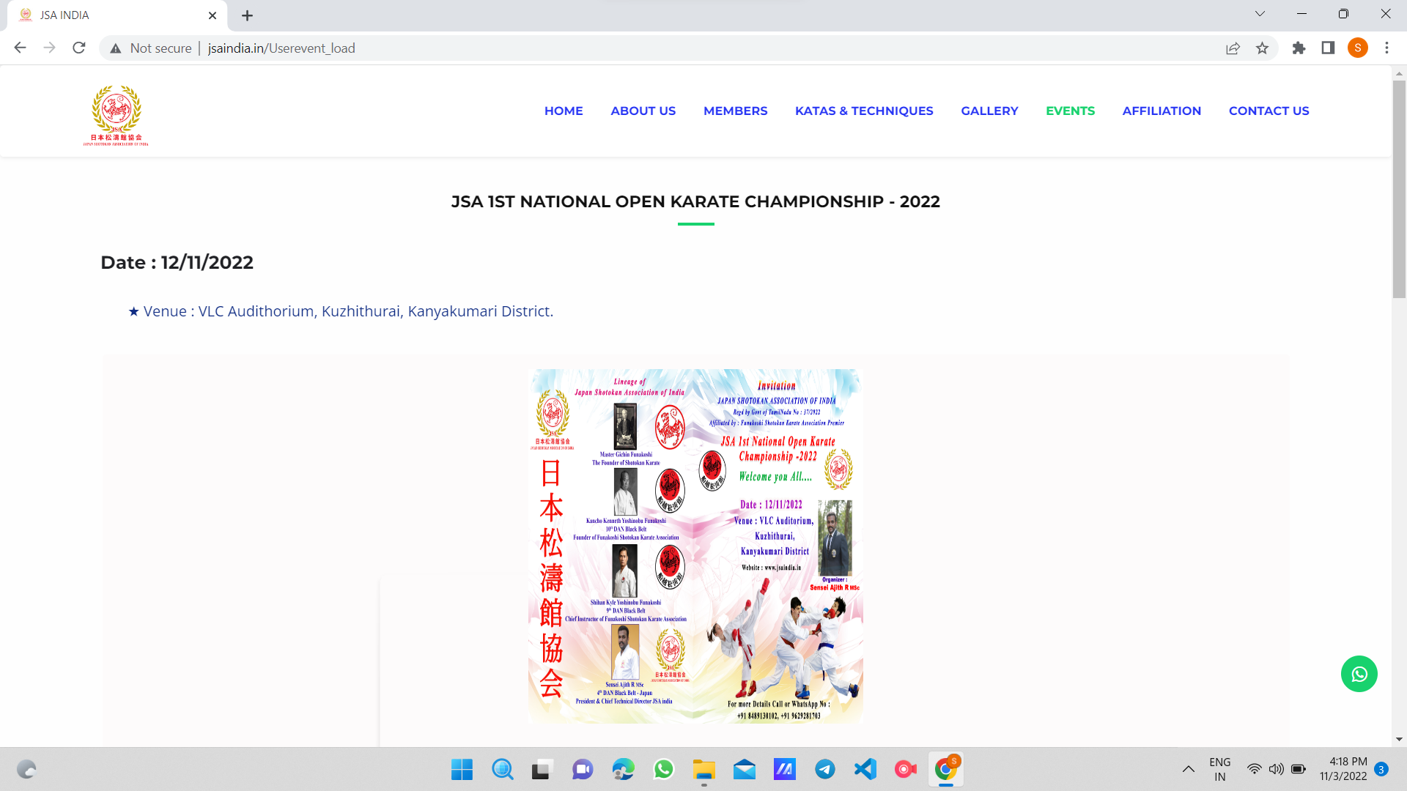
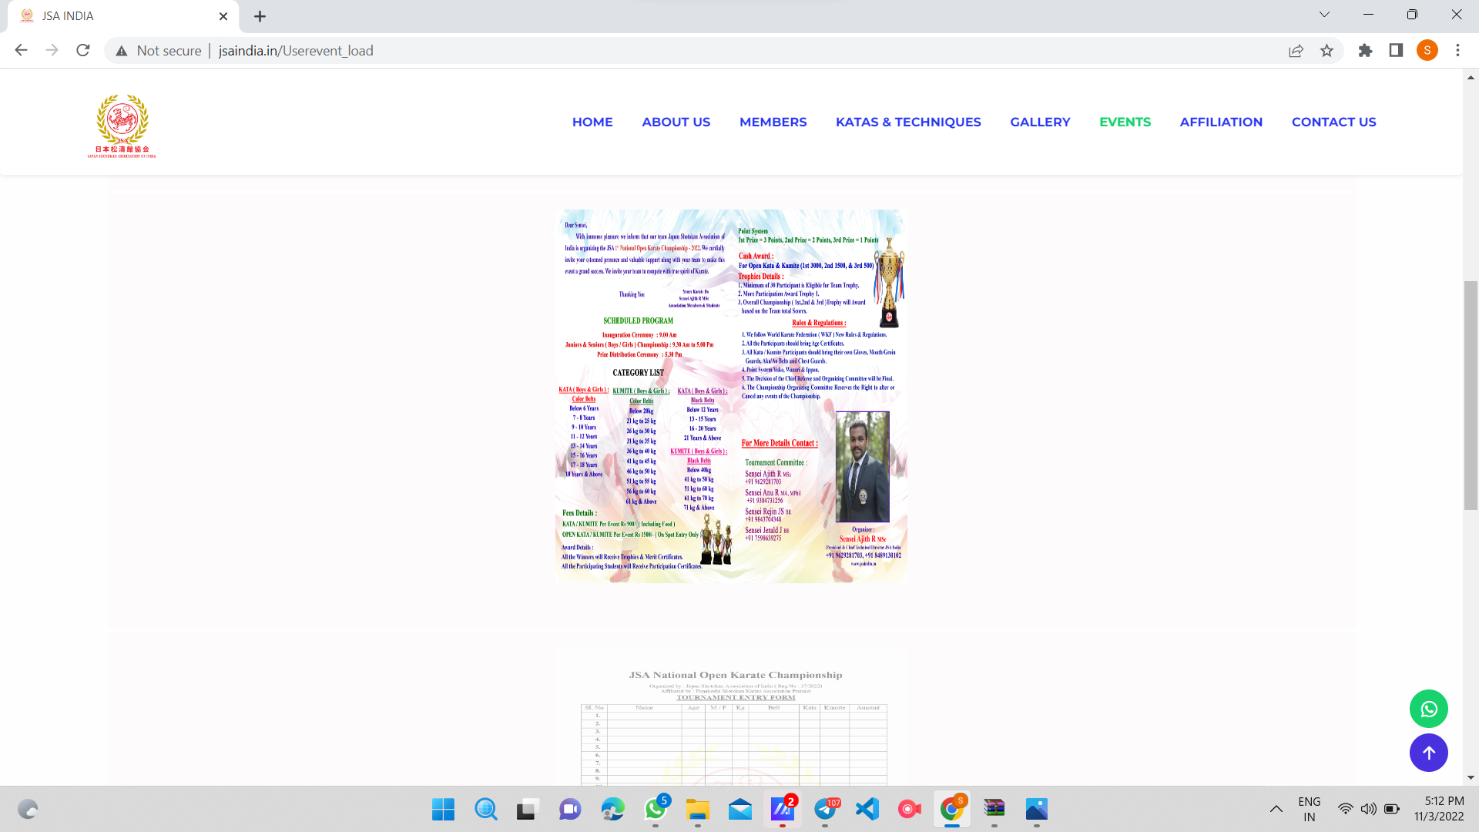

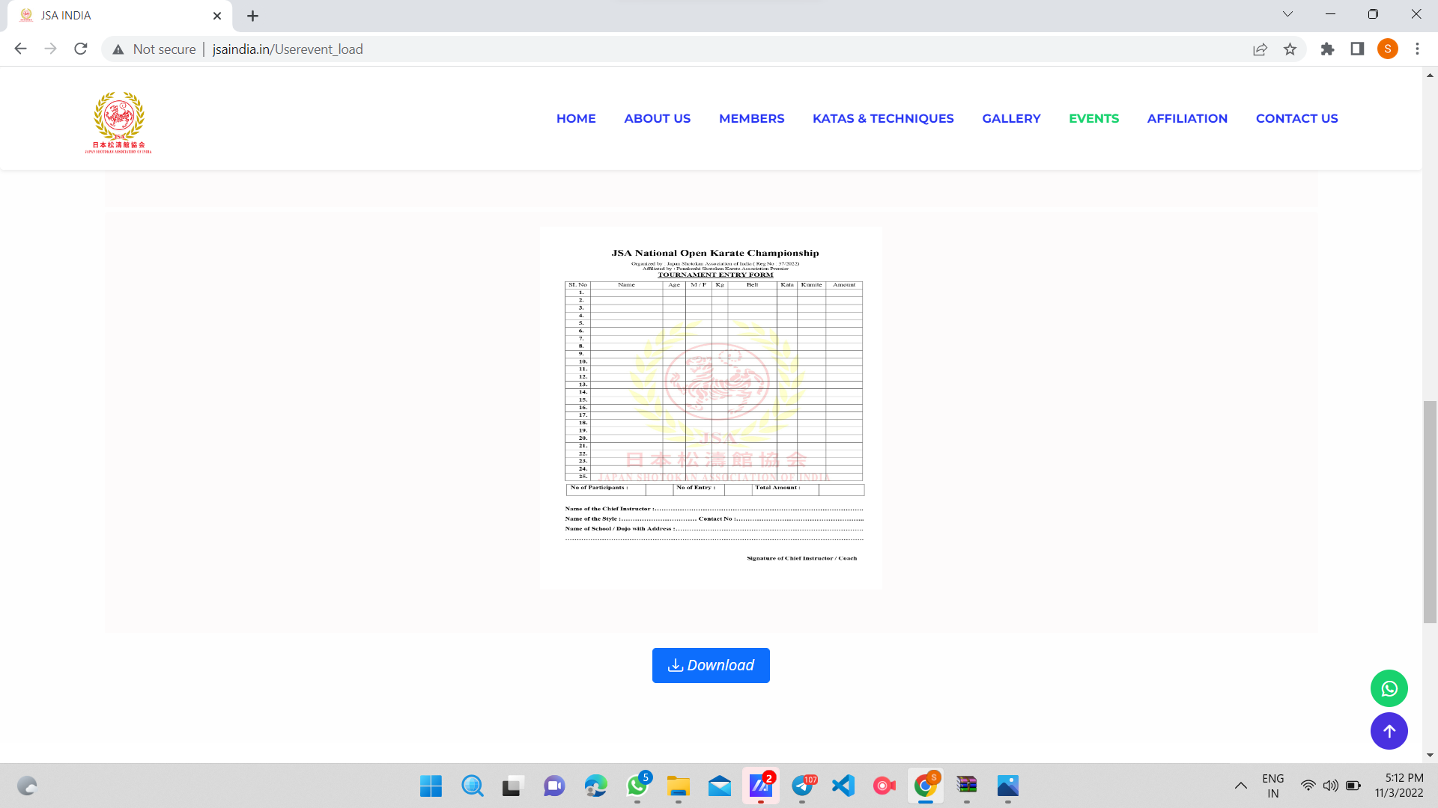
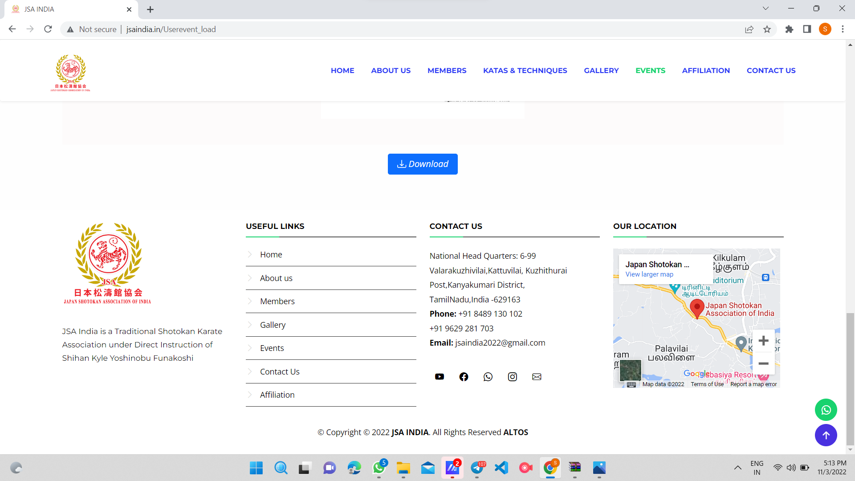

code flow

Affiliation

consists of details about the affiliation of the association.We have provided an option to directly add this from admin panel

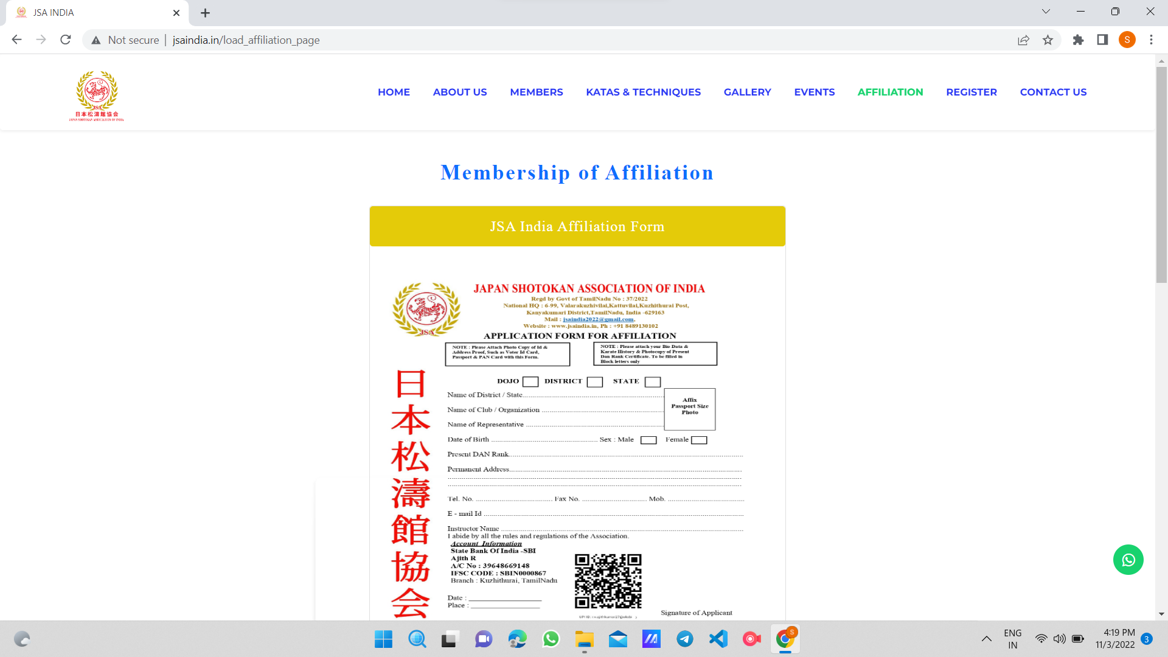

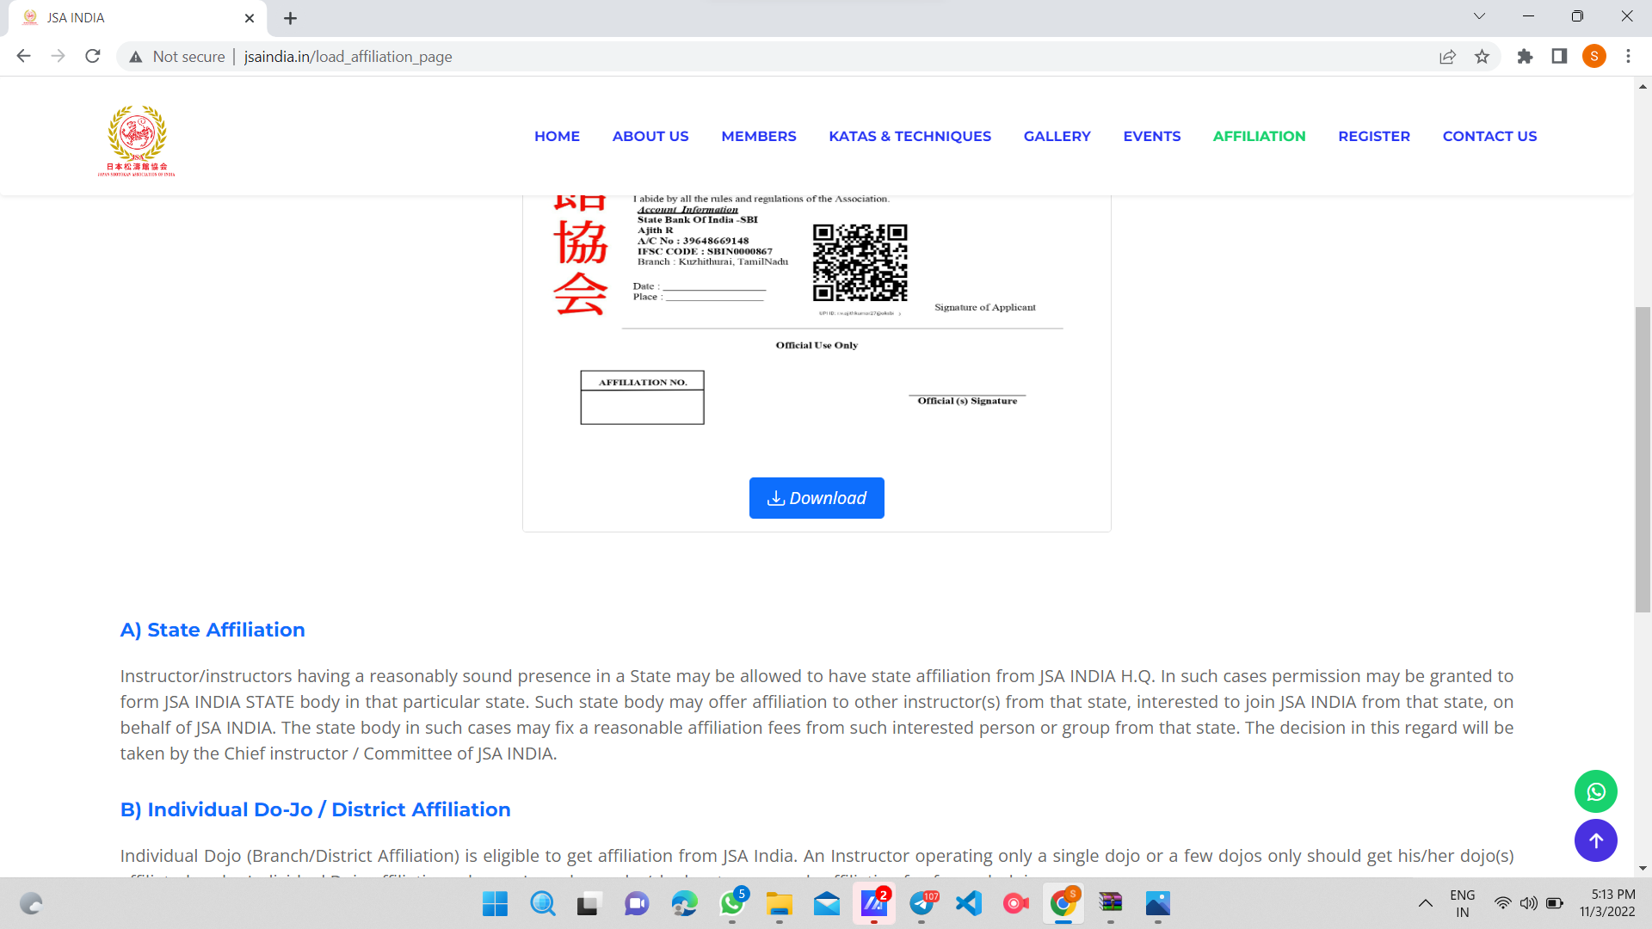

code flow

Student registration

near affiliation there is a student registration form which students can register for karate.The admins can view the students who registers on the site in admin panel.
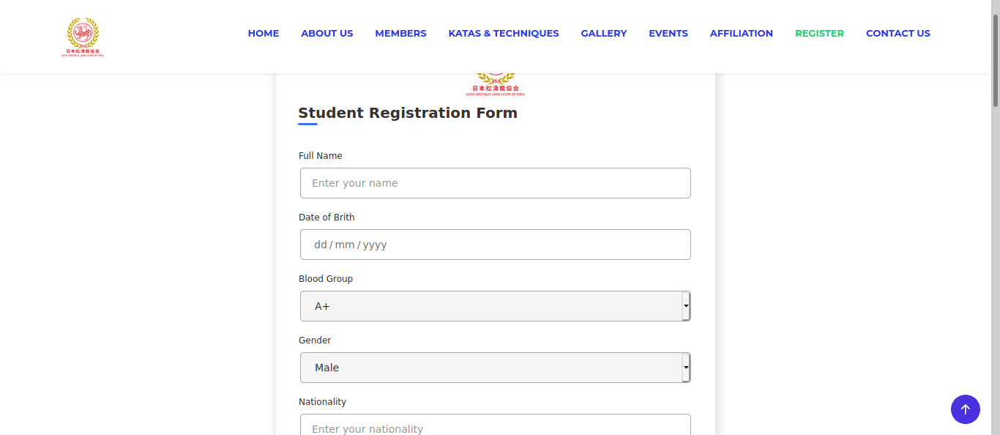

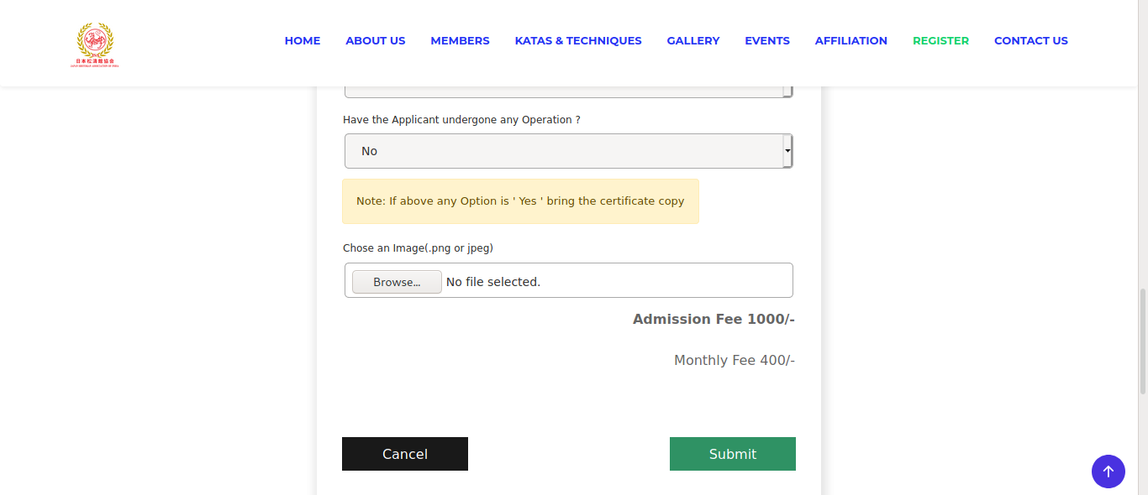
Code Flow

Finally a contact us form which directly points towards contact us form in home page

ADMIN PANEL

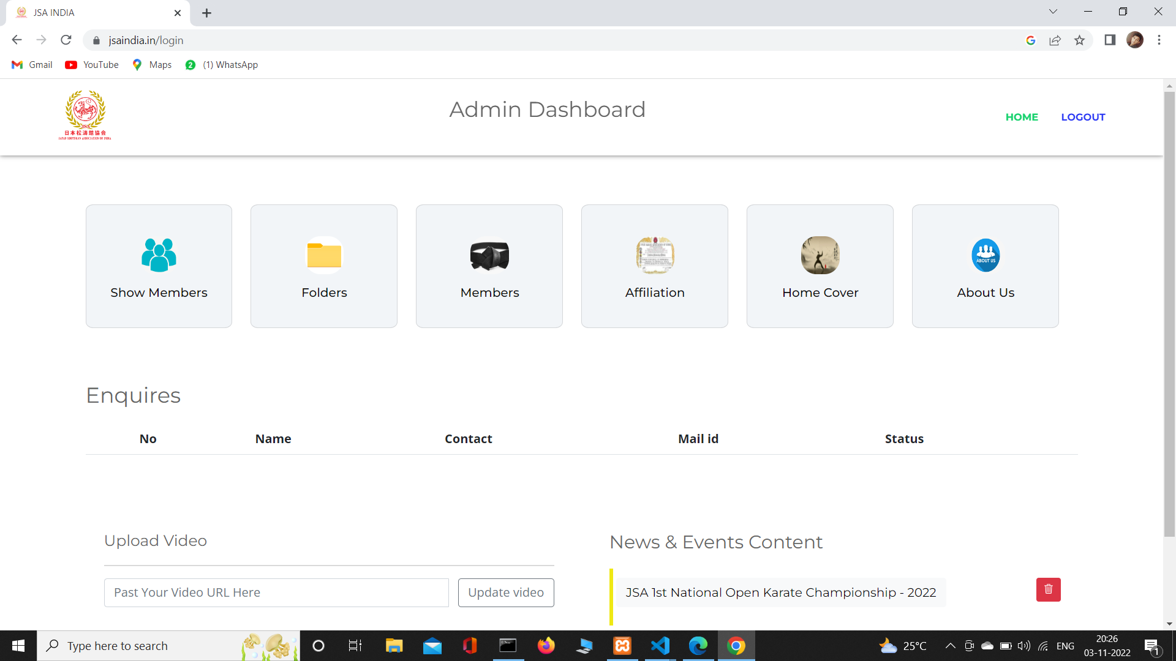
The admin panel consists of many options. We have given options to change the youtube video in the home page.In the show member section admin can see all registration details

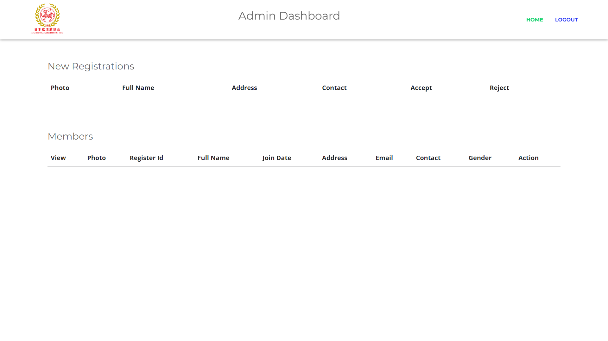
Code flow

In folder section admin can create folder and inside the folder admin can add images.This comes in gallery section of the home page.

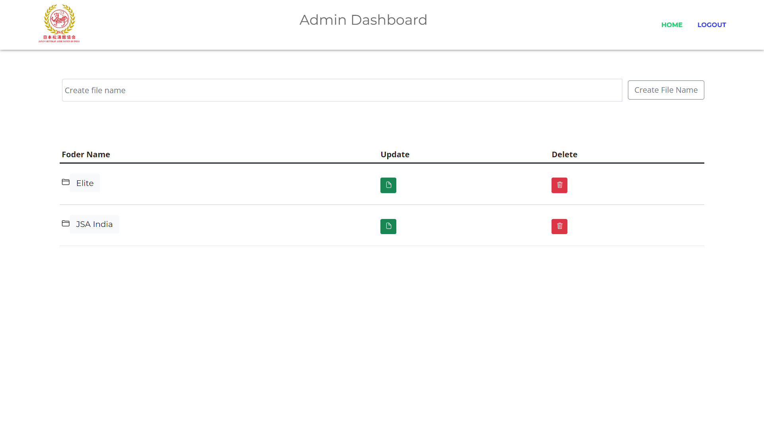

Code flow

In member section admin can add associate members and black belt members which is visible in member section of the site.

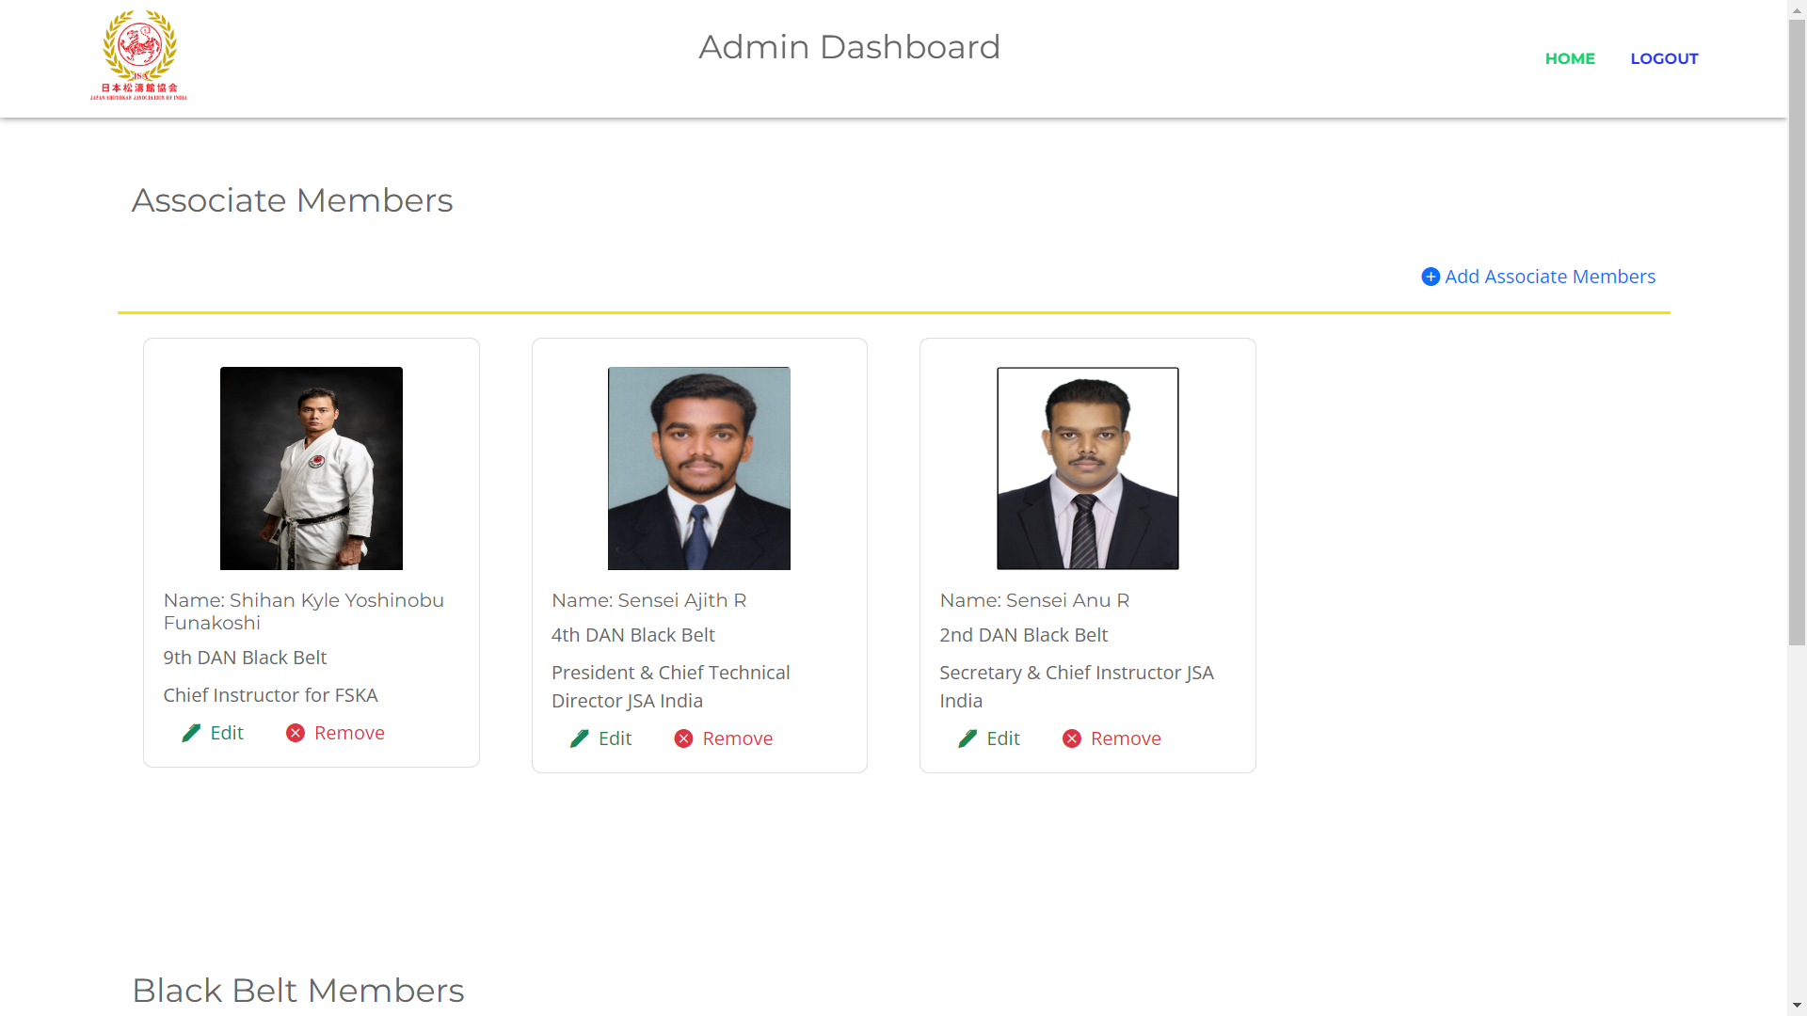

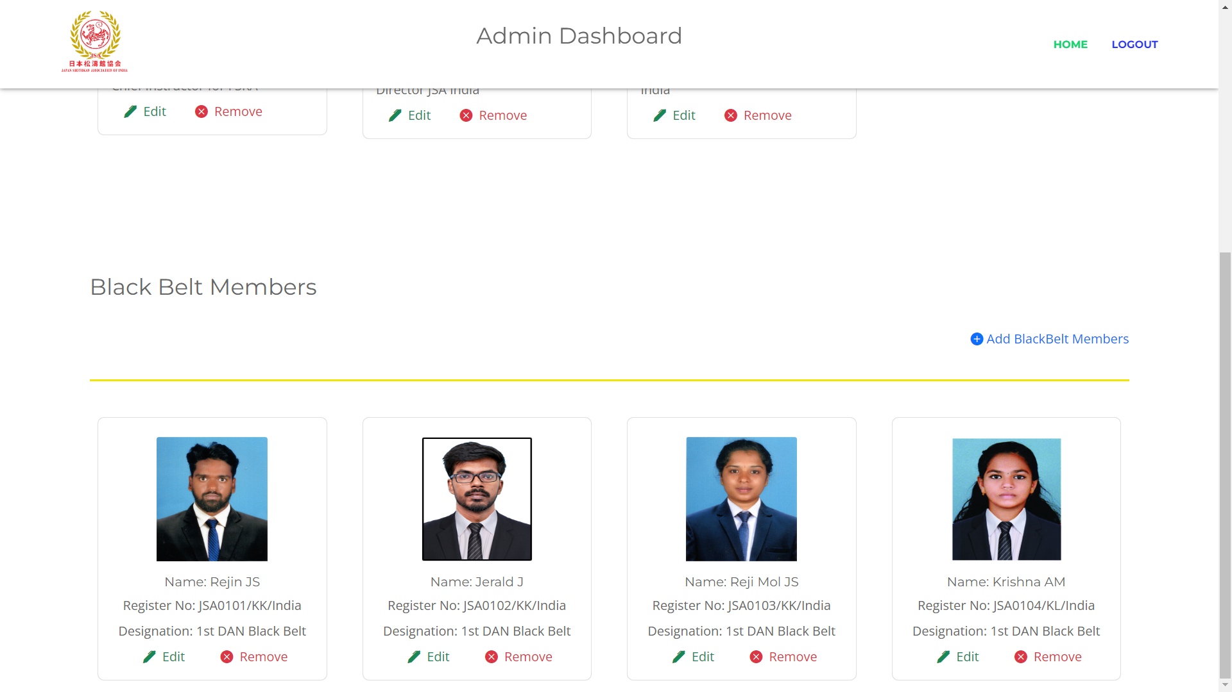

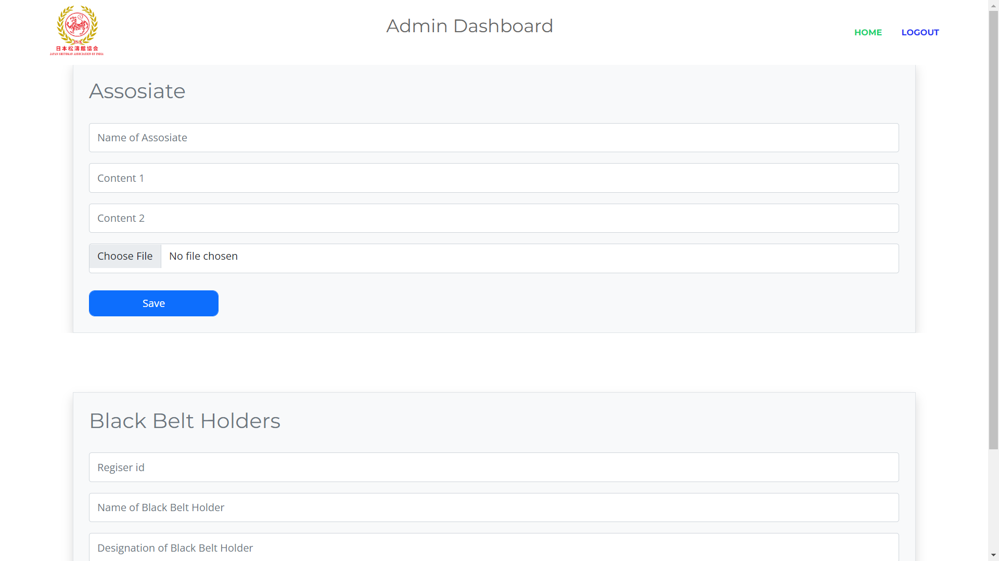

Code flow

In affiliation section admin can add new affiliation details,affiliation file, and a cover photo. This goes in the affiliation page in navbar section

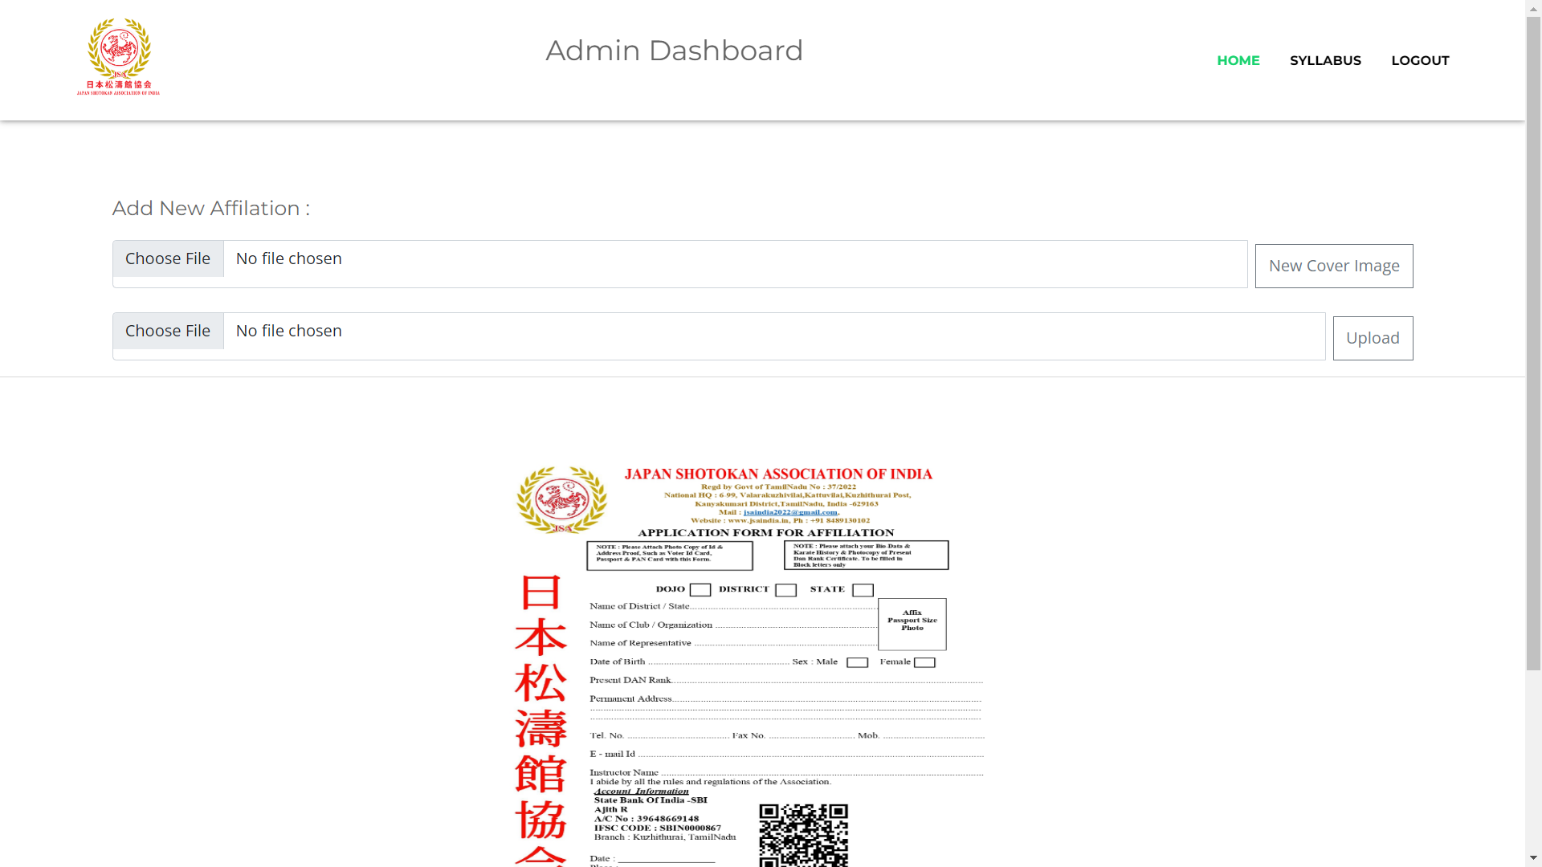
In the katas section we have given an option to add katas.the katas goes in katas section in navbar

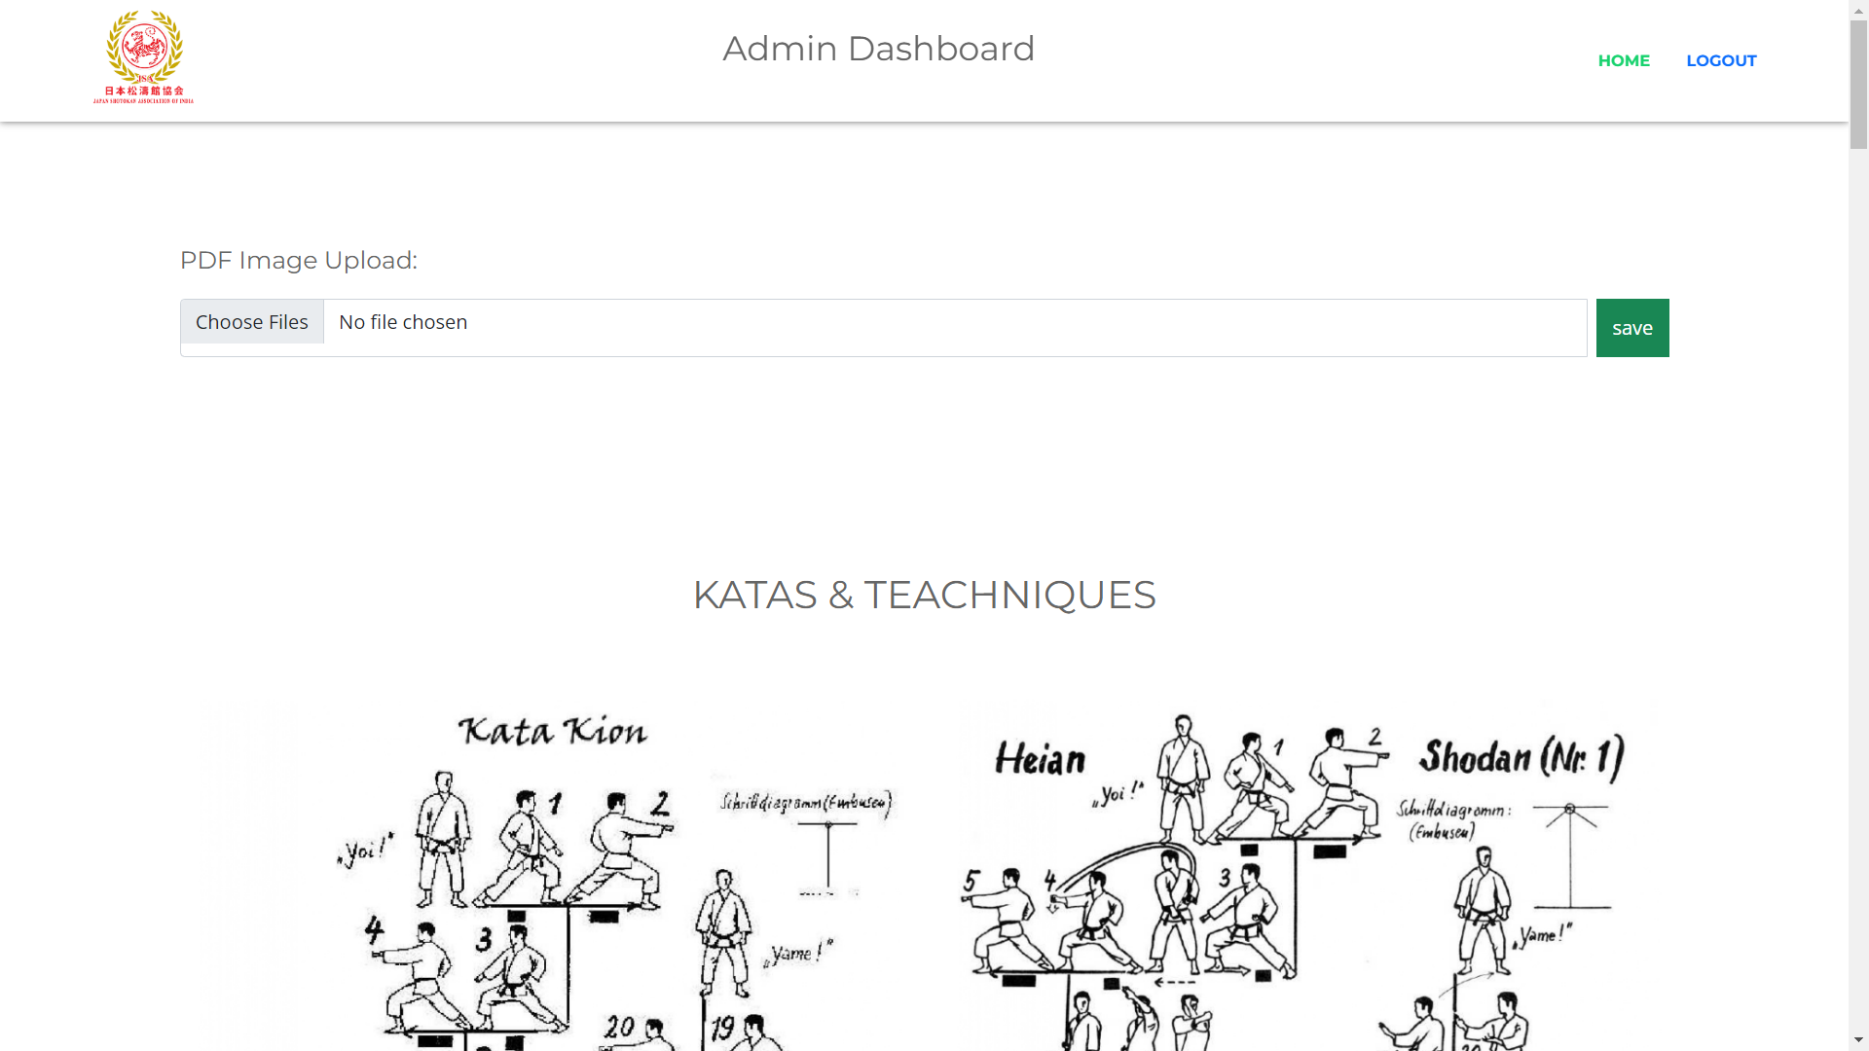

code flow

In home cover section admin can add number carousel images,no limit has been set.This images comes in home page as carousel images.

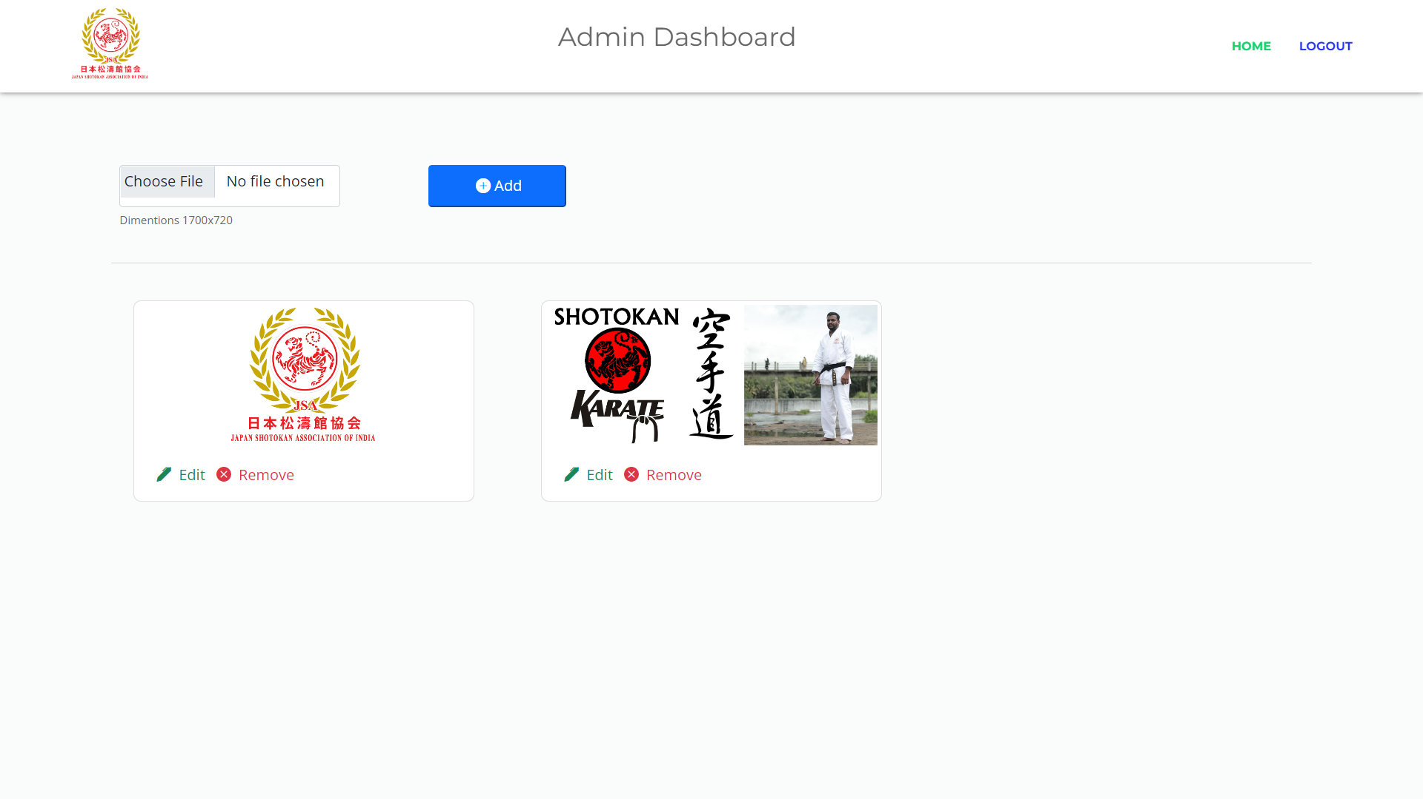

code flow

Admin can add about us content in about us section from admin panel. This comes in about us section in home page as a new paragraph

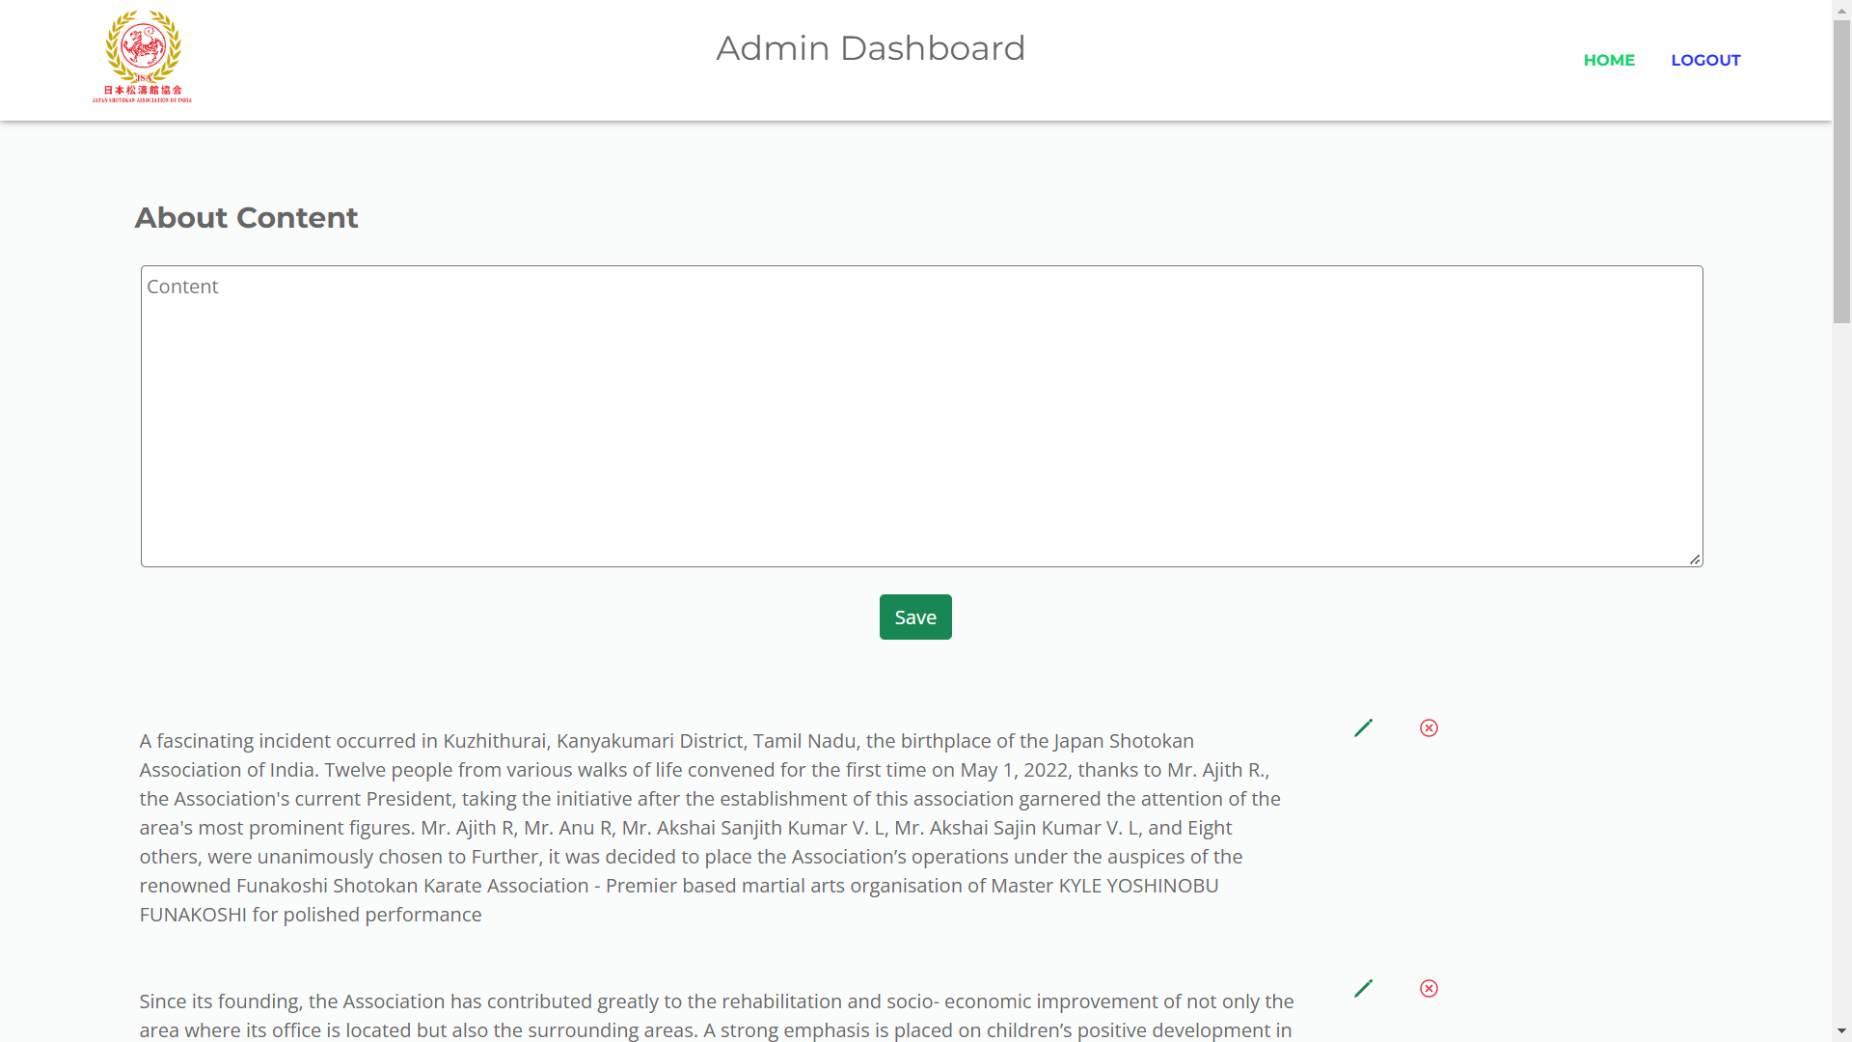

code flow

