**Functional Requirements**

* Support account creation, listing, deletion
* Deposit and withdraw funds
* Track balance and transaction history

**Technical Requirements**

* Spring Boot (Java 17)
* In-memory storage using ConcurrentHashMap
* REST API interface
* Jakarta Bean Validation
* JUnit for testing

**Assumptions**

* No persistent database,all data is stored in memory
* Account IDs must be unique
* Withdrawals cannot exceed account balance
* Timestamps for transactions must be ISO date-time format

**High-Level Design (HLD)**

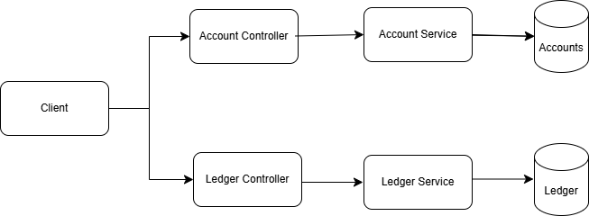

**Components:**

* **Controller Layer**: Handles API endpoints for account and ledger operations
* **Service Layer**: Contains business logic for account management and transaction handling
* **Model Layer**: Holds Account and Transaction data classes

**Flow:**

1. Client sends HTTP request to controller
2. Controller delegates to corresponding service
3. Service accesses in-memory map and performs operations
4. Response is returned to client