SHERIN JOSEPH

Communication Address | E-Mail Id | sherin.civil90@gmail.com | 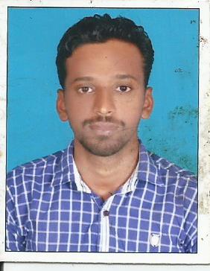
Sherin Joseph  Ethackattu(H),  Umbidi P.O  Thottackadu,Kottayam  Kerala-686539  Mob- | Contact Number | +91-
 | Date of Birth | 27 – 03 -1989

Objectives
To accelerate my pace towards the growth of the organization by riding on my strength and to make innovations with my talented skills.

Academic Qualifications

Exam Passed | Institution | Board/University | Month &Year of Passing | Percent
12th | St.Peter’s H.S.S,Kurumpanadom,Kottayam,kerala | State | 2007 | 60%
10th | St.Peter’s H.S.S,Kurumpanadom,kottayam,Kerala | State | 2005 | 60 %

Personal Skills

- Oral and written Communication Skills.
- Organized & self-motivated.
- excellent ability to adapt to difficult situations.
- detail oriented.
- capable problem solver.
- time and project management
- leadership skills
- Ability to work under challenging and stressed conditions.
- Enthusiasm towards work.
- Willingness to work in a team.
- Good computer skill.

Technical Skills

- NEBOSH
- IOSH
- MEDIC

Work Experience

- SHOBHA Ltd.
Paradise2 STP Project(Safety)
- Mavanal Granites

Achievements
- NCC

Personal Information

Father’s Name | Joseph Antony
Permanent Address | Ethackattu(H),  Umbidi P.O  Thottackadu,Kottayam  Kerala-686539
Nationality | Indian
Marital Status | Single
Area of Interesting | Playing Cricket ,Chess, surfing to internet, Travelling, cooking.
Languages Known  Speak  Read  Write | English, Malayalam,Hindi,Kannada,Tamil  English, Hindi,Malayalam  English, Hindi,Malayalam

Declaration
I, SHERIN JOSEPH, certify that to the best of my knowledge and belief, these data correctly describe my qualifications, my experience, and me.

SHERIN JOSEPH

