**application link:** [**http://ec2-34-228-26-63.compute-1.amazonaws.com/**](http://ec2-34-228-26-63.compute-1.amazonaws.com/)

**This rest application is create in php and it consists of service classes for rest api along with the ui to interact with the rest api.the routing of the application is done with the help of .htaccess file.**

**Application can be auto deployed using the attached ansible script and small test script also include to check the response from the api.**

**ARCHITECTURE DIAGRAM**

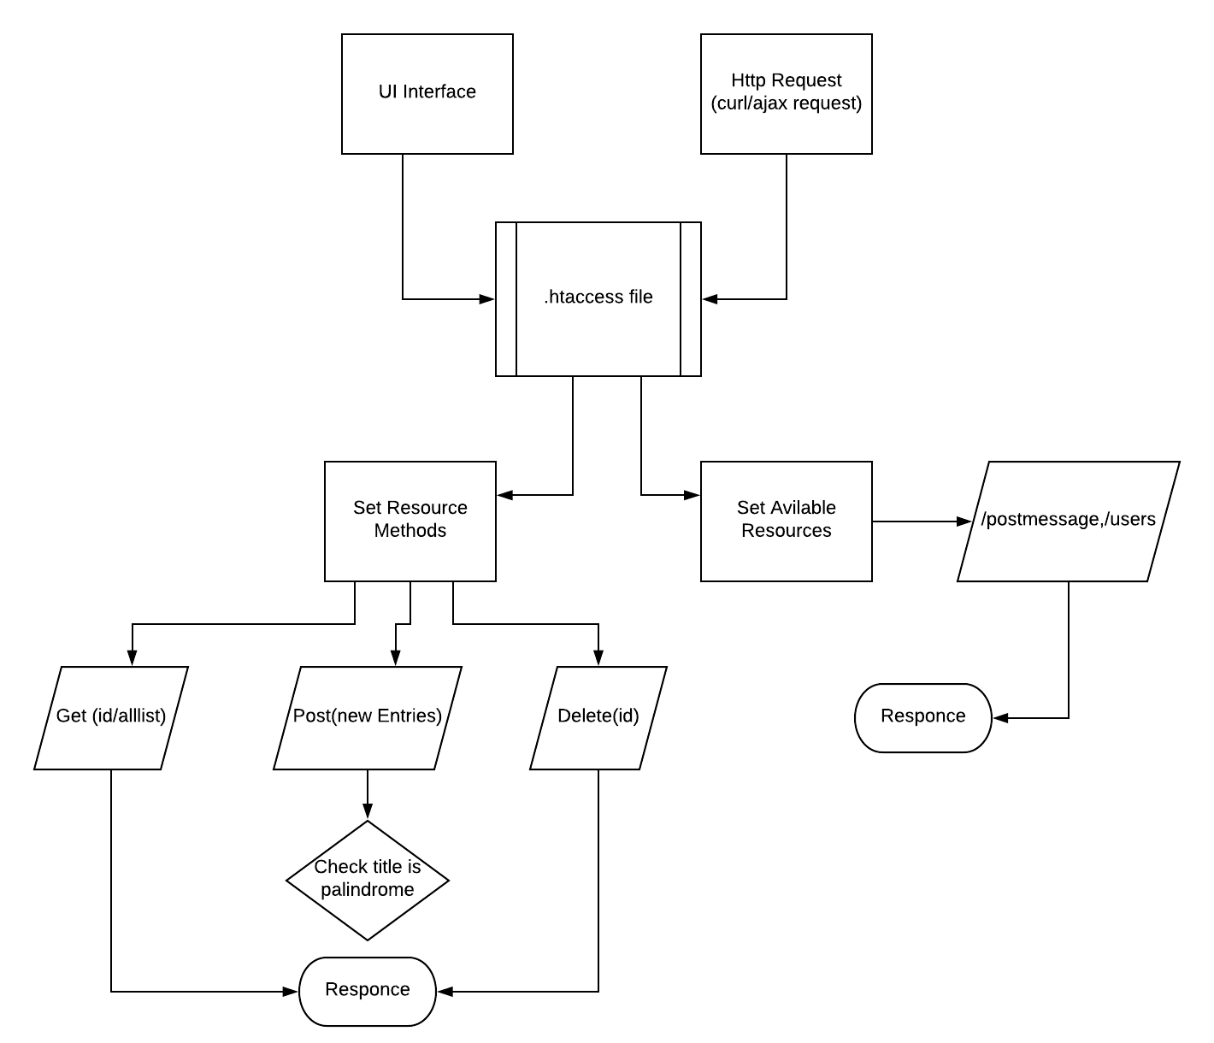

**RESOURCE METHODS**

**GET**

There is two types of service offered by GET

* GET based on id: It returns “postmessage” based on id.
* GET based on all List: It returns all the available “postmessage”.

**Example of a request**

GET api/postmessage/getall

ACCEPT: application/json

$ curl <http://ec2-34-228-26-63.compute-1.amazonaws.com/api/postmessage/getall>

**Response:**

[{"id":2,"title":"message1","content":"content1","addtime":1489825793,"user_id":1},{"id":4,"title":"message3","content":"content3","addtime":1489825793,"user_id":1},{"id":11,"title":"sadsadasd","content":"sadsadsad","addtime":null,"user_id":1},{"id":12,"title":"dsfdsfs","content":"sadfdsafdfdsfdsf","addtime":null,"user_id":1},{"id":17,"title":"test","content":"test","addtime":null,"user_id":1},{"id":19,"title":"madam","content":"sadasdsad","addtime":null,"user_id":1}

**POST**

Post creates a new entry, i.e. “postmessage”.

**Example of a request**

POST api/postmessage/

RawInput : {"title":"test","content":"test"}

Response:

{"postId":"25","title":"test","content":"test","addtime":null,"userId":"1"}

**DELETE**

Delete lets you delete the “postmessage” based on the given id.

**Example of a request**

DELETE: [/api/postmessage/delete/2](http://ec2-34-228-26-63.compute-1.amazonaws.com/api/postmessage/delete/2)

ACCEPT: application/json

**Response:**

[{"id":2,"title":"message1","content":"content1","addtime":1489825793,"user_id":1,"palindrom":0}]

**USECASE DIAGRAM**

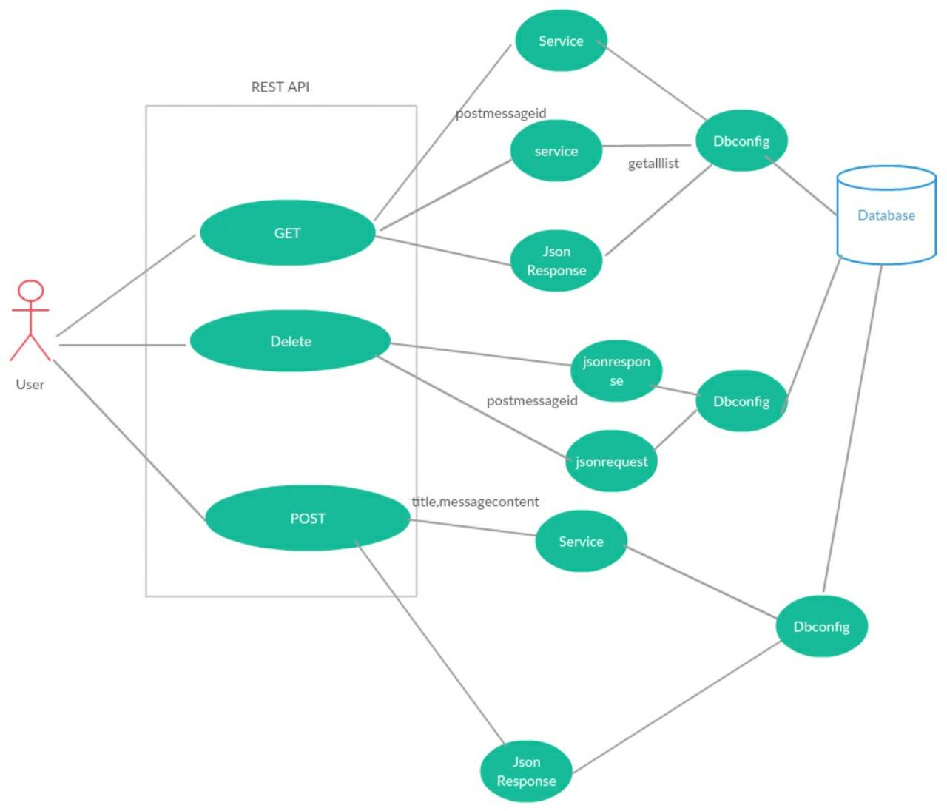

**UI INTERFACE**

