**application link:** [**http://ec2-34-228-26-63.compute-1.amazonaws.com/**](http://ec2-34-228-26-63.compute-1.amazonaws.com/)

**This rest application is create in php and it consists of some services class for rest api along with the ui to interactt with the rest api.the routing of the application is done with the help of .htaccess file.**

**ARCHITECTURE DIAGRAM**

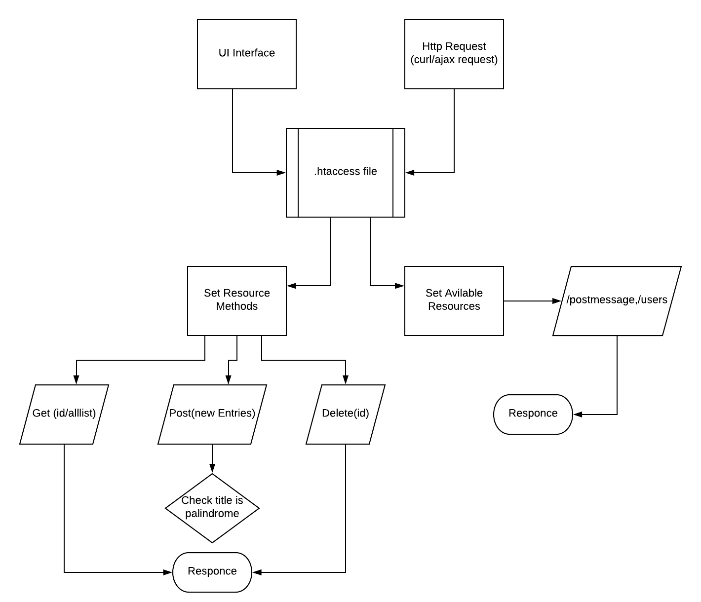

**RESOURCE METHODS**

**GET**

There is two types of service offered by GET

* GET based on id: It returns “postmessage” based on id.
* GET based on all List: It returns all the available “postmessage”.

**Example of a request**

GET api/postmessage/getall

ACCEPT: application/json

$ curl <http://ec2-34-228-26-63.compute-1.amazonaws.com/api/postmessage/getall>

**Response:**

[{"id":2,"title":"message1","content":"content1","addtime":1489825793,"user_id":1},{"id":4,"title":"message3","content":"content3","addtime":1489825793,"user_id":1},{"id":11,"title":"sadsadasd","content":"sadsadsad","addtime":null,"user_id":1},{"id":12,"title":"dsfdsfs","content":"sadfdsafdfdsfdsf","addtime":null,"user_id":1},{"id":17,"title":"test","content":"test","addtime":null,"user_id":1},{"id":19,"title":"madam","content":"sadasdsad","addtime":null,"user_id":1}

**POST**

Post creates a new entry, i.e. “postmessage”.

**Example of a request**

POST api/postmessage/

RawInput : {"title":"test","content":"test"}

Response:

{"postId":"25","title":"test","content":"test","addtime":null,"userId":"1"}

**DELETE**

Delete lets you delete the “postmessage” based on the given id.

**Example of a request**

DELETE: [/api/postmessage/delete/2](http://ec2-34-228-26-63.compute-1.amazonaws.com/api/postmessage/delete/2)

ACCEPT: application/json

**Response:**

[{"id":2,"title":"message1","content":"content1","addtime":1489825793,"user_id":1,"palindrom":0}]

**USECASE DIAGRAM**

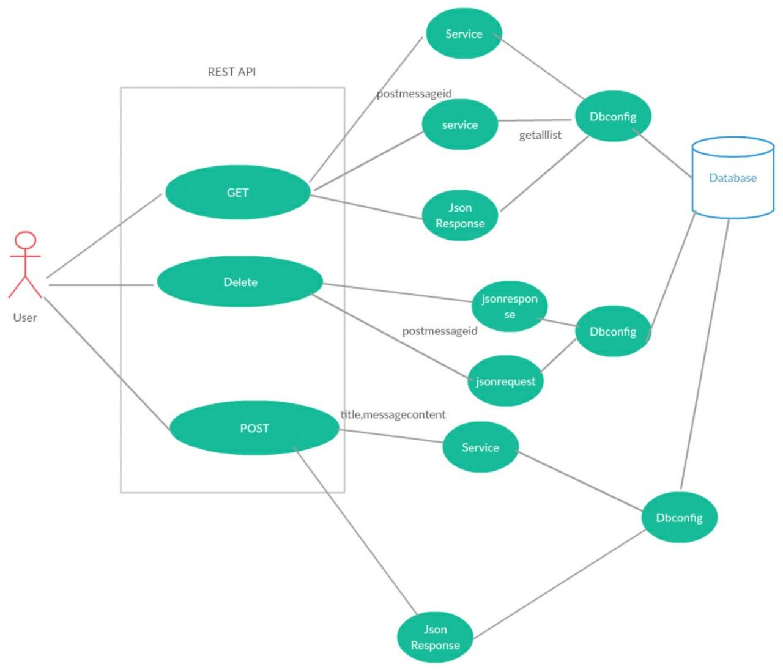

**UI INTERFACE**

