1. 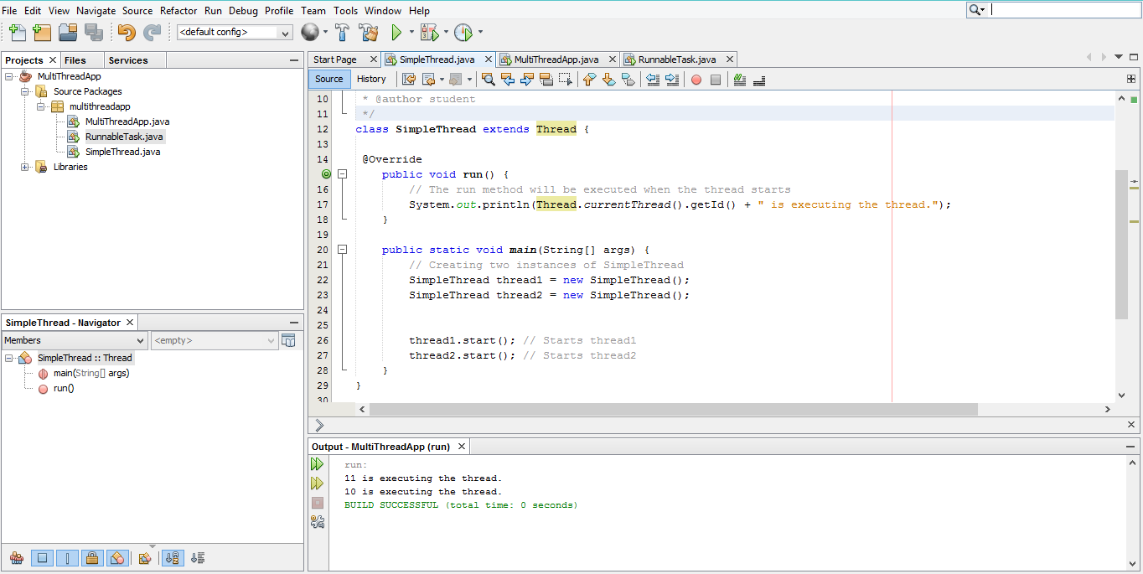**Create a Simple Thread Class**