## Zaman Asif

## BESE-5A

## Reg#111375

## Question#2

## Construct a model of your own.

Introduction:

In this system, I have modelled the charging circuitry of a mobile. The circuit is designed to auto-disconnect when charging of mobile reaches 100% and then mobile starts discharging. Circuit is opened again only when battery falls below 90%. In this way, the mobile is not overcharged as it never charges when battery is already 100%.

Screenshots and Explanation:

Below are my models of mobile (on left) and the charging circuit (on right).

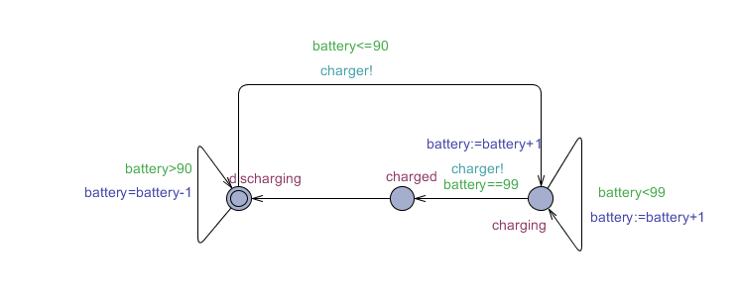

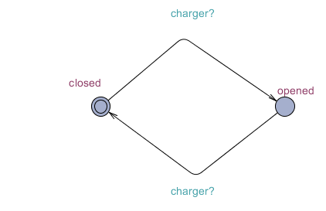

As verified by the simulator and verifier (screenshots below), these models work in accordance with the expected behaviour as defined in *Introduction* section above. In the above models,***charged*** is synchronisation channel and ***battery*** is a variable representing charging available in the mobile’s battery. Variable and system declarations below:

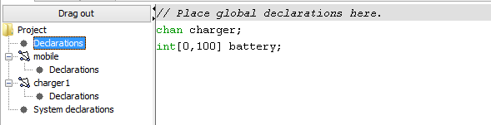

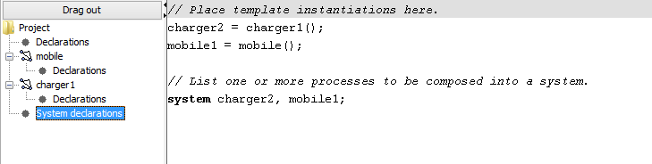

In the verifier, I wrote four conditions and ensured that my system satisfied those conditions. The conditions are:

1. For all states, if mobile is charged, then circuit should be closed.
2. For all states, if mobile is discharging, then circuit should be closed.
3. There should never be a deadlock.

As can be seen in the verifier output below, the above conditions are satisfied by the model:

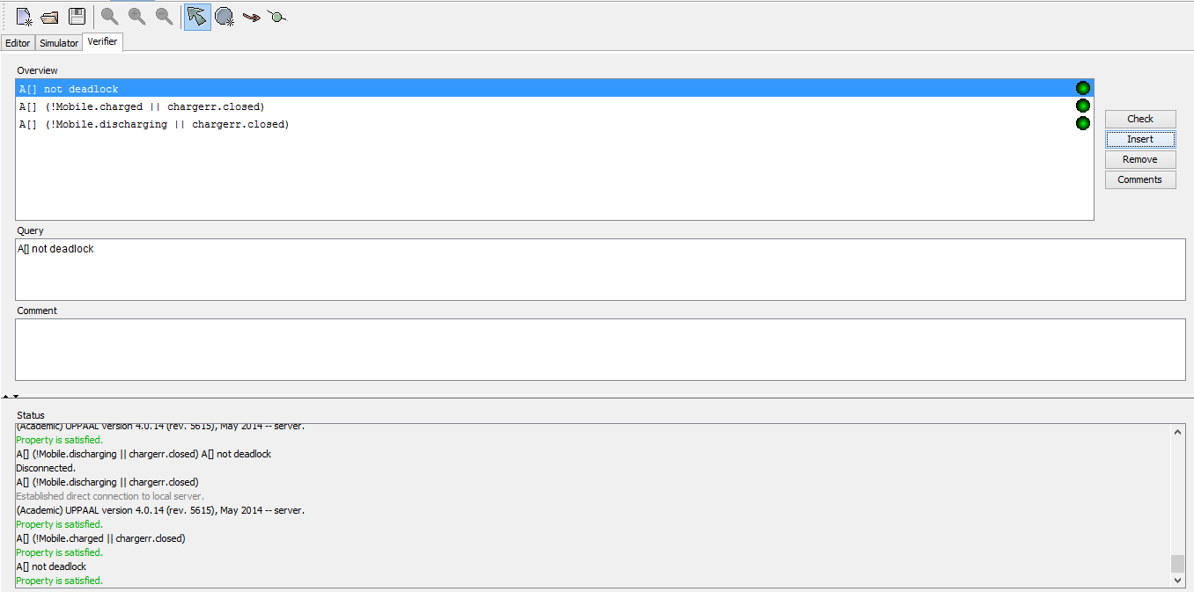

Following is the simulator output:

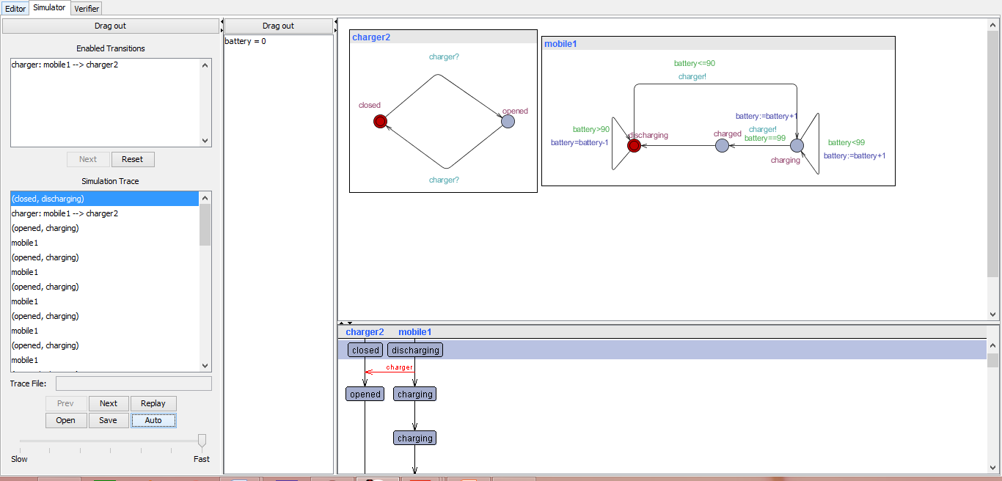

### Q#1

### Prepare and Enhance (add some more states etc.) in the example done in the class of Light with various levels of brightness and properties like "Mutual exclusion", ("deadlock avoidance") etc.

Introduction:

In this system, I have modelled a light bulb and a switch. It is supposed to work in the following way:

* 1. The light bulb is initially off.
  2. When the switch is pressed, bulb turns on with dim light.
  3. If switch is pressed again within 3 seconds, light turns off.
  4. If switch is pressed again after three seconds, light becomes bright.
  5. When bright, if switch is pressed, light blinks for 5 seconds and then turns off.

Screenshots and Explanation:

Below are my models of light bulb and the switch.

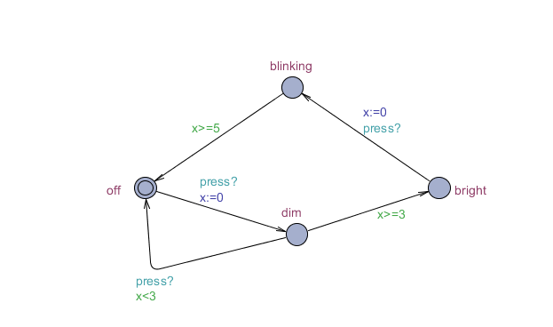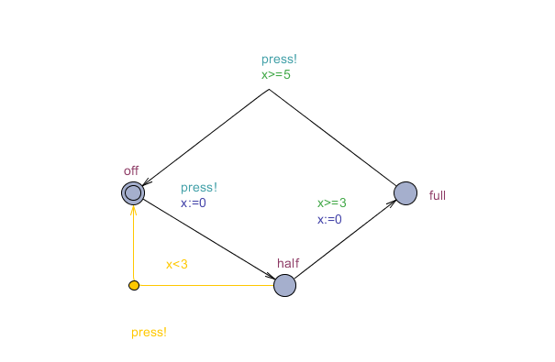

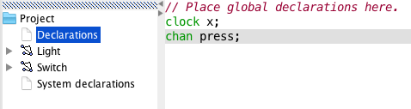

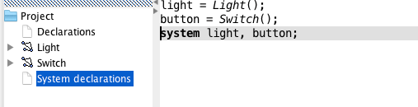

In the verifier, I wrote four conditions and ensured that my system satisfied those conditions. The conditions are:

1. For all states, if switch is not off, then light is not off either.
2. There exists a state such that if light is blinking and switch is off.
3. For all states, if light is off then switch is off too.
4. There should never be a deadlock.



As can be seen in the verifier output below, the above conditions are satisfied by the model:

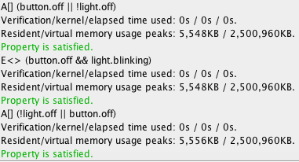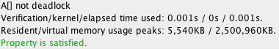

Following is the simulator output:

