Sheridan Dela Cruz
June 20, 2026
Module 4.2

GitHub Link: https://github.com/shedzip-wq/csd-340
GitHub Landing Page: https://shedzip-wq.github.io/csd-340/
DelaCruz_Mod4_2.html
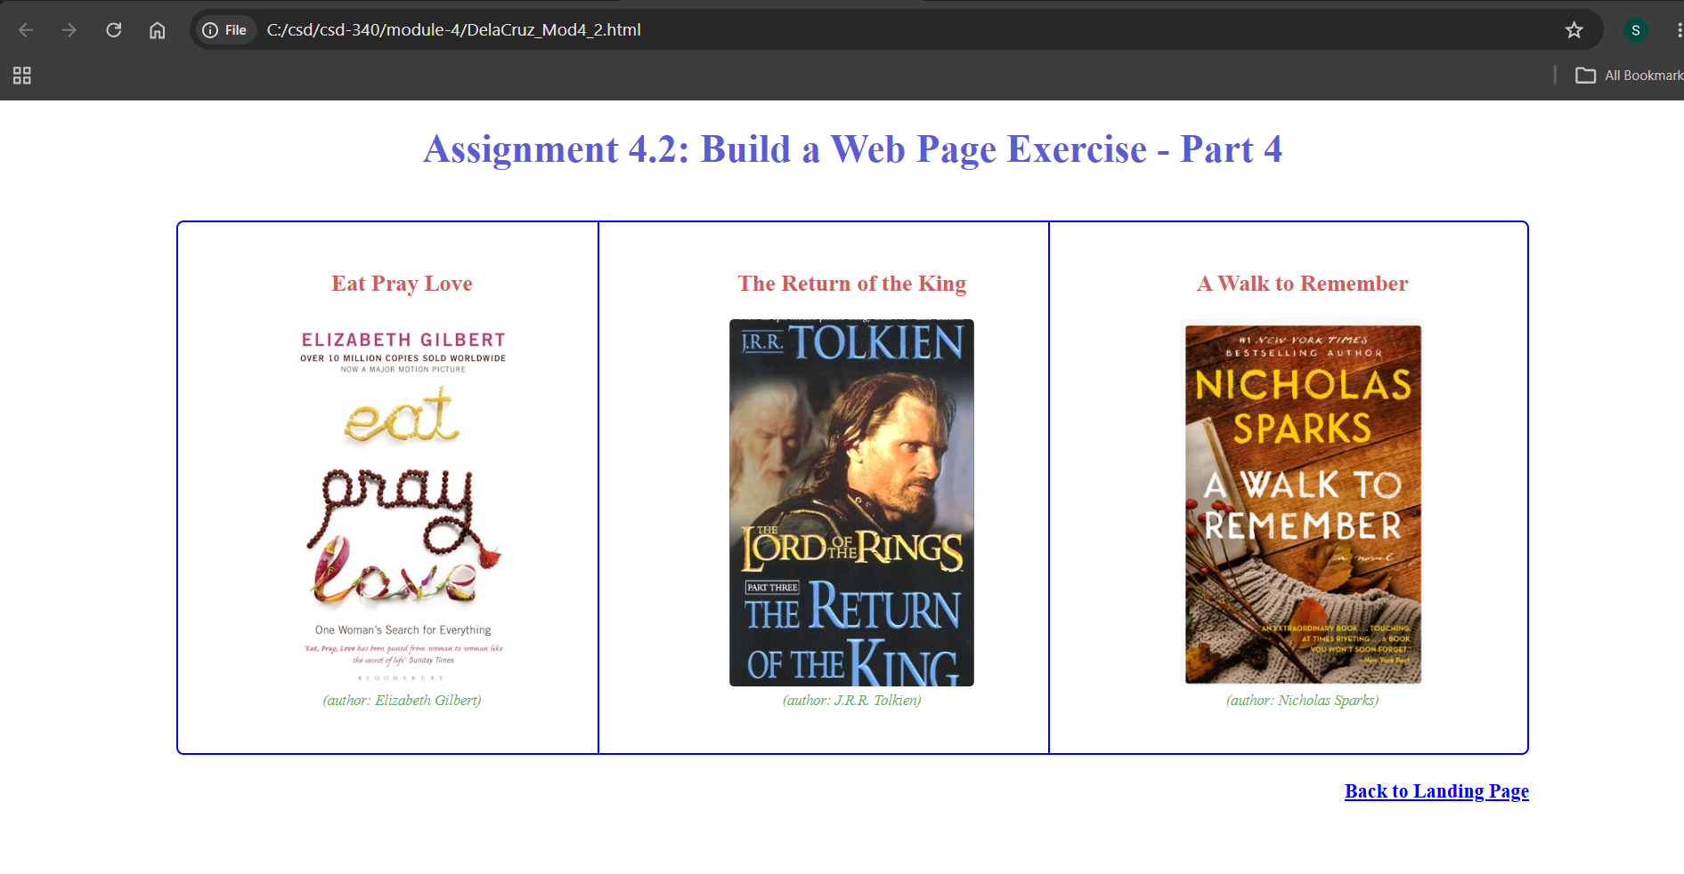
Github Landing Page
