Project: | Todo Web Application
Course: | CSD 380 DevOps
Description: | Functional test plan verifying the business requirements for the Todo application
Date: | 11/12/2026

TABLE OF CONTENTS
Allow users to visit the website through a standard URL 2
Create a new todo task item and prevent empty submission 3
Edit a todo task item and prevent empty edit submission 4
Delete a todo task item 5
Provide users with a custom 404 error page for invalid URLs 6

Test 1 | Allow users to visit the website through a standard URL
 | Test Objective: Verifies standard URL access (Requirement 10) | Developer: Marco Rodriguez  Date tested: 2026/11/12 | Peer tester: Sheridan Dela Cruz  Date tested: 2026/11/13
Step | Action | Expected results: | Developer pass/fail | Tester pass/fail + Screenshot
1 | Open a web browser | Browser opens successfully | yes | Yes 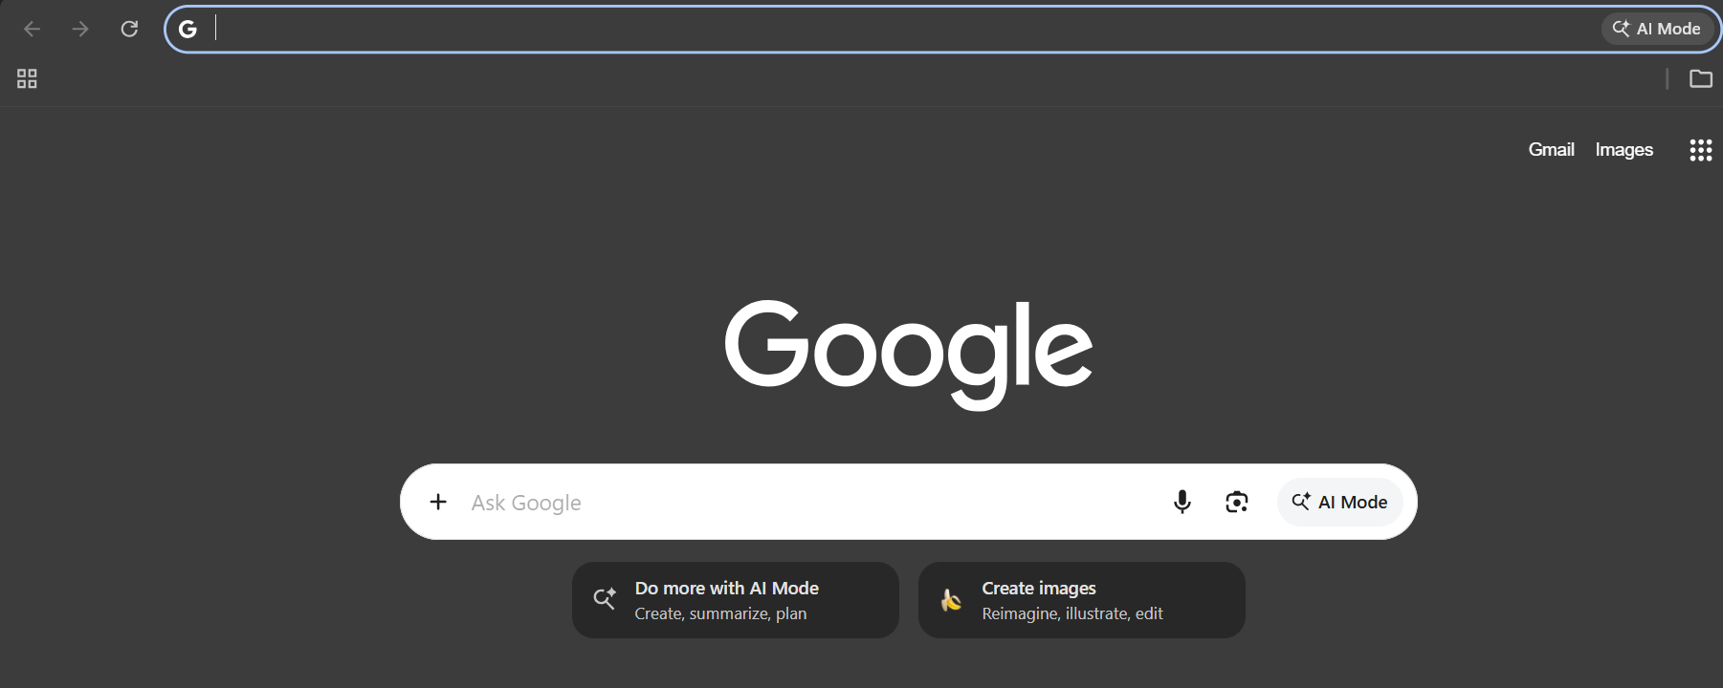
2 | Enter https://buwebdev.github.io/todo/ into the address bar | URL is registered in address bar | yes | Yes 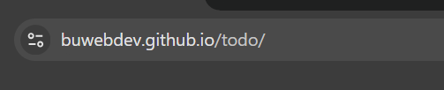
3 | Press Enter to navigate | Application begins loading | yes | Yes 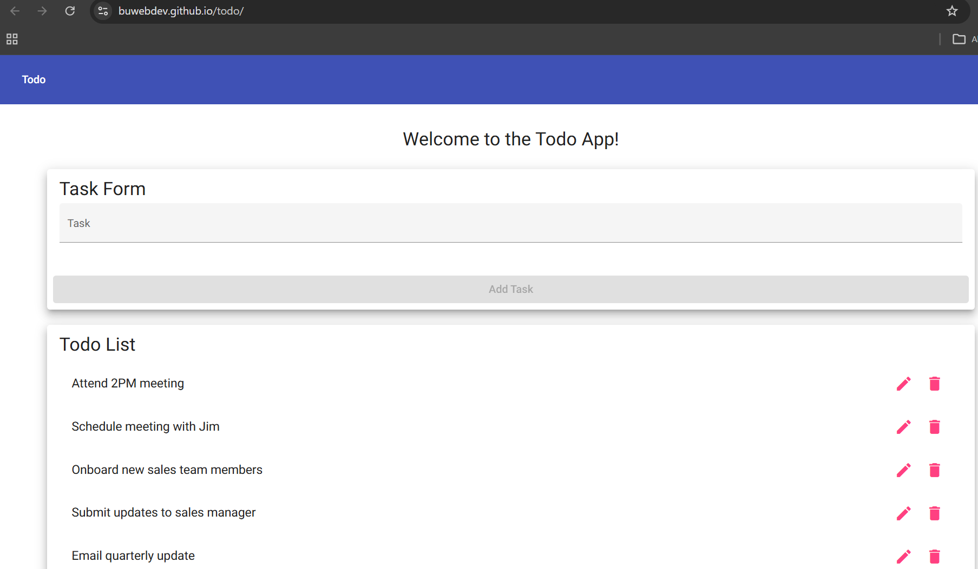
4 | Confirm the landing page loaded without errors | Landing page loads correctly | yes | Yes
5 | Verify the Task Form and Todo List views are visible | Interface matches the design requirements | yes | Yes
Comments | The application successfully met the requirement for standard URL access. The landing page, task form, and todo list elements loaded perfectly upon navigation. No further development action is needed for this specific functional requirement, as all steps passed execution.

Test 2 | Create a new todo task item and prevent empty submission
 | Test Objective: Verifies task creation and empty form validation (Requirements 2 and 6) | Developer: Marco Rodriguez  Date tested: 2026/11/12 | Peer tester: Sheridan Dela Cruz  Date tested: 2026/11/13
Step | Action | Expected results: | Developer pass/fail | Tester pass/fail + Screenshot
1 | Locate the Task Form on the landing page | Task form is visible | yes | Yes 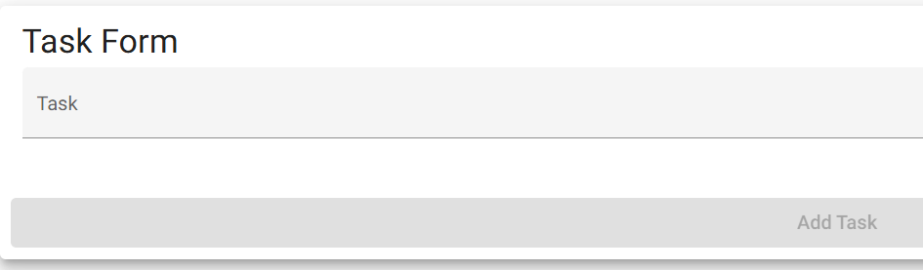
2 | Leave the input empty and click Add Task | Form submission is prevented | yes | Yes
3 | Enter "New Client Call at 3PM" in the Task Form | Text appears in input | yes | Yes 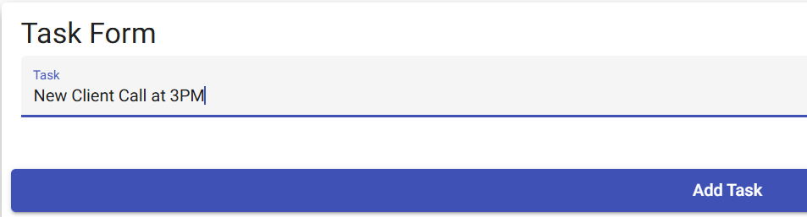
4 | Click the Add Task button | Task is submitted successfully | yes | Yes 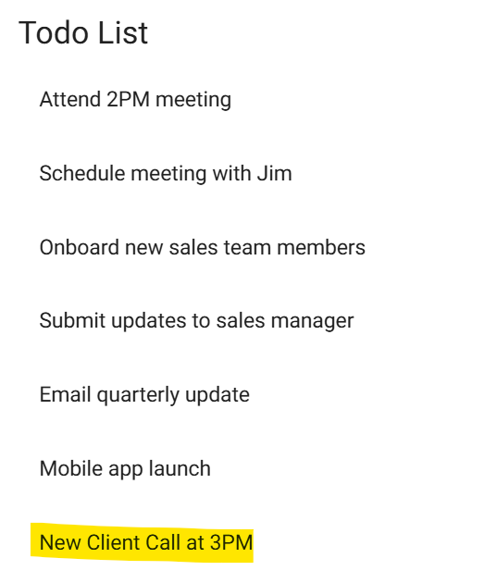
5 | View the Todo List | "New Client Call at 3PM" appears in the list | yes | Yes
Comments | Task creation and empty form validation are working exactly as intended. The application correctly blocks users from submitting a blank task and successfully appends valid text to the list. The interface behaves as expected during the creation workflow

Test 3 | Edit a todo task item and prevent empty edit submission
 | Test Objective: Verifies the edit form functionality and empty validation (Requirements 3 and 7) | Developer: Marco Rodriguez  Date tested: 2026/11/12 | Peer tester: Sheridan Dela Cruz  Date tested: 2026/11/13
Step | Action | Expected results: | Developer pass/fail | Tester pass/fail + Screenshot
1 | Trigger the edit action on an existing task item | The Edit Form appears | yes | Yes 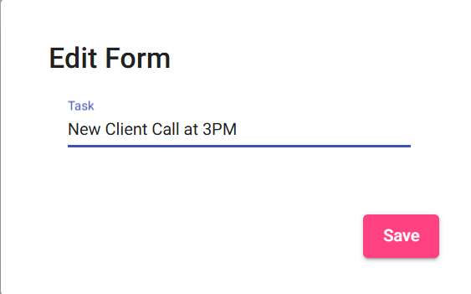
2 | Delete all text in the Edit Form | Input field is empty | yes | Yes 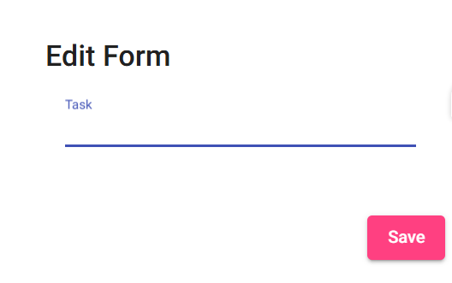
3 | Click the Save button | Edit form submission is prevented | no | No 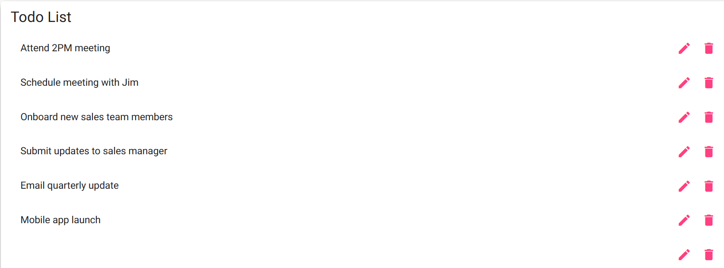
4 | Enter updated text into the Edit Form | Text appears in input | yes | Yes 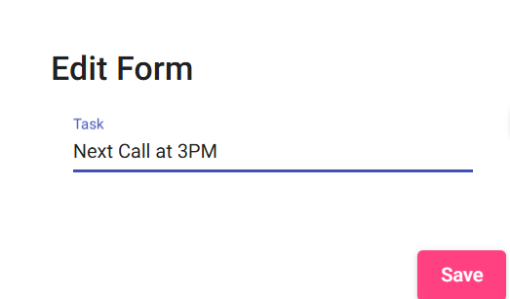
5 | Click the Save button | Item updates successfully in the Todo List | yes | Yes 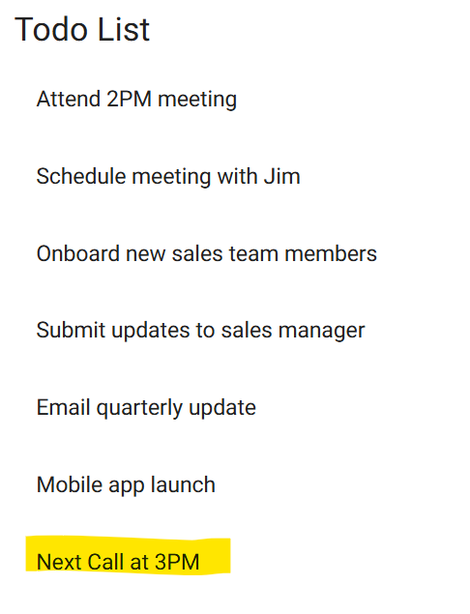
Comments | While the edit form loads and saves valid text correctly, it fails to prevent users from submitting an empty string. Step 3 resulted in a failure because clicking the Save button on a blank field did not block the submission. Developers need to add validation logic to the edit form to match the empty submission prevention used on the initial task creation form.

Test 4 | Delete a todo task item
 | Test Objective: Verifies the ability to delete tasks and view the updated list (Requirements 1 and 4) | Developer: Marco Rodriguez  Date tested: 2026/11/12 | Peer tester: Sheridan Dela Cruz  Date tested: 22026/11/13
Step | Action | Expected results: | Developer pass/fail | Tester pass/fail + Screenshot
1 | Locate an existing item in the Todo List | Item is visible | yes | Yes
2 | Trigger the delete action for the item | Deletion process initiates | yes | Yes 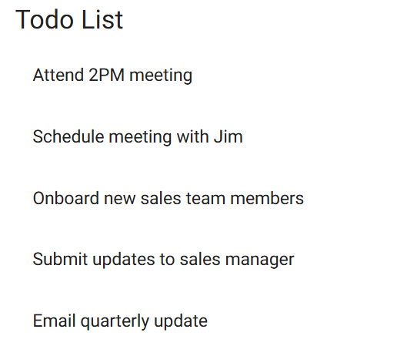
3 | Confirm the deletion if prompted | Item is removed | no | Yes
4 | View the updated Todo List | The deleted item is no longer visible | yes | Yes
5 | Refresh the browser window | The item remains deleted from the list | no | No 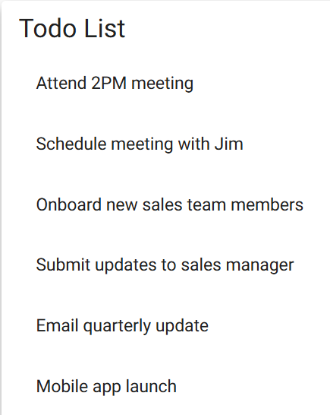
Comments | There are critical functional bugs in the deletion workflow. The item is not properly removed upon confirmation (Step 3 failure), and more importantly, deleted items reappear when the browser is refreshed (Step 5 failure). This indicates an issue with state management or local storage, as the delete action is not persisting properly across page reloads.

Test 5 | Provide users with a custom 404 error page for invalid URLs
 | Test Objective: Verifies the custom error page routing (Requirement 5) | Developer: Marco Rodriguez  Date tested: 2026/11/12 | Peer tester: Sheridan Dela Cruz  Date tested: 2026/11/13
Step | Action | Expected results: | Developer pass/fail | Tester pass/fail + Screenshot
1 | Open a web browser | Browser opens successfully | yes | Yes
2 | Enter an invalid URL (e.g. https://buwebdev.github.io/todo/invalid) | URL is registered in address bar | yes | Yes 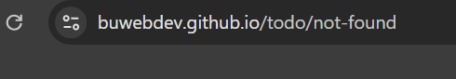
3 | Press Enter to navigate | Browser attempts to load the page | yes | Yes 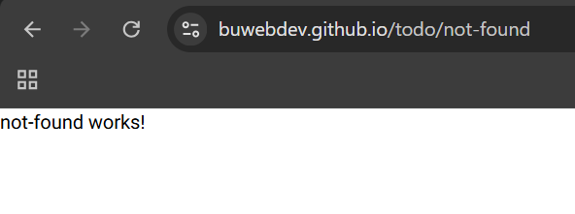
4 | Observe the loaded web page | A custom 404 error page is displayed | yes | Yes
5 | Check for navigation links on the 404 page | User is provided a way back to the main app | no | No
Comments | The application successfully detects invalid URLs and renders a custom 404 error page, satisfying the core routing requirement. However, the page is missing a navigation link to return the user to the main application (Step 5 failure). A functional "Return to Home" link must be added to the 404 template to prevent users from getting trapped on the error screen.

