Project: Todo Application - Functional Test Plan
Course: CSD 380 DevOps
Description: Functional test plan for the Todo web application (https://buwebdev.github.io/todo/) covering all ten functional requirements in the Todo Business Requirements document (Req #1-#10).
Date: 2026/11/10
TABLE OF CONTENTS
Test 1: Access the Todo Application Through a Standard URL 3
Test 2: Add a New Task 5
Test 3: Validate Task Input 7
Test 4: Edit an Existing Task 9
Test 5: Delete a Task 9
Test 6: Custom 404 Page for Invalid URLs 9
Test 7: Mobile Device View 9
Test 8: Tablet Device View 9

For each test, the developer should: provide a test description, a test objective, the developer name and date tested. For each step, fill out the actions to be taken and describe the expected results, and indicate yes or no for each step depending upon the result. The peer tester should provide their name, date tested, indicate yes or no for each step depending upon the result, and a screenshot (thumbnail) of the result.

Test 1 | Access the Todo Application Through a Standard URL
 | Test Objective: Covers Req #10 and #1. Verifies users can reach the application at https://buwebdev.github.io/todo/ and view the list of todo task items, on first visit and on refresh. | Developer: Garvin Stewart  Date tested: <2026/11/12> | Peer tester: Sheridan Dela Cruz  Date tested: 22026/11/13
Step | Action | Expected results: | Developer pass/fail | Tester pass/fail  + Screenshot
1 | Open a web browser and visit https://buwebdev.github.io/todo/. | The page loads without errors. The browser tab title reads "Todo". | <yes/no> | Yes 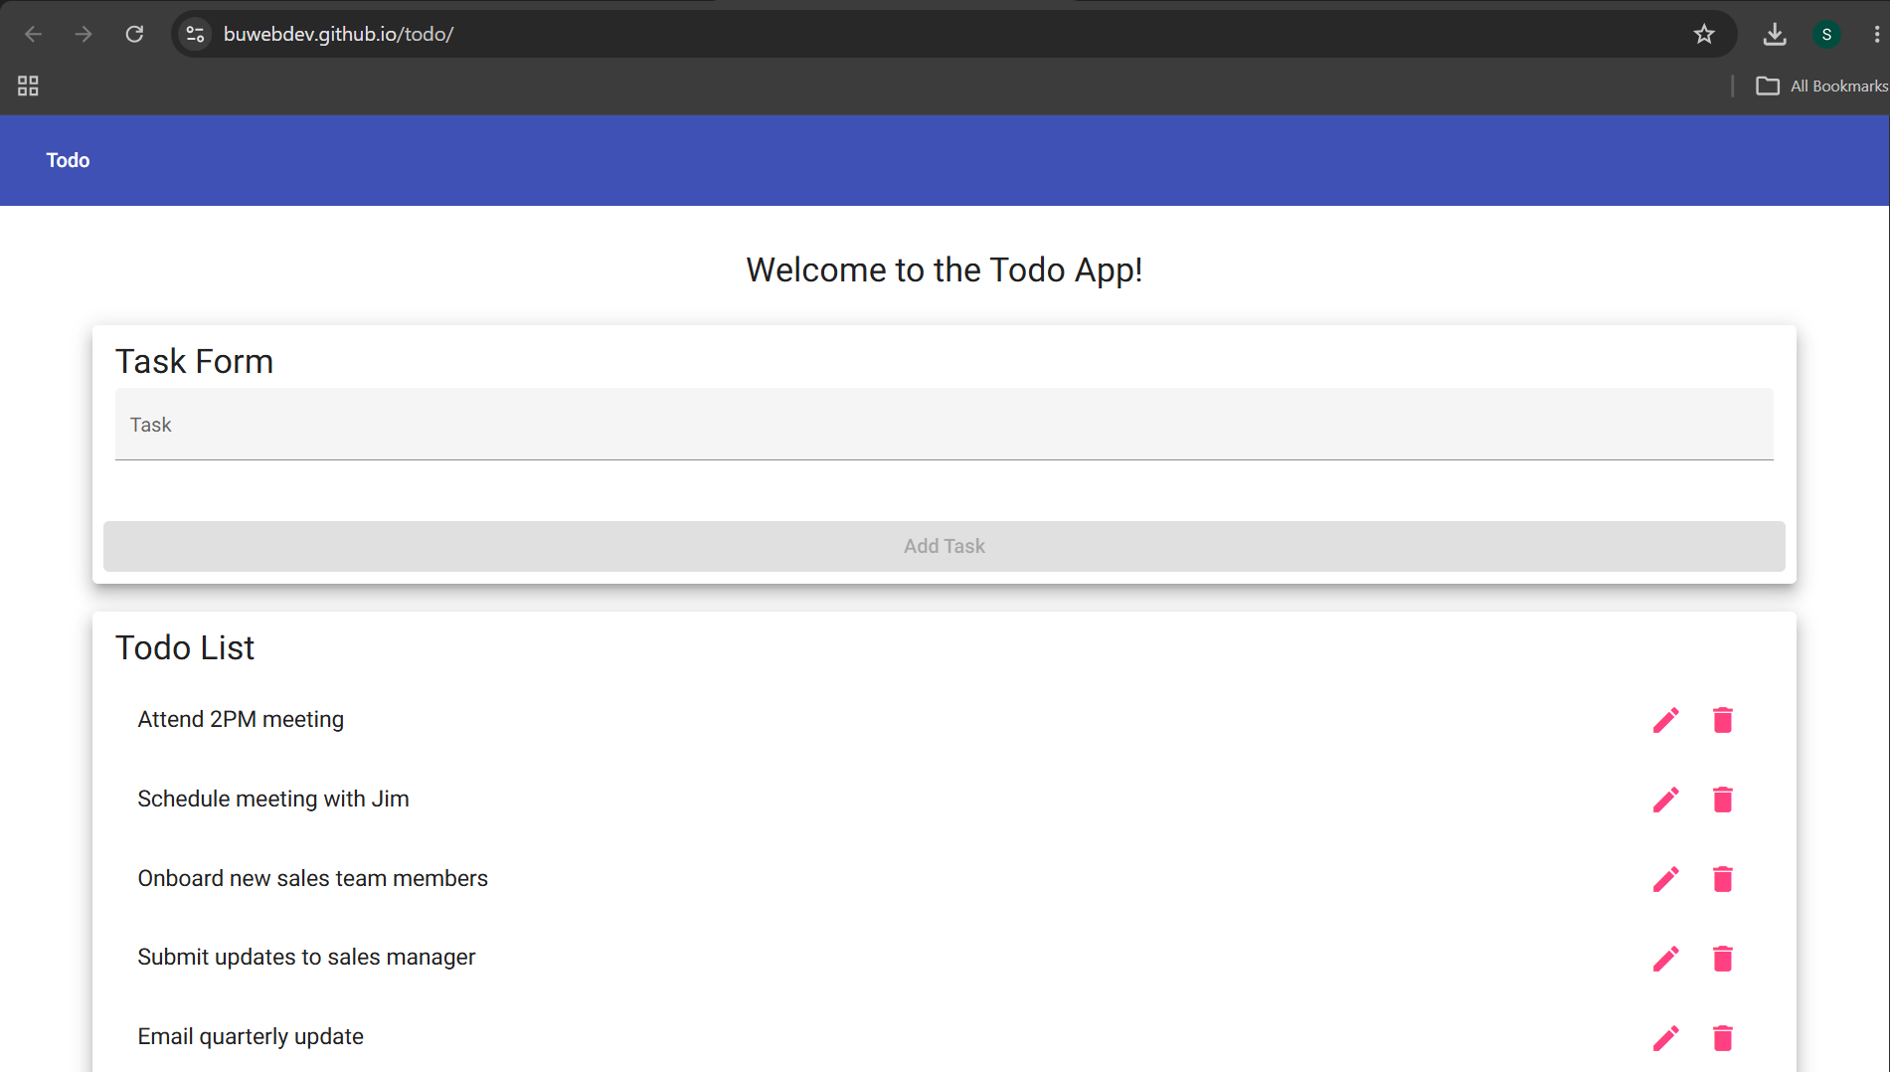
2 | Review the page header. | The toolbar shows a "Todo" button and the main card title reads "Welcome to the Todo App!". | <yes/no> | Yes 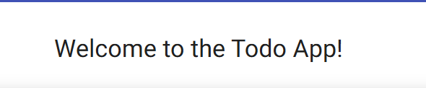
3 | Review the page body. | A "Task Form" card and a "Todo List" card are shown. The list holds six default tasks ("Attend 2PM meeting" through "Mobile app launch"), each with edit and delete icons. | <yes/no> | Yes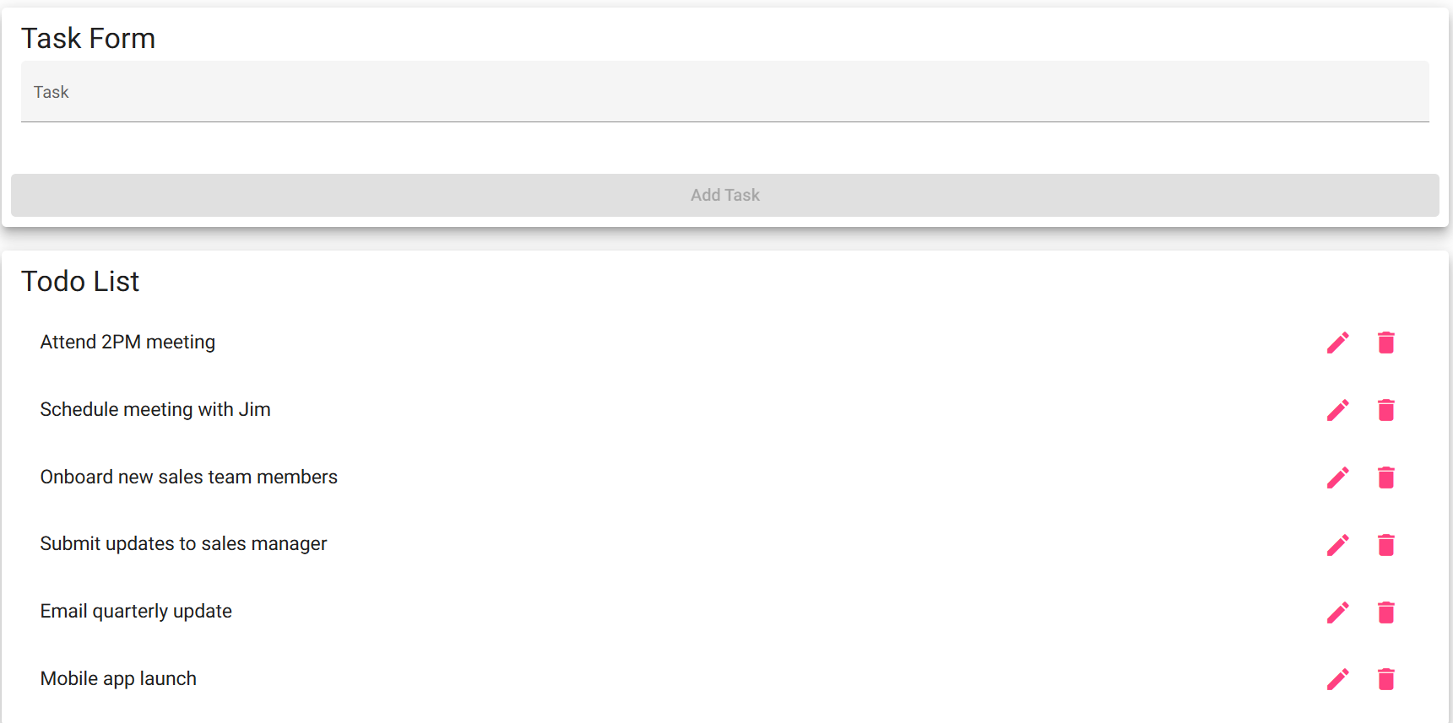
4 | Refresh the browser window (F5 / Ctrl+R). | The page reloads correctly with no errors; the header, Task Form and six default tasks are displayed again. | <yes/no> | Yes
5 | Click the "Todo" button in the toolbar. | The application stays on the home page at https://buwebdev.github.io/todo/ with no error or blank page. | <yes/no> | Yes
Comments | Page, header, Task Form and six default tasks load; refresh and the Todo toolbar button work. No console errors.

Test 2 | Add a New Task
 | Test Objective: Covers Req #2. Verifies a user can create a new todo task item through the Task Form and that it appears in the Todo List. | Developer: Garvin Stewart  Date tested: <2026/11/12> | Peer tester: Sheridan Dela Cruz  Date tested: 2026/11/13
Step | Action | Expected results: | Developer pass/fail | Tester pass/fail
1 | Visit https://buwebdev.github.io/todo/. | The home page loads and the Todo List shows the six default tasks. | <yes/no> | Yes
2 | Click in the Task field and type "Review sprint backlog". | The text appears in the field and the Add Task button becomes enabled. | <yes/no> | Yes 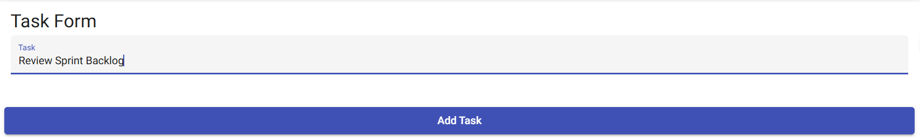
3 | Click the Add Task button. | "Review sprint backlog" appears at the bottom of the Todo List with edit and delete icons. The list now shows seven tasks. | <yes/no> | Yes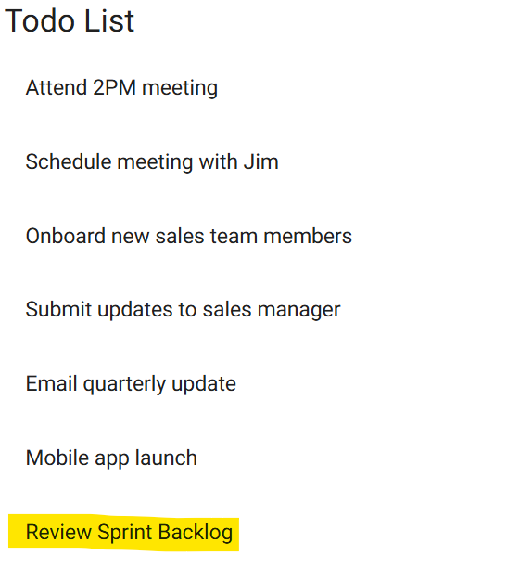
4 | Look at the Task field after the task is added. | The Task field is cleared and ready for the next entry. | <yes/no> | Yes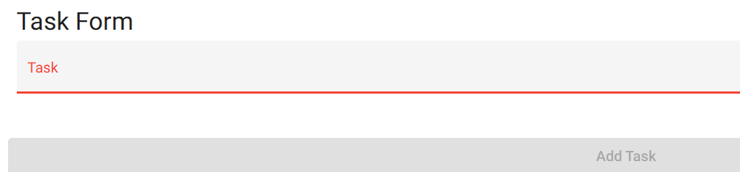
5 | Type "Call vendor" in the Task field and press Enter. | "Call vendor" is added below "Review sprint backlog". The list shows eight tasks in the order they were entered. | <yes/no> | No 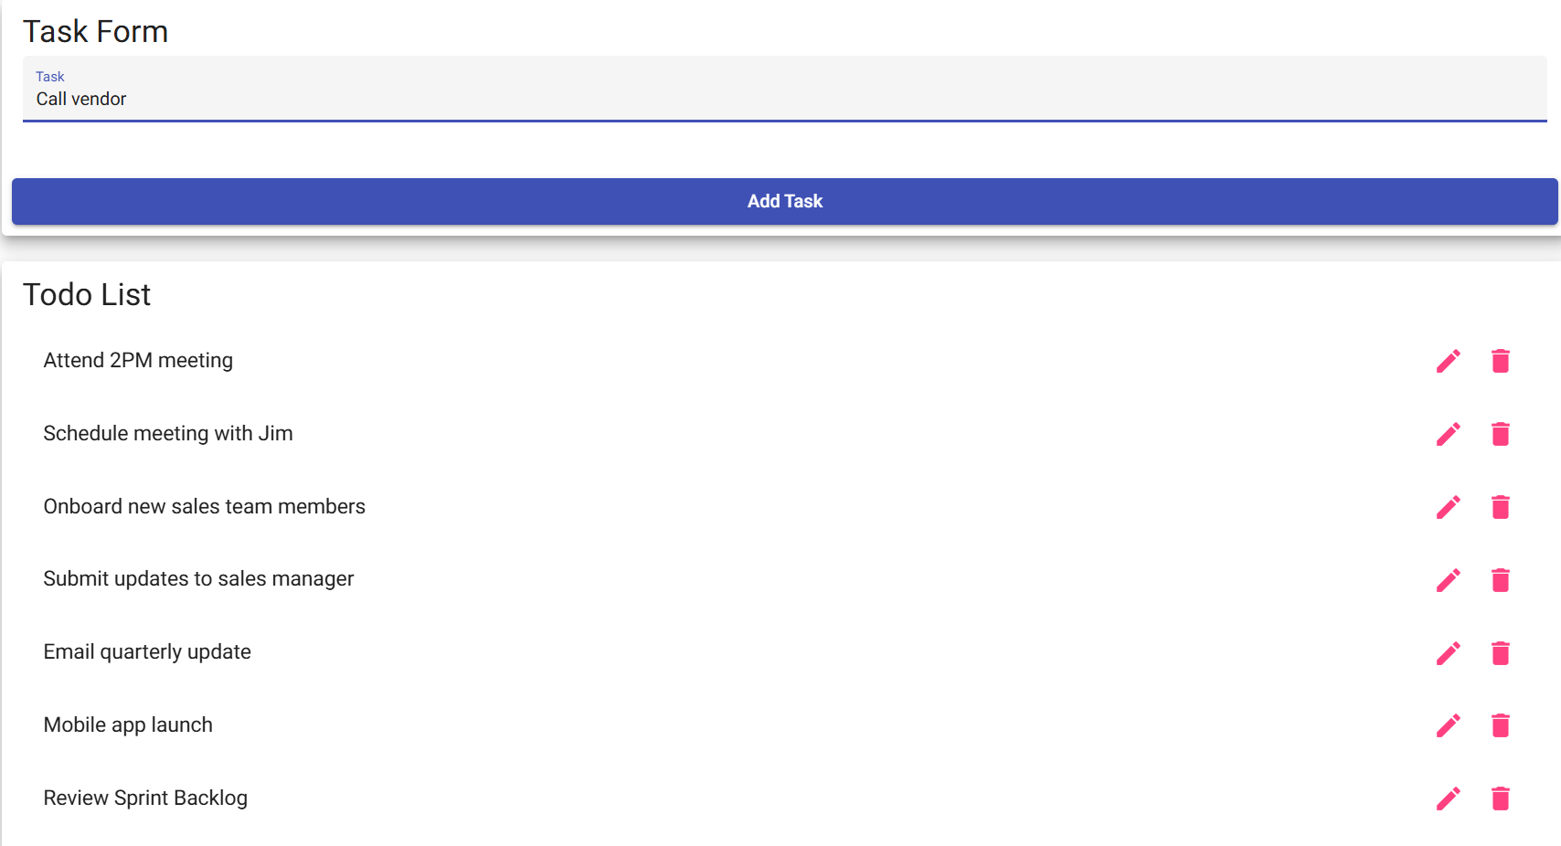
Comments | Pressing Enter does not add a task: the Add Task button sits outside the <form>. Not required by #2, so reword step 5 to click Add Task.

Test 3 | Validate Task Input
 | Test Objective: Covers Req #6. Verifies input data meets requirements: users cannot submit the Task Form without entering a todo item (field required, at least 4 characters). | Developer: Garvin Stewart  Date tested: <2026/11/12> | Peer tester: Sheridan Dela Cruz  Date tested: 2026/11/13
Step | Action | Expected results: | Developer pass/fail | Tester pass/fail
1 | Visit https://buwebdev.github.io/todo/. Do not type anything in the Task field. | The Add Task button is disabled (greyed out); no task can be added. | <yes/no> | Yes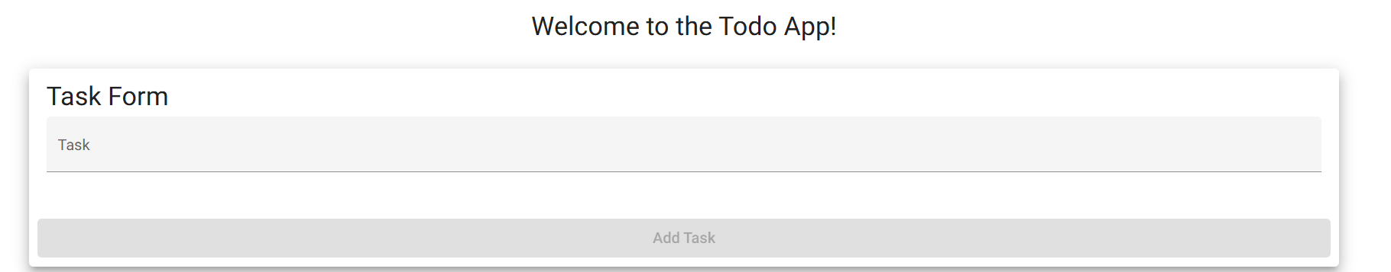
2 | Type "abc" (3 characters) in the Task field. | The Add Task button stays disabled. | <yes/no> | Yes 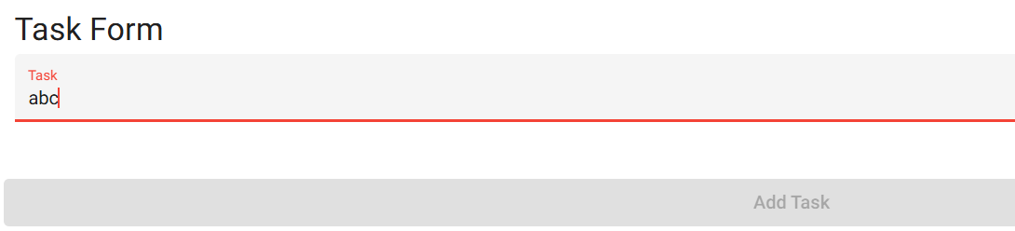
3 | Type one more character so the field reads "abcd" (4 characters). | The Add Task button becomes enabled. | <yes/no> | Yes 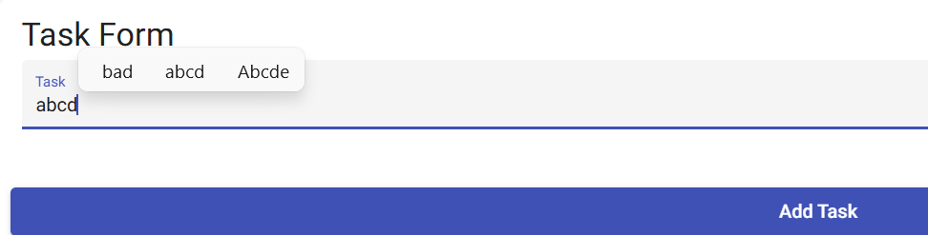
4 | Delete all text from the Task field, then click outside the field. | The Add Task button returns to disabled and the Task field is flagged as required (red label/underline). | <yes/no> | Yes 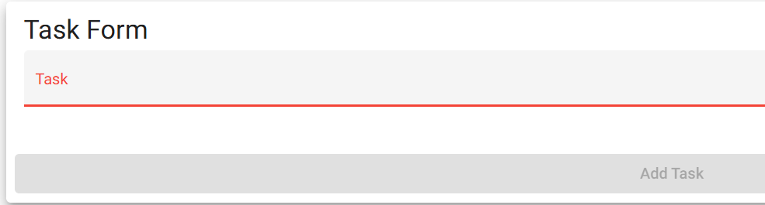
5 | Type four spaces (no other characters) in the Task field. | The Add Task button stays disabled; a blank task cannot be added. | <yes/no> | No 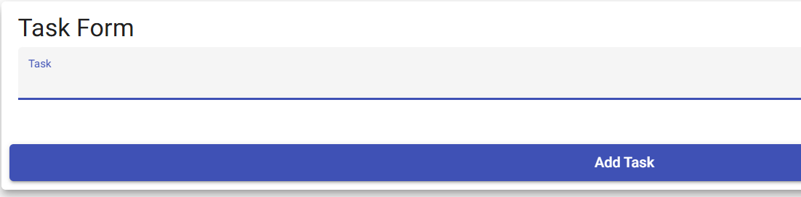
6 | Type "Test task input" and click Add Task. | The task is added to the bottom of the list, the field clears, and the Add Task button returns to disabled. | <yes/no> | Yes 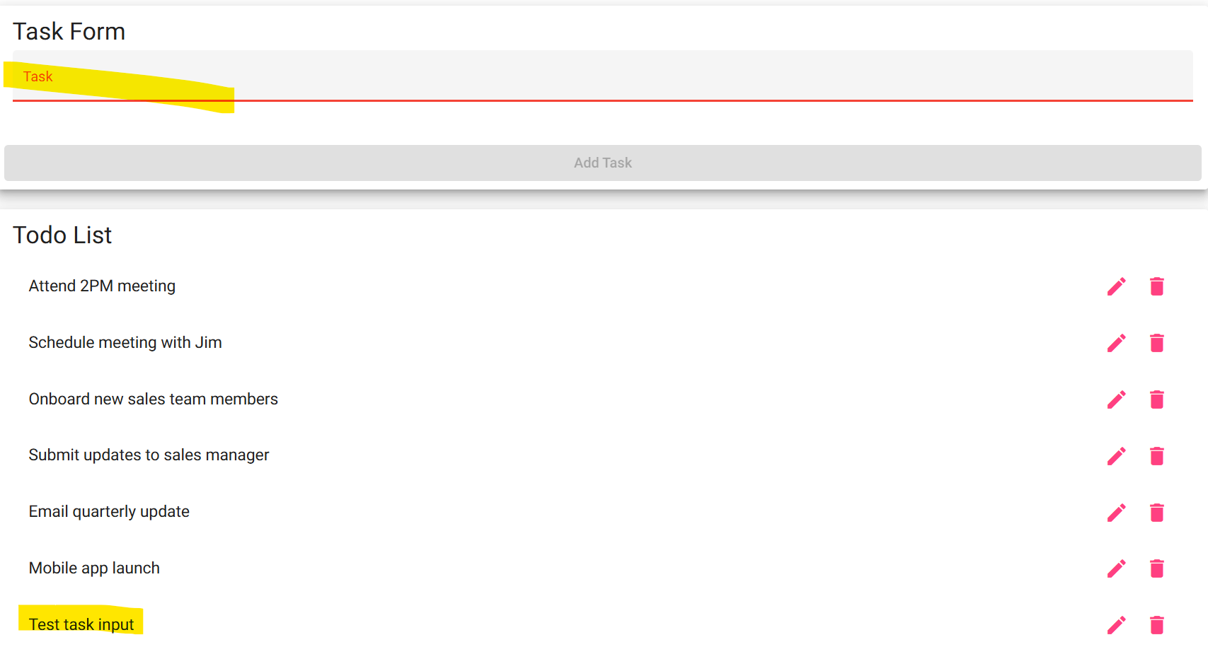
Comments | Four spaces count as 4 characters and enable Add Task, so a blank task can be added. Violates #6.

Test 4 | Edit an Existing Task
 | Test Objective: Covers Req #3 and #7. Verifies a user can edit a todo task item, and cannot submit the Edit Form without entering a todo item. | Developer: Garvin Stewart  Date tested <2026/11/12> | Peer tester: Sheridan Dela Cruz  Date tested: 2026/11/13
Step | Action | Expected results: | Developer pass/fail | Tester pass/fail
1 | Visit https://buwebdev.github.io/todo/. | The home page loads and the Todo List shows the six default tasks. | <yes/no> | Yes 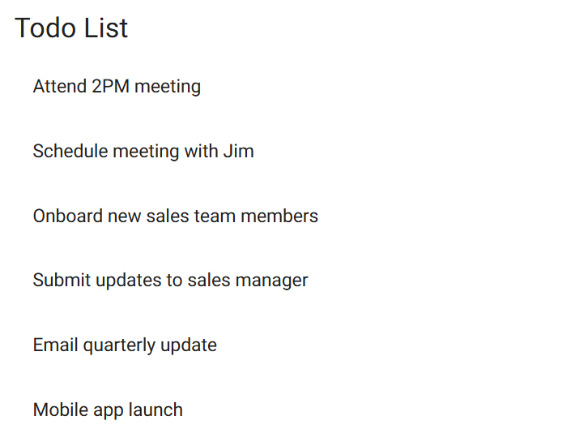
2 | Click the edit (pencil) icon next to "Schedule meeting with Jim". | An "Edit Form" dialog opens. Its Task field already contains "Schedule meeting with Jim" and a Save button is shown. | <yes/no> | Yes 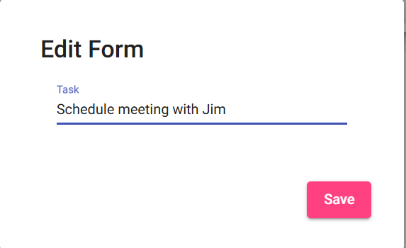
3 | Change the text to "Schedule meeting with Jim and Sarah" and click Save. | The dialog closes. The task now reads "Schedule meeting with Jim and Sarah" in the same position in the list. | <yes/no> | Yes 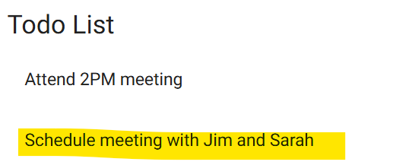
4 | Review the rest of the Todo List. | The other five tasks are unchanged and the list still shows six tasks. | <yes/no> | Yes 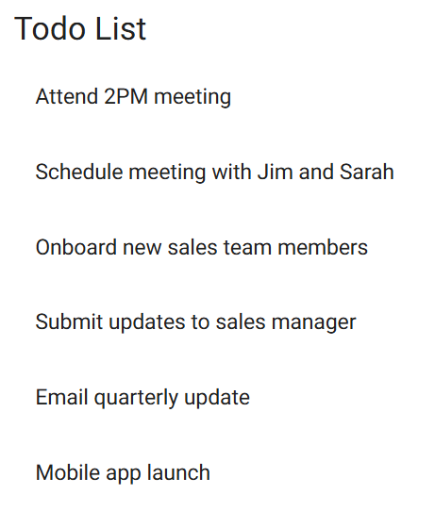
5 | Click the edit icon on the same task, delete all text in the field, and click Save. | The blank value is not saved (same rule as the Task Form: required, at least 4 characters). The task keeps its previous text. | <yes/no> | No 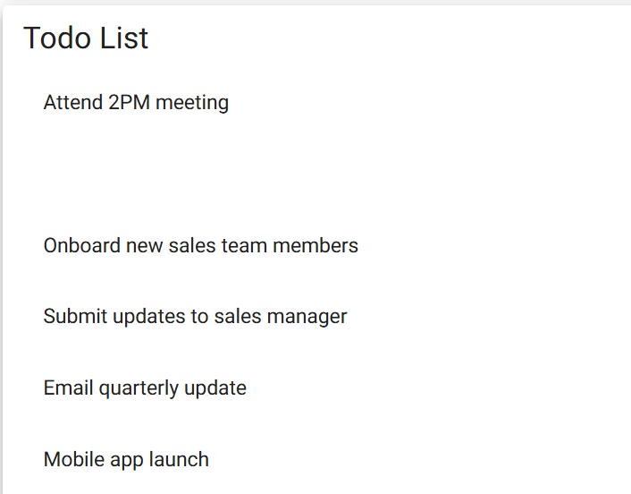
Comments | Clearing the edit field and clicking Save leaves a blank row with edit/delete icons. Save is never disabled. Violates #7.

Test 5 | Delete a Task
 | Test Objective: Covers Req #4. Verifies a user can delete a todo task item and that only the selected task is removed. | Developer: Garvin Stewart  Date tested: <2026/11/12> | Peer tester: Sheridan Dela Cruz  Date tested: 2026/11/13
Step | Action | Expected results: | Developer pass/fail | Tester pass/fail
1 | Visit https://buwebdev.github.io/todo/. | The home page loads and the Todo List shows the six default tasks. | <yes/no> | Yes
2 | Click the delete (trash) icon next to "Email quarterly update". | "Email quarterly update" is removed immediately. The list shows five tasks. | <yes/no> | Yes 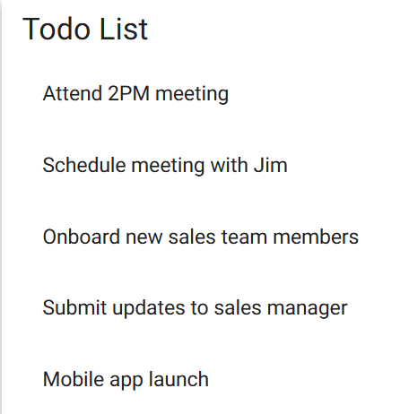
3 | Review the remaining tasks. | The other five tasks are still listed in their original order. | <yes/no> | Yes
4 | Add a task named "Temporary task", then click its delete icon. | "Temporary task" appears at the bottom of the list, then is removed. The list shows five tasks again. | <yes/no> | Yes
5 | Delete each remaining task one at a time. | Each task is removed when its icon is clicked. The Todo List ends up empty with no errors, and the Task Form can still add a new task. | <yes/no> | Yes 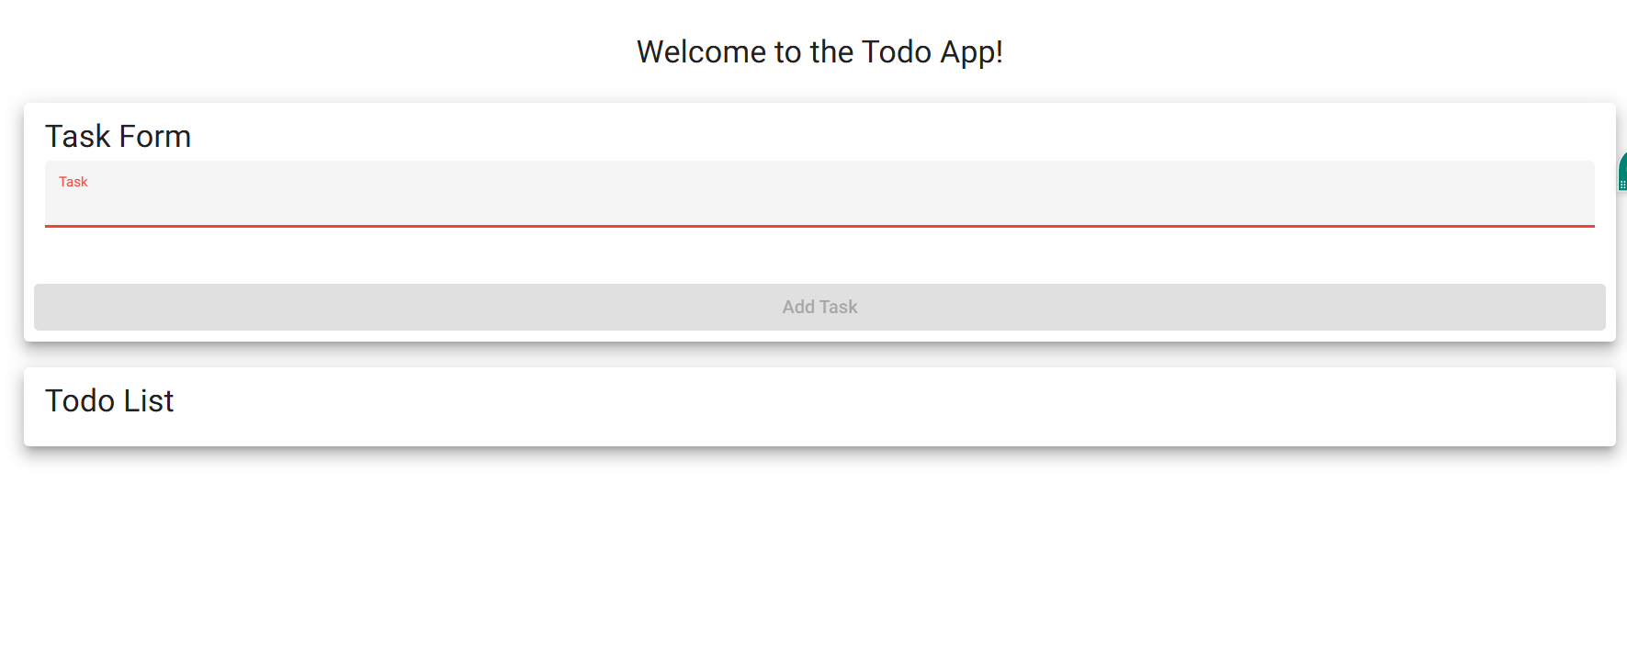
Comments | Deletes only the selected task; list can be emptied and the form still adds tasks.

Test 6 | Custom 404 Page for Invalid URLs
 | Test Objective: Covers Req #5. Verifies users who enter an invalid URL see a custom 404 error page instead of a broken page or a generic browser/server error. | Developer: Garvin Stewart  Date tested: <2026/11/12> | Peer tester: Sheridan Dela Cruz  Date tested: 22026/11/13
Step | Action | Expected results: | Developer pass/fail | Tester pass/fail
1 | Visit https://buwebdev.github.io/todo/does-not-exist. | A custom 404 error page for the Todo application is displayed (not a blank page or a generic GitHub/browser error). | <yes/no> | No 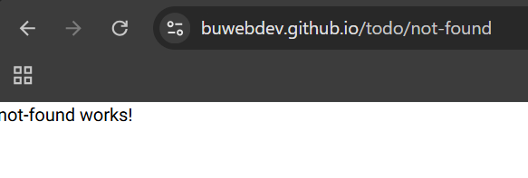
2 | Read the content of the page. | The page clearly tells the user the page was not found (e.g. "404 - Page Not Found"). | <yes/no> | No
3 | Look for a way back to the application. | The page provides a link or button that returns the user to the Todo home page. | <yes/no> | No
4 | Use that link/button (or the browser Back button if none is provided). | The Todo home page loads with the Task Form and Todo List. | <yes/no> | Yes
5 | Visit a second invalid URL: https://buwebdev.github.io/todo/tasks/123. | The same custom 404 error page is displayed. | <yes/no> | Yes 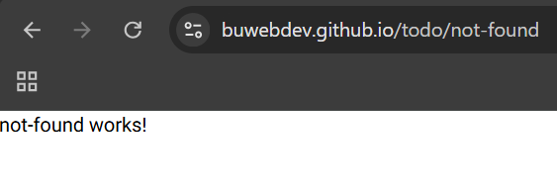
Comments | Bad URLs redirect to /todo/not-found, a blank page showing only "not-found works!" (Angular placeholder): no header, no not-found message, no link home. Step 4 (browser Back) not checked.

Test 7 | Mobile Device View
 | Test Objective: Covers Req #8. Verifies the application provides a usable view on mobile devices. | Developer: Garvin Stewart  Date tested: <2026/11/12> | Peer tester: Sheridan Dela Cruz  Date tested: 22026/11/13
Step | Action | Expected results: | Developer pass/fail | Tester pass/fail
1 | Visit https://buwebdev.github.io/todo/ in Chrome and open DevTools (F12), then turn on the device toolbar (Ctrl+Shift+M). | The page shows in device-emulation mode. | <yes/no> | Yes 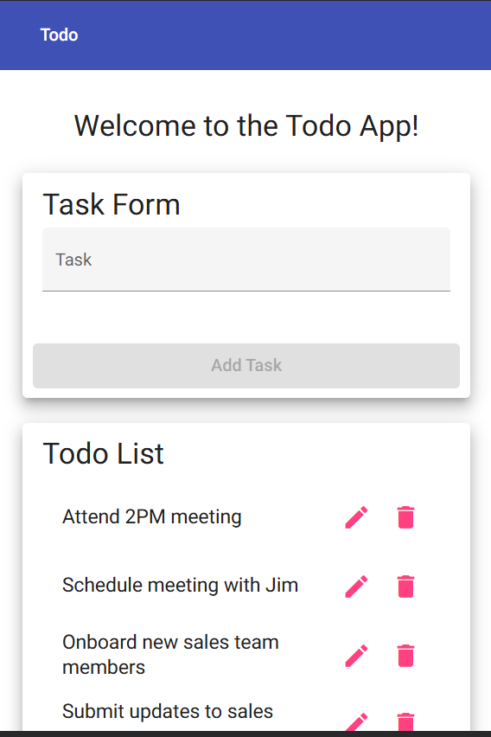
2 | Select a mobile device such as "iPhone SE" (375 x 667). | The Task Form and Todo List cards resize to fill most of the screen width (about 90%). No horizontal scrolling is needed and no text is cut off. | <yes/no> | Yes 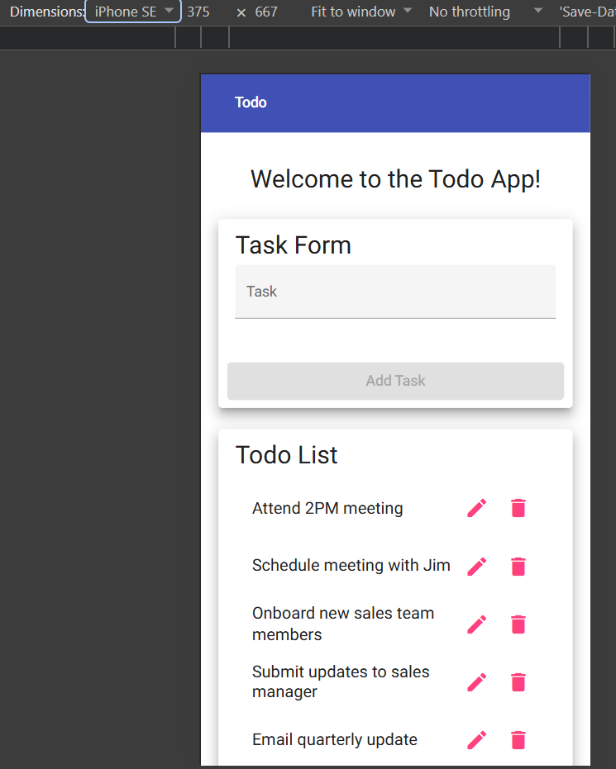
3 | Review the header and the Todo List. | "Welcome to the Todo App!" and all six default tasks are readable, and each task's edit and delete icons are visible and tappable. | <yes/no> | Yes 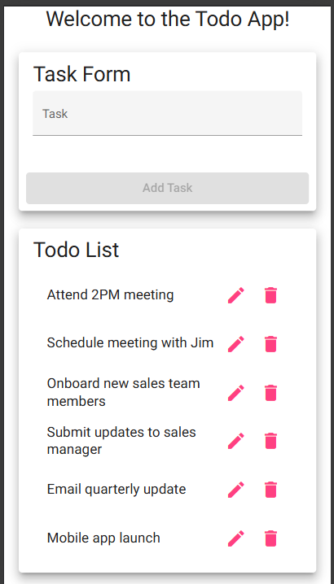
4 | Add a task named "Mobile test task" using the Task Form. | The task is added to the bottom of the list and displays correctly on the small screen. | <yes/no> | Yes 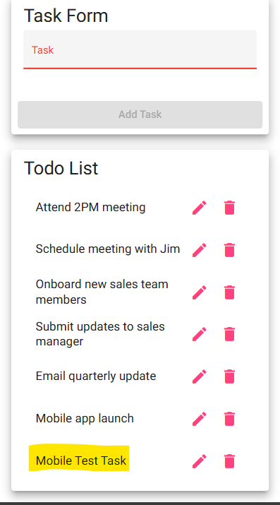
5 | Edit "Mobile test task" using the edit icon, change it to "Mobile task edited" and click Save. | The Edit Form dialog fits on the screen, the Save button is reachable, and the updated task text shows in the list. | <yes/no> | Yes 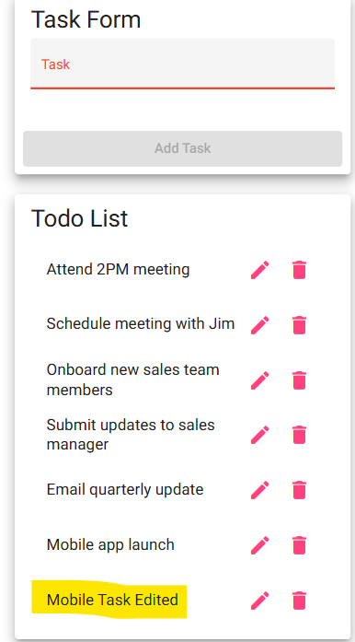
Comments | Cards fill about 90% of the width, no sideways scrolling; edit dialog fits with Save reachable.

Test 8 | Tablet Device View
 | Test Objective: Covers Req #9. Verifies the application provides a usable view on tablet devices. | Developer: Garvin Stewart  Date tested: <2026/11/12> | Peer tester: Sheridan Dela Cruz  Date tested: 2026/11/13
Step | Action | Expected results: | Developer pass/fail | Tester pass/fail
1 | Visit https://buwebdev.github.io/todo/ in Chrome with the DevTools device toolbar on (Ctrl+Shift+M). | The page shows in device-emulation mode. | <yes/no> | Yes
2 | Select a tablet device such as "iPad Mini" (768 x 1024). | The Task Form and Todo List cards resize to about 90% of the screen width. No horizontal scrolling is needed and no text is cut off. | <yes/no> | Yes 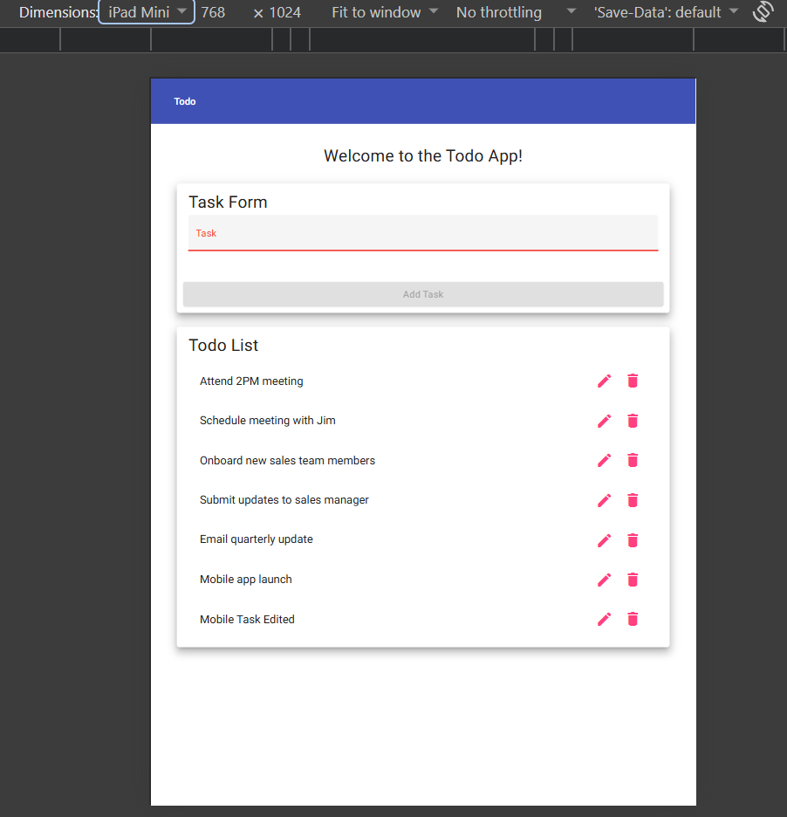
3 | Rotate the view to landscape with the device toolbar's rotate button. | The layout adjusts to the wider screen. All content stays readable and no horizontal scrolling is needed. | <yes/no> | Yes 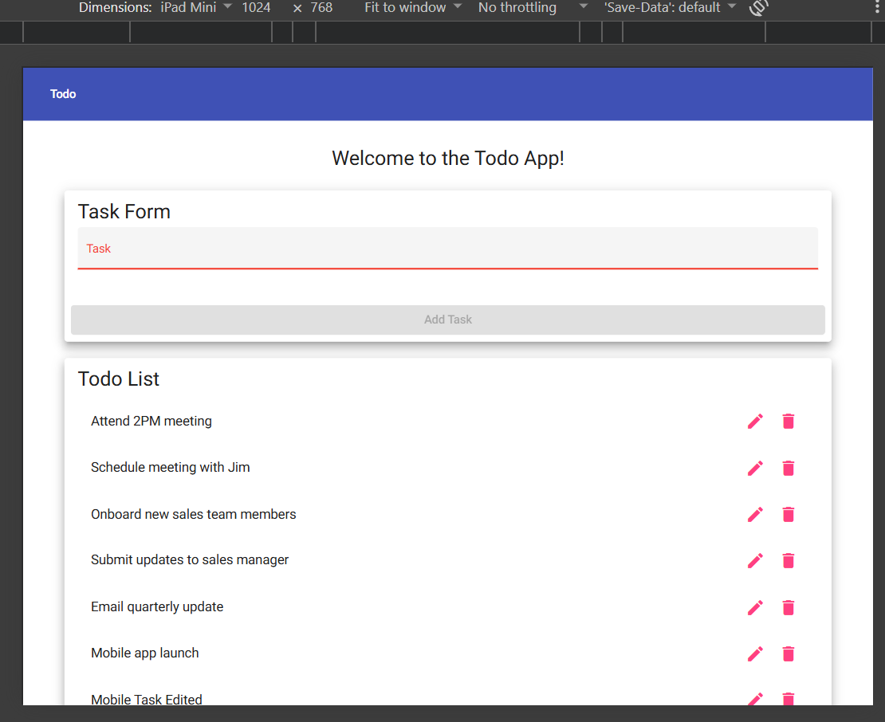
4 | Add a task named "Tablet test task". | The task is added to the bottom of the list and displays correctly. | <yes/no> | Yes 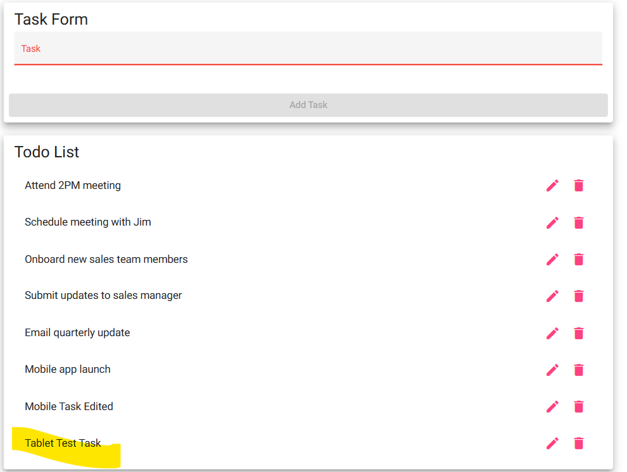
5 | Delete "Tablet test task" using its delete icon. | The task is removed and the list returns to the six default tasks. | <yes/no> | Yes 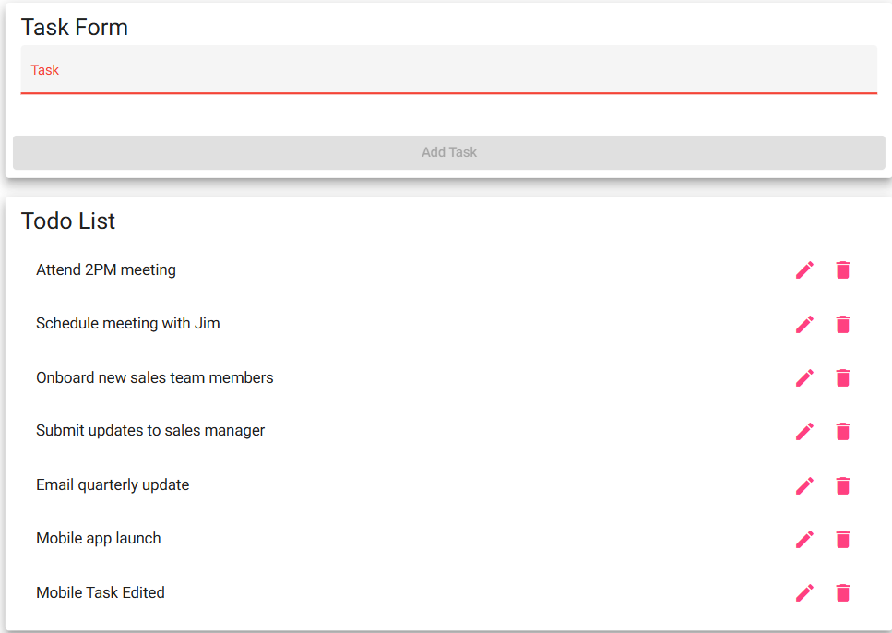
Comments | Cards fill about 90% of the width in portrait and landscape, no sideways scrolling; add and delete work.

