Sheridan Dela Cruz
October 21, 2026
Module 1.2

GitHub Repository Link: https://github.com/shedzip-wq/csd-430
GitHub, CSD-430 Page:
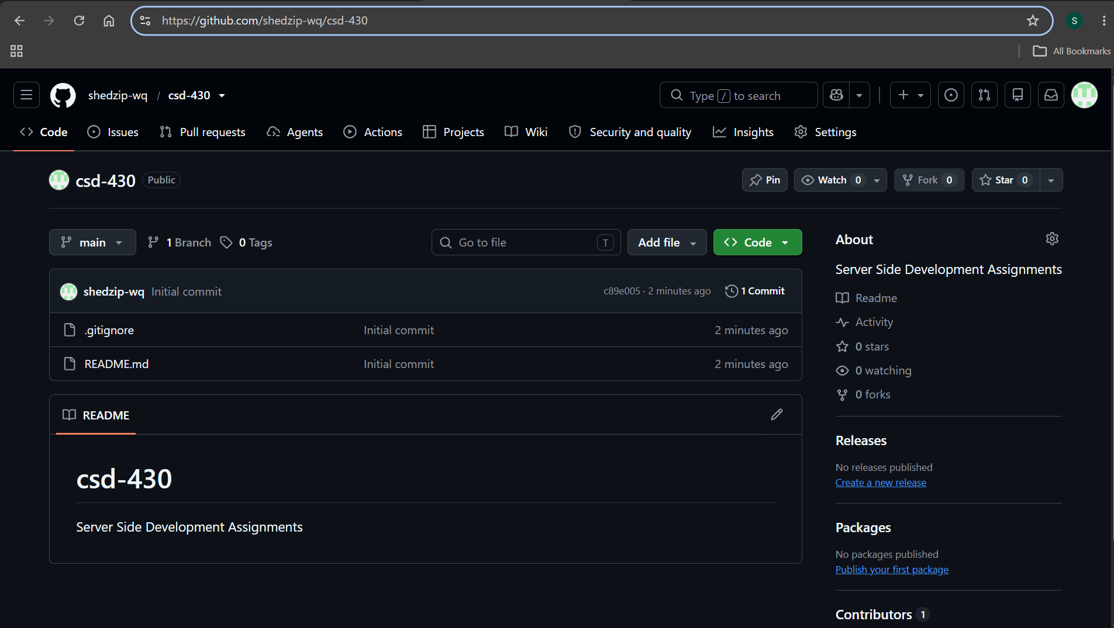
Local Directory:
