Phase 1: Brainstorming & Ideation
EduGenie Problem Formulation, User Personas & Feasibility Analysis
📌 DOCUMENT METADATA
Project: EduGenie (Google Gemini Powered Learning Assistant)
Framework: FastAPI ASGI • Runtime: Python 3.10+ / 3.13 • Frontend: Vanilla JS & CSS3
AI Models: Google Gemini (gemini-1.5-flash / pro) + Local MBZUAI/LaMini-Flan-T5-783M
Verification: 37 Automated Pytest Test Cases (100% Pass) • Real Playwright Screenshots

1. Problem Statement
Modern educational environments present students with unprecedented volumes of academic material. However, learners frequently struggle to extract actionable knowledge from dense textbooks, understand abstract scientific concepts, or validate their retention through immediate active recall. Traditional study approaches suffer from three acute challenges:
- Cognitive Overload: Students encounter overwhelming cognitive load when reviewing multi-page textbook passages.
- Conceptual Abstraction: Static definitions in physics, chemistry, and computer science lack relatable analogies.
- Lack of Active Recall: Learners spend hours reading passively without structured self-assessment or feedback.
- Cloud AI Fragility: Most cloud-based AI tools crash or fail when API quotas or internet connectivity drops.
2. Target Users & User Personas
EduGenie is engineered for three primary educational demographics:
Persona 1: Maya — High School Student (Grade 11)
- Academic Need: Preparing for board exams in Physics, Chemistry, and Mathematics.
- Pain Point: Gets stuck on abstract concepts like Quantum Computing and Photosynthesis; traditional textbooks are too dense.
- EduGenie Value: Uses EduGenie's Concept Explainer and Smart Q&A to break down concepts into simple real-world analogies.
Persona 2: Alex — University Computer Science Undergrad
- Academic Need: Mastering Data Structures and Algorithms for technical internships.
- Pain Point: Needs rapid active recall testing on topics like Binary Search and Pythagoras theorem before coding rounds.
- EduGenie Value: Generates instant 3-MCQ quizzes and tests edge cases with real-time score grading.
Persona 3: Priya — Self-Taught Career Switcher
- Academic Need: Transitioning into Data Analytics and Database Engineering.
- Pain Point: Lacks a structured curriculum; feels overwhelmed by disjointed online tutorials.
- EduGenie Value: Leverages EduGenie's Learning Path Recommender to get milestone-based roadmaps for SQL and Python.
3. Candidate Ideas Considered & Selection Matrix
During the initial brainstorming sprint, five potential project concepts were evaluated against five key criteria:
Concept Idea | Student Value | AI Feasibility | Offline Fallback | Implementation Complexity | Selected?
1. EduGenie Learning Assistant | Very High | High (Gemini Flash) | High (Deterministic) | Moderate (FastAPI) | YES (Chosen)
2. Multi-Agent Debate Arena | Moderate | Moderate | Low (Fragile) | Very High | No
3. Automated Video Transcriber | High | High (Whisper) | None (Heavy CPU) | High | No
4. Flashcard Generator Only | Moderate | High | High | Low (Too Basic) | No
5. PDF Essay Auto-Grader | High | Moderate | Low | High | No

4. Proposed Solution & Unique Value Proposition
EduGenie is a lightweight, responsive learning assistant powered by Google Gemini and local transformer models. It combines 5 core learning capabilities into a unified glassmorphism dashboard: Smart Q&A, Concept Simplification, Text Summarization, Interactive Quiz Generation with automated grading, and Personalized Learning Roadmaps. Its unique value lies in its hybrid inference architecture and deterministic fallback engine that guarantees zero downtime.
5. Key Features: Must-Have vs Nice-to-Have
Feature Category | Feature Description | Target Route | Priority
Smart Q&A | Concise, factual answering of student queries | GET /qa | Must-Have (P1)
Concept Explainer | Simplifies concepts using analogies for school students | POST /explain | Must-Have (P1)
Dual Backend | Support for Google Gemini Cloud & Local HuggingFace model | POST /explain | Must-Have (P1)
Interactive Quiz | Generates exactly 3 MCQs with 4 options and automated grading | POST /quiz | Must-Have (P1)
Text Summarizer | Condenses long textbook passages into 4 key bullet points | POST /summarize | Must-Have (P1)
Learning Roadmap | Milestone curriculum roadmap from Beginner to Advanced | GET /learn | Must-Have (P1)
Offline Fallbacks | Deterministic zero-downtime offline generator on API failure | All Modules | Must-Have (P1)
Voice Interaction | Speech-to-text input and audio explanation output | UI Audio | Nice-to-Have (P2)
Multi-Language | Multilingual translation for non-English speakers | Localization | Nice-to-Have (P2)

6. Why Generative AI (Gemini) Fits & Risk Mitigation
Google Gemini (gemini-1.5-flash and gemini-1.5-pro) offers massive context windows, rapid reasoning, and structured JSON generation. However, deploying Generative AI in education requires strict risk controls:
- Risk 1 — Factual Hallucinations: Handled by strict prompt constraints, temperature control (0.2), and verified offline fallbacks.
- Risk 2 — API Rate Limits & Cost: Mitigated by caching, payload minimization, and automatic offline demo generator routing.
- Risk 3 — Data Privacy & Security: EduGenie operates statelessly without persisting student PII or credentials.
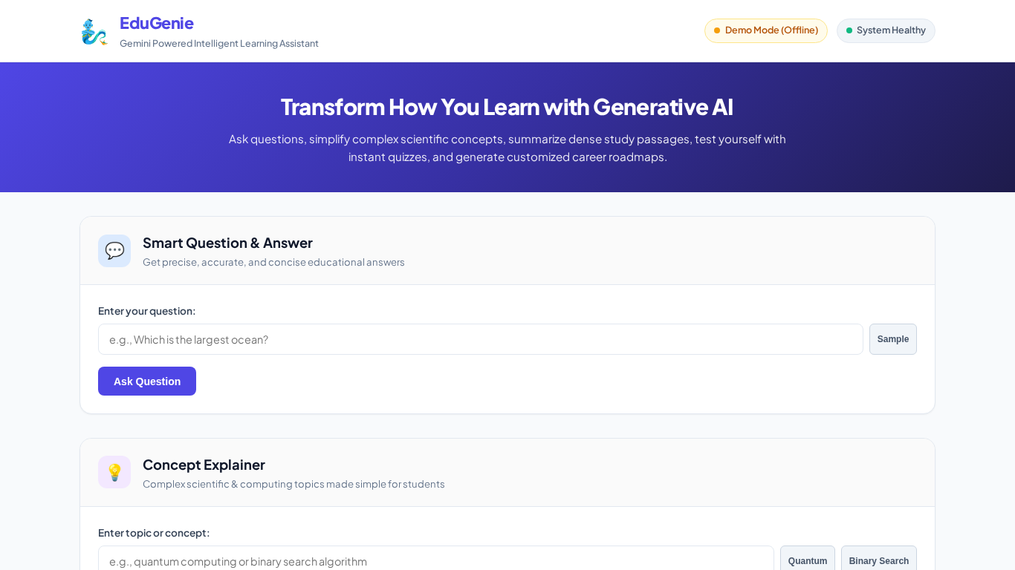
Figure 1.1: EduGenie Web Dashboard Landing State with Demo Mode Badge and 5 Feature Cards

