Phase 2: Requirement Analysis
Functional & Non-Functional Specifications, User Stories, and Scope
📌 DOCUMENT METADATA
Project: EduGenie (Google Gemini Powered Learning Assistant)
Framework: FastAPI ASGI • Runtime: Python 3.10+ / 3.13 • Frontend: Vanilla JS & CSS3
AI Models: Google Gemini (gemini-1.5-flash / pro) + Local MBZUAI/LaMini-Flan-T5-783M
Verification: 37 Automated Pytest Test Cases (100% Pass) • Real Playwright Screenshots

1. Functional Requirements Specification
The functional requirements for EduGenie define all capabilities exposed via RESTful endpoints and web UI:
Req ID | Module | Requirement Description | Priority
FR-01 | QnA | Provide concise, accurate answers (2-4 sentences) for academic queries via GET /qa. | High (P1)
FR-02 | Explainer | Explain complex scientific concepts with relatable school analogies via POST /explain. | High (P1)
FR-03 | AI Dual Engine | Allow user selection between cloud Gemini API and local LaMini-Flan-T5 model. | High (P1)
FR-04 | Quiz Module | Generate exactly 3 MCQs with 4 options each, formatted as strictly validated JSON. | High (P1)
FR-05 | Quiz Grader | Interactive web UI that evaluates answers, reveals correct options, and scores 0-3. | High (P1)
FR-06 | Summarizer | Summarize educational passages from textarea input into 4 key bullet points. | High (P1)
FR-07 | Learning Path | Generate 3-stage milestone roadmaps (Beginner to Advanced) with time estimates. | High (P1)
FR-08 | Health & Fallback | Provide /health status endpoint and automatic deterministic offline fallback. | High (P1)

2. Non-Functional Requirements (NFRs)
- NFR-01: Performance & Latency — REST API endpoints must respond within 1.5 seconds under live API conditions and < 100ms in demo mode.
- NFR-02: Usability & UX — The web interface must be clean, accessible, intuitive, and responsive across desktop and mobile devices.
- NFR-03: Security & Privacy — Zero hard-coded secrets; API keys read strictly from environment variables (.env.example).
- NFR-04: Reliability & Fault Tolerance — Zero downtime; automatic graceful degradation to offline generators if API calls fail or timeout.
3. User Stories with Acceptance Criteria
US-01: Factual Question Answering
As a high school student, I want to ask factual questions like 'Which is the largest ocean?' so that I receive immediate, accurate answers.
Acceptance Criteria: Acceptance Criteria: Endpoint GET /qa returns status 200, non-empty answer citing Pacific Ocean details.
US-02: Complex Concept Simplification
As a learner, I want to enter 'quantum computing' and get an explanation using simple spinning-coin analogies.
Acceptance Criteria: Acceptance Criteria: POST /explain returns structured markdown with analogies and definition.
US-03: Local Inference Option
As a developer running offline, I want to select the local LaMini-Flan-T5 backend so that I do not incur cloud API costs.
Acceptance Criteria: Acceptance Criteria: POST /explain with backend='local' routes through HuggingFace pipeline or fallback.
US-04: Automated 3-MCQ Quiz Generation
As a student preparing for a test on 'Pythagoras theorem', I want 3 MCQs with 4 options each.
Acceptance Criteria: Acceptance Criteria: POST /quiz returns valid JSON array of 3 items; answer exactly matches one of 4 options.
US-05: Real-Time Interactive Quiz Grading
As a learner, I want immediate visual feedback when I answer a quiz question.
Acceptance Criteria: Acceptance Criteria: Correct options highlight in green, mistakes in red with correct answer shown; score banner updates.
US-06: Educational Text Summarization
As a student revising history, I want to paste an Industrial Revolution passage into a multiline textarea and get 4 bullet points.
Acceptance Criteria: Acceptance Criteria: POST /summarize returns concise executive summary with core takeaways.
US-07: Personalized Career Roadmaps
As a self-learner studying 'SQL', I want a structured 3-stage roadmap with time estimates.
Acceptance Criteria: Acceptance Criteria: GET /learn/recommendations returns Stage 1 (Weeks 1-2), Stage 2 (Weeks 3-4), and Stage 3 (Weeks 5-6).
US-08: Health Monitoring & Offline Fallback
As a system administrator, I want to verify system health and runtime mode via /health.
Acceptance Criteria: Acceptance Criteria: GET /health returns status='healthy', mode='demo' or 'live', and model names.
4. Technical Requirements & Environment
Component | Specification / Package | Version | Purpose
Programming Language | Python | 3.10+ / 3.13.14 | Core backend and test runner runtime
Web Framework | FastAPI + Starlette | >= 0.110.0 | Asynchronous RESTful API framework
ASGI Web Server | Uvicorn | >= 0.28.0 | High-performance asynchronous server
Cloud AI SDK | google-genai / google.generativeai | >= 0.1.1 | Official Google Gemini SDK
Data Validation | Pydantic | >= 2.6.0 | Request schema validation & sanitization
Test Suite | pytest + pytest-cov | >= 8.0.0 | Automated unit, integration, and coverage tests
Browser Automation | Playwright (Chromium) | >= 1.42.0 | Automated UI tests, screenshots, and video recording
Video Processing | FFmpeg | 7.1.5 | Video transcoding, compression, and MP4 generation

5. Project Scope: In-Scope vs Out-of-Scope
- In-Scope: FastAPI backend with 5 REST endpoints, HTML5 frontend with 5 cards, Gemini AI integration, LaMini-Flan-T5 local backend, deterministic offline generators, automated Playwright screenshots, 2 MP4 videos, and 37 automated tests.
- Out-of-Scope: Multi-user authentication, persistent SQL database storage, paid third-party SMS/email integrations, native iOS/Android mobile apps, and paid cloud hosting deployments.
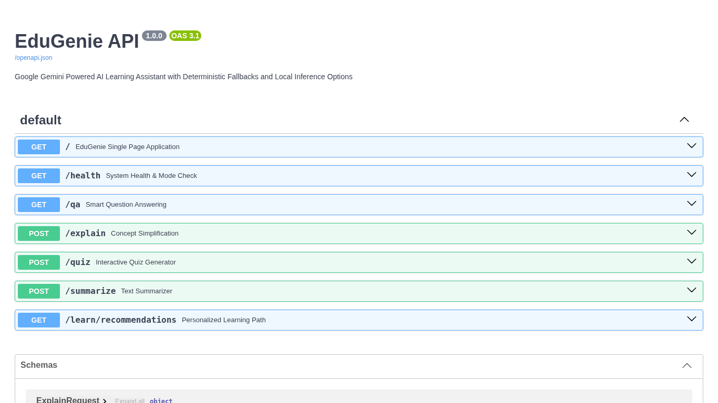
Figure 2.1: FastAPI OpenAPI Interactive Swagger UI Documenting All System Endpoints

