Phase 3: Project Design
System Architecture, Flowcharts, Data Models, and Prompt Engineering
📌 DOCUMENT METADATA
Project: EduGenie (Google Gemini Powered Learning Assistant)
Framework: FastAPI ASGI • Runtime: Python 3.10+ / 3.13 • Frontend: Vanilla JS & CSS3
AI Models: Google Gemini (gemini-1.5-flash / pro) + Local MBZUAI/LaMini-Flan-T5-783M
Verification: 37 Automated Pytest Test Cases (100% Pass) • Real Playwright Screenshots

1. Architectural Diagrams & Technical Analysis
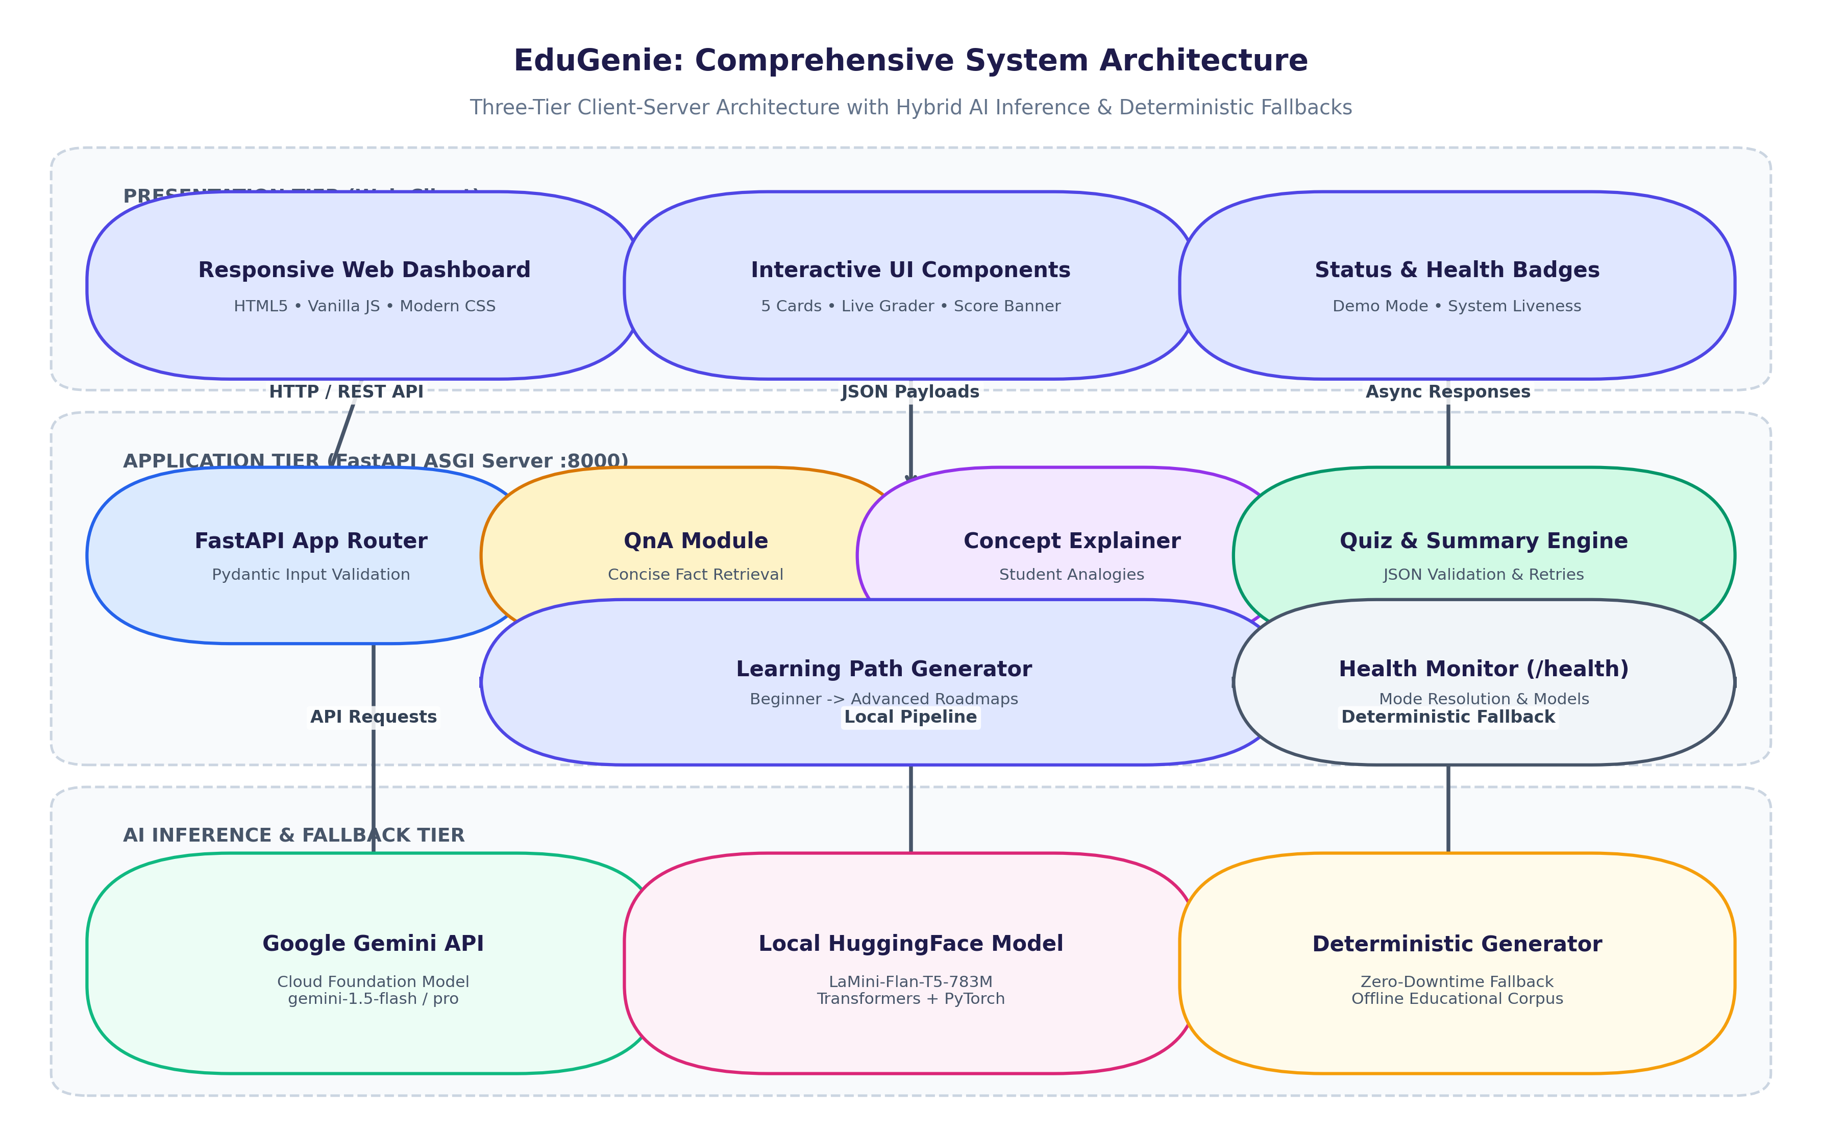
Figure 3.1: EduGenie Three-Tier System Architecture Diagram
Figure 3.1 illustrates EduGenie's three-tier client-server architecture. The Presentation Tier consists of a lightweight HTML5/CSS3/JS single-page application. The Application Tier is powered by an asynchronous FastAPI ASGI engine on port 8000. The AI Inference Tier features a hybrid routing layer communicating with Google Gemini API, a local HuggingFace LaMini-Flan-T5 pipeline, and a deterministic offline knowledge generator for zero-downtime reliability.
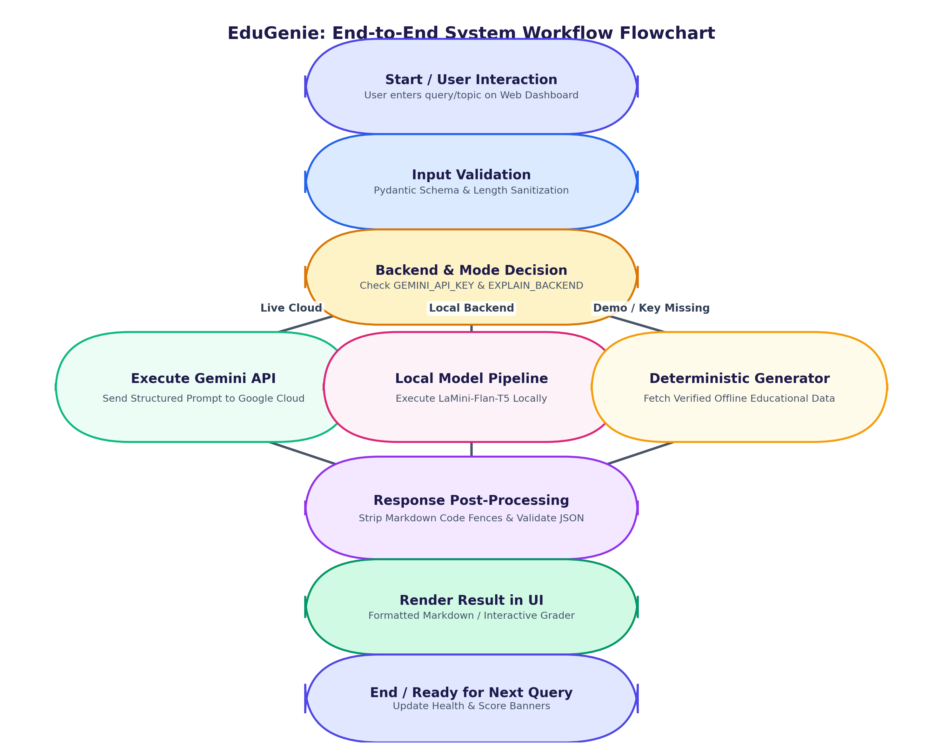
Figure 3.2: End-to-End System Workflow Flowchart
Figure 3.2 details the complete execution lifecycle of a user request. Inputs are validated by Pydantic schema guards. The engine dynamically selects the AI backend based on environment flags, cleans raw responses (stripping markdown code fences), validates the structure, and delivers rendered markdown or interactive quiz elements to the client.
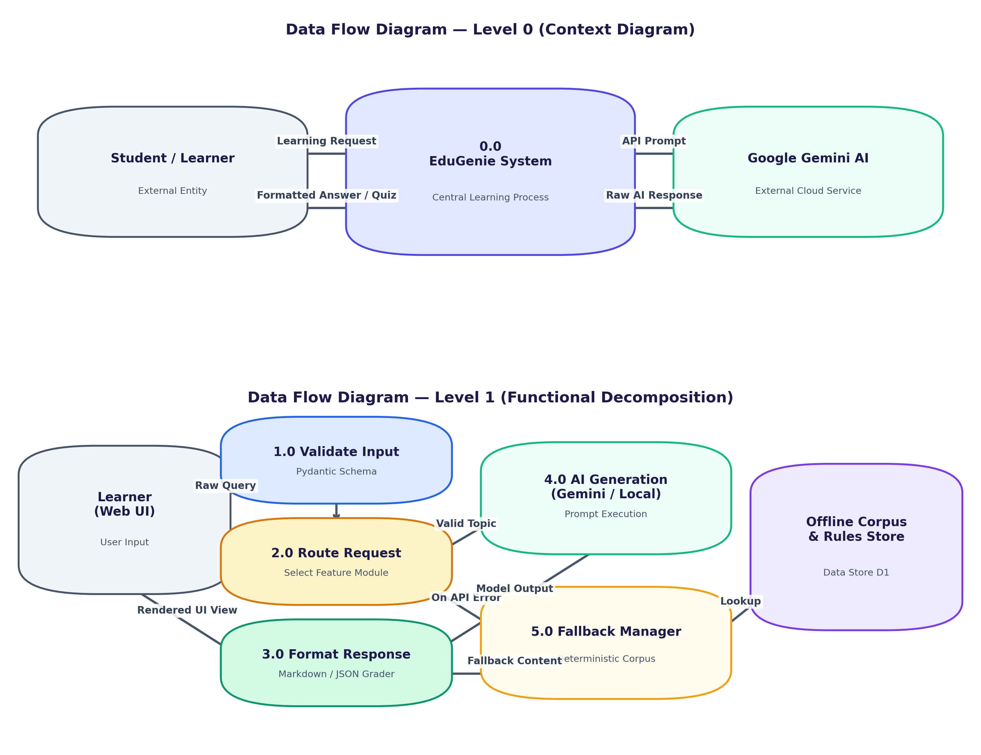
Figure 3.3: Data Flow Diagrams (Level 0 Context and Level 1 Functional Decomposition)
Figure 3.3 presents the data flow diagrams. Level 0 depicts external entities (Learner and Google Gemini Cloud) interacting with the central EduGenie process. Level 1 decomposes the application into five sub-processes: Input Validation (1.0), Route Management (2.0), Response Formatting (3.0), AI Generation (4.0), and Fallback Handling (5.0) linked to the offline rules repository.
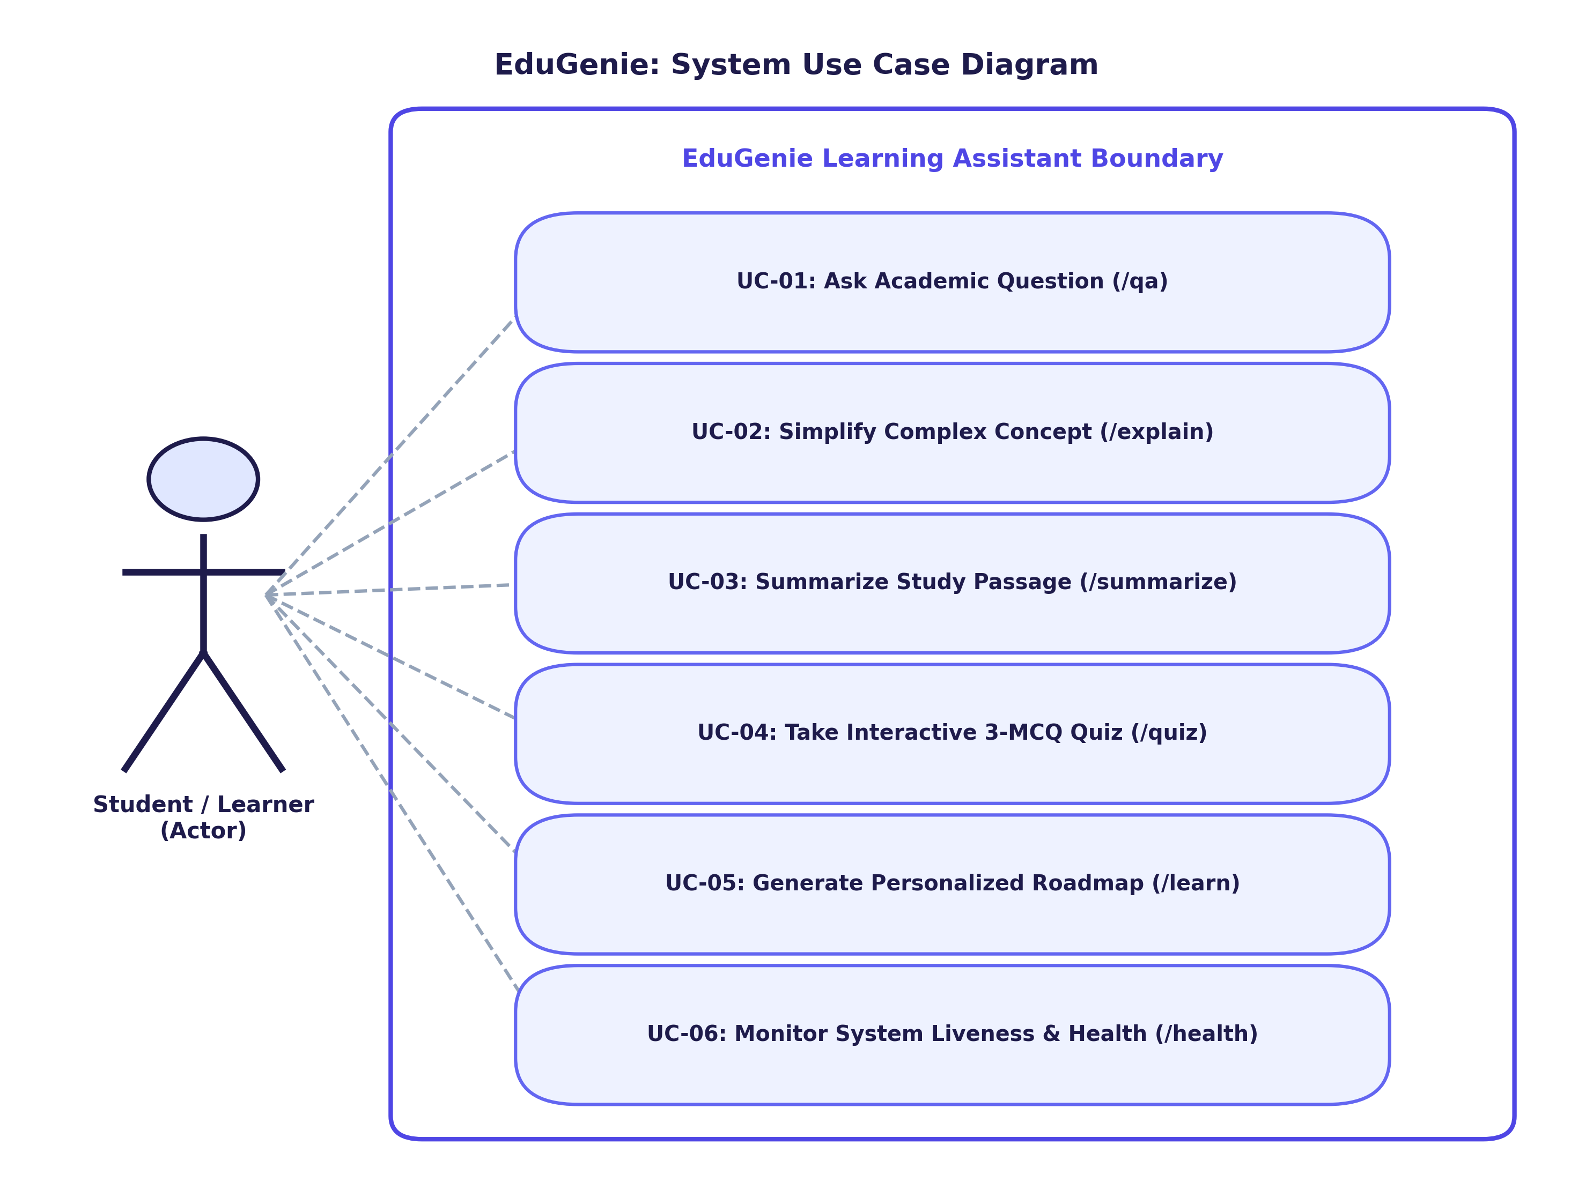
Figure 3.4: System Use Case Diagram with Actor Interactions
Figure 3.4 models all interactions between the primary actor (Student/Learner) and the six primary system use cases: UC-01 (Ask Question), UC-02 (Explain Topic), UC-03 (Summarize Text), UC-04 (Take Interactive Quiz), UC-05 (View Learning Roadmap), and UC-06 (Monitor System Health).
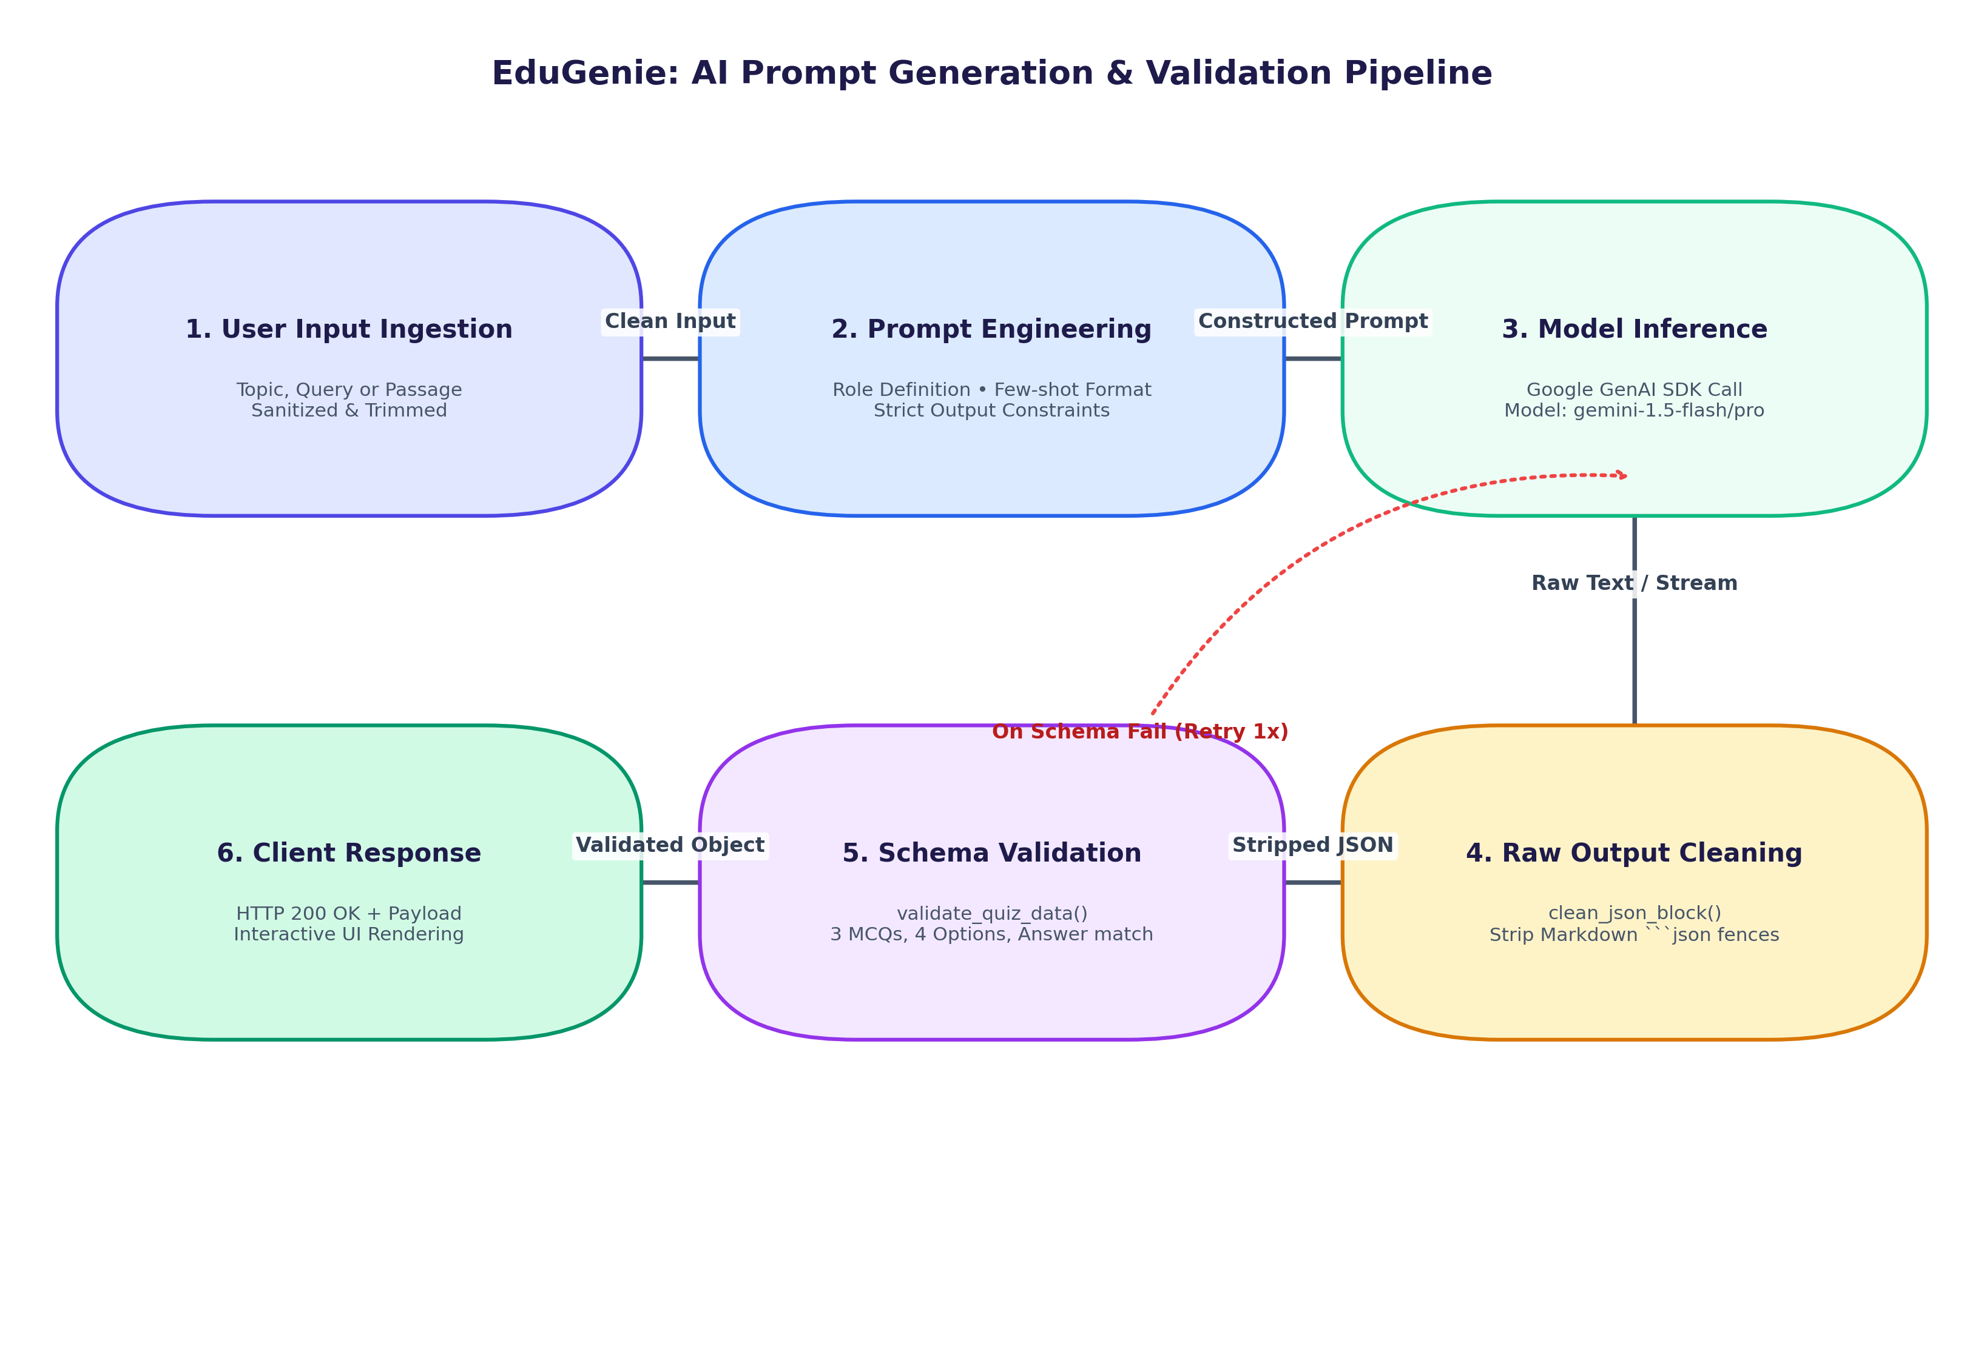
Figure 3.5: AI Prompt Generation, Inference, and Strict JSON Schema Validation Pipeline
Figure 3.5 outlines the prompt generation and validation pipeline. Prompt templates enforce structured outputs. A dedicated sanitizer strips markdown code fences, and a validator ensures exactly 3 MCQs with 4 options each, retrying once before falling back.
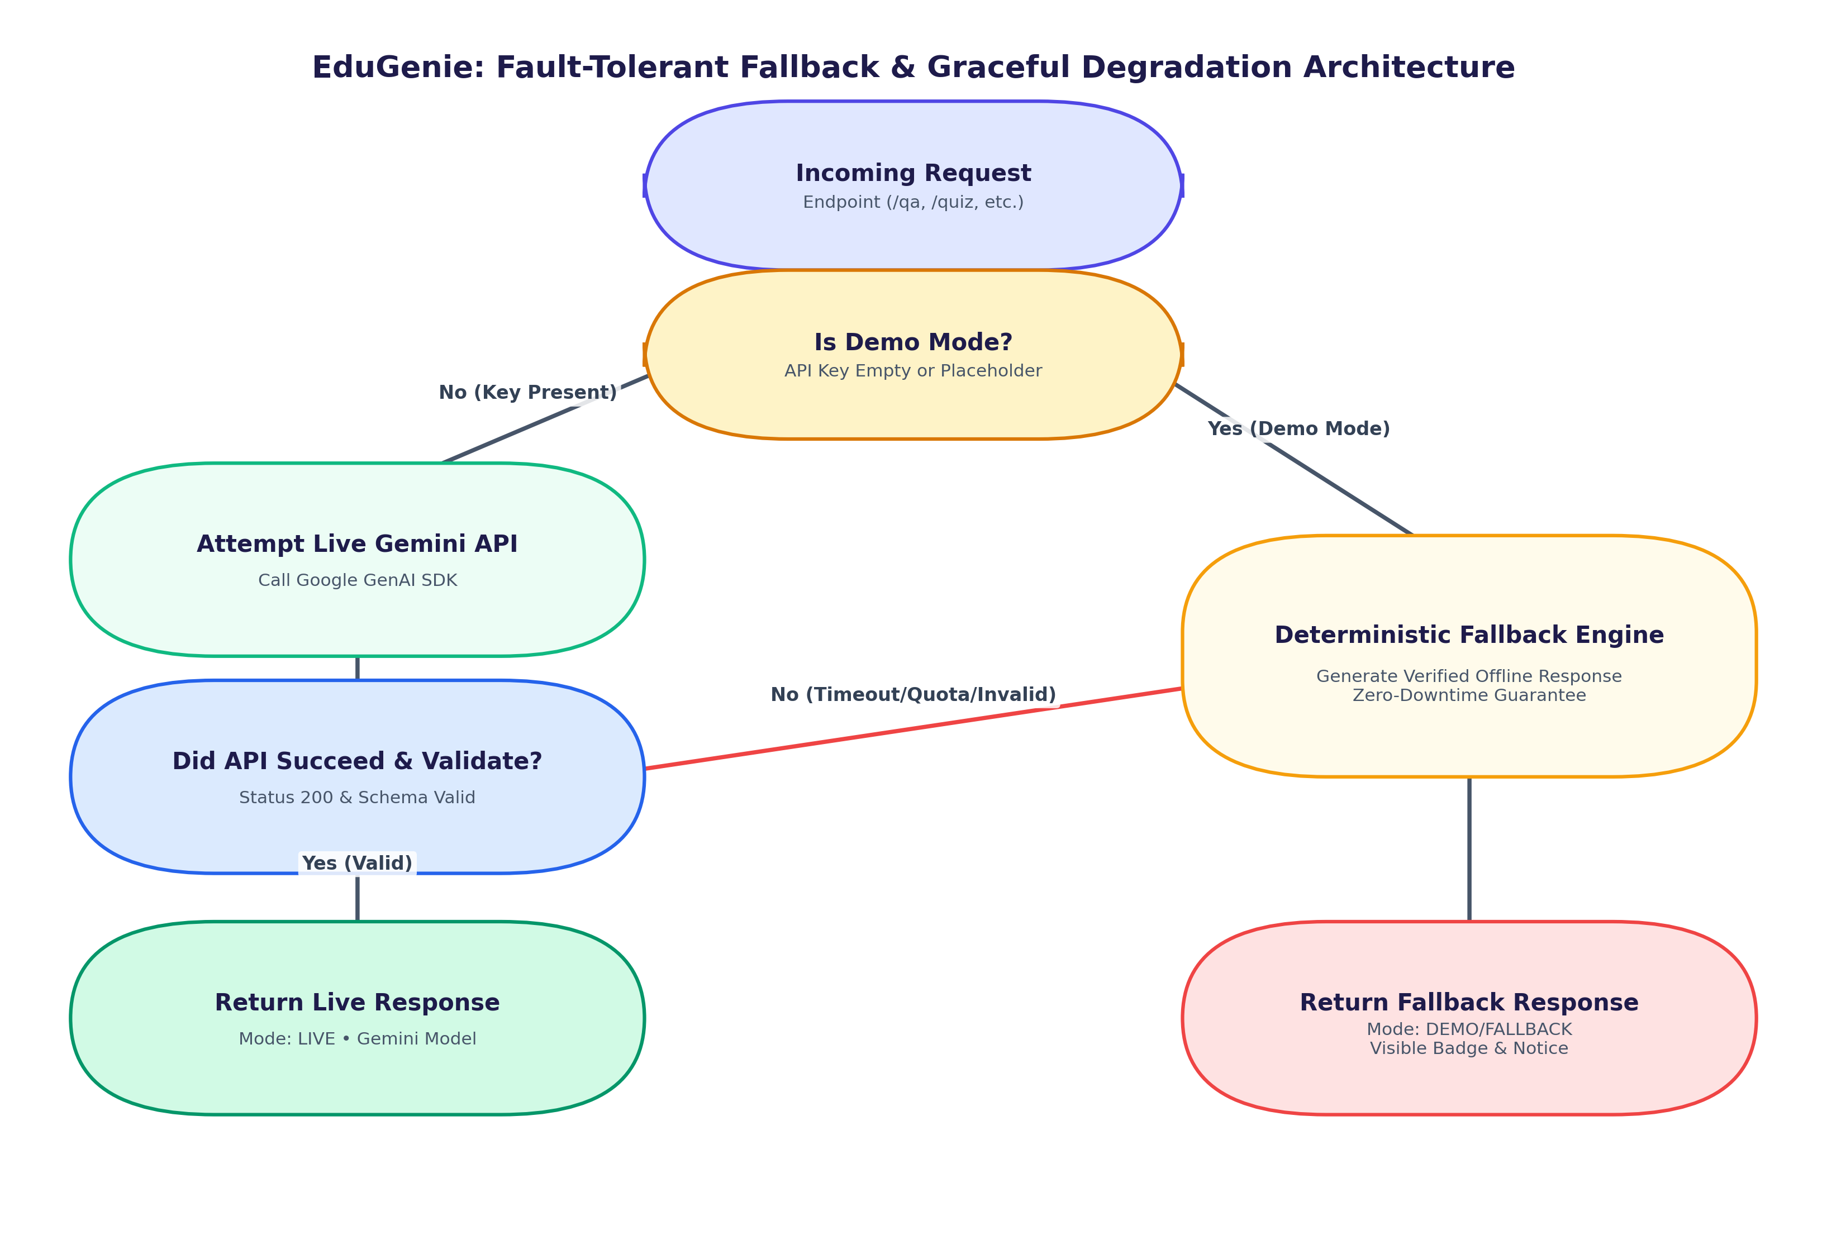
Figure 3.6: Fault-Tolerant Fallback & Graceful Degradation Architecture
Figure 3.6 demonstrates the zero-downtime fallback mechanism. When an API key is missing, or when an external API error occurs (e.g., HTTP 429 rate limits, connection timeouts, or malformed JSON), EduGenie routes the query to its verified deterministic generator.
2. API & Route Design Specifications
Method | Route | Input Payload / Query | Output Format | Status
GET | / | None | HTML5 Single Page Dashboard | 200 OK
GET | /health | None | {"status":"healthy","mode":"demo"|"live"} | 200 OK
GET | /qa | ?question=<str> | {"question":"...","answer":"...","mode":"..."} | 200 / 400 / 422
POST | /explain | {"topic":"...","backend":"gemini"|"local"} | {"topic":"...","explanation":"...","backend":"..."} | 200 / 400 / 422
POST | /quiz | {"topic":"..."} or {"text":"..."} | {"quiz":[{"question":"...","options":[...],"answer":"..."}]} | 200 / 400 / 422
POST | /summarize | {"text":"..."} | {"summary":"...","original_length":...} | 200 / 400 / 422
GET | /learn/recommendations | ?topic=<str> | {"topic":"...","recommendations":"..."} | 200 / 400 / 422

3. Prompt Engineering Design
Every module uses prompt engineering tailored for pedagogy:
- QnA Prompt: 'You are an expert educational tutor. Provide a smart, concise, and highly accurate answer (2 to 4 sentences) for: {question}'
- Explainer Prompt: 'You are a friendly teacher. Explain {topic} simply for a school student with definitions, real-world analogies, step-by-step logic, and why it matters.'
- Quiz Prompt: 'Generate exactly 3 MCQs in raw JSON array format with keys: question, options (4 strings), and answer (EXACT STRING matching one of the options).'
- Summarizer Prompt: 'Summarize the educational passage into clear study notes: 1-line overview, 4 bullet takeaways, and concluding significance.'
- Learning Path Prompt: 'Create a 3-stage roadmap for {topic} (Stage 1: Beginner, Stage 2: Intermediate, Stage 3: Advanced) with hours and interactive resources.'

