Phase 4: Project Planning
Work Breakdown Structure, Milestone Gantt Chart, and Risk Register
📌 DOCUMENT METADATA
Project: EduGenie (Google Gemini Powered Learning Assistant)
Framework: FastAPI ASGI • Runtime: Python 3.10+ / 3.13 • Frontend: Vanilla JS & CSS3
AI Models: Google Gemini (gemini-1.5-flash / pro) + Local MBZUAI/LaMini-Flan-T5-783M
Verification: 37 Automated Pytest Test Cases (100% Pass) • Real Playwright Screenshots

1. Work Breakdown Structure (WBS)
The project execution was organized into 4 distinct milestones over a 4-week timeline:
- Milestone 1: Model Selection & Architecture (Days 1–5) — Activity 1.1: AI Model Evaluation (Gemini 1.5 vs LaMini-Flan-T5) • Activity 1.2: Repository & Environment Setup.
- Milestone 2: Core Backend Development (Days 6–12) — Activity 2.1: QnA Module • Activity 2.2: Explainer Module • Activity 2.3: Quiz Engine • Activity 2.4: Summarizer & Learning Path • Activity 2.5: FastAPI REST Endpoints & Health Route.
- Milestone 3: Web Frontend & UI Integration (Days 13–18) — Activity 3.1: Glassmorphism Dashboard Layout • Activity 3.2: Interactive Quiz Grader & Score Tracking • Activity 3.3: Async API Integration & Loading Spinners.
- Milestone 4: Testing, Verification & Deployment (Days 19–24) — Activity 4.1: Automated Pytest Suite (37 tests) • Activity 4.2: Playwright Screenshots & Video Recording • Activity 4.3: Phase Documentation & Packaging.
2. Project Gantt Chart & Schedule
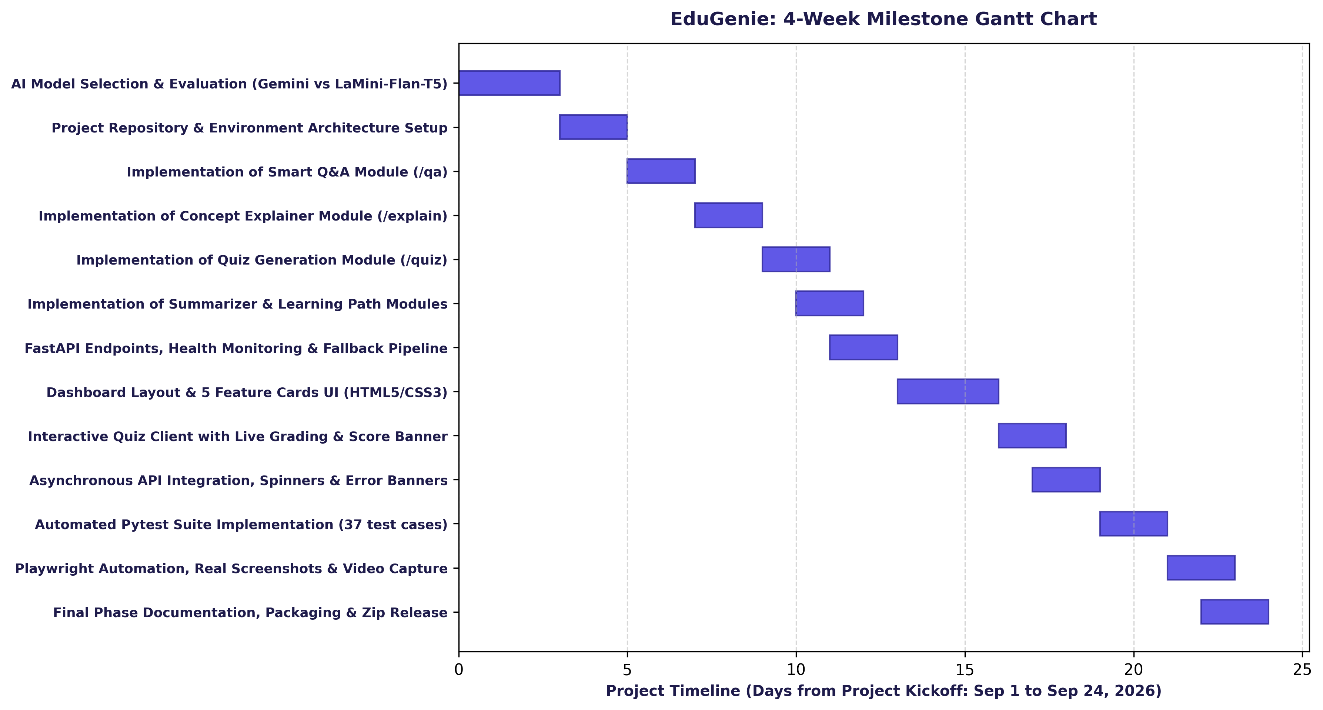
Figure 4.1: EduGenie 4-Week Milestone Gantt Chart
Figure 4.1 illustrates the schedule across all 4 weeks. Milestone dependencies were managed sequentially, allowing backend API endpoints and frontend interface components to be tested concurrently during Week 3.
3. Risk Management & Register
Risk ID | Identified Risk Description | Probability | Impact | Mitigation Strategy | Status
R-01 | Google Gemini API rate-limit quota exhaustion (HTTP 429) | High | High | Implemented deterministic offline generators with automatic fallback | Mitigated
R-02 | Malformed or non-JSON output from LLM during quiz generation | Medium | High | Built clean_json_block fence stripper + 2-pass schema validator | Mitigated
R-03 | Heavy local model download latency (~3GB LaMini-Flan-T5) | High | Medium | Configured EXPLAIN_BACKEND=gemini|local with fast demo fallbacks | Mitigated
R-04 | Empty or whitespace-only inputs causing unhandled 500 crashes | Medium | Medium | Enforced strict Pydantic field validators on all endpoints | Mitigated
R-05 | UI responsiveness breakage on mobile screen widths | Low | Medium | Responsive CSS flexbox/grid tested at 390x844 mobile viewport | Mitigated

4. Development Tools & Technologies
- VS Code & Python 3.13 — Primary code development, debugging, and linting environment.
- Git & GitHub — Distributed version control and release tagging.
- Pytest & Pytest-Cov — Comprehensive test runner executing 37 automated unit and integration tests.
- Playwright — Headless Chromium browser automation capturing 13 real screenshots and video recordings.
- FFmpeg — H.264 video encoding and compression producing high-definition MP4 walkthroughs.

