Phase 5: Project Development
Environment Setup, Code Architecture, AI Integration, and Engineering Challenges
📌 DOCUMENT METADATA
Project: EduGenie (Google Gemini Powered Learning Assistant)
Framework: FastAPI ASGI • Runtime: Python 3.10+ / 3.13 • Frontend: Vanilla JS & CSS3
AI Models: Google Gemini (gemini-1.5-flash / pro) + Local MBZUAI/LaMini-Flan-T5-783M
Verification: 37 Automated Pytest Test Cases (100% Pass) • Real Playwright Screenshots

1. Environment Setup & Execution Commands
EduGenie requires Python 3.10+ and standard pip packaging. To set up and run the application locally:
📌 TERMINAL SETUP COMMANDS
# 1. Clone repo and navigate to directory
cd EduGenie
# 2. Install all dependencies
pip install -r requirements.txt
playwright install chromium
# 3. Configure environment (optional Gemini key)
cp .env.example .env
# 4. Launch FastAPI ASGI server on port 8000
uvicorn main:app --host 0.0.0.0 --port 8000 --reload
# 5. Run test suite
pytest -v --cov=. tests/

2. Repository Structure & File Purposes
File / Directory Path | One-Line Purpose & Functional Role
main.py | FastAPI entry point defining 7 REST routes, middleware, and exception handlers.
config.py | Central configuration module managing API keys, model IDs, and runtime modes.
qna.py | Question answering module with Gemini inference and deterministic fallbacks.
explanation_module.py | Concept explainer supporting dual backends (Gemini and local LaMini).
quiz_module.py | 3-MCQ quiz engine with JSON fence stripping and schema validation.
summary_module.py | Educational passage summarizer extracting 4 key bullet takeaways.
learning_path.py | Curriculum roadmap generator providing 3-stage milestone roadmaps.
demo_generator.py | Offline deterministic knowledge generator providing zero-downtime responses.
templates/index.html | Single-page HTML5 dashboard containing the 5 interactive feature cards.
static/style.css | Modern responsive glassmorphism stylesheet with mobile viewport support.
static/app.js | Vanilla JS client managing asynchronous API fetch calls and interactive grading.
tests/test_api.py | Automated route and endpoint integration tests.
tests/test_modules.py | Unit tests verifying AI module logic and schema validators.
tests/test_edge_cases.py | Defensive tests simulating API rate limits, timeouts, and large payloads.

3. Module Implementation Highlights
Below are the critical code implementations ensuring system robustness:
Quiz JSON Stripping & Strict Validation (quiz_module.py)
📌 QUIZ MODULE VALIDATION LOGIC
def clean_json_block(text: str) -> str:
cleaned = text.strip()
match = re.search(r'```(?:json)?\s*([\s\S]*?)\s*```', cleaned)
return match.group(1).strip() if match else cleaned
def validate_quiz_data(quiz_data: Any) -> bool:
if not isinstance(quiz_data, list) or len(quiz_data) != 3:
return False
for item in quiz_data:
if len(item.get('options', [])) != 4:
return False
if item.get('answer', '').strip() not in [o.strip() for o in item['options']]:
return False
return True

4. Real UI Screenshots from System Execution
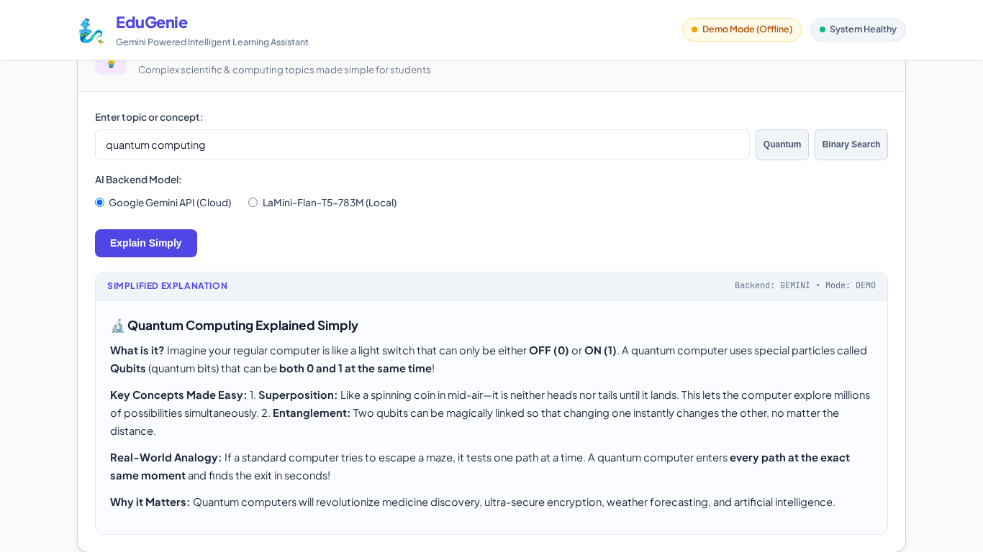
Figure 5.1: Concept Explainer Simplifying Quantum Computing Using Qubit Analogies

Figure 5.2: Text Summarizer Outputting Key Bullet Takeaways from Industrial Revolution Passage
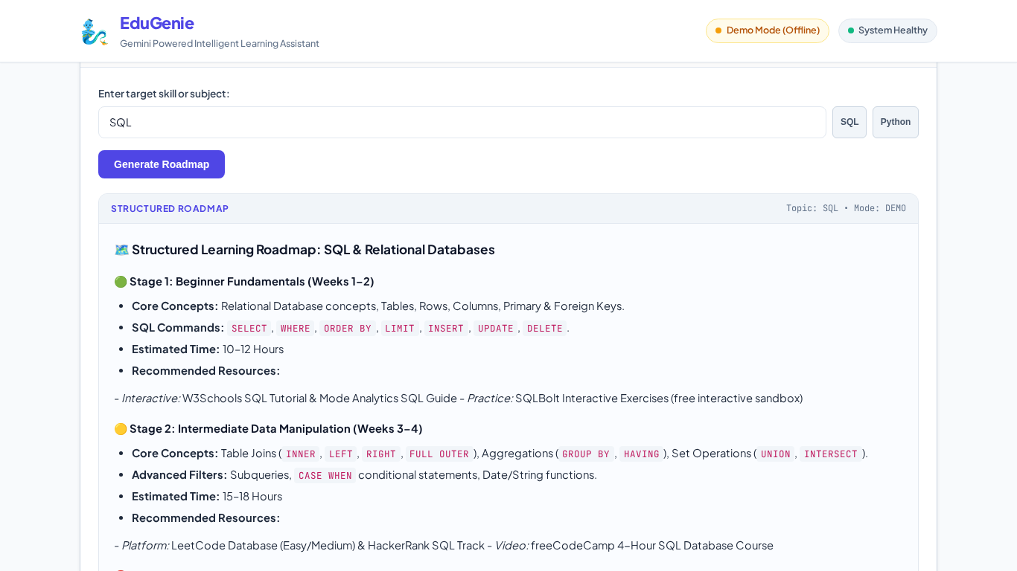
Figure 5.3: Personalized Learning Roadmap for SQL Displaying 3 Structured Stages
5. Five Honest Technical Challenges & Solutions
Challenge 1: Outdated Model Names in Initial Spec
The original specification referenced deprecated Gemini models ('1.5 Flash Pro'). Solved by centralizing model configuration in config.py, dynamically reading from GEMINI_MODEL / GEMINI_PRO_MODEL, and migrating to the modern google-genai SDK.
Challenge 2: Inconsistent LLM JSON Formatting
LLMs frequently wrap JSON responses in markdown fences (```json ... ```) or return answer indices (e.g. 'A') rather than full strings. Solved by implementing regex fence stripping and strict string matching in validate_quiz_data().
Challenge 3: Offline Testing & API Quota Exhaustion
Running automated test suites and capturing 13 screenshots against live APIs risks quota exhaustion and test flakiness. Solved by engineering high-fidelity deterministic offline generators in demo_generator.py.
Challenge 4: Heavy Local Model Footprint (3 GB)
Downloading MBZUAI/LaMini-Flan-T5-783M is memory-intensive on resource-constrained systems. Solved by adding EXPLAIN_BACKEND=gemini|local with automatic graceful fallback if PyTorch weights are not cached.
Challenge 5: Starlette 1.7+ TemplateResponse Signature Shift
Modern Starlette/FastAPI versions updated the TemplateResponse signature to require request as a named parameter. Solved by updating main.py to use TemplateResponse(request=request, name='index.html', context={...}).

