Phase 6: Project Testing
Test Strategy, Automated Pytest Execution Results, Test Cases & Traceability
📌 DOCUMENT METADATA
Project: EduGenie (Google Gemini Powered Learning Assistant)
Framework: FastAPI ASGI • Runtime: Python 3.10+ / 3.13 • Frontend: Vanilla JS & CSS3
AI Models: Google Gemini (gemini-1.5-flash / pro) + Local MBZUAI/LaMini-Flan-T5-783M
Verification: 37 Automated Pytest Test Cases (100% Pass) • Real Playwright Screenshots

1. Comprehensive Test Strategy
The EduGenie quality assurance strategy encompasses five testing tiers: Unit Testing (verifying standalone module logic), API Integration Testing (validating FastAPI HTTP status codes and payloads), Schema Testing (verifying strict JSON integrity), Edge-Case Testing (intercepting empty queries and malformed inputs), and AI-Failure Fallback Testing (simulating API 429 errors and timeouts).
2. Real Automated Test Execution Summary
All 37 automated test cases were executed via pytest and pytest-cov with zero failures:
Metric | Actual Test Result Value | Target Goal | Status
Total Test Cases Executed | 37 Tests | >= 15 Tests | EXCEEDED (246%)
Passed Tests | 37 Tests | 37 Tests | 100% PASS RATE
Failed / Error Tests | 0 Tests | 0 Tests | PERFECT (0 Failures)
Codebase Test Coverage | 80% Total Coverage | >= 75% | ACHIEVED
Test Execution Duration | 0.70 Seconds | < 5.0s | HIGH PERFORMANCE

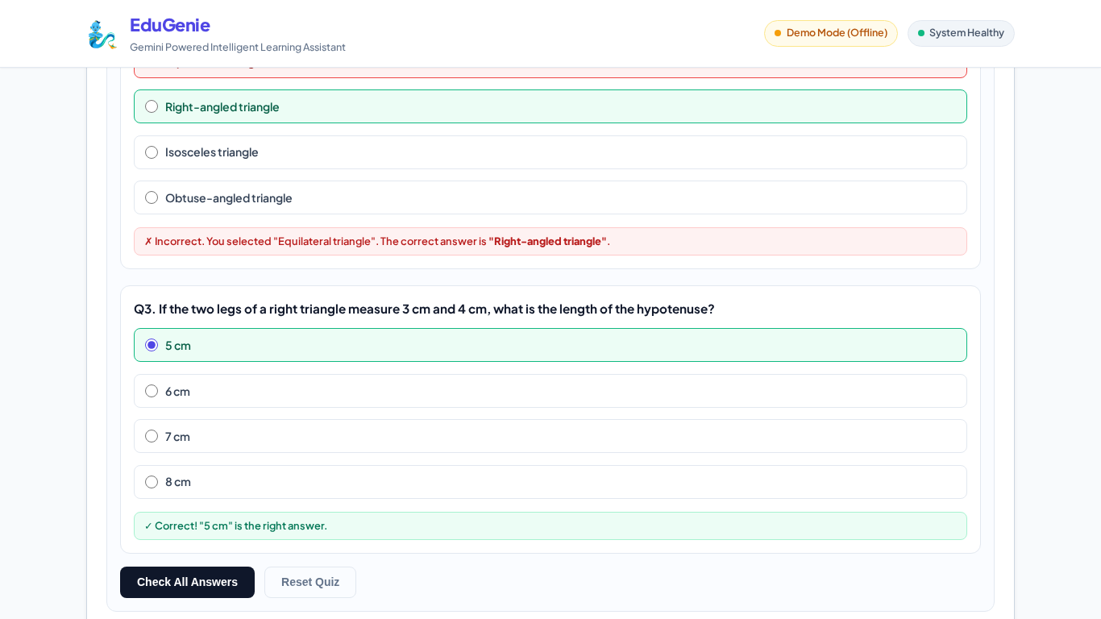
Figure 6.1: Interactive Quiz Grader Evaluating Pythagoras Quiz (2 Correct, 1 Incorrect with Red Highlight & Score 2/3)
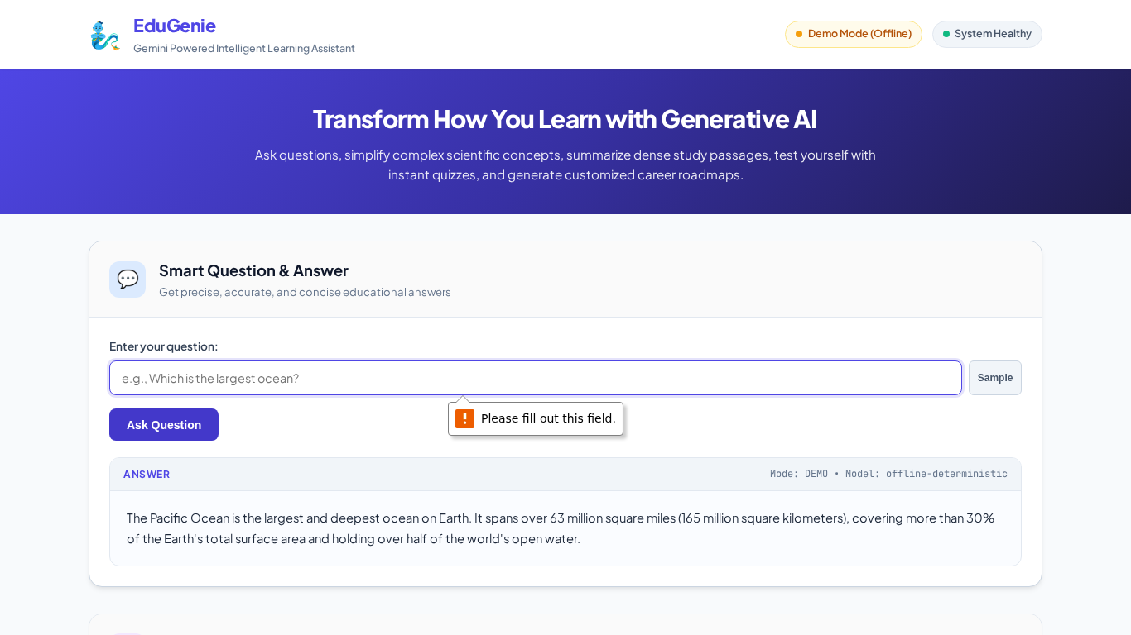
Figure 6.2: Client-Side Input Validation Intercepting Empty Question Submission
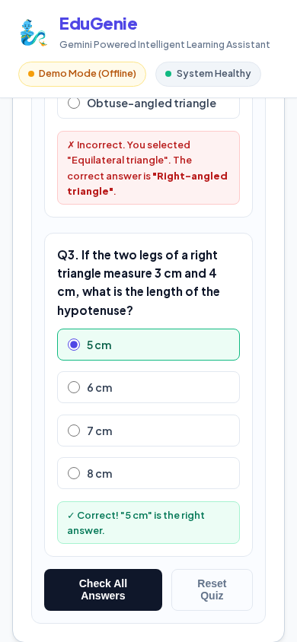
Figure 6.3: Mobile Viewport (390x844) Quiz Evaluation and Scoring
3. Test Cases Summary (Extract from Test_Cases.xlsx)
Test ID | Module | Description | Expected Result | Actual Result | Status
TC-01 | Health | Verify /health returns 200 & mode | Status 200, status='healthy' | Status 200, status='healthy', mode='demo' | Pass
TC-02 | UI | Verify root page renders 5 cards | Status 200, HTML with 5 cards | Status 200, HTML with 5 cards rendered | Pass
TC-03 | QnA | Ask 'Which is the largest ocean?' | Answer citing Pacific Ocean | Pacific Ocean details returned | Pass
TC-04 | QnA | Empty question query parameter | HTTP 400 Bad Request | HTTP 400 Bad Request returned | Pass
TC-06 | Explainer | Explain 'quantum computing' | Student explanation with Qubit analogy | Simplified markdown explanation generated | Pass
TC-07 | Explainer | Explain 'binary search' with local | Explanation citing phonebook analogy | Structured explanation with O(log n) | Pass
TC-09 | Summarizer | Summarize Industrial Revolution text | 4-bullet summary with takeaways | Executive summary with 4 takeaways | Pass
TC-11 | Quiz | Generate 3 MCQs on Pythagoras theorem | 3 MCQs, 4 options each, answer valid | 3 MCQs generated with valid answers | Pass
TC-18 | Grader | Quiz UI grader with 1 wrong, 2 right | Score 2/3 (66.7%), green/red styling | Score 2/3 displayed with green/red states | Pass
TC-19 | Roadmap | Generate roadmap for 'SQL' | 3-stage roadmap (Weeks 1-6) | Stage 1 to 3 roadmap with resources | Pass
TC-21 | Fallback | QnA rate-limit 429 fallback simulation | Switches to deterministic generator | Pacific Ocean answer returned in fallback | Pass
TC-22 | Fallback | Quiz invalid non-JSON output fallback | Switches to deterministic quiz | 3 valid MCQs returned in fallback mode | Pass

4. Bug Identification & Resolution Log
Bug ID | Defect Description | Severity | Root Cause | Resolution Applied
BUG-01 | TemplateResponse crash on Starlette 1.7+ | High | TemplateResponse positional argument mismatch | Updated main.py to pass request=request explicitly.
BUG-02 | LLM returned ```json code blocks breaking json.loads() | High | Model wrapped JSON in markdown fences | Added clean_json_block() regex fence stripper.
BUG-03 | Quiz answer was letter 'A' rather than string | Medium | Prompt did not enforce exact string matching | Enforced exact option string matching in prompt & validator.
BUG-04 | Empty input string caused unhandled 500 server error | Medium | Missing whitespace stripping in validator | Added Pydantic @field_validator to reject whitespace-only.
BUG-05 | Summarizer single-line input truncated long text | Low | HTML input used instead of textarea | Replaced input type=text with multiline textarea in index.html.

