Final Project Report
PocketSmart AI
PocketSmart AI — Your Smart Budget and Recommendation Assistant
Submitted by: Vishwa Mentor: B.Sheeba Date: 29 September 2026

Table of contents
(Use Word: References → Table of Contents after opening this file.)

Certificate (placeholder)
This is to certify that [YOUR NAME] has completed the academic project PocketSmart AI under the guidance of [MENTOR NAME].

Acknowledgement
Thanks to faculty and to the open-source Flask, pytest and Playwright communities.

Abstract
PocketSmart AI is a Flask web application that plans home interiors, parties and jewelry inside a stated INR budget. Google Gemini is optional; empty GEMINI_API_KEY enables Demo mode with deterministic catalog pickers. Twenty-two pytest cases passed with 83% coverage. Mock catalogs are labelled sample data.

1 Introduction
Cross-platform shopping for life events is noisy. This project gives three focused planners and a hard budget invariant.

2 Literature and technology review
Flask for routing and sessions; Gemini multimodal for outfit photos; pytest for API contracts. IBM Watsonx and FastAPI appear in an older prerequisite list but were not used, following the architecture section of the spec.

3 Problem and objectives
Objectives: (1) budget-capped lists (2) three domains (3) demo/live AI (4) tests and phase documents.

4 System analysis
See Phase 02 FR-01–FR-10. Users are renters, hosts and wedding guests in India.

5 System design
Modular package pocketsmart with config-driven model IDs. Diagrams live in Phase_Wise_Submission/03_Project_Design/diagrams/.

6 Implementation
create_app registers pages_bp and api_bp, enables CORS and sessions. recommend.py hydrates AI ids against catalogs then enforce_budget.

7 Testing and results
pytest: 22 passed. Playwright: 18 screenshots including 3 mobile. Demo video 1m35s; testing video 1m02s (shorter than the 3–4 / 2–3 minute brief because scene timers were conservative; scripts can be re-run with longer waits).
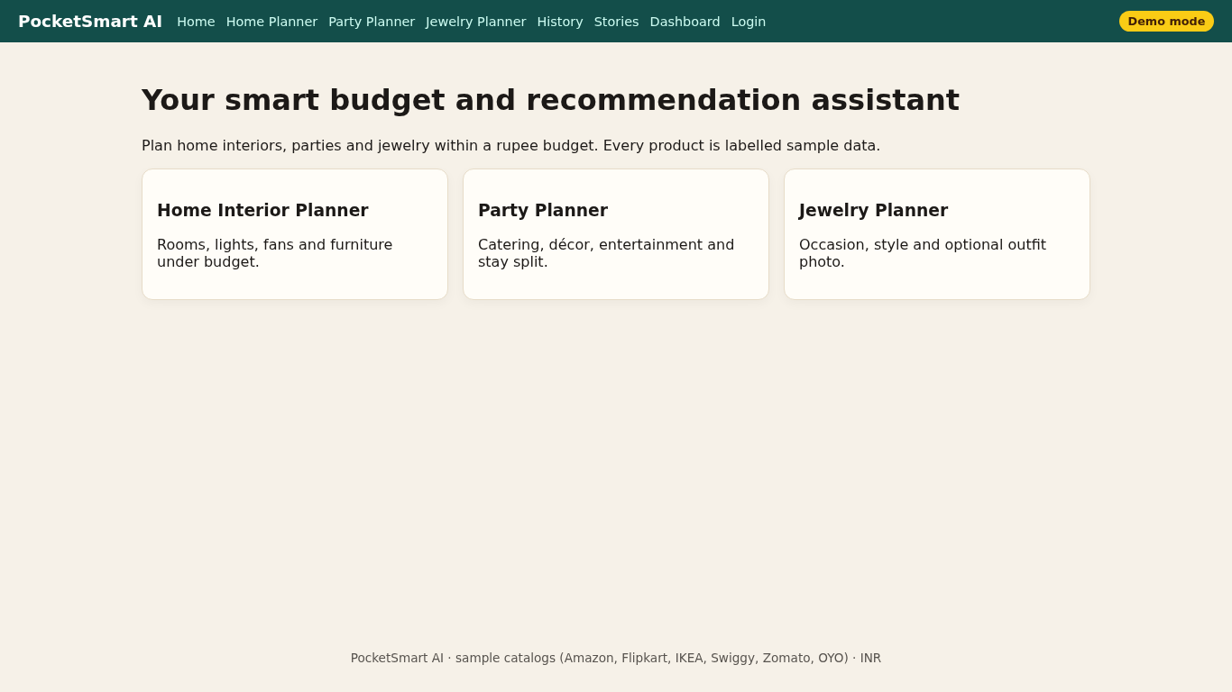
Figure 1. Home.
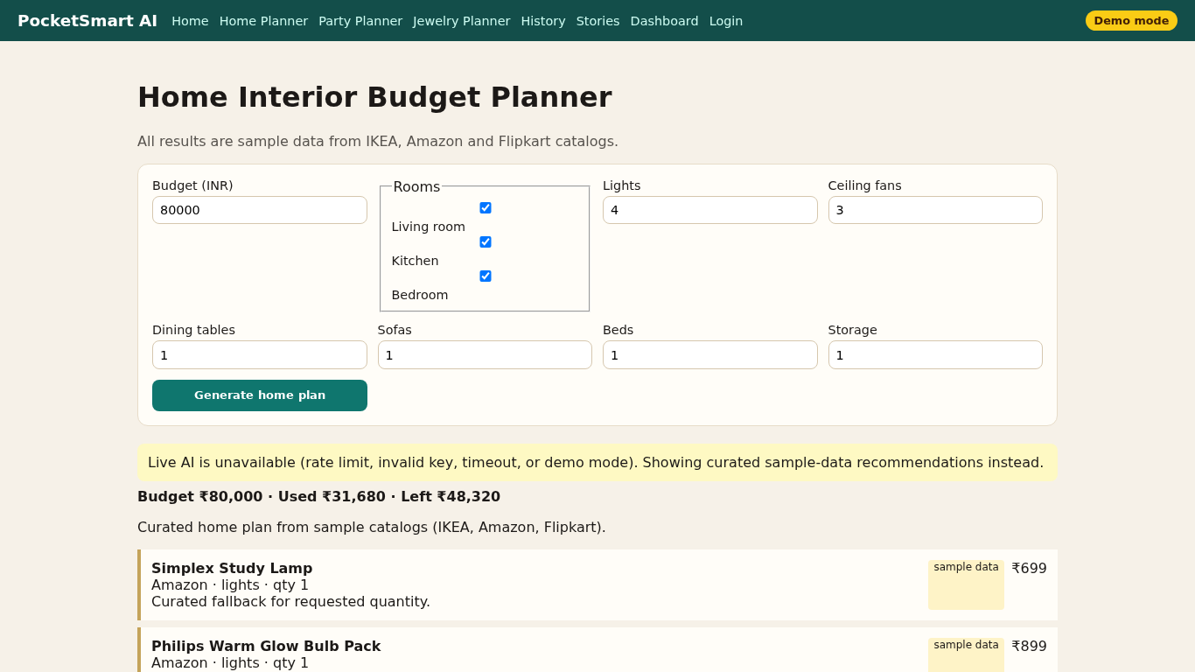
Figure 2. Home plan ₹80,000.
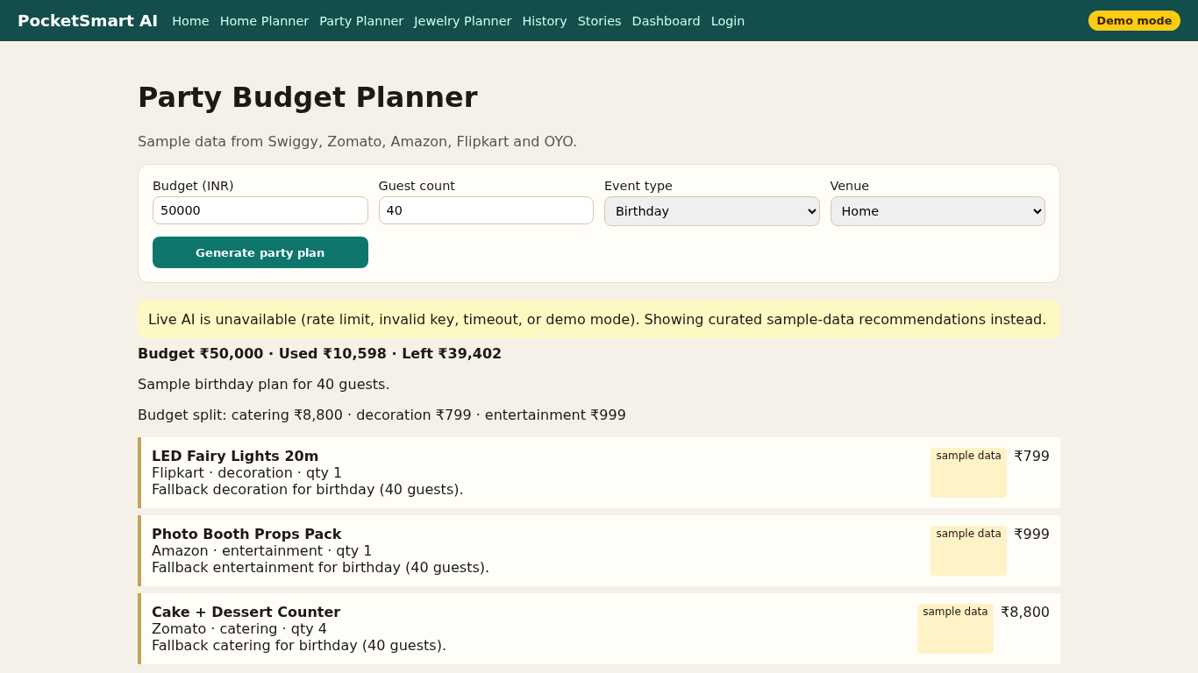
Figure 3. Party ₹50,000 / 40 guests.
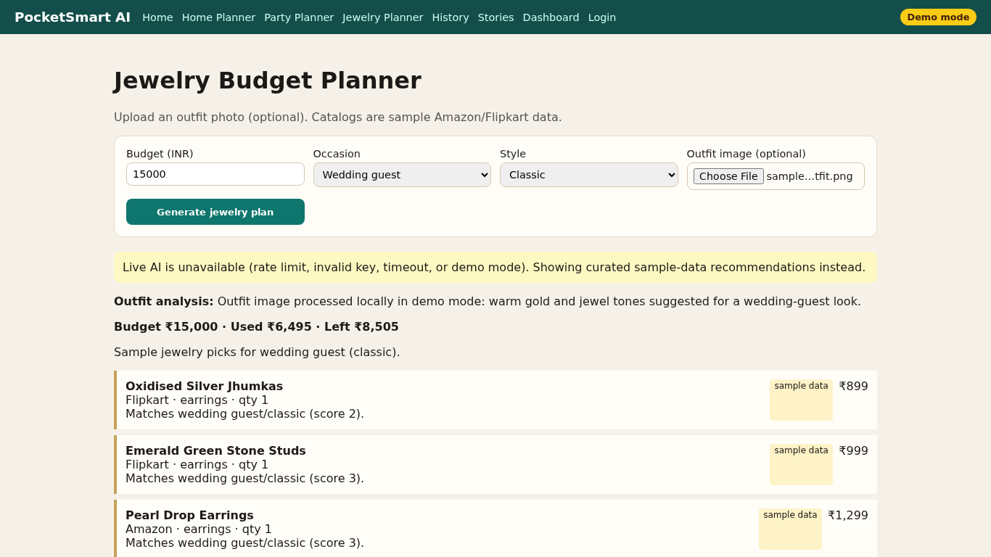
Figure 4. Jewelry ₹15,000.
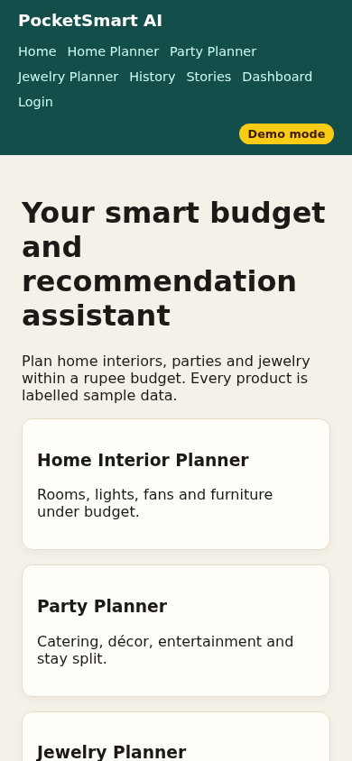
Figure 5. Mobile 390×844.

8 Limitations
Mock prices; no payments; demo AI; videos under the requested duration; Chrome needed extra system libraries in the build sandbox.

9 Future enhancements
Live price APIs with user consent, PDF export, multi-user database, GST-aware totals.

10 Conclusion
PocketSmart AI shows that a small Flask service plus optional Gemini can keep lifestyle spending inside a budget when catalogs are controlled and totals are validated in code.

References
Flask documentation; Google Gen AI Python SDK; pytest; Playwright.

Appendix A — Setup
pip install -r requirements.txt && PYTHONPATH=. python3 -m pocketsmart.app

Appendix B — API
See Phase 03 route table.

