Phase 01 — Brainstorming and Ideation
PocketSmart AI — Your Smart Budget and Recommendation Assistant
Submitted by: Vishwa Mentor: B.Sheeba Date: 29 September 2026

Table of contents
(Use Word: References → Table of Contents after opening this file.)

1. Problem statement
People who furnish a home, host a party, or buy jewelry for an occasion must compare prices across Amazon, Flipkart, IKEA, Swiggy, Zomato and OYO. Spreadsheets overflow and totals quietly cross the budget. PocketSmart AI turns a rupee budget plus simple preferences into a capped shopping list. Catalogs in this academic build are mock JSON labelled “sample data”; they are not live scrapes.

2. Target users and personas
Persona | Role | Need | Pain
Riya Sharma | New renter, Chennai | Furnish 2BHK under ₹80,000 | Too many SKUs, no room-wise split
Arjun Patel | Event host, Pune | Birthday for 40 guests, ₹50,000 | Catering + décor + stay overshoots
Nisha Reddy | Wedding guest, Hyderabad | Jewelry under ₹15,000 matching outfit | Guessing colours from a photo

3. Five candidate ideas
Idea | Pros | Cons
Generic expense tracker | Simple | No product suggestions
Single-store IKEA bot | Accurate SKUs | Not cross-platform
Scraped live marketplace | Real prices | Against this spec; legal risk
Spreadsheet template | Offline | No AI, no images
PocketSmart AI (chosen) | Three planners, budget cap, demo mode | Mock catalogs only
PocketSmart AI was chosen because the spec requires Flask, Gemini multimodal jewelry photos, and three planners with a hard budget rule.

4. Proposed solution and unique value
A Flask app on port 5000 with HTML/CSS/JS, session history, CORS, and /health. Gemini (google-genai, model from GEMINI_MODEL) is used when GEMINI_API_KEY is set; otherwise deterministic catalog pickers run (Demo mode badge). After any AI JSON, enforce_budget() drops items until the total is ≤ budget.

5. Features
Must-have: Home / Party / Jewelry POST routes, validation, budget cap, demo fallback, sample-data labels, screenshots, pytest.
Nice-to-have: Register/login session, testimonials, history page, outfit image analysis.

6. Why Gemini, and risks
Gemini fits because jewelry needs optional image understanding and planners need structured JSON. Risks: wrong SKUs, API cost, privacy of outfit photos. Mitigations: mock catalogs only, demo mode, no stored uploads, fallback lists, visible sample-data tags.
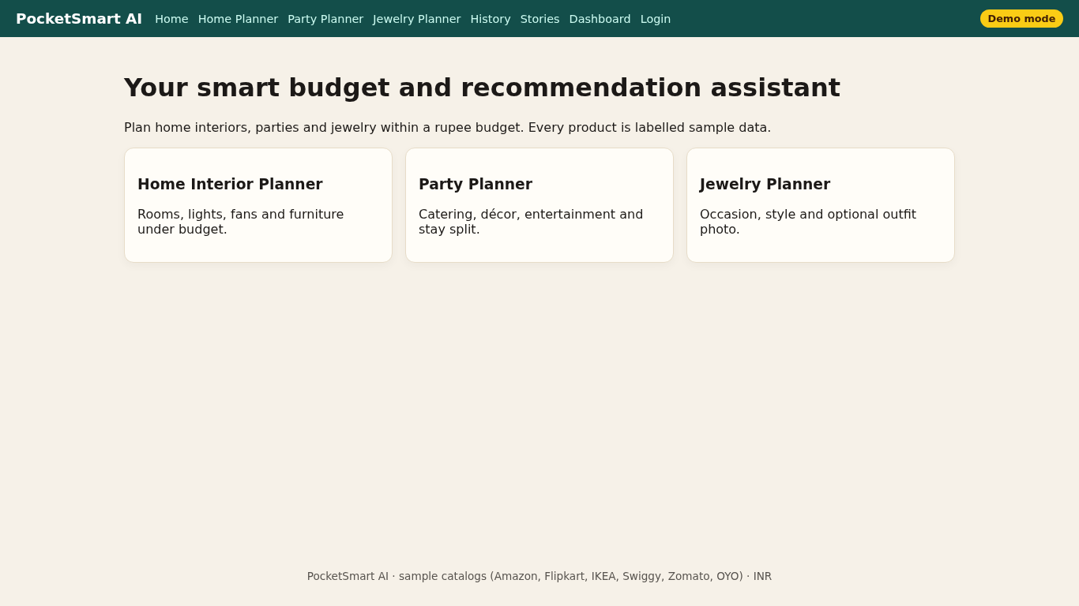
Figure 1. Landing page used in ideation walkthroughs.

