Phase 05 — Project Development
PocketSmart AI — Your Smart Budget and Recommendation Assistant
Submitted by: Vishwa Mentor: B.Sheeba Date: 29 September 2026

Table of contents
(Use Word: References → Table of Contents after opening this file.)

1. Environment
python3 -m venv .venv && pip install -r requirements.txt
Copy .env.example to .env (leave GEMINI_API_KEY empty for demo).
PYTHONPATH=. python3 -m pocketsmart.app # port 5000

2. Structure
pocketsmart/app.py — Flask factory. config.py — model + demo flag. routes/api.py — REST. routes/pages.py — HTML. services/ai_client.py — Gemini. services/recommend.py — budget engine. models/schemas.py — validation. data/*.json — catalogs. templates/ + static/.

3. AI integration
google-genai Client. Model GEMINI_MODEL default gemini-2.0-flash. DEMO_MODE if key empty. parse_json_payload strips fences. Fallback lists from catalogs.

4. Frontend
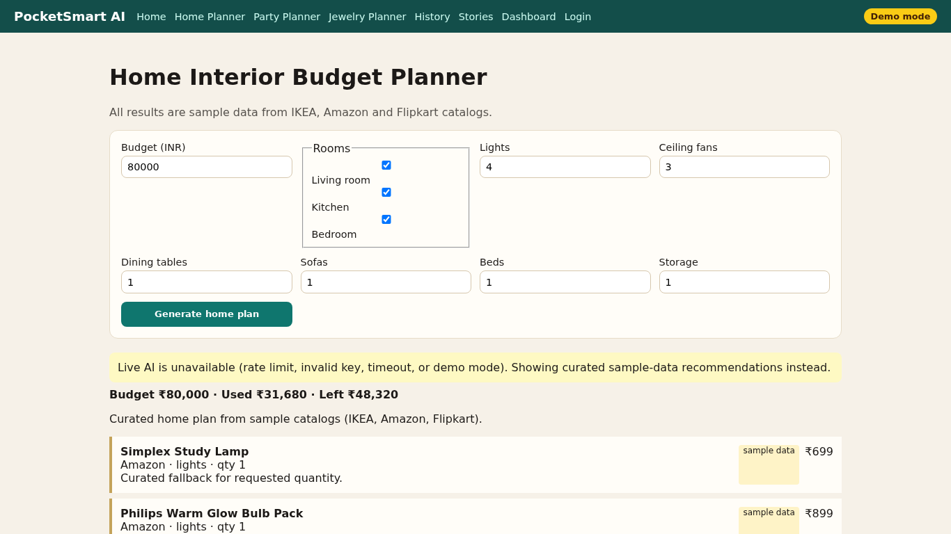
Figure 1. Home results.
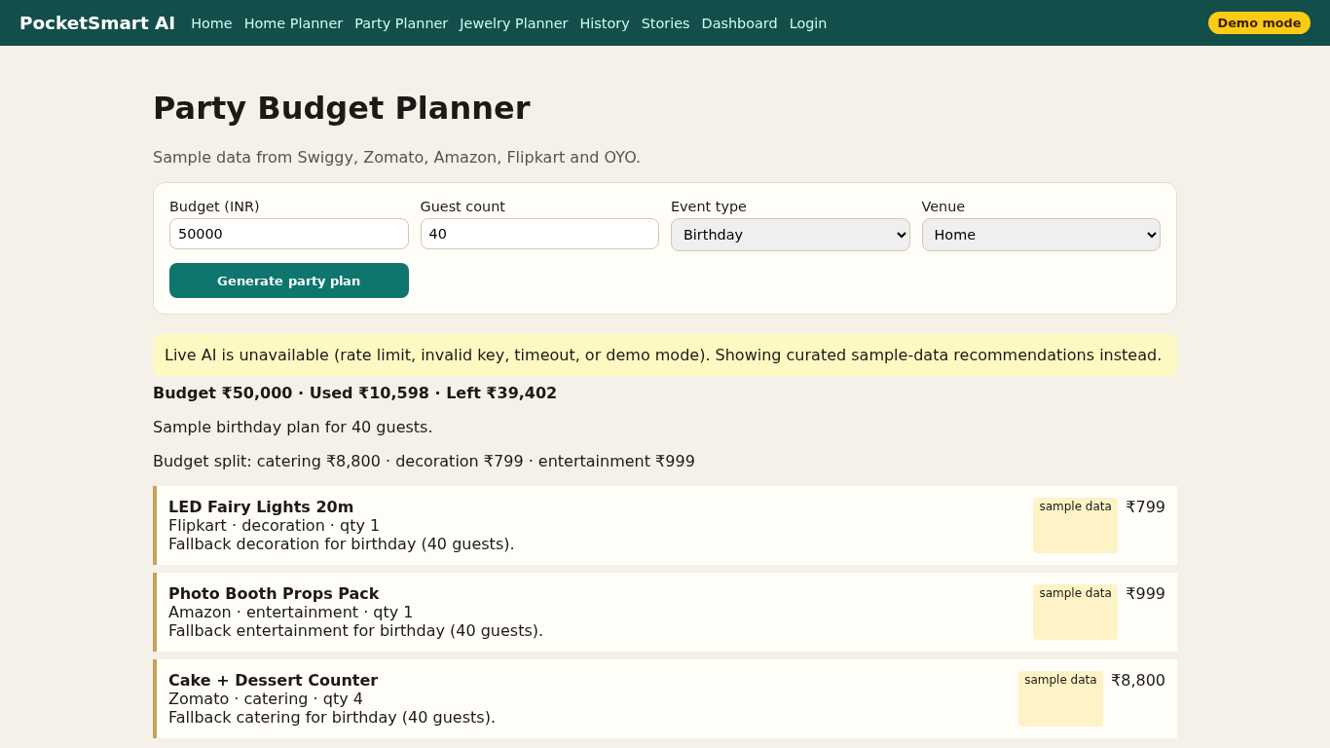
Figure 2. Party results.
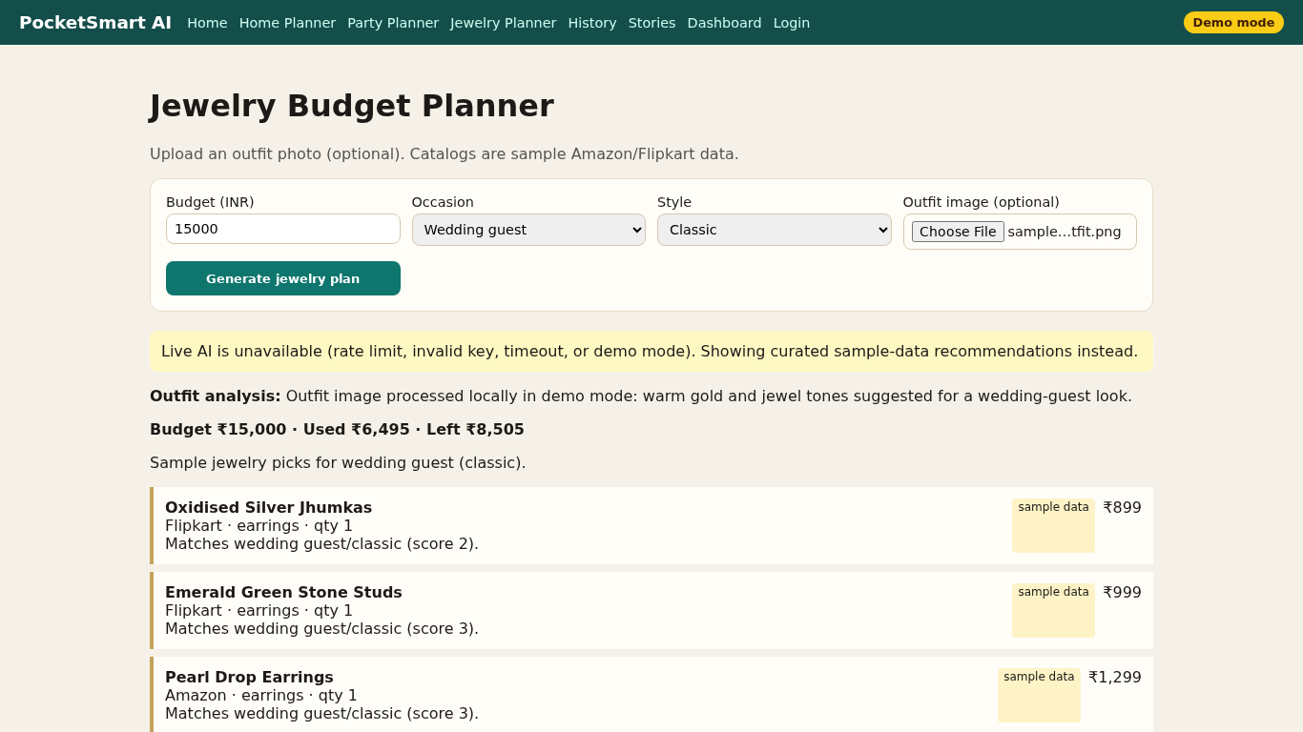
Figure 3. Jewelry with outfit.

5. Challenges (honest)
1. Spec mixes FastAPI/Watsonx with Flask/Gemini — implemented Flask as architecture section requires.
2. Gemini 1.5 names outdated — env-driven GEMINI_MODEL.
3. /history collided with HTML page — JSON moved to /api/history.
4. Playwright needed extra .so libraries in this sandbox (libnspr4, libnss3, atk).
5. System ffmpeg missing — used imageio-ffmpeg static binary to write MP4.

