Phase 06 — Project Testing
PocketSmart AI — Your Smart Budget and Recommendation Assistant
Submitted by: Vishwa Mentor: B.Sheeba Date: 29 September 2026

Table of contents
(Use Word: References → Table of Contents after opening this file.)

1. Strategy
Unit (enforce_budget), API (Flask test client), UI (Playwright), edge (budget/image), AI-failure (mock generate_structured).

2. Summary (real pytest)
22 collected, 22 passed, 0 failed. Coverage 83% (pocketsmart). Evidence: docs/evidence/pytest.txt and pytest_cov.txt.

3. Bugs found and fixed
Bug | Fix | Status
GET /history returned HTML so JSON tests failed | Moved API to /api/history | Fixed
Invalid image test sent raw bytes | BytesIO + filename notes.txt | Fixed
Outfit analysis missing without image_bytes | Multipart branch + demo analysis text | Fixed
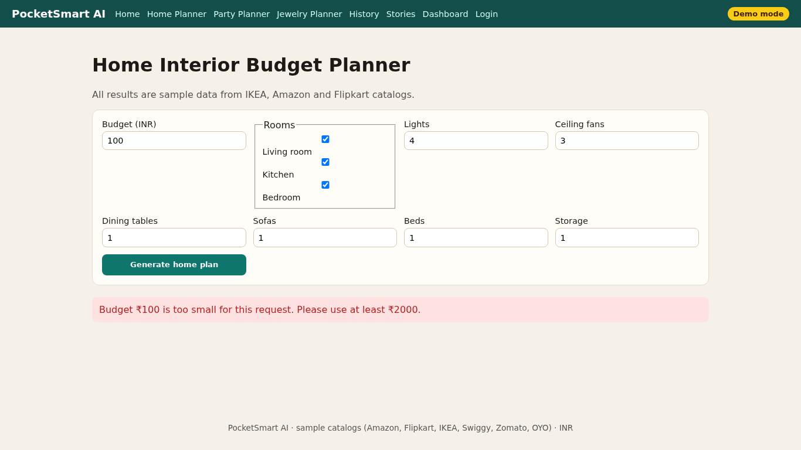
Figure 1. Budget too low.
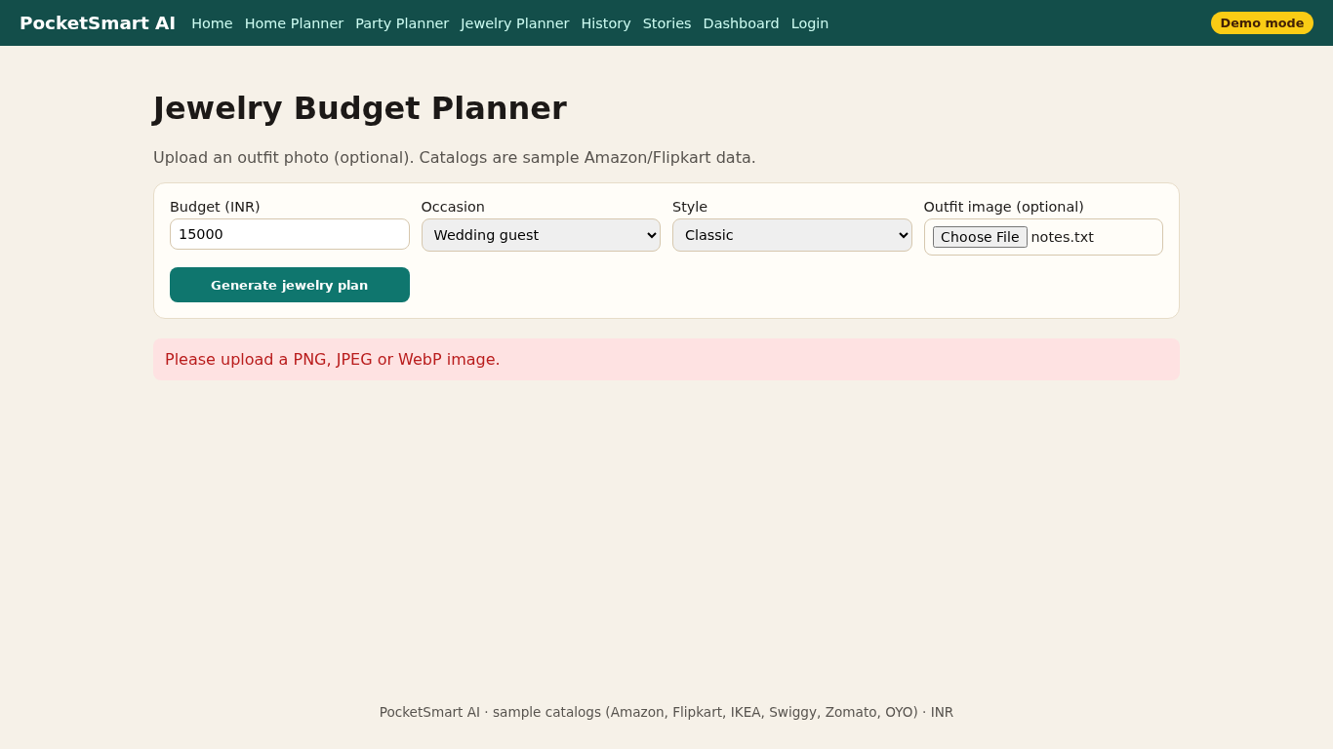
Figure 2. Invalid image.
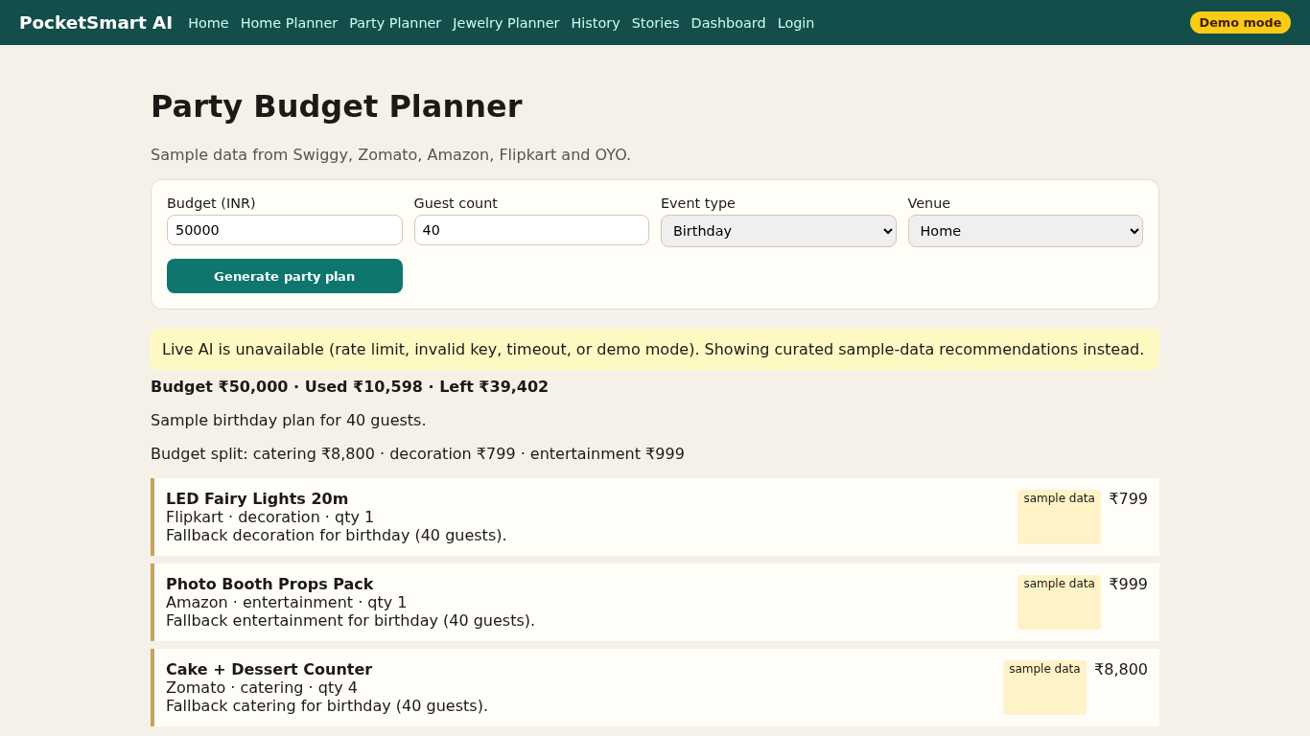
Figure 3. Fallback list.

