Exercise 1: Implementing Edge Services for Routing and Filtering

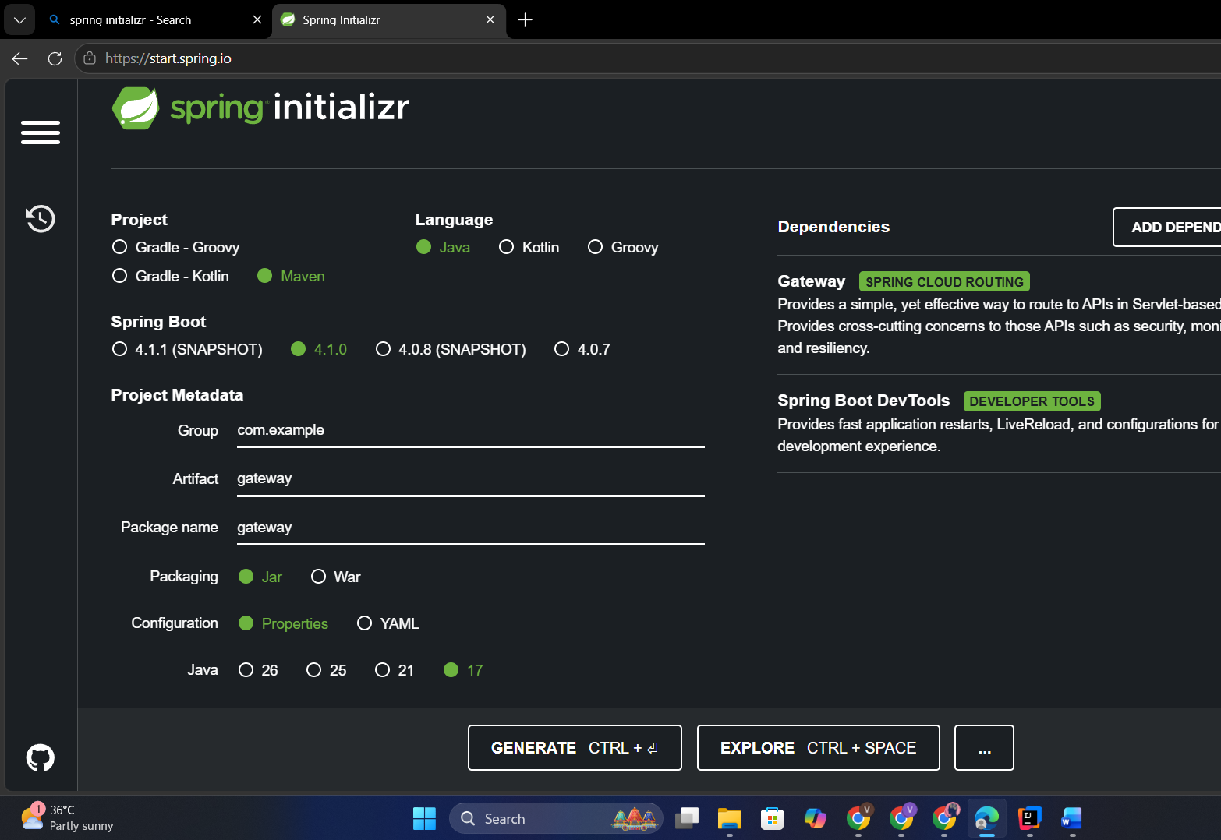

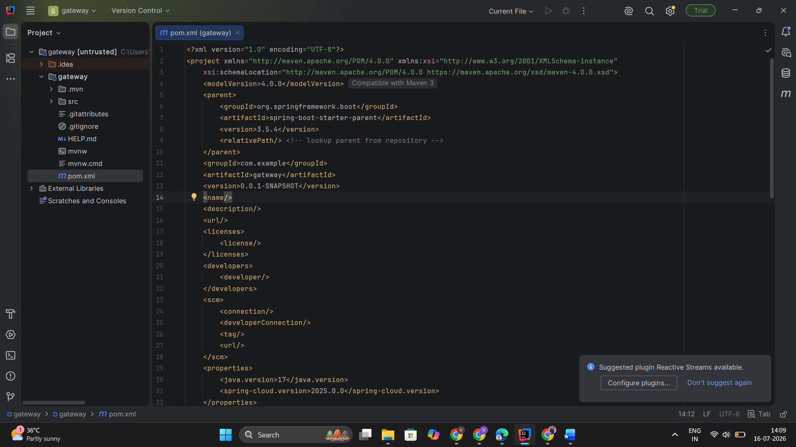

package com.example.gateway;

import org.springframework.cloud.gateway.filter.GatewayFilterChain;
import org.springframework.cloud.gateway.filter.GlobalFilter;
import org.springframework.stereotype.Component;
import org.springframework.web.server.ServerWebExchange;
import reactor.core.publisher.Mono;

@Component
public class LoggingFilter implements GlobalFilter {

@Override
public Mono<Void> filter(ServerWebExchange exchange,
GatewayFilterChain chain) {

System.out.println("Request : " +
exchange.getRequest().getURI());

return chain.filter(exchange);
}
}

Output:
Response received from http://example.org

Exercise 2: Load Balancing in an API Gateway


<dependency>
<groupId>org.springframework.cloud</groupId>
<artifactId>spring-cloud-starter-gateway</artifactId>
</dependency>

<dependency>
<groupId>org.springframework.cloud</groupId>
<artifactId>spring-cloud-starter-loadbalancer</artifactId>
</dependency>

@Configuration
public class LoadBalancerConfiguration {

@Bean
public ReactorLoadBalancer<ServiceInstance> randomLoadBalancer(
Environment environment,
LoadBalancerClientFactory loadBalancerClientFactory) {

String name = environment.getProperty(
LoadBalancerClientFactory.PROPERTY_NAME);

return new RandomLoadBalancer(
loadBalancerClientFactory.getLazyProvider(
name,
ServiceInstanceListSupplier.class),
name);
}
}

@RestController
public class DemoController {

@GetMapping("/")
public String home() {
return "Hello from Service 1";
}
}

@RestController
public class DemoController {

@GetMapping("/")
public String home() {
return "Hello from Service 2";
}
}

Output:
Hello from Service 1

Exercise 3: Resilience Patterns in an API Gateway



<dependency>
<groupId>org.springframework.cloud</groupId>
<artifactId>spring-cloud-starter-gateway</artifactId>
</dependency>

<dependency>
<groupId>io.github.resilience4j</groupId>
<artifactId>resilience4j-spring-boot2</artifactId>
</dependency>

@Configuration
public class ResilienceConfiguration {

@Bean
public Customizer<ReactiveResilience4JCircuitBreakerFactory> defaultCustomizer() {

return factory -> factory.configureDefault(id ->
new Resilience4JConfigBuilder(id)
.circuitBreakerConfig(CircuitBreakerConfig.ofDefaults())
.timeLimiterConfig(TimeLimiterConfig.ofDefaults())
.build());
}
}

Output:
Backend Service Running

