4COSC001W: Software Development I – TEST PLAN for Part 1

Student Name/ID: Sharm Fernando / w1985557

Seminar Day/Time: Friday. 10.30 am - 12.30 pm Module Tutor: Guhanathan Poravi /
Deshan Sumanathilaka, Dilshard Ahamed

 | Student Name: Sharm Fernando Student ID: w1985557
TEST PLAN for Part 1
Submit completed test plan with your code solution
Test Component | Test No. | Test Input | A - Expected Result | B - Actual Result  (Or state ‘not attempted’)  Copied result with a screenshot of the output. | Pass/Fail  (‘A’ matches ‘B’ == Pass)
Progress | 1 | Pass = 120  Defer = 0  Fail = 0 | ‘Progress’ displayed | Enter your total PASS credits: 120  Enter your total DEFER credits: 0  Enter your total FAIL credits: 0  Progress  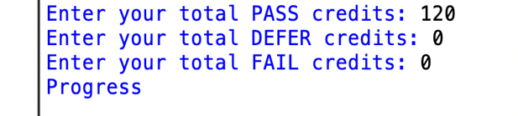 | Pass
Progress (module trailer) | 2.1 | Pass = 100  Defer = 20  Fail = 0 | ‘Progress (module trailer)’ displayed | Enter your total PASS credits: 100  Enter your total DEFER credits: 20  Enter your total FAIL credits: 0  Progress (module trailer)  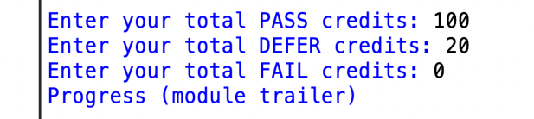 | Pass
Progress (module trailer) | 2.2 | Pass = 100  Defer = 0  Fail = 20 | ‘Progress (module trailer)’ displayed | Enter your total PASS credits: 100  Enter your total DEFER credits: 0  Enter your total FAIL credits: 20  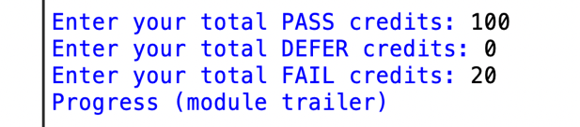  Progress (module trailer) | Pass
Module retriever | 3.1 | Pass = 80  Defer = 20  Fail = 20 | ‘Module retriever’ is displayed | Enter your total PASS credits: 80  Enter your total DEFER credits: 20  Enter your total FAIL credits: 20  Module retriever  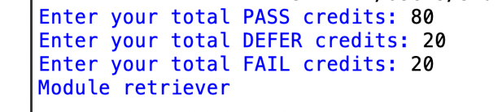 | Pass
Module retriever | 3.2 | Pass = 60  Defer = 0  Fail = 60 | ‘Module retriever’ is displayed | Enter your total PASS credits: 60  Enter your total DEFER credits: 0  Enter your total FAIL credits: 60  Module retriever  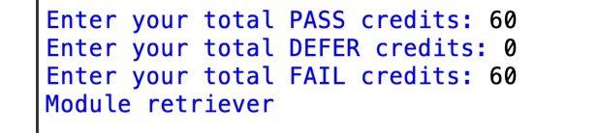 | Pass
Module retriever | 3.3 | Pass = 40  Defer = 80  Fail = 0 | ‘Module retriever’ is displayed | Enter your total PASS credits: 40  Enter your total DEFER credits: 80  Enter your total FAIL credits: 0  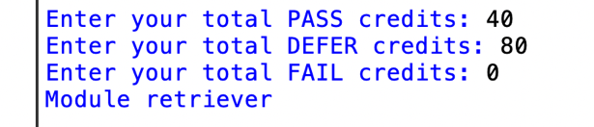  Module retriever | Pass
Module retriever | 3.4 | Pass = 20  Defer = 40  Fail = 60 | ‘Module retriever’ is displayed | Enter your total PASS credits: 20  Enter your total DEFER credits: 40  Enter your total FAIL credits: 60  Module retriever  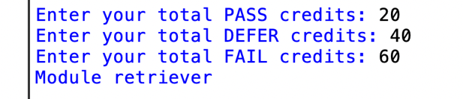 | Pass
Module retriever | 3.5 | Pass = 0  Defer = 60  Fail = 60 | ‘Module retriever’ is displayed | Enter your total PASS credits: 0  Enter your total DEFER credits: 60  Enter your total FAIL credits: 60  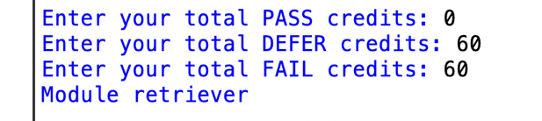  Module retriever | Pass
Exclude | 4.1 | Pass = 40  Defer = 0  Fail = 80 | ‘Exclude’ displayed | Enter your total PASS credits: 40  Enter your total DEFER credits: 0  Enter your total FAIL credits: 80  Exclude  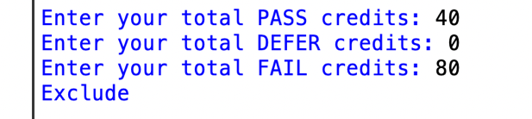 | Pass
Exclude | 4.2 | Pass = 20  Defer = 0  Fail = 100 | ‘Exclude’ displayed | Enter your total PASS credits: 20  Enter your total DEFER credits: 0  Enter your total FAIL credits: 100  Exclude  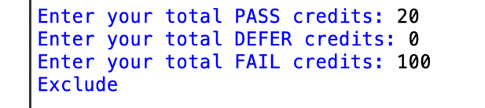 | Pass
Validation | 5.1 | Pass = a | ‘Integer required’ | Enter your total PASS credits: a  Integer required  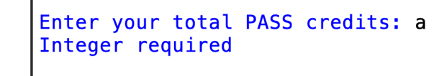 | Pass
Validation | 5.2 | Pass = 5 | ‘Out of range’ | Enter your total PASS credits: 5  Out of range  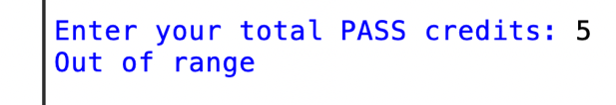 | Pass
Validation | 5.3 | Pass = 100  Defer = 40  Fail = 0 | ‘Total incorrect’ displayed | Enter your total PASS credits: 100  Enter your total DEFER credits: 40  Enter your total FAIL credits: 0  Total incorrect  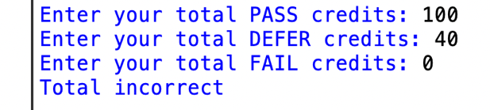 | Pass
Loops for multiple inputs | 6.1 | Program loops | Predicts multiple progression outcomes | Enter your total PASS credits: 120  Enter your total DEFER credits: 0  Enter your total FAIL credits: 0  Progress  Would you like to enter another set of data?  Enter 'y' for yes or 'q' to quit and view results: y  Enter your total PASS credits: 100  Enter your total DEFER credits: 0  Enter your total FAIL credits: 20  Progress (module trailer)  Would you like to enter another set of data?  Enter 'y' for yes or 'q' to quit and view results: y  Enter your total PASS credits:  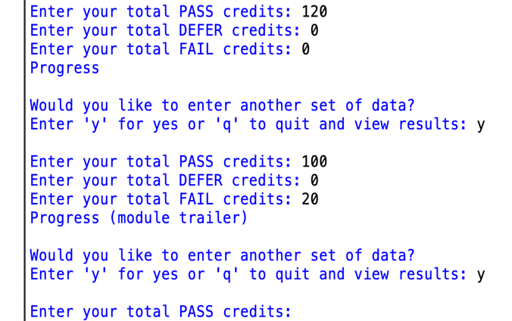 | Pass
Loops for multiple inputs | 6.2 | Enter ‘q’ | Exits loop | Would you like to enter another set of data?  Enter 'y' for yes or 'q' to quit and view results: q  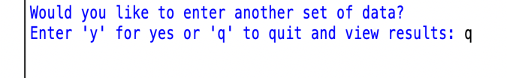 | Pass
Histogram | 7.1 |  | Progress 1 : *  Trailer 2 : **  Retriever 4 : *****  Excluded 3 : ** | Histogram  Progress 1 : *  Trailer 2 : **  Retriever 4 : ****  Excluded 3 : *** | Pass
Histogram | 7.2 |  | 10 outcomes in total. | 10 outcomes in total. | Pass

