What is HTML?
HTML (Hypertext Markup Language) is the standard language used to create web pages.
It defines the structure of a webpage.
• The basic language used to create web pages.
• Not a programming language.
• A markup language that uses tags to structure content.
- Developed under standards by the World Wide Web Consortium
- Used by all web browsers

What is an HTML Element?
An HTML element is defined by a start tag, some content, and an end tag:

<tagname> Content goes here... </tagname>
The HTML element is everything from the start tag to the end tag:
What is a Tag?
HTML uses tags to define elements.
<p>This is a paragraph</p>

<p> → Opening tag
</p> → Closing tag

Content → Text inside the tag
<h1>My First Heading</h1>
<p>My first paragraph.</p>
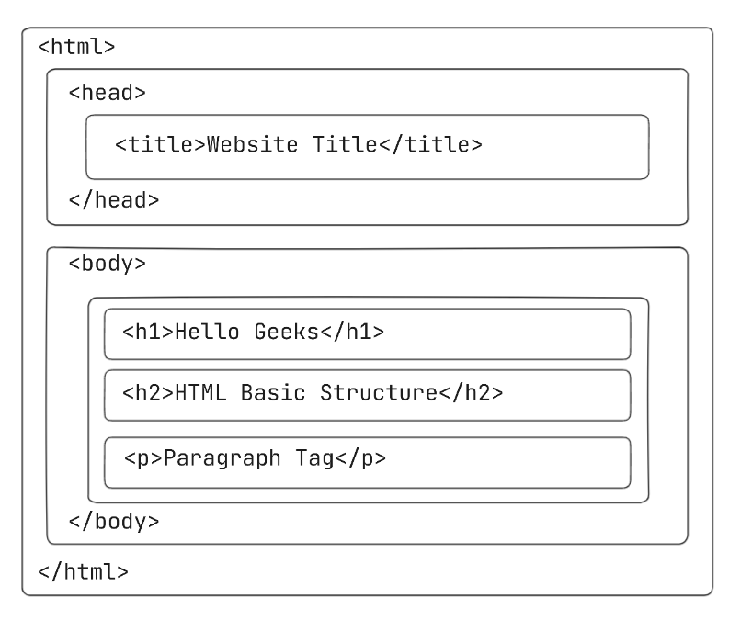
<!DOCTYPE html> //Declares the document type.
<html> //Root element of the webpage. // <head><body>
<head> //Contains meta information about the page.
<title>My Web Page</title> //Title shown on browser tab
</head>
<body> // Contains visible content.
<h6>Welcome to HTML</h6>
<p>This is a basic HTML structure
AksjgfiugAFIADSBFADSGFDSU;OFHDSFLDS
SDHGDFSHG;IDSHGFSKDDGSFH
</p>
</body>
</html>

HTML Headings
HTML headings are defined with the <h1> to <h6> tags.
<h1> defines the most important heading. <h6> defines the least important heading:

Example
<h1>This is heading 1</h1>
<h2>This is heading 2</h2>
<h3>This is heading 3</h3>

HTML Paragraphs
HTML paragraphs are defined with the <p> tag:

Example
<p>This is a paragraph.</p>
<p>This is another paragraph.</p>
HTML BREAK Tag
The <br> element is used to insert a line break into your document. The tells the computer to stop the text at that point and start a new line.
<br>

horizontal rule
The <hr> element is most often displayed as a horizontal rule that is used to separate content (or define a change) in an HTML pag

Basic Web Page Structure
<!DOCTYPE html>
<html>
<head>
<title>My First Web Page</title>
</head>
<body>
<h1>Welcome to Web Technologies</h1>
<h2>Introduction</h2>
<p>This is a simple paragraph explaining HTML basics.</p>
<br>
<hr>
<h3>Subheading Example</h3>
<p>HTML is used to create web pages.</p>
</body>
</html>

• Their name as heading
• A paragraph about themselves

Text Formatting Tags
<!DOCTYPE html>
<html>
<head>
<title>Text Formatting</title>
</head>
<body>
<h2>Text Formatting Examples</h2>
<p><b>Bold Text</b></p>
<p><i>Italic Text</i></p>
<p><u>Underlined Text</u></p>
<p><strong>Important Text</strong></p>
<p><em>Emphasized Text</em></p>
<p><mark>Highlighted Text</mark></p>
<p><small>Small Text</small></p>
<p>H<sub>2</sub>O (Subscript Example)</p>
<p>10<sup>2</sup> (Superscript Example)</p>
</body>
</html>
Question 2: HTML Formatting Tags
Write an HTML program that demonstrates the use of the following tags:
- <b>, <i>, <u>
- <strong>, <em>
- <br>, <hr>
- <sub>, <sup>
The webpage should display:
- H₂O
- (a + b)²
- A short paragraph about Web Technology with proper formatting
\

HTML is Not Case Sensitive
HTML tags are not case sensitive: <P> means the same as <p>.

HTML Comments
Comments can be used to hide content.
This can be helpful if you hide content temporarily:
<!-- Write your comments here -->

HTML Attributes
- All HTML elements can have attributes
- Attributes provide additional information about elements
- Attributes are always specified in the start tag
- Attributes usually come in name/value pairs like: name="value"

The href Attribute
The <a> tag defines a hyperlink. The href attribute specifies the URL of the page the link goes to:

Example
<a href="https://www.w3schools.com">Visit W3Schools</a>

The src Attribute
The <img> tag is used to embed an image in an HTML page. The src attribute specifies the path to the image to be displayed:

Example
<img src="img_girl.jpg">

The alt Attribute
The required alt attribute for the <img> tag specifies an alternate text for an image, if the image for some reason cannot be displayed. This can be due to a slow connection, or an error in the src attribute, or if the user uses a screen reader.

Example
<img src="img_girl.jpg" alt="Girl with a jacket">

The style Attribute
The style attribute is used to add styles to an element, such as color, font, size, and more.

Example
<p style="color:red;">This is a red paragraph.</p>

The title Attribute
The title attribute defines some extra information about an element.
The value of the title attribute will be displayed as a tooltip when you mouse over the element:

Example
<p title="I'm a tooltip">This is a paragraph.</p>

HTML Lists

HTML lists allow web developers to group a set of related items in lists.

Ordered HTML List
An ordered list starts with the <ol> tag. Each list item starts with the <li> tag.

Unordered HTML List
An unordered list starts with the <ul> tag. Each list item starts with the <li> tag.

<!DOCTYPE html>
<html>
<head>
<title>List Example</title>
</head>
<body>
<h2>Ordered List</h2>
<ol>
<li>HTML</li>
<li>CSS</li>
<li>JavaScript</li>
</ol>
<h2>Unordered List</h2>
<ul>
<li>Apple</li>
<li>Banana</li>
<li>Orange</li>
</ul>
</body>
</html>

HTML Links

HTML Links - Hyperlinks
HTML links are hyperlinks.
You can click on a link and jump to another document.
When you move the mouse over a link, the mouse arrow will turn into a little hand.

The HTML <a> tag defines a hyperlink. It has the following syntax:
<a href="url">link text</a>
The most important attribute of the <a> element is the href attribute, which indicates the link's destination.
The link text is the part that will be visible to the reader.
Clicking on the link text, will send the reader to the specified URL address.

Hyperlink and Image
<!DOCTYPE html>
<html>
<head>
<title>Link and Image</title>
</head>
<body>
<h2>Hyperlink Example</h2>
<a href="https://www.google.com">Visit Google</a>
<h2>Image Example</h2>
<img src=""C:\Users\user\Downloads\images.jpg” alt="Sample Image">
</body>
</html>

PART 1 – LINK TAG QUESTIONS

1️⃣ Create a webpage with:
- A heading “Useful Websites”
- A link to Google
- A link to YouTube
- A link to your college website

Create:
- Add an image
- If image is not found, display alternative text

PART 3 – TABLE QUESTIONS

7NOCreate a student details table:
Columns:
- Name
- Register Number
- Department

Table Cells
Each table cell is defined by a <td> and a </td> tag.
td stands for table data.
Everything between <td> and </td> is the content of a table cell.
<table>
<tr>
<td>Emil</td>
<td>Tobias</td>
<td>Linus</td>
</tr>
</table>

Table Rows
Each table row starts with a <tr> and ends with a </tr> tag.
tr stands for table row.
<table>
<tr>
<td>Emil</td>
<td>Tobias</td>
<td>Linus</td>
</tr>
<tr>
<td>16</td>
<td>14</td>
<td>10</td>
</tr>
</table>

Table Headers
Sometimes you want your cells to be table header cells. In those cases use the <th> tag instead of the <td> tag:
th stands for table header.
<table>
<tr>
<th>Person 1</th>
<th>Person 2</th>
<th>Person 3</th>
</tr>
<tr>
<td>Emil</td>
<td>Tobias</td>
<td>Linus</td>
</tr>
<tr>
<td>16</td>
<td>14</td>
<td>10</td>
</tr>
</table>
By default, the text in <th> elements are bold and centered, but you can change that with CSS.

Table Example
<!DOCTYPE html>
<html>
<head>
<title>Table Example</title>
</head>
<body>
<h2>Student Marks Table</h2>
<table border="1">
<tr>
<th>Name</th>
<th>Subject</th>
<th>Marks</th>
</tr>
<tr>
<td>Rahul</td>
<td>Maths</td>
<td>85</td>
</tr>
<tr>
<td>Anita</td>
<td>Science</td>
<td>90</td>
</tr>
</table>
</body>
</html>

Assignment 1: Student Details Table
Create an HTML page and design a table to display student details.
Table Columns:
- Register Number
- Name
- Department
- Year
- Email

HTML Table Colspan & Rowspan
TML tables can have cells that span over multiple rows and/or columns.

NAME

APRIL
2022
FIESTA

HTML Table - Colspan
To make a cell span over multiple columns, use the colspan attribute:
<!DOCTYPE html>
<html>
<head>
<style>
table, th, td {
border: 1px solid black;
border-collapse: collapse;
}
</style>
</head>
<body>

<h2>Cell that spans two columns</h2>
<p>To make a cell span more than one column, use the colspan attribute.</p>
<table style="width:100%">
<tr>
<th colspan="2">Name</th>
<th>Age</th>
</tr>
<tr>
<td>Jill</td>
<td>Smith</td>
<td>43</td>
</tr>
<tr>
<td>Eve</td>
<td>Jackson</td>
<td>57</td>
</tr>
</table>
</body>
</html>

HTML Table - Rowspan
To make a cell span over multiple rows, use the rowspan attribute:
table>
<tr>
<th>Name</th>
<td>Jill</td>
</tr>
<tr>
<th rowspan="2">Phone</th>
<td>555-1234</td>
</tr>
<tr>
<td>555-8745</td>
</tr>
</table>

<!DOCTYPE html>
<html>
<head>
<style>
table, th, td {
border: 1px solid black;
border-collapse: collapse;
}
</style>
</head>
<body>

<h2>Cell that spans two rows</h2>
<p>To make a cell span more than one row, use the rowspan attribute.</p>

<table style="width:100%">
<tr>
<th>Name</th>
<td>Jill</td>
</tr>
<tr>
<th rowspan="2">Phone</th>
<td>555-1234</td>
</tr>
<tr>
<td>555-8745</td>
</tr>
</table>
</body>
</html>

HTML Table Padding & Spacing
HTML tables can adjust the padding inside the cells, and also the space between the cells.
With Padding
hello | hello | hello
hello | hello | hello
hello | hello | hello

With Spacing
hello | hello | hello
hello | hello | hello
hello | hello | hello

Cell padding
Is the amount of space held between the content of the cell and cell border.
<table cellpadding=”15” border=”3”>
<tr>
<td> cell 1</td>
<td> cell 2</td> </tr>
<tr>
<td> cell 3</td>
<td> cell 4</td> </tr> </tabkle>

HTML Table - Cell Spacing
Cell spacing is the space between each cell.
<table cellspacing=”15” border=”3”>
<tr>
<td> cell 1</td>
<td> cell 2</td> </tr>
<tr>
<td> cell 3</td>
<td> cell 4</td> </tr> </tabkle>

"Create an HTML page with different tables: Student details table, Student marks table using rowspan, and a class timetable using colspan."

