Lab 1 - Getting Started with RISC-V (Assembly Language) in VS Code

Name: Shaheer Qureshi, Areeba Izhar | Student ID: sq09647, ai09625

Task 3:
Code:
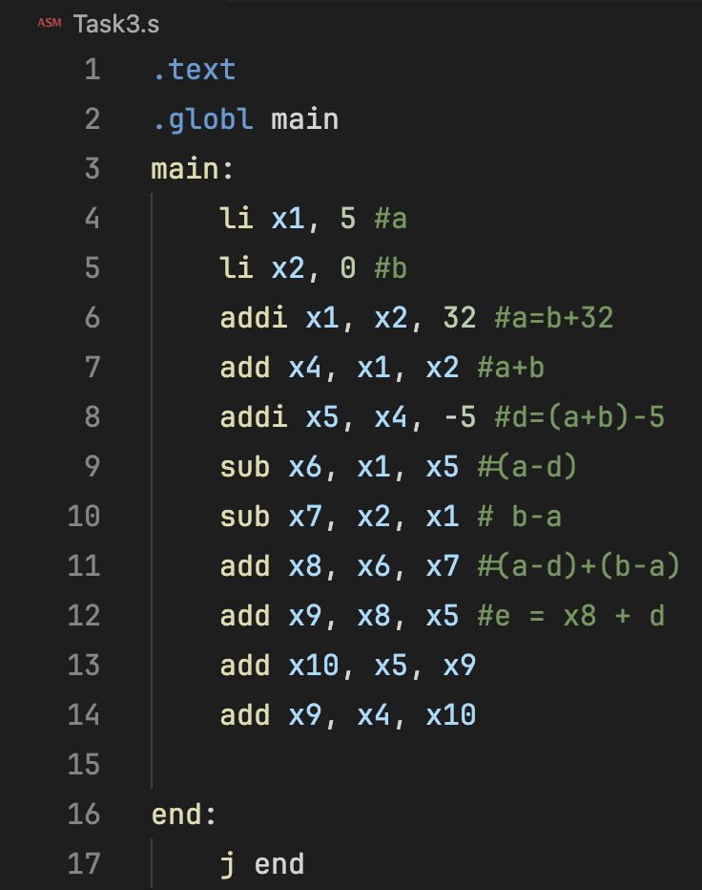
Results:
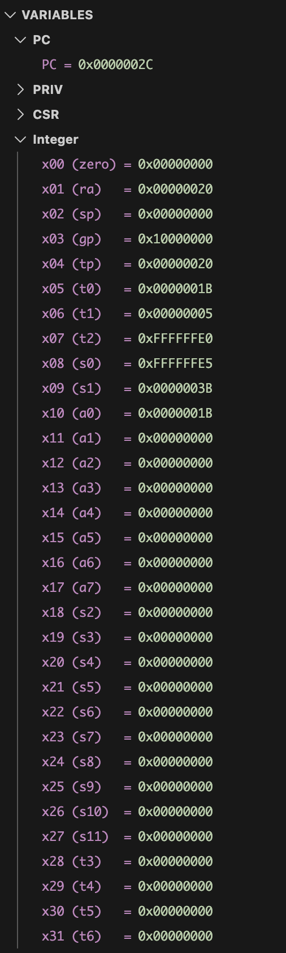
Task 4a:
- Store x10 as unsigned integer at address 0x100.
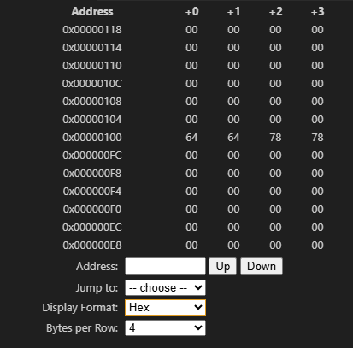
- Store x11 as unsigned integer at address 0x1F0.
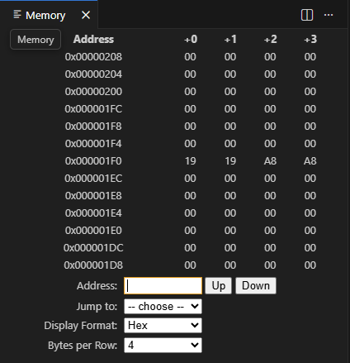

- Load an unsigned short integer (two bytes) from address 0x100 in x12.

- Load a short integer from address 0x1F0 in register x13.

- Load a singed character from address 0x1F0 in register x14.

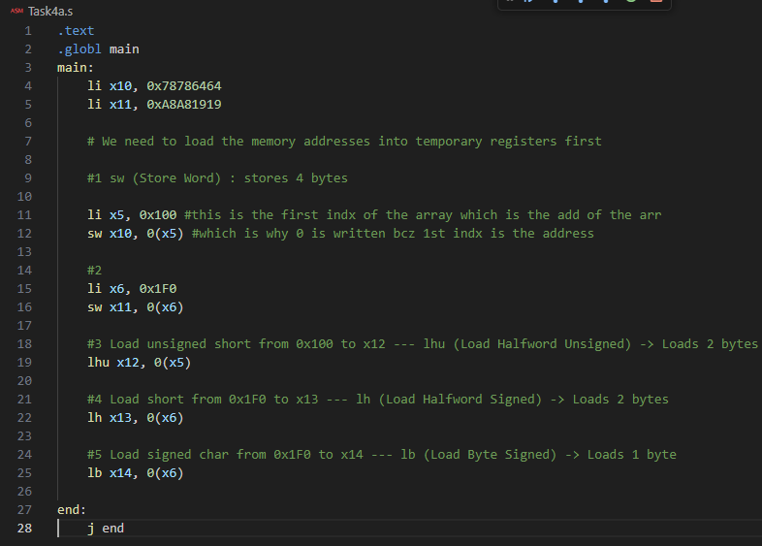

Task 4b:
Code:
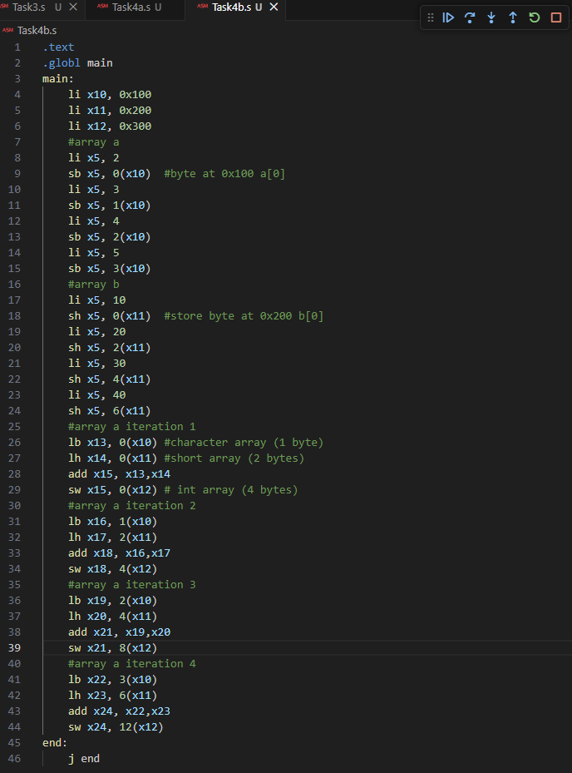
Results:
Array A
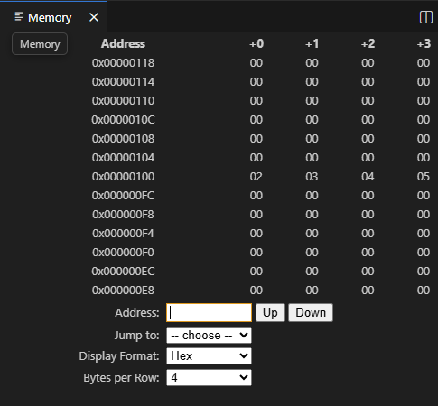
Array B
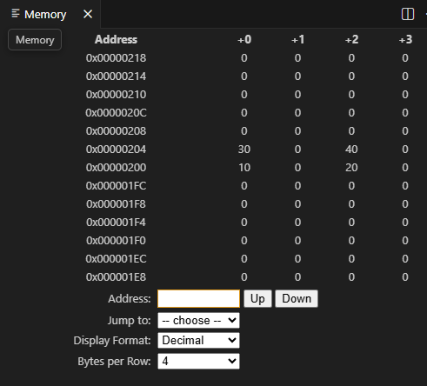
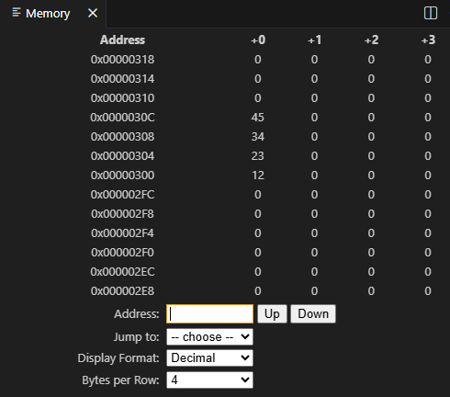
Array C
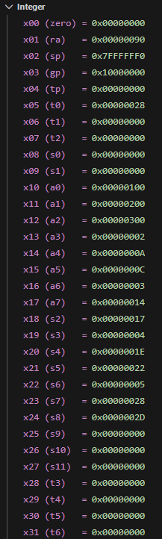

Assessment Rubric
Lab 1: Getting Started with RISC-V (Assembly Language) n VS Code

Name | Student ID: | Section:

Points Distribution:

 | Task No. | LR 2 (Code) | LR 5 (Results)
In-Lab | Task 1 | - | /15
In-Lab | Task 2 | - | /15
In-Lab | Task 3 | /10 | /5
In-Lab | Task 4a | /10 | /5
In-Lab | Task 4b | /10 | /10
Total Points: 100 |  | /30 | /50
CLO Mapped |  | CLO 2

Affective Domain Rubric |  | Points | CLO Mapped
AR7 | Report Submission & Git Upload | /10 & /10 | CLO 2

CLO | Total Points | Points Obtained
2 | 100
Total | 100

