Lab 03 – Worksheet
Name: Shaheer Qureshi, Areeba Izhar | ID: sq09647, ai09625 | Section: T1

Note: Assumptions and logics should be explained separately in tasks after the task results.

Task 1
Provide appropriately commented codes (Mention question part before each part)
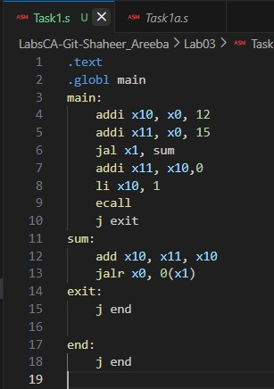
Add screenshot of your results (register)
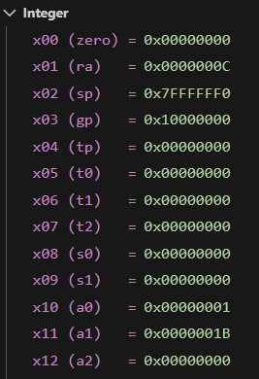

Function Logic:
In our main function, we first loaded value 12 in register x10 (a). Then we loaded value 15 in register x11 (b). the jal x1, sum statement jumps to sum function. It is saving the very next line address. When the line jumps to the sum function, it performs the sum operations by adding a and b and storing it in x10. This is useful since we need to RETURN the output value.
The jalr x0, 0(x1) is our return instruction that jumps to address stored in x1 (in the main function)
Then in main, the next statement to go to is addi x11, x10, 0 so it stores return output in x11.
Then the ecall statement prints the output in terminal.

Task 2
Provide appropriately commented codes (Mention question part before each part)
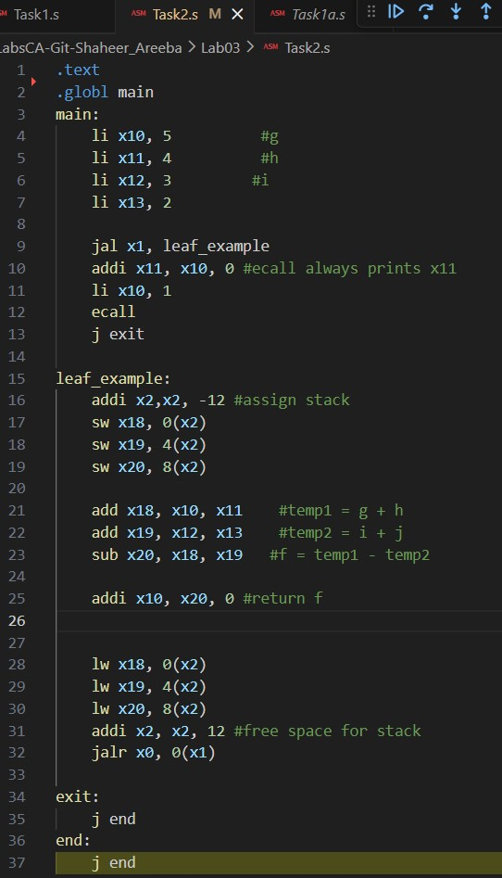

# note: Since our systems weren’t able to process long long integer, instead of taking 8 offset, we choose offset 4 (which is long int)

Add screenshot of your results

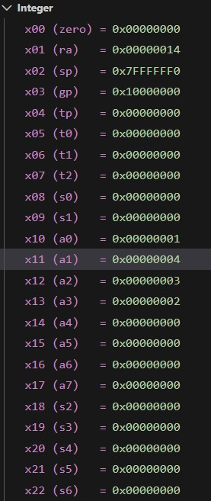
Code Logic:

For this code, we first declared our g,h,i,j with sample values. The next statement, jal x1, leaf_example allows us to jump the the leaf_example function we made, and this later will save the return address in x1. In the leaf_example function, we declared a stack with space -12 and stack pointer pointing to it, (sp -> x2). Each stack space (4 byte offset) is storing space for the operations to perform. The output is stored in x20 and this final result is stored in x10. Since the address is safe, we then deallocate the stack to ‘free space’ and then the jalr x0, 0(x1) is used, to return to main
- Our assumption was using 32-bit RISC-V as we used sw, lw (4 bytes) and adjusted our stack by 12 bytes for 3 registers.

Task 3 Provide appropriately commented codes (Mention question part before each part)

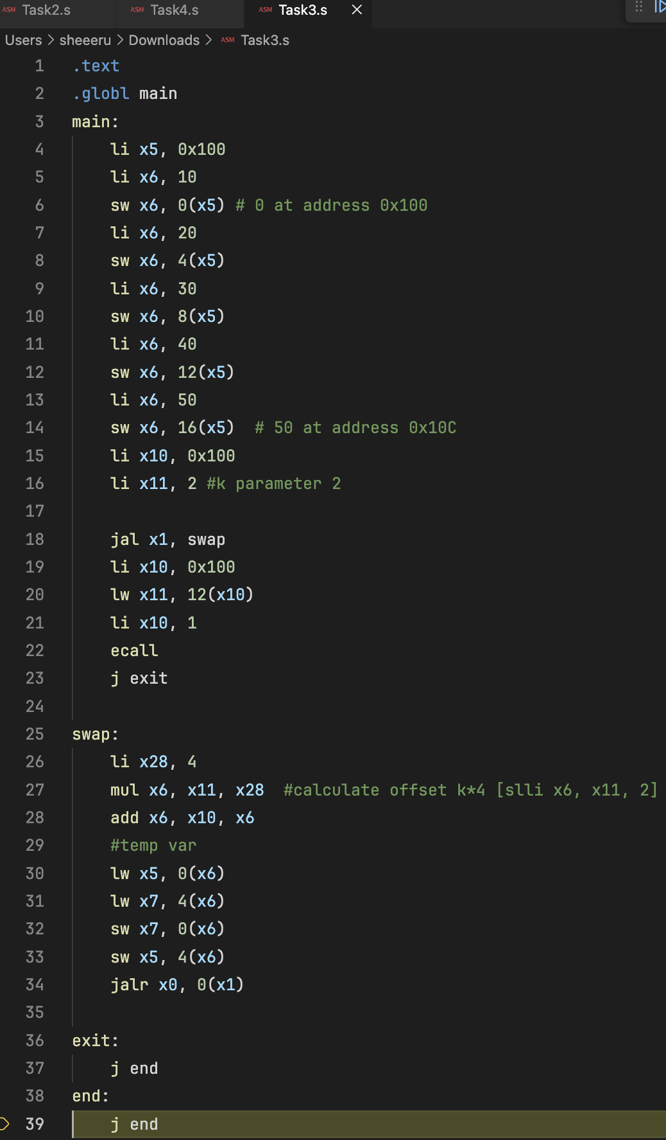
Add screenshots of your results
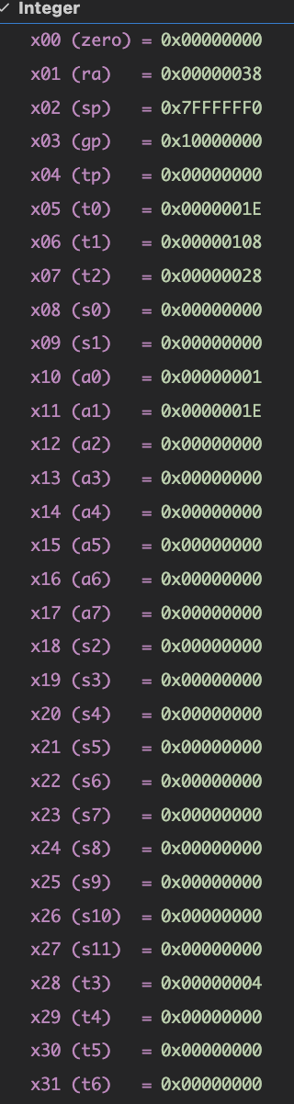

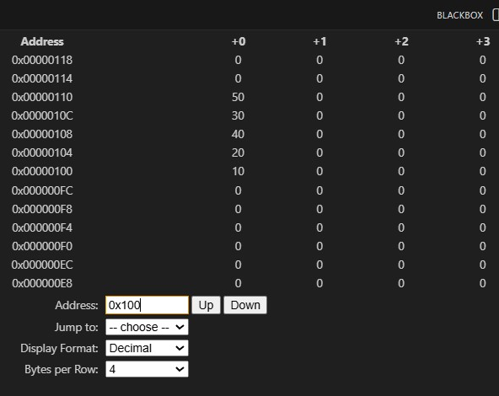

Code Logic:

First our code populates an array with a base address of 0x100. Then each value with an offset of 4 bytes is stored in the array.
Then we load the base address of the array as the first argument for the swap function (x10 respectively)
The second argument is k (we stored a dummy value of 2) in x11.
Since its an array and to get the values, we need to set its offset and for that we stored a value of 4 (4 bytes) in x28 and mutliplied it by index k. (2*4 = 8 bytes offset)
Then the add statement (add x6, x10, x6) adds this offset to base address and now the x6 register will point at kth index of v[]
Then we used the simple swapping logic to load the value of v[k] in temp reg (x5)
Then then value of v[k+1] in temp reg (x7). And then changed the valued stored in these registers (interchanged with each other)
The jalr x0, 0(x1) statement helps to return to the main function, and lw x11, 12(x10) is what loads value at 0x10C (val 40 in our array) into x11. And ecall prints it.

- Our assumption was using 32-bit RISC-V as we used sw, lw (4 bytes) and adjusted our stack by 12 bytes for 3 registers.

Task 4 Provide appropriately commented codes
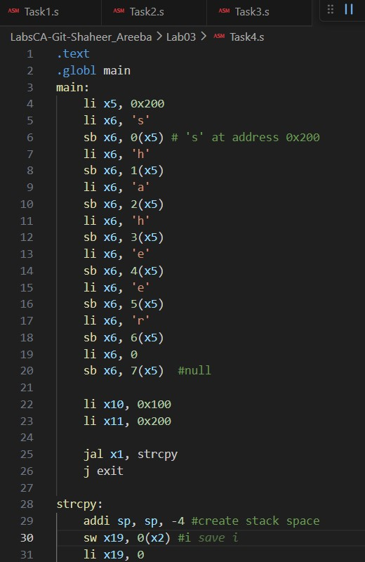
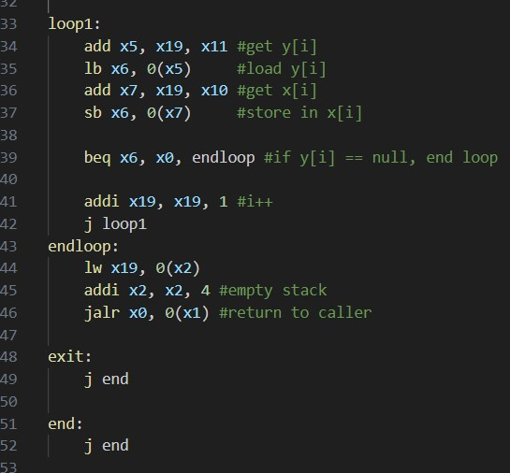

Code logic:

The ‘main’ part populates the character array char by char at 0x200 using sb (store byte)
It includes a null terminator at the end.
Reg x11 stores the address of the array (0x200) and x10 loads the destination array (0x100) [our parameters for the strcpy function]
jal x1, strcpy jumps to the function and stores address in x1 (return address)
Since x19 used in the strcpy is a saved register, the stack pointer (sp) is decremented to create space (sw x19, 0(x2)) to save old value of x19.
It then sets x19 to 0.
The loop1 (copy loop) adds current index x19 to base address of x11 and x10 to find the byte locations and loads a single byte into x6 and stores it in destination through [sb x6, 0(x7)]
Beq statement checks for null terminator to end loop and if its not, the index I keeps incrementing (addi x19, x19, 1) by 1 and loop continues.

At the end, the original value of x19 is loaded from stack and sp is returned to its original position.

- Our assumption was using 32-bit RISC-V as we used sw, lw (4 bytes) and adjusted our stack by 12 bytes for 3 registers.

Add screenshots of your results
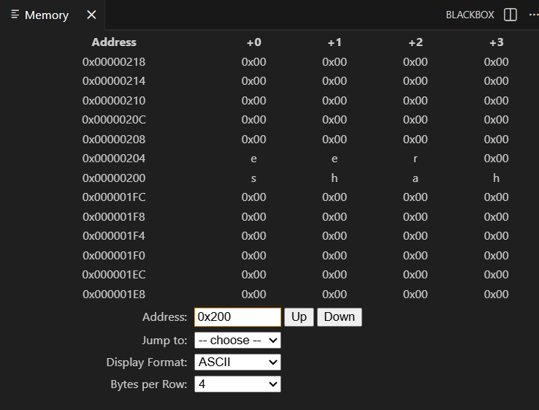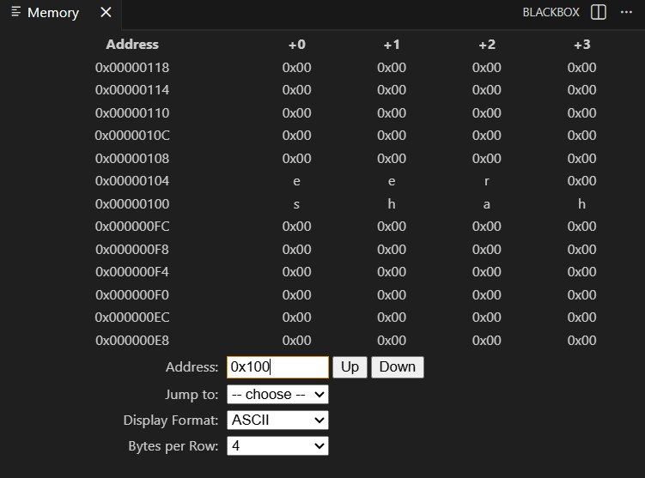
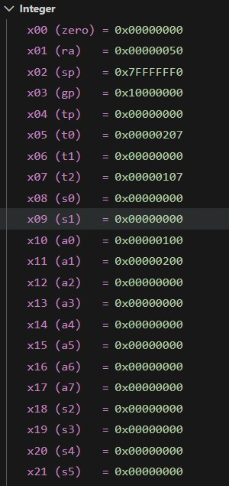
Lab 03 – Introduction to RISC V Assembly (Jumps and Returns)

Assessment Rubrics

Points Distribution
Task No. | LR2  Code | LR5  Results | AR7  Report  Submission and Git Upload
Task 1 | /10 | /05 | /10 & /10
Task 2 | /10 | /10 | /10 & /10
Task 3 | /10 | /10 | /10 & /10
Task 4 | /15 | /10 | /10 & /10
Total Points | /100 Points
CLO Mapped | CLO 2
For description of different levels of the mapped rubrics, please refer the provided Lab Evaluation Assessment Rubrics and Affective Domain Assessment Rubrics.
# | Assessment Elements | Level 1: Unsatisfactory  Points 0-1 | Level 2: Developing  Points 2 | Level 3:Good  Points 3 | Level 4:Exemplary  Points 4
LR2 | Program/Code/ Simulation Model/ Network Model | Program/code/simulation model/network model does not implement the required functionality and has several errors. The student is not able to utilize even the basic tools of the software. | Program/code/simulation model/network model has some errors and does not produce completely accurate results. Student has limited command on the basic tools of the software. | Program/code/simulation model/network model gives correct output but not efficiently implemented or implemented by computationally complex routine. | Program/code/simulation /network model is efficiently implemented and gives correct output. Student has full command on the basic tools of the software.
LR5 | Results & Plots | Figures/ graphs / tables are not developed or are poorly constructed with erroneous results. Titles, captions, units are not mentioned. Data is presented in an obscure manner. | Figures, graphs and tables are drawn but contain errors. Titles, captions, units are not accurate. Data presentation is not too clear. | All figures, graphs, tables are correctly drawn but contain minor errors or some of the details are missing. | Figures / graphs / tables are correctly drawn and appropriate titles/captions and proper units are mentioned. Data presentation is systematic.
AR9 | Report | All the in-lab tasks are not included in report and / or the report is submitted too late. | Most of the tasks are included in report but are not well explained. All the necessary figures / plots are not included. Report is submitted after due date. | Good summary of most the in-lab tasks is included in report. The work is supported by figures and plots with explanations. The report is submitted timely. | Detailed summary of the in-lab tasks is provided. All tasks are included and explained well. Data is presented clearly including all the necessary figures, plots and tables.

