Lab 04 – Worksheet
Name: Shaheer Qureshi, Areeba Izhar | ID: sq09647, ai09625 | Section: T1

Note: Assumptions and logics should be explained separately in tasks after the task results.

Task 1
Provide appropriately commented codes.
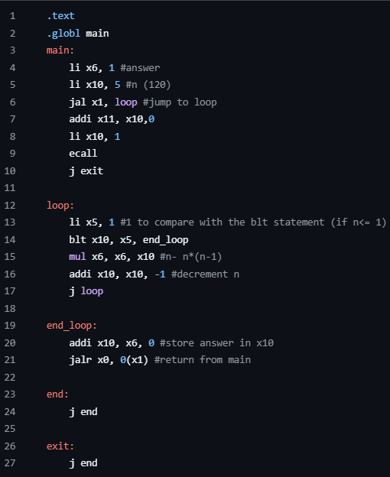
*Add snip of relevant Registers / Memory locations where you think results are obtained. Make sure the irrelevant area of snip is cropped. Make sure the irrelevant area of snip is cropped.
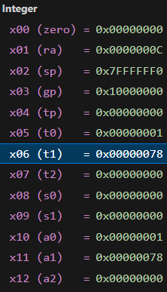
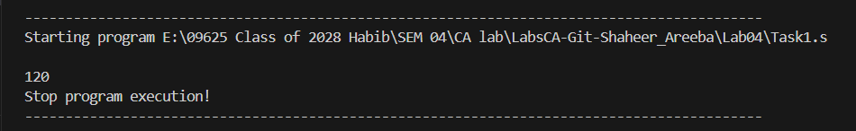
Comments

In the main loop, we stated the value of our n, and called for the loop. Loop compares if the value is the base case of recursive call. If not, it causes a decrement in value on n and stores its value in x6, calls loop again until n=1. Then it reaches the end_loop and from there the value is traced back in x10 back to all the older cases.

Task 2
Provide appropriately commented codes
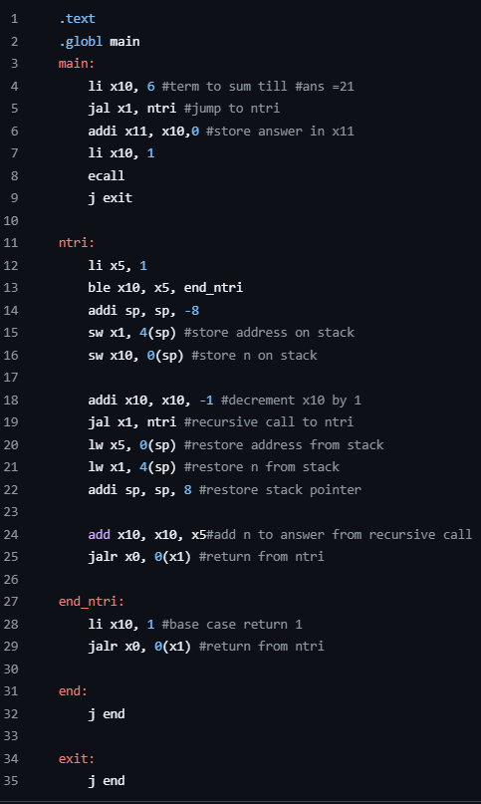
Add screenshot of your results
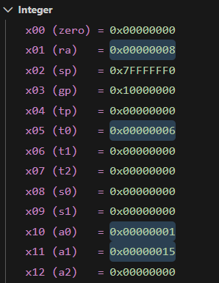
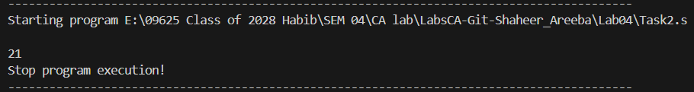
Comments :
Since task 2 was based on iterative approach, we introduced a stack pointer.
We initialized a counter register (x5) to 1 and an accumulator register (like x11) to 0. When we jump to loop, it adds the counter in x11 and does increment counter by 1, and branches back to the start of the loop as long as the counter is less than or equal to our target x10. Once the counter exceeds , the loop terminates, and the total sum is saved in x11. With return address the value is printed from x11 in terminal using ecall.

Task 3: Provide appropriately commented codes 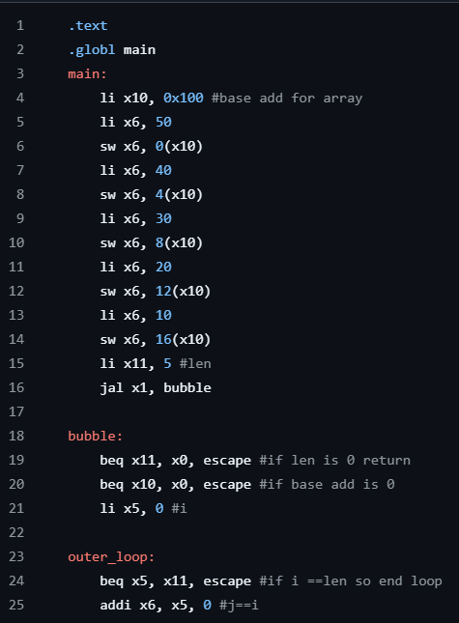
(code continued on next page)

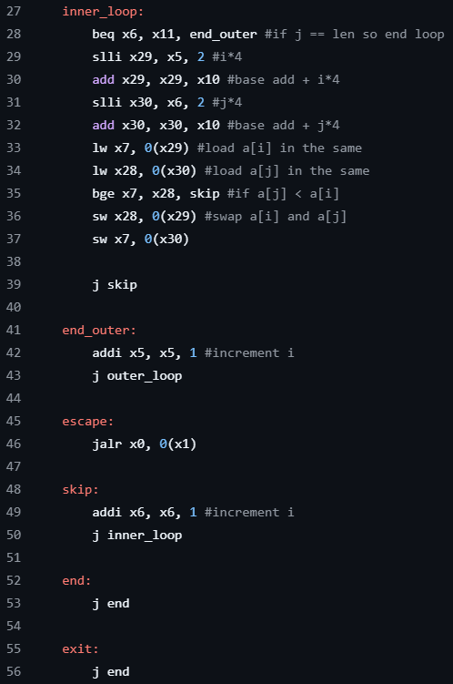

Add screenshots of your results
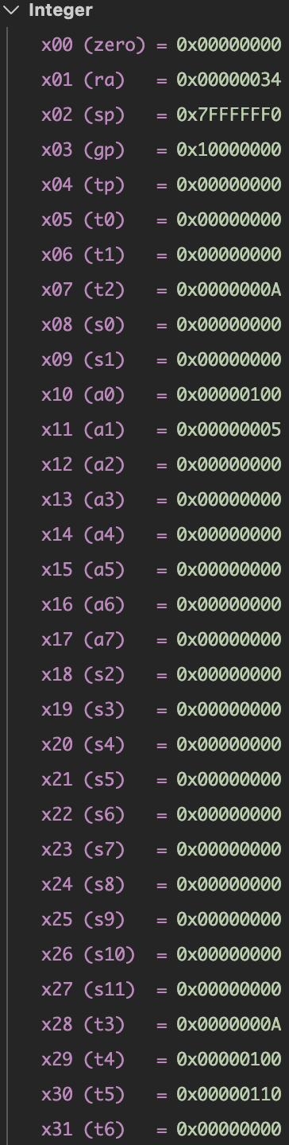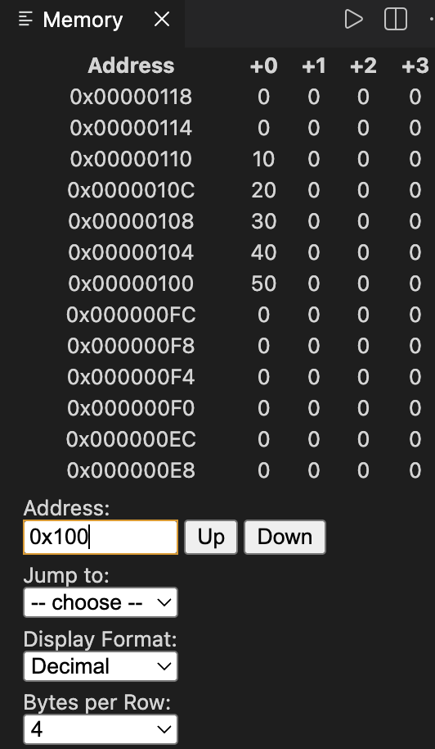
Comments:
The code performs selection sort (sorting array in descending order) The ‘bubble’ part checks if values of x10, x11 are 0 or not (if 0 the sorting would simply be exit) The outerloop part runes for i iteration (in C++) (x5 = i) for every i iteration a j loop is ran over (j =x6)
The j loop, or inner loop checks element at i and j, (index at x5 is shifted 2 bits and is added to base address in x10, its result stored in x29). Same is followed with index in x6, and its address is fetched and stored in x30. The value from these addresses are stored in x7 and x28 and compared. if x7>= x28, the swap is skipped. Else if i is small, its swapped. Once the x6 (j loop) reaches its max length (x11) it exits and the value of i loop is incremented by 1 and it continues until i loop reaches its max length. (and then exits using escape label)

Task 4

Provide appropriately commented codes
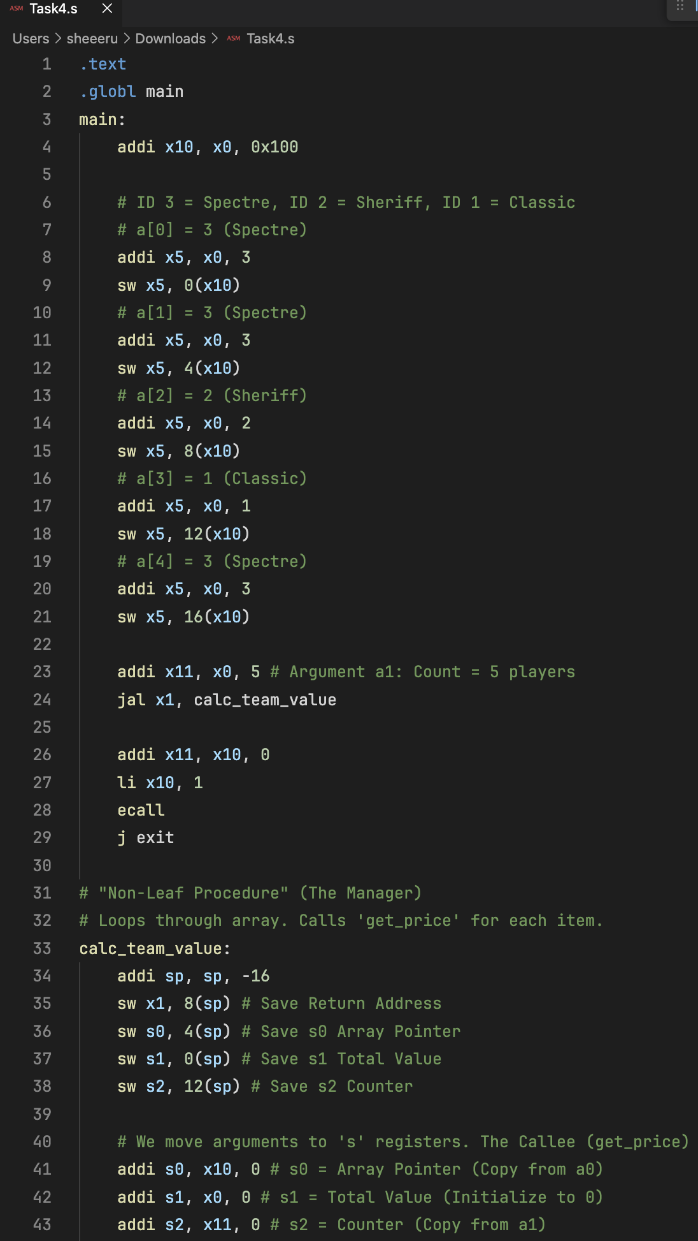

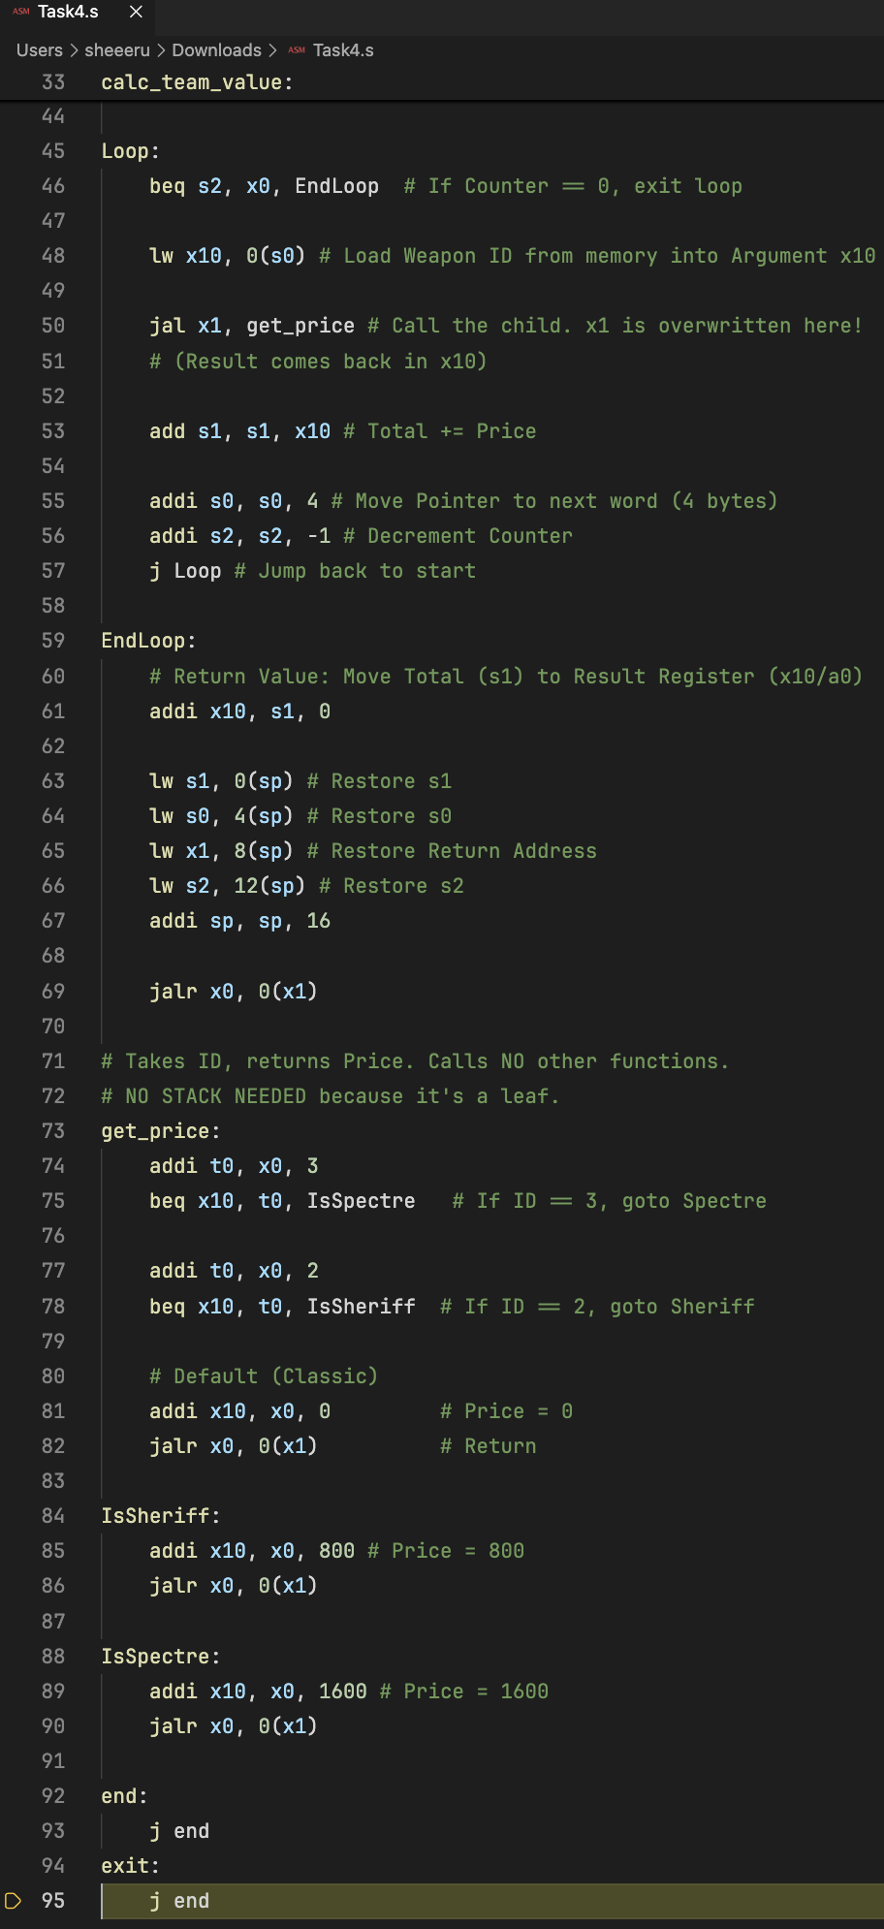
Add screenshots of your results
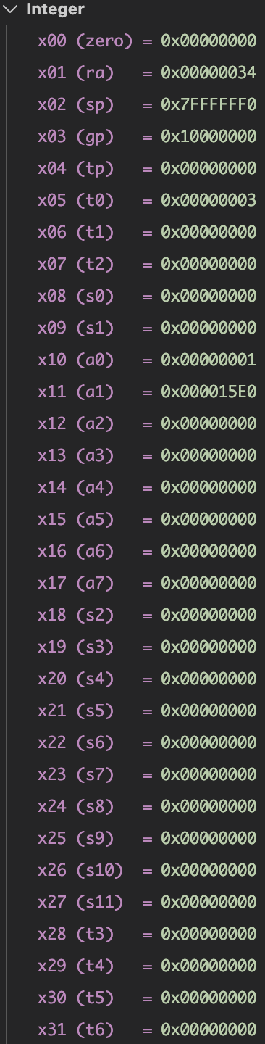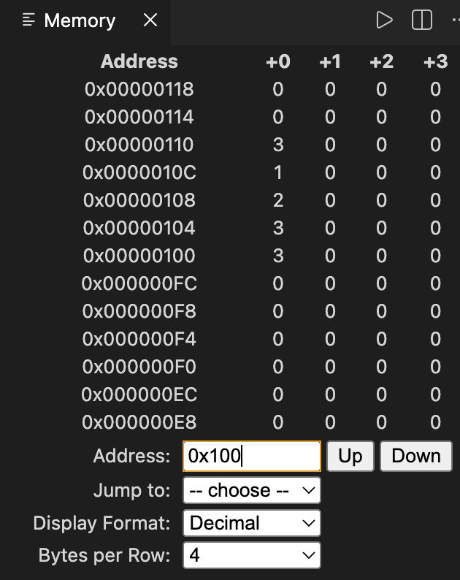
Comments:
Main function sets up 5 weapons. The loop runs 5 times.
Iteration | Weapon ID | Logic in get_price | Price Returned (x10) | Running Total (s1)
1 | 3 (Spectre) | beq to IsSpectre | 1600 | 0 + 1600 = 1600
2 | 3 (Spectre) | beq to IsSpectre | 1600 | 1600 + 1600 = 3200
3 | 2 (Sheriff) | beq to IsSheriff | 800 | 3200 + 800 = 4000
4 | 1 (Classic) | Default (No Match) | 0 | 4000 + 0 = 4000
5 | 3 (Spectre) | beq to IsSpectre | 1600 | 4000 + 1600 = 5600
Final Result: The program prints 5600.

The Stack

Inside calc_team_value, used the stack because we were about to call a "mini-game" (get_price).
- addi sp, sp, -16: You dug a hole 16 bytes deep to store your stuff.
- sw x1, 8(sp): Saved the Return Address (ra).
- sw s0, s1, s2: Saved "Work Variables" (Pointer, Total, Counter).
Memory Offset | Register Saved | Why?
12(sp) | s2 (Counter) | Remembers we have "5" players left.
8(sp) | x1 (Return Addr) | Remembers how to get back to main.
4(sp) | s0 (Pointer) | Remembers which weapon we are looking at.
0(sp) | s1 (Total) | Remembers the current money total.

Jal jumps to the label (e.g., get_price) AND saves the current location into x1 so we can return later.
- main uses jal x1, calc_team_value (Call the manager).
- calc uses jal x1, get_price (Call the worker).
- get_price uses jalr x0, 0(x1) (Return to manager).
- calc uses jalr x0, 0(x1) (Return to main).
- a Registers (x10-x17):
  - In Code: Weapon ID in x10 to send it to get_price.
  - get_price put the cost in x10 to send it back.
- s Registers (x8, x9, x18-x27):
  - In Code: calc_team_value used s0, s1, s2.
- t Registers (x5-x7, x28-x31):
  - In Code: get_price used t0 for comparing numbers. It didn't need to save/restore it.

Lab 04 – Nest Procedures and Sorting

Assessment Rubrics

Points Distribution
Task No. | LR2  Code | LR 5  Results | AR 7  Report Submission & Github
Task 1 | /10 | /05 | /10 & /10
Task 2 | /10 | /10 | /10 & /10
Task 3 | /10 | /10 | /10 & /10
Task 4 | /15 | /10
Total Points | /100 Points
CLO Mapped | CLO 2
For description of different levels of the mapped rubrics, please refer the provided Lab Evaluation Assessment Rubrics and Affective Domain Assessment Rubrics.
# | Assessment Elements | Level 1: Unsatisfactory  Points 0-1 | Level 2: Developing  Points 2 | Level 3:Good  Points 3 | Level 4:Exemplary  Points 4
LR2 | Program/Code/ Simulation Model/ Network Model | Program/code/simulation model/network model does not implement the required functionality and has several errors. The student is not able to utilize even the basic tools of the software. | Program/code/simulation model/network model has some errors and does not produce completely accurate results. Student has limited command on the basic tools of the software. | Program/code/simulation model/network model gives correct output but not efficiently implemented or implemented by computationally complex routine. | Program/code/simulation /network model is efficiently implemented and gives correct output. Student has full command on the basic tools of the software.
LR5 | Results & Plots | Figures/ graphs / tables are not developed or are poorly constructed with erroneous results. Titles, captions, units are not mentioned. Data is presented in an obscure manner. | Figures, graphs and tables are drawn but contain errors. Titles, captions, units are not accurate. Data presentation is not too clear. | All figures, graphs, tables are correctly drawn but contain minor errors or some of the details are missing. | Figures / graphs / tables are correctly drawn and appropriate titles/captions and proper units are mentioned. Data presentation is systematic.
AR9 | Report | All the in-lab tasks are not included in report and / or the report is submitted too late. | Most of the tasks are included in report but are not well explained. All the necessary figures / plots are not included. Report is submitted after due date. | Good summary of most the in-lab tasks is included in report. The work is supported by figures and plots with explanations. The report is submitted timely. | Detailed summary of the in-lab tasks is provided. All tasks are included and explained well. Data is presented clearly including all the necessary figures, plots and tables.

