Lab 2 - Implementing Decision Instructions in RISC V Assembly Language
Name: Shaheer Qureshi, Areeba Izhar | Student ID: sq09647, ai09625

Task 1:
Code:

Listing 3:
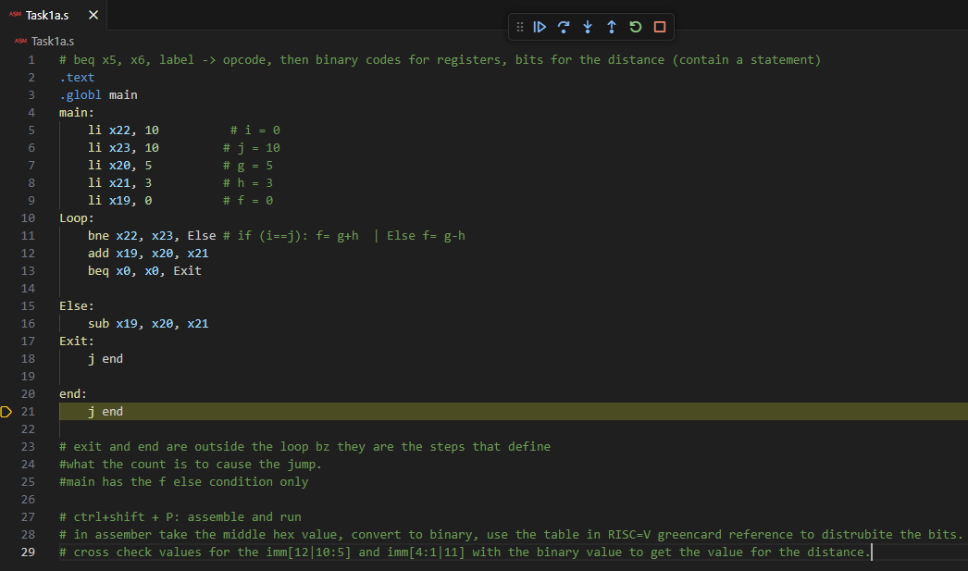

Results:
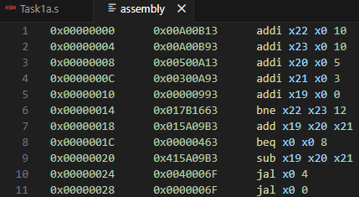

The hex value for bne we obtained was: 0x017B1663
converting it to binary we obtained:
Field | imm[12] | imm[10:5] | rs2 | rs1 | funct3 | imm[4:1] | imm[11] | opcode
Value | 0 | 000000 | 11000 | 01001 | 001 | 0110 | 0 | 1100011
splitting it based on the RISC-V table we obtained the value for our offset:
000000001100 = 12

The hex value for beq we obtained was: 0x00000463
converting it to binary we obtained:
Field | imm[12] | imm[10:5] | rs2 | rs1 | funct3 | imm[4:1] | imm[11] | opcode
Value | 0 | 000000 | 00000 | 00000 | 000 | 0100 | 0 | 1100011
splitting it based on the RISC-V table we obtained the value for our offset:
000000001000 = 8
Task 1:
Code:
Listing 4:
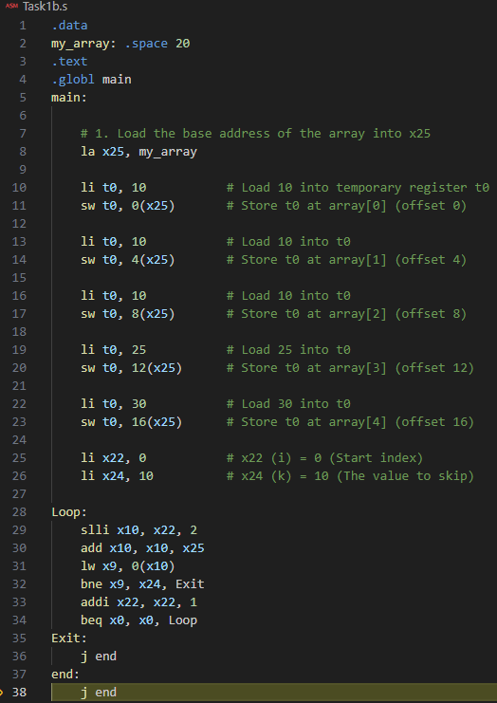
Results:

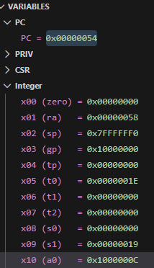
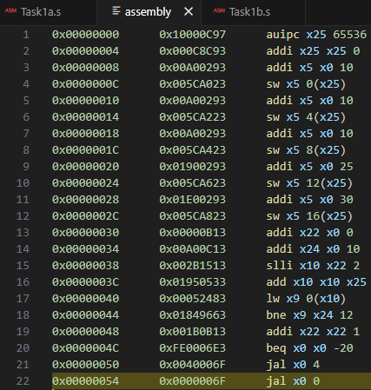
Complete for bne and beq, take 2’ compliment of beq

Task 2:
Code:
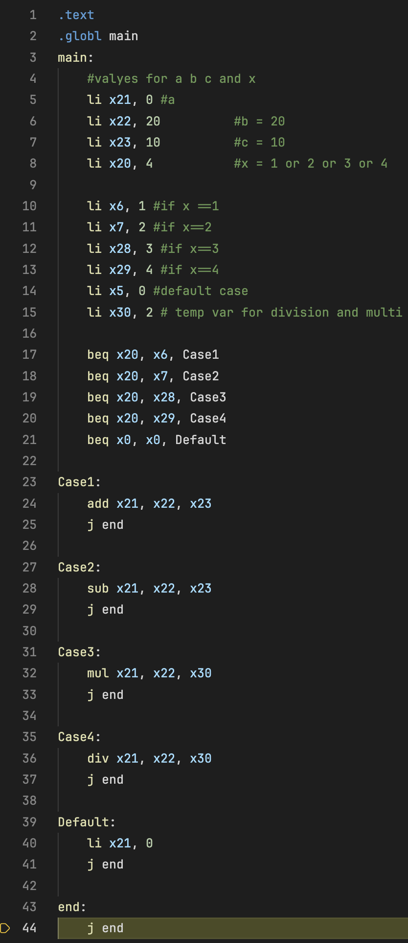

Results:
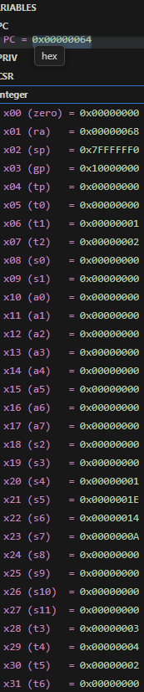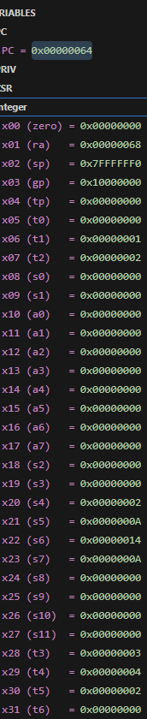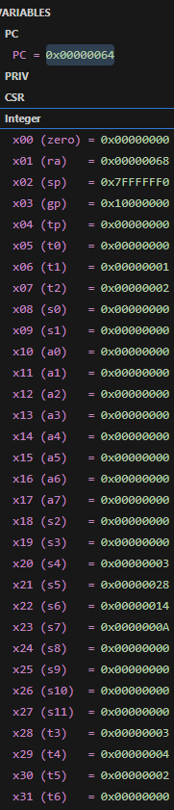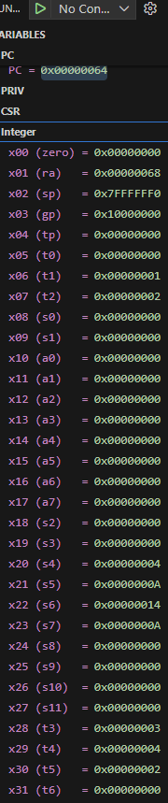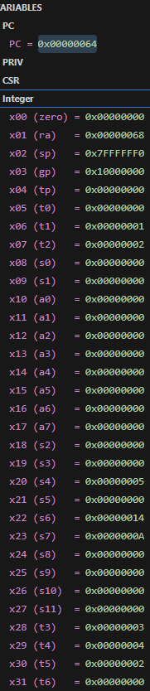
Case 1 Case 2 Case 3 Case 4 Default

Task 3:
Code:
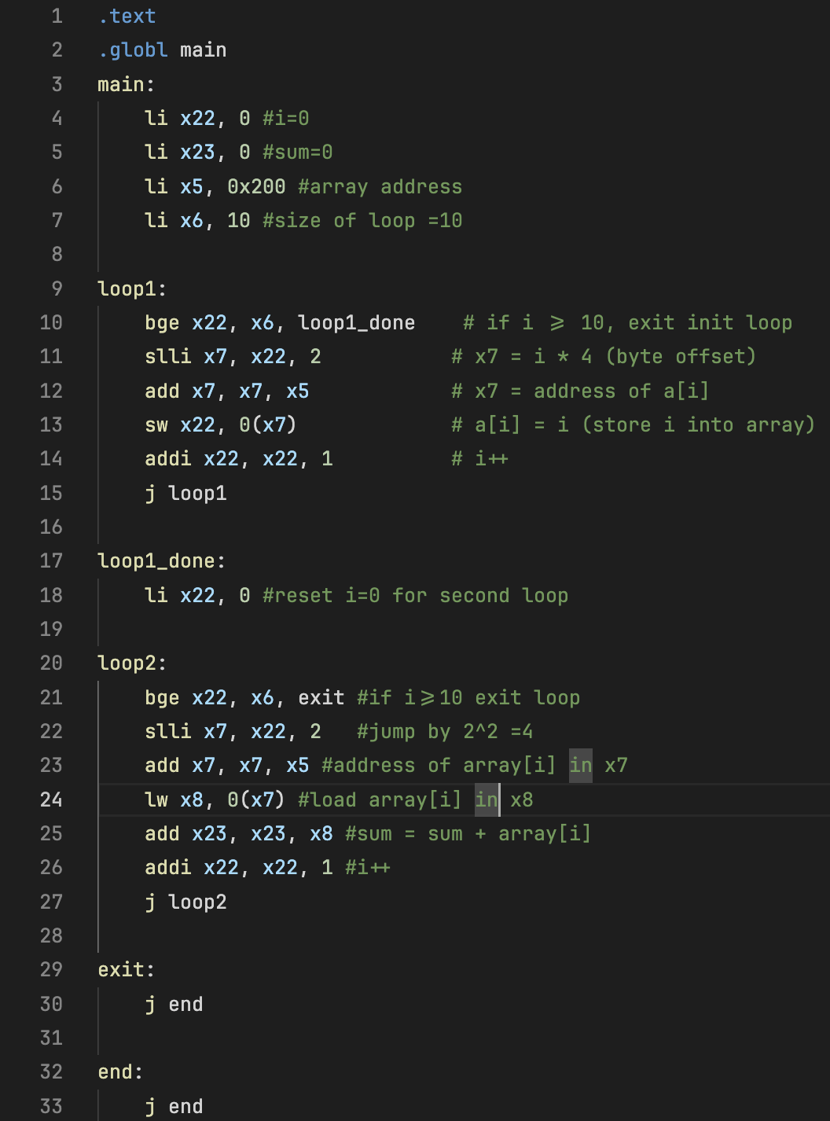
Results:
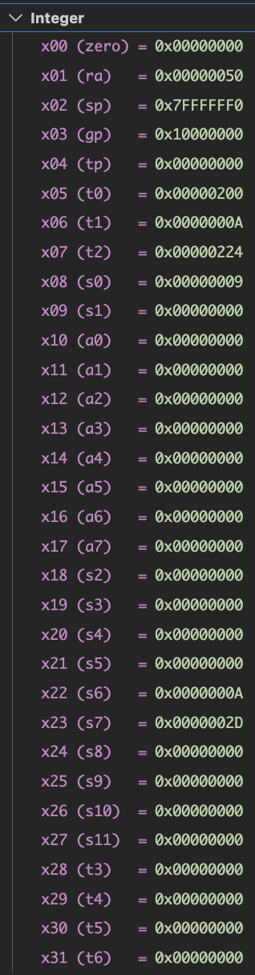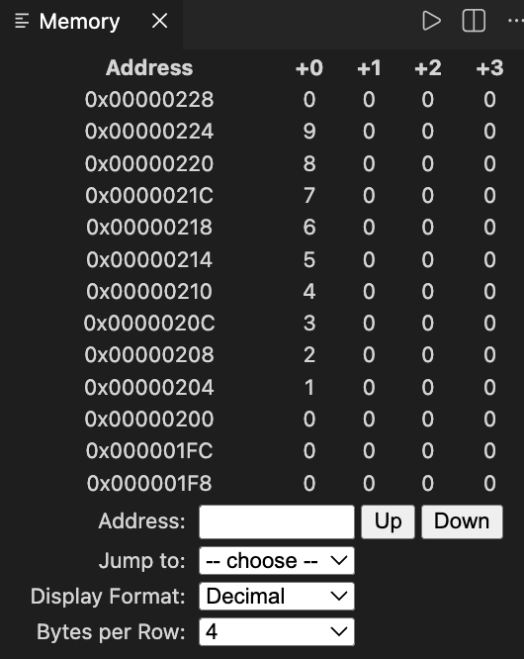
Task 4:
Code:
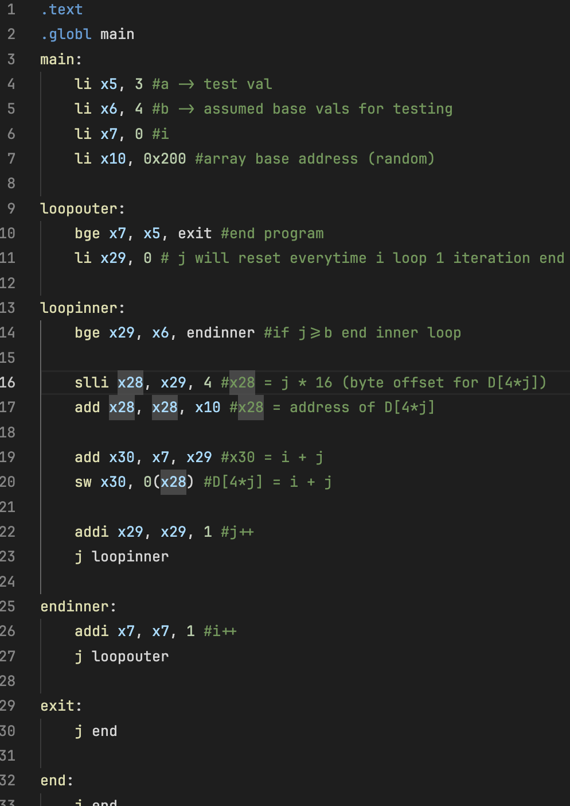
Results:
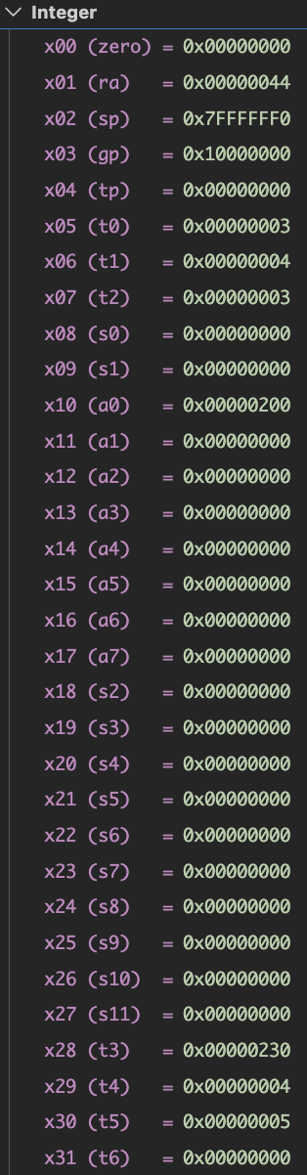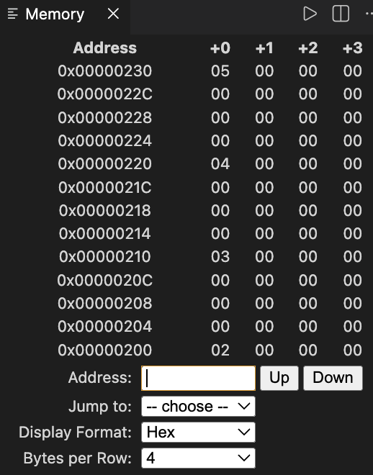

Assessment Rubric
Lab 2 - Implementing Decision Instructions in RISC V Assembly Language

Name | Student ID: | Section:

Points Distribution:

 | Task No. | LR 2 (Code) | LR 5 (Results)
In-Lab | Task 1 | - | /5
In-Lab | Task 2 | /10 | /10
In-Lab | Task 3 | /15 | /10
In-Lab | Task 4 | /20 | /10
Total Points: 100 |  | /45 | /35
CLO Mapped |  | CLO 2

Affective Domain Rubric |  | Points | CLO Mapped
AR7 | Report Submission & Git Upload | /10 & /10 | CLO 2

CLO | Total Points | Points Obtained
2 | 100
Total | 100

